What is HTTP?
HTTP stands for Hypertext Transfer Protocol. It’s a formally defined set of rules for communication between a client (the network resource requesting data or services) and a server (the resource that receives and responds to the request).
HTTP is an application layer protocol in the seven-layer OSI networking model, which standardizes the communication functions of telecommunications or computing systems regardless of the underlying internal structure and technology. The definition and ongoing development of this protocol is now the responsibility of an international organization called the Internet Engineering Task Force (IETF).
The World Wide Web uses HTTP to communicate between web clients and servers—requests for web pages, updates to web resources, status of requests, and so on. The HTTP protocol defines how the web client and server interact with each other.

Difference between HTTP/2 and HTTP/1.1
HTTP stands for hypertext transfer protocol & it is used in client-server communication. By using HTTP user sends the request to the server & the server sends the response to the user. There are several stages of development of HTTP but we will focus mainly on HTTP/1.1 which was created in 1997 & the new one is HTTP/2 which was created in 2015.
HTTP/2 allows clients to make multiple requests over one TCP connection while HTTP/1.1 allows only one request (even with request pipelining).
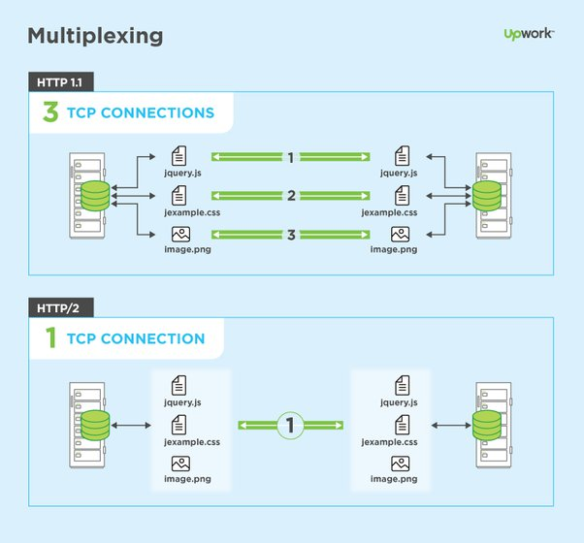
HTTP/1.1: For better understanding, let’s assume the situation when you make a request to the server for the geeksforgeeks.html page & server responds to you as a resource geeksforgeeks.html page. before sending the request and the response there is a TCP connection established between client & server. again you make a request to the server for image img.jpg & the server gives a response as an image img.jpg. the connection was not lost here after the first request because we add a keep-alive header which is the part of the request so there is an open connection between the server & client. there is a persistent connection which means several requests & responses are merged in a single connection. These are the drawbacks that lead to the creation of HTTP/2: The first problem is HTTP/1.1 transfer all the requests & responses in the plain text message form. The second one is head of line blocking in which TCP connection is blocked all other requests until the response does not receive. all the information related to the header file is repeated in every request.
HTTP/2: HTTP/2 was developed over the SPDY protocol. HTTP/2 works on the binary framing layer instead of textual that converts all the messages in binary format. it works on fully multiplexed that is one TCP connection is used for multiple requests. HTTP/2 uses HPACK which is used to split data from header. it compresses the header. The server sends all the other files like CSS & JS without the request of the client using the PUSH frame.
Difference between HTTP/1.1 and HTTP/2 are:
HTTP/1.1 | HTTP/2
It works on the textual format. | It works on the binary protocol.
There is head of line blocking that blocks all the requests behind it until it doesn’t get its all resources. | It allows multiplexing so one TCP connection is required for multiple requests.
It uses requests resource Inlining for use getting multiple pages | It uses PUSH frame by server that collects all multiple pages
It compresses data by itself. | It uses HPACK for data compression.

The differences are quite significant:
HTTP/2 is a binary protocol. This is potentially much more compressed than HTTP/1.1 and this fewer bytes on-the-wire. This means less bandwidth usage and faster load times - benefits which are amplified with many smaller requests.
HTTP/2 is multiplexed. This means many requests can leverage an existing connection in parallel. Coming from HTTP/1.1’s one connection per request this is a huge leap in efficiency.
HTTP/2 requests can be pushed. This means requests can be pre-sent (and be ready before they've even been requested). While that creates some interesting questions (mostly revolving around caches) it's a potentially exciting area of development.

