**WhatsApp Pay**

**STAKEHOLDERS**

|  |  |
| --- | --- |
| **ACTOR** | **What he can do on the Software Created** |
| WhatsApp users | 1. Transfer fund to pre-defined/eligible people in their contacts.  2. Request fund to pre-defined/eligible people in their contacts.  3. Define beneficiaries and their accounts details to transfer/request fund to and or from. |
| Banks | 1. Authorize the linkage between WhatsApp payment and user’s bank account during the initial setup of WhatsApp pay.  2. Approves adding/deleting beneficiaries.  3. Approves requested transactions through WhatsApp pay application.  4. Secure transactions.  5. Transfer the funds to the beneficiary.  6. Shows transactions on the monthly statement. |
| Credit card providers | 1. Authorize the linkage between WhatsApp payment and user’s credit card during the initial setup of WhatsApp pay.  2. Approves requested transactions through WhatsApp pay application.  3. Secure transactions.  4. Transfer the funds to the beneficiary.  5. Shows transactions on the monthly statement. |
| Bank (debit card provider) | 1. Authorize the linkage between WhatsApp payment and user’s debit card during the initial setup of WhatsApp pay.  2. Approves requested transactions through WhatsApp pay application.  3. Secure transactions.  4. Transfer the funds to the beneficiary.  5. Shows transactions on the monthly statement. |

**Risk Identification**

|  |  |  |  |  |  |  |
| --- | --- | --- | --- | --- | --- | --- |
| **S no.** | **Risk Event** | **Consequence** | **Probability** | **Impact** | **Risk Modification/Mitigation Plan** | **Residual Risk** |
| 1 | Switching cost between wallet is too low. Can work both ways (in favor as well as against) | Loss of Business & Revenue | High | High | 1. Periodic Customer Loyalty Benefits and Promotions  2. Cashbacks on Transactions  3. Brand Promotions | Low |
| 2 | Cyberattacks – Malware & Virus Attacks | Loss of Business Loss of Brand Value Legal Implications | High | High | 1. Periodic IT Security control audits  2. Periodic Security Patches to users  3. Data Encryption | Medium |
| 3 | Phishing, Impersonation and SIM swapping attacks | Loss of Customer's money Loss of Customer's Personal Information | High | High | 1. Periodic IT Security control audits  2. Periodic Security Patches to users  3. Authentication | Low |
| 4 | Unintentional exposure of Personal and Sensitive user information | Loss of Customer's money Loss of Customer's Personal Information | High | High | 1. Periodic IT Security control audits  2. Periodic Security Patches to users  3. Data Encryption | Low |
| 5 | Breach of Compliance Standards like PCI etc. | Legal Penalties Loss of Brand Value | High | High | Periodic third party IT Control Audits | Low |
| 6 | Time To Market – New competitors may evolve & capture market share | Loss of Market Share | Low | Low | 1. Expedite Product Delivery  2. Pre-launch promotions and branding | Low |
| 7 | Wrong Transactions | Loss of Customer's money | Low | Medium | Mechanism to report such transactions and reverse them | Low |

**SWOT Analysis of WhatsApp pay**

Perform SWOT Analysis for the system.

**Strengths:**

* Easy to adopt and user-friendly payment method
* Safe & Secure method of payment
* Wide applicability and acceptance like retail shops, KIOSK centers, shopping malls, online payments and peer to peer payments.
* No limit on the minimum amount required for payment making this an attractive option
* Easy to connect new accounts and one-time payments
* Direct link to user’s bank account
* Strong government push
* High Customer adoption rate
* Existing user base of ~2 billion whatsapp users as initial target base

**Weakness:**

* Lack of supporting Infrastructure – Internet connectivity, compatible mobile devices etc.
* In certain low value but high-volume transactions, cash transactions are still preferred
* e-literacy is a challenge as current yet traditional whatsapp users may not be able perform financial transactions with same ease.
* Dependency on bank accounts: low income group might not have

**Opportunity:**

* Curbing Black Money as all the transactions would be carried out via bank accounts leaving a financial footprint
* Increased Tax Collection due to transactions
* High growth rate of this segment overall (CAGR: 23%)
* Cashless/paperless payments reducing carbon footprint
* Small Vendors/Merchants can be convinced to adopt cashless medium
* Traditional users can be target base.

**Threat:**

* Existing competitors holding large market share like PayPal, GooglePay etc
* Switching cost between wallet is too low. Can work both ways (in favor as well as against)
* Cyberattacks – Malware & Virus Attacks
* Phishing, Impersonation and SIM swapping attacks
* Unintentional exposure of Personal and Sensitive user information
* Breach of Compliance Standards like PCI etc.
* Time To Market – New competitors may evolve & capture market share

**PROPOSED SYSTEM**

What is the proposed solution or system? Mention in points how the system itself will be for the user.

1. User friendly interface

2. Facilitate users to perform one-tap or One-click payment to listed beneficiaries

3. Easy payments to one-time beneficiaries by scanning the QR codes

4. Facilitate users to receive money

5. The App will assist users to report any fraudulent or incorrect transactions

6. Users will not have to go specific Bank Apps or wallets to make the payments

**SCOPE using Use Case Diagram (UML)**

Create a use case diagram including all the actors and processes for an end to end process of the system.



**IN SCOPE**

The In-scope requirements are as follows:

1. New Payment Feature for WhatsApp user

2. Add New Payment Option

3. Remove Payment Option

4. Scan QR code for making payment option

5. Approve Payment Request

6. Reject Payment Request

7. Report an Issue

8. View Transaction History both overall and per user.

**OUT OF SCOPE**

The out-of-scope requirements are as follows:

1. New Bank Account Creation

2. Virtual Wallet Money in form of virtual points

3. Money Transfer without linking payment methods/account (at receiver’s end)

4. Transfer money to non-WhatsApp QR codes

**Business Requirements:**

**Business Objective:**

* Have at least 1 million users use WhatsApp pay feature within the first 3 months of launch.
* Over 1 year of its launch have 30% of user base using WhatsApp pay.
* Be among top-5 market players in the first year of launching.

**FUNCTIONAL REQUIREMENTS**

1. New Payment Feature for WhatsApp user

2. Create Pin

3. Change Pin

4. Add New Payment Option

5. Remove Payment Option

6. Block a Contact

7. Un-block a Contact

8. Scan QR code for making payment option

9. Approve Payment Request

10. Reject Payment Request

11. Report an Issue

12. View Transaction History both overall and per user.

13. Change Language Feature

14. Change Theme

**NON-FUNCTIONAL REQUIREMENTS**

Write all the nonfunctional requirements for the system.

**System Requirement:**

**1.** Existing WhatsApp Chat platform technology should be used to develop the WhatsApp Pay as well to ensure tight integration between the two.

**2.** Feature should be available in multiple languages and should support transactions in different currencies

**3.** Strong Encryption Technologies should be used as user PI data would be stored

**4.** The transactions should be end to end secured via secured Internet Protocols and encryption

**5.** The backend data base should be highly scalable and should use redundancy and mirroring to ensure availability of services all the time

**6.** The system performance should be optimized and should not degrade considerably based on the internet speed fluctuation of the user

**Usability:**

1. The screens should be self-explanatory and very user friendly.

2. Screens should use the current WhatsApp aesthetics and themes in the WhatsApp Pay pages as well to ensure user familiarity.

3. There should be FAQ section available to answer generally asked queries

**Screen Wireframes**

Create wireframes for every screen that will appear to the users.

Method 1:

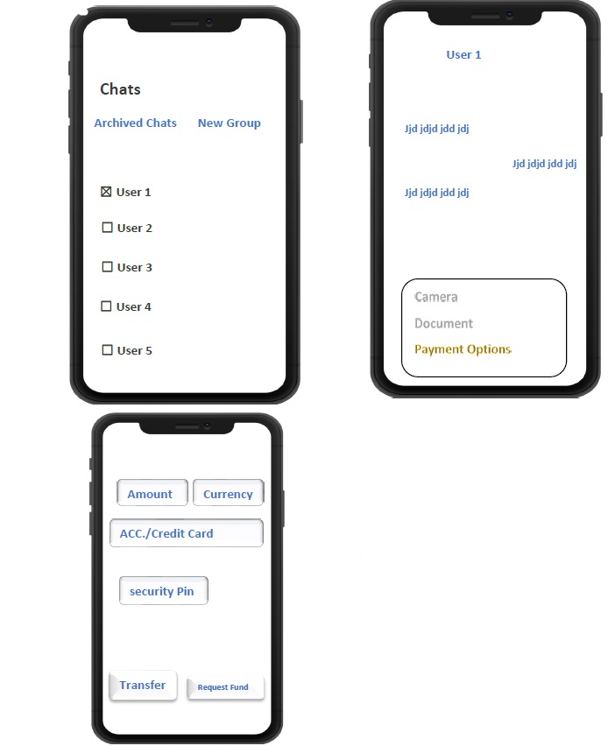

**Method 2:**

