Stanford Library

STAKEHOLDERS

ACTOR | What he can do on the Software Created
Student | - Student can be able to open the portal using the username and password with an unique identification number  - Student shall be able to reserve, order the book as per his/her choice from the options given (subject, authors, publishers, price etc.)  - Student will be given options to add, delete, cancel, return the books ordered, view books, magazines, journals, research papers etc.  - Student to have options on download e-books with search engine and get access to information with respect to last date of return, calculation of fine and penalty for losing book  - Change password of his/her account at any point of time.
Library Staff | - Please mention here what the library staff should be able to do. You can have more than 1 point.  - Librarian to have options to add, delete member, add any new additions of books, delete and save book records.  - Send email reminders to the students on the due dates of returning the books, fine calculations, penalty calculation for losing the books.  - Keep updating on the stock of books, journals, newspapers and other magazines availability information on the portal highlighting any new additions to the library with offers, discounts etc.  - The library staff to update the record on daily basis on the use a RFID reader to capture the details of the book. The student's name to be tagged along with the book they borrowed.  - Librarian to keep stock of books and update the management on the low stock or non m movement of stock through proper maintenance of records.  - Librarian to ensure that alarm for RFID readers is in working mode and ensure that books pass through exit gates.  - Librarian to update on the RFID enabled drop box stations for the books to be returned by students anytime within the due date.  Librarian to ensure that Student’s loan is immediately cancelled once the student deposits the book in the drop box.
Management | - Management to ensure that the portal is user friendly and is easy to access  - In this line item please suggest what the management system must do. Note: management system is not a stakeholder.  - Core of this system will be a COTS database able to manage millions of records.  - Database will be secured and will grant access via multiple entry points, for both Student and Staff users.  - Reporting interface will allow users to access materials data via Standardized Reporting and Ad Hoc Reporting.  - User Interface will allow users to manage materials access, regarding:  1. search/location of materials,  2. issue and return materials,  3. penalties calculations,  4. locate/map return stations  5. determine scheduled return date

PROBLEM DEFINITION AND SOLUTION

ISSUES with MANUAL SYSTEM

- Paper-based record keeping.
- Miss-management of data due to manual and paper-based handling.
- A vast amount of time consumption in searching for books and library management.
- Book-thefts from the library.
- Manual operating systems are vulnerable to human error.
- Manual systems are also slow to operate. Instead of using a computer to issue and take back books, locating and updating a card index is slow and laborious.
- Manual systems are unable to store large amounts of data efficiently.
- With manual systems staff spends a lot of their time on mechanical, clerical tasks rather than liaising with library visitors.

SOLUTIONS with ONLINE SYSTEM
- The system excludes the use of paper work by managing all the book information electronically.
- Admin can keep updating the system by providing the new books arrival in system and their availability thus students need not to go to library for issuing purpose.
- The system has books well organized and systematically arranged in different categories in the system so that user can easily search and find the book.
- Saves human efforts and resources.
- Proper reports can be generated with the necessary information to view the real-time updates and progress, with a click of a button.

Advantages of LMS
- Integration of all records of students
- Manage the records systematically
- It can track any information online
- One can generate the reports
- Manage all information online
- Easy to maintain records
- It leads to fast book entry

Advantages of Library Management System:
- It is user-friendly software and easy way to enter book data
- It is cost-effective and easy to install and easy to export and import records
- It helps in maintaining records and one can track any information through this system
- It increases the efficiency and It saves human effort and time
- It reduces the chances of error and acts as an anti-theft

HIGH LEVEL ADVANTAGES for LIBRARY
- Simple & Easy to Use, clear search interface for all users
- Increased Library Engagement
- Efficient Cloud Data Management
- Highly Secure, Scalable & Reliable
- Mobile Access
- Dynamic Reports
- Error-free and innovative web portal
- Fully Customizable and can Print own barcodes
- Web-based OPAC (Online Public Access Catalogue) system and Cost-effective

HIGH LEVEL ADVANTAGES for STUDENT
- Student can also check the availability status of a particular book online
- Instant access to educational content
- Online libraries help the scientific society since they act as a reservoir for the storage of important research data, information and findings
- Digital libraries give access to multiple contents with a potentially infinite number of resources and selections at hand.
- The digital storage of books and, above all, audios, solve the problem of deterioration.
- They can access an enormous amount of knowledge and share contents with others, facilitating the expansion of education.
EXISTING SYSTEM

- The existing manual library system need more effort and physical space to keep track of paper documents, to find information and to keep details secure.
- Manual-based systems are dependent on humans being correct with details and more space is needed for documents.
- The manual-based system is more time consuming and need many number of employees to manage 4 million books present in the library
- Every system humans work with is vulnerable to errors.
- It takes a lot of time to enter data manually.
- Paperwork can take up a significant amount of space, and the need of space will increase as the number of the document increases with an increase in growth of the business

PROPOSED SYSTEM

- User friendly interface .Students could deposit the books only in the library timings.
- The Proposed online library system should keep records of different categories of material available in the library like books, magazines, research papers, journals, and newspapers.
- The books should be classified subject wise in the software. All books, magazines, research papers, journals, and newspapers will have different issuing periods. For example, a book can be issued for 3 weeks but a magazine only for 1 week.
- The library staff will use a RFID reader to capture the details of the book. The student's name is tagged along with the book they borrowed.
- System will record the issue date and return date of the book.
- System shall do an automatic calculation of fines in case of delayed return of books
- Every reading material available shall have a RFID tag on it. The record of the same will be stored in the database. For each reading material record information like author, book name, publisher name, book edition, date and year of publication, cost of the book, and date of purchase of the book,.
- Students should be able to access the library system online to know the return date. They should be able to access it via the web or mobile interface.
- System shall send automated emails to the students 3 days before the return date to avoid late return of books.
- Access to free e-journals and e-books through the software.
- Anti-theft detection: RFID readers are placed at the exit gate of the library and the RFID reader tracks books to a range of 2 meters and would trigger the alarm with a loud sound in case anyone tried to pass through the gate with an unissued book.
- Book drop box stations to be installed outside the library: Students can return books at any time in the RFID enabled book drop box station. Student’s loan is immediately cancelled once the student deposits the book in the drop box.

Flowchart for LMS
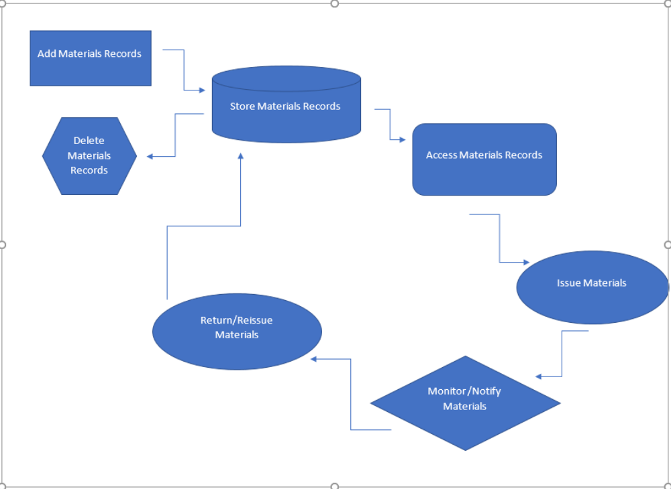
SCOPE using Use Case Diagram (UML)
Create a use case diagram including all the actors and processes for an end to end process of the system.
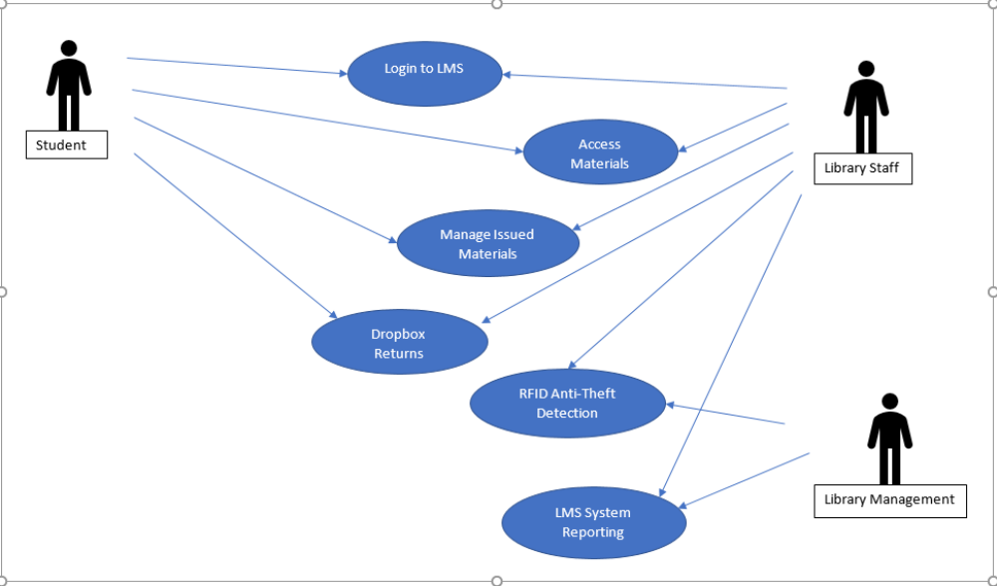

SCOPE using Context Diagram

Depict the scope using Context diagram.
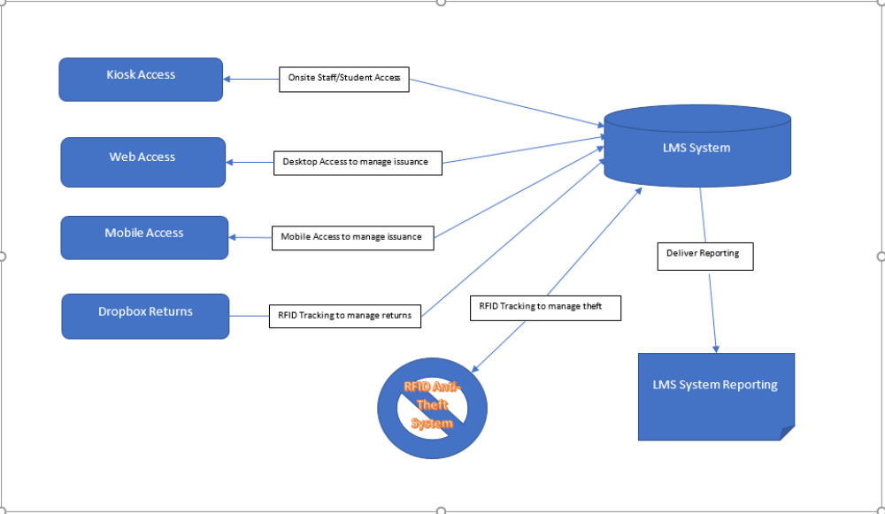

DATA FLOW DIAGRAM

Create a data flow diagram.
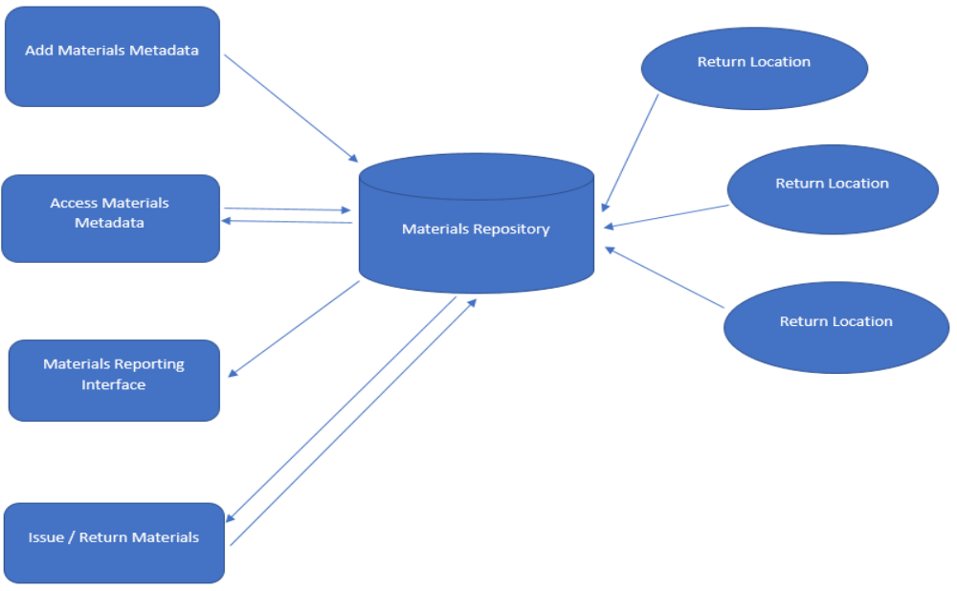

IN SCOPE

Physical “Kiosk” access points on location will be used by students and staff to locate and manage materials.
● Browser application will be used to allow web access by students, staff, and management actors, for materials activities.
● Mobile application will be used to allow web access by students and staff, for materials activities.
● Dropbox locations will allow collections for materials, and transmit data to LMS system for status and location updates
● LMS System will track materials metadata.
● LMS System will track materials location.
● LMS System will track materials status.
● LMS System will track materials overdue penalties debits and credits.

● LMS System will deliver reporting on materials metadata.

● LMS database will conform to Stanford information systems non-functional requirements standards regarding accessibility.
● Autogenerated notifications for due-date, availability and penalties payments.

OUT OF SCOPE

LMS will not manage materials required for classes or otherwise not owned by the Library.
● LMS will not manage fees unrelated to the Library.
● LMS will not manage systems security unrelated to the Library.
● Browser access will be limited to Stanford-approved and -supported browsers and browser versions.
● Mobile application will be limited to Android OS devices.
● Materials not available in electronic formats will not be accessible within web and mobile access points.
● Materials access will be limited to items allowed by governing copywrite laws.

Wireframes:
Create sample wireframes for the system. Capture what screen will be show to the library employees to create records for each book and at what stage in the system.
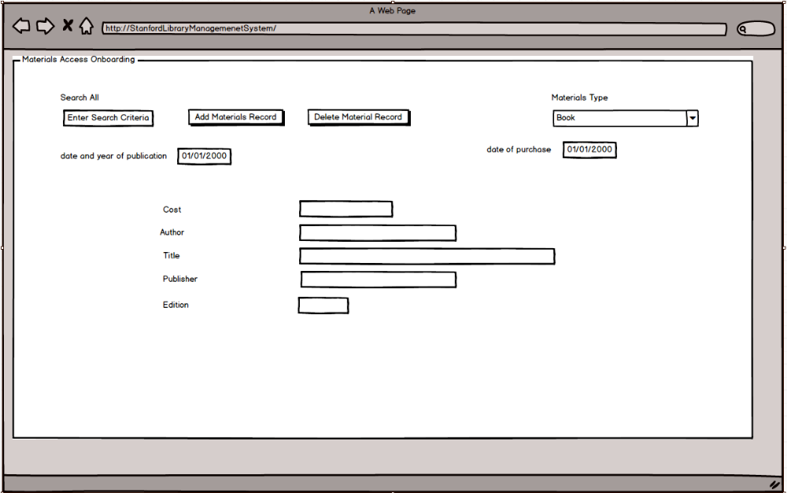
ER DIAGRAM FOR THE SOFTWARE

Create an ER Diagram for the system you have designed.
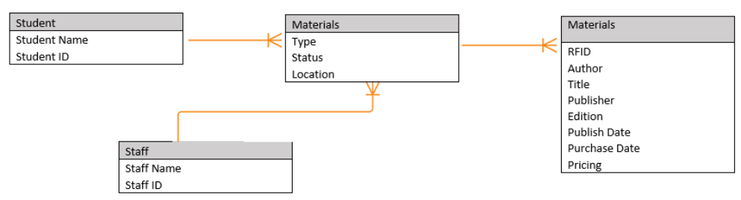

FUNCTIONAL REQUIREMENTS

The LMS should keep records of different categories of material available in the library like books, magazines, research papers, journals, and newspapers.
2. The books should be classified subject wise in the software.
3. Each category like books, magazines, research papers, journals, and newspapers will have different issuing periods. For example, a book can be issued for 3 weeks but a magazine only for 1 week. Newspapers cannot be issued for use outside the library and so on.
4. Every reading material available shall have a RFID tag on it. The record of the same will be stored in the database. For each reading material record information like author, book name, publisher name, book edition, date and year of publication, cost of the book, and date of purchase of the book.
5. When a student wants a reading material from the library, they will select the material and go to the checkout counter. The library staff will use a RFID reader to capture the details of the book. The student's name is tagged along with the book they borrowed.
6. System will record the issue date and return date of the book.
7. System shall do an automatic calculation of fines in case of delayed return of books.
8. Library staff should be able to search for books on the LMS by search criteria like name of the book or author.
9. Students should be able to access the library system online to know the return date. They should be able to access it via the web or mobile interface.
10. System shall send automated emails to the students 3 days before the return date to avoid late return of books.
11. Access to free e-journals and e-books through the software.

12. Anti-theft detection: RFID readers are placed at the exit gate of the library and the RFID reader tracks books to a range of 2 meters and would trigger the alarm with a loud sound in case anyone tried to pass through the gate with an unissued book.
13. Book drop box stations to be installed outside the library: Students can return books at any time in the RFID enabled book drop box station. Student’s loan is immediately cancelled once the student deposits the book in the drop box.
14. Management would like the following reports:
• Which books are most rented?
• Records of issued and unissued materials in the library (management will decide whether to stock them or not)
• Amount of fine collected in a day, week, and month.
• Number of lost books
• Report on total number of books, journals, etc.
• Age of books, that is, which books are more than 20 years old.

NON-FUNCTIONAL REQUIREMENTS
System Requirement:
● Data should be stored in cloud.
● Highly secure, scalable, and reliable.

Usability:
● Users will need an active internet connection.

Environments
● Browser support limited to latest 3 versions of Safari, Chrome, Edge, Explorer.
● LMS can be used on any Windows run computers.
● LMS can be used on any MacOS run computers.

