Software Requirements Specification

for

QA Automation Course Blog

April 2017
Version 0.1

Prepared By
Team Papaya

Table of Contents
1. Introduction 1
1.1 Purpose 1
1.2 Scope 1
1.3 Overview 1
2. Overall Description 2
2.1. Product Functions 2
2.1.1. User Types 2
2.1.2. Page Content 2
2.1.3. Articles 2
2.2. General Constraints 3
2.3. Format Fields Constrains: 3
2.4. Assumptions and Dependencies: 4
3. Specific Requirements 5
3.1. Functional Requirements 5
3.1.1. Use case diagrams 6
3.2 Non-Functional Requirements 8
3.2.1 Performance 8
3.2.2 Availability 8
3.2.3 Supportability 9
3.2.4 Security 9
3.2.5 Portability 10
4 Mock-ups 10
4.1 Home page 10
4.2 Login page 10
4.3 Register page 11
4.4 Articles 11
4.5 Manage Users 12

Introduction
One of our new Clients have requested from “Papaya” to create a new web application. The main goal of the application is to be used by customers as a blog. For the purpose of this project the application will be called “QA Automation Blog”.

Purpose
The purpose of the document is define the application, its requirements, how this product will be used. The futures that will be developed and document the concept of the project. In short, the purpose of this SRS document is to provide a detailed overview of our software product, its parameters and goals. This document describes the application’s functionalities and software specifications. It defines how our client, team and audience see the product and its functionality.
A detailed description of the new Web Application “QA Automation Blog”. It will explain the purpose and features of the system, the interfaces of the system, what the system will do and the constraints under which it must operate. This document is intended for both the stakeholders and the developers of the system and will be send to the Client for its approval before “Papaya” starts with actual development.

Scope
This SRS is aimed at specifying requirements of software to be developed. The purpose of this software is to provide the automation testers with a blog for learning and commenting on QA automation news, events and resources.

Overview
The remaining sections of this document provide an overall description including functional and data requirements of the product. We are going to focus on describing the system in terms of product perspective, product functions, user characteristics and dependencies on the following sections of this document. Next, we will address specific requirements of the system, performance requirements, and other requirements.

2. Overall Description

2.1. Product Functions
The main purpose of the blog is to meet students, lectors and fans of SoftUni in order to discuss courses and programming in general.
There will be the following pages:
- Home Page
- Register Page
- Log in Page
- Create Article Page
- Edit Article Page
- Manage Profile Page
- For Admin users there will be the below extra pages
  - Users Page
  - Edit user Page

2.1.1. User Types
There will be three types of users: Regular(not logged in), Logged user and Admin.
Regular users will be able to read articles.
Logged users will be able to read articles, create new article, edit and delete their own articles.
Admin users will have the rights of logged user, but they will also be able to edit and delete other user’s articles. Admin user will be able to edit and delete user profiles. This includes providing other users with admin access rights.

2.1.2. Page Content
Each page will have header, page content and footer. The blog logo - “SOFTUNI BLOG” should be visible in the header on every page. Upon click on the logo users will be redirected to home page. “© 2017 - SoftUni Blog” text should be in the footer on every page.

2.1.3. Articles
Each article will have title, content, author and date of creation.

2.2. General Constraints
- Application requires Internet connection.
- The application must be Web-based.
- The product will only work within a particular network environment
- The system should be up 24/7

2.3. Format Fields Constrains:
“Email address” field:
Emails are considered to be in format <user>@<host>, where:
- <user> is a sequence of letters and digits, where '.', '-' and '_' can appear between them.
- <host> is a sequence of at least two words, separated by dots '.'. Each word is sequence of letters and can have hyphens '-' between the letters
“Full Name” field:
- “full name” is a sequence of letters, special symbols, blank spaces and digits
- Small and capital letters from Latin alphabet
- Minimum length of 3 characters
- Maximum length of 50 characters
- Each name must start with small or capital letter
“Password” field:
- A minimum of 6 characters is required.
- Maximum length of 50 characters
- Small and capital letters from Latin alphabet
- Password can be mix of uppercase and lowercase characters, numbers and punctuation.
“Confirm password” field:
- Exact match with “Password” field input
“Current password” field:
- Exact match with “Password” field input upon login

“Article Title” field:
- Minimum length of 5 characters
- Maximum length of 50 characters
“Article Content” field:
- Minimum length of 100 characters
- Maximum length of 2000 characters

2.4. Assumptions and Dependencies:
The availability and load time of the Blog depends on user’s internet connection strength which also depends on the media from which the product is run.
The performance depend upon hardware components of the user’s machine.

3. Specific Requirements

3.1. Functional Requirements
The application should support the following use cases:

CLASS OF USE CASES | № | USE CASES | DESCRIPTION OF USE CASES
Related to System Authentication | 1 | Register | Register in the blog
Related to System Authentication | 2 | Log in | Login in the blog
Related to Articles | 3 | View articles | View articles with/without login
 | 4 | Create article | Only Logged user is able to create article
 | 5 | Edit article | Only Logged user is able to edit his own article. Admins are able to edit all articles.
 | 6 | Delete article | Only Logged user is able to delete his own article. Admins are able to delete all articles.
 | 7 | Comment article | Only Logged user is able to comment articles.
Related to Admin Rights | 8 | Edit user | Admins can edit other user’s “Email”, “Full Name”, “Password”, “User Status”(from user to admin and vice versa)
 | 9 | Delete user | Admins can delete other user’s profiles(this should not include deleting of admin profiles)

3.1.1. Use case diagrams
Use Case Diagram №1: Register
Primary Actor: User
Pre Condition: Installed browser and active internet connection. User hits „QA Automation blog” url in the address bar. User is redirected to “QA Automation blog” main page. From there user hits “Register” and is redirected to registration page of the blog.

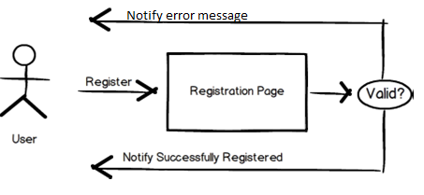

Use case Diagram №2: Login
Primary Actor: Registered User
Pre Condition: Registered user select the “Log in” button and is redirected to “Log in” page of the blog.

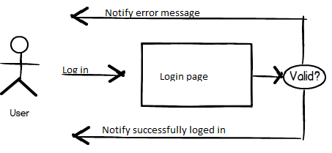

Use case Diagram №3: Create article
Primary Actor: Registered User
Pre Condition: Registered user is logged into „QA Automation blog” page. User selects “Create” button in order to create article.
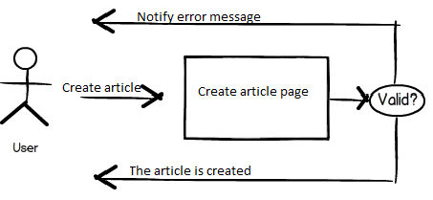

Use case Diagram №4: Edit article
Primary Actor: Registered User
Pre Condition: Registered user is logged into „QA Automation blog” page and selects an own article in order to modify(edit, delete). User selects “Create” button in order to create article.

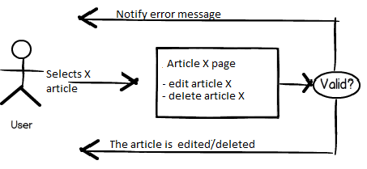

3.2 Non-Functional Requirements
In this section, last group of the requirements which is non-functional requirements will be explained in detail. Non-functional requirements include performance, availability, supportability, security and portability.

3.2.1 Performance
Since this software is going to be web – based, it does require a powerful server machine with high band internet access.
Server machine should have a powerful CPU and high speed internet access so that it can handle multiple users at the same time. Another performance requirement is the storage space. Higher storage space means more user and bigger workspace per user so higher the storage, better the performance.
Performance requirement by the user side is, web application should be developed as a lightweight web app so that it can work on almost any platform even with slower internet connections.
The product shall take initial load time depending on internet connection strength which also depends on the media from which the product is run.
The performance shall depend upon hardware components of the user.
Expected number of simultaneous user should be at least 100. System should be able to deal with 100 users at the same time. Also database of the system should handle at least a thousand of users at any periods.

3.2.2 Availability
The “QA Automation blog” should be available 24 hours per day, 7 days per week.
The system shall provide a contractual agreement with an internet service provider who can provide 99.99% - 52 minutes/year availability through their network facilities onto the internet.
Maintenance access period should be no more than a week overall for the year.

3.2.3 Supportability
Compatible with Browsers
- Microsoft Internet Explorer
- Mozilla Firefox
- Google Chrome
- Opera mini
- Safari

3.2.4 Security
Since this software will be hosted on cloud server, all the user data will be kept on the cloud server. Product should be able to protect privacy of user data. Workspace of the user should only be accessed through user own credentials and any other user should not be able to access to the user private data.
Since execution will also be done in the machine in the cloud, user should be restricted in terms of user rights. User should only access to his own workspace and should not access to any other workspace with the programs they run on the cloud. Also rights of the user should be restricted so that user can not harm to system by the programs they run or by the commands they run on terminal.
Since all the data will be transferred on the web, system should also use an encryption and decryption mechanism only intended user can decode the data and work on the data.
Data Transfer
The system shall automatically log out all customers after a period of inactivity.
Data Storage
The customer’s web browser shall never display a customer’s password. It shall always be echoed with special characters representing typed characters.
The system’s back-end servers shall never display a customer’s password. The customer’s password may be reset but never shown.
The system’s back-end databases shall be encrypted.

3.2.5 Portability
As explained in the performance requirements section, software should be lightweight so that it can run on a machine with slow internet connection. To make the web application lightweight, simple libraries and tools should be used at developing phase. Such as using JavaScript and HTML5. Portability also means running on most number of different platform without an additional effort. To achieve this, web application should be developed by using the common technologies and tools which are provided by all common web browsers and operating system such as HTML5, JQuery etc.

Mock-ups

Home page
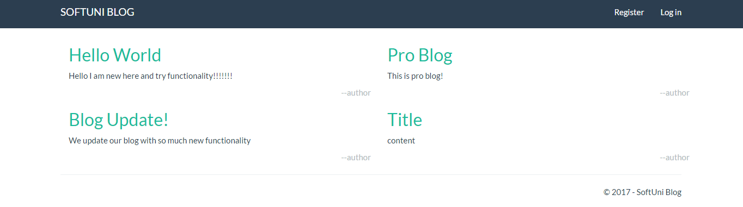

Login page
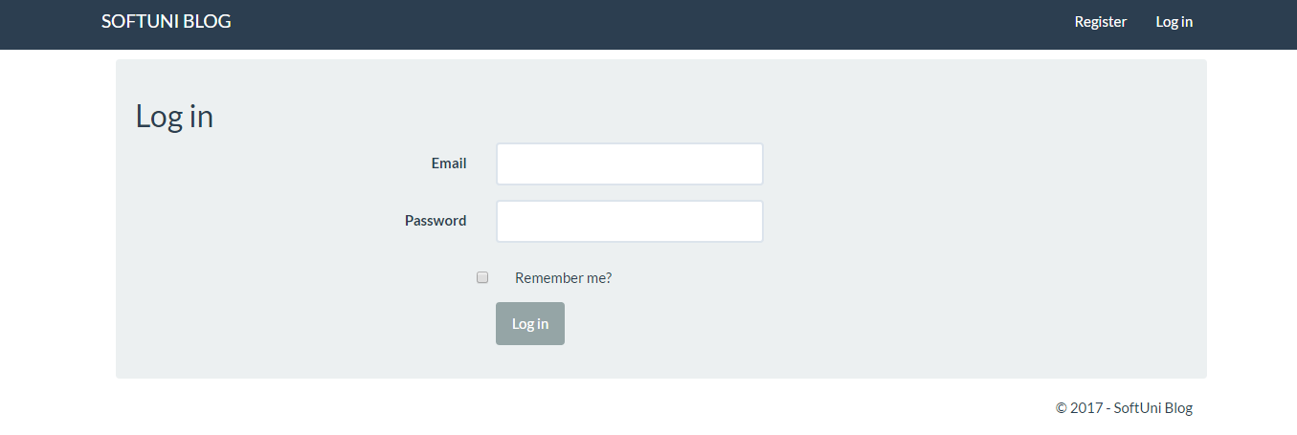

Register page

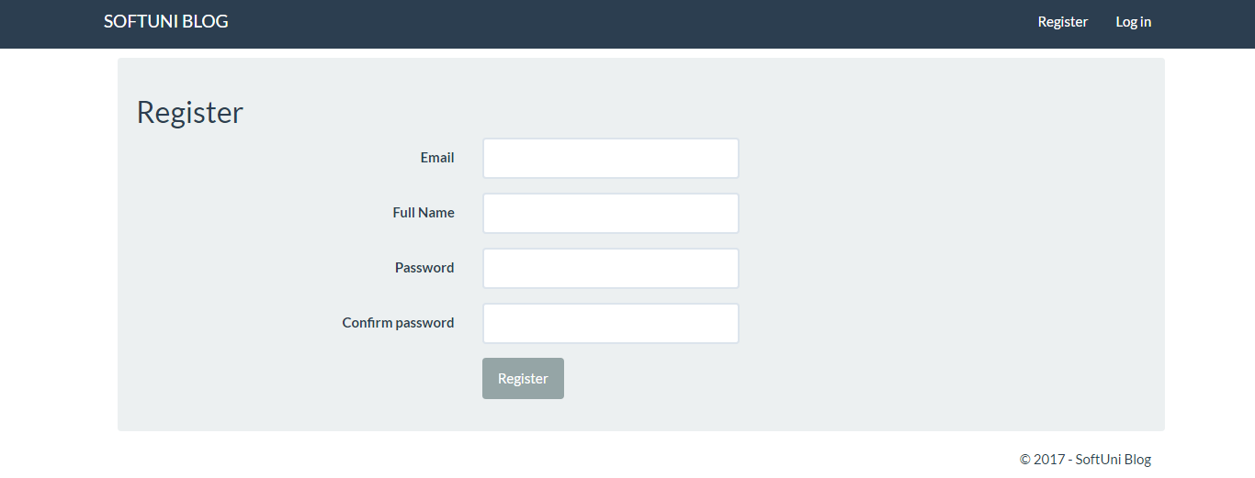

Articles

- Create article

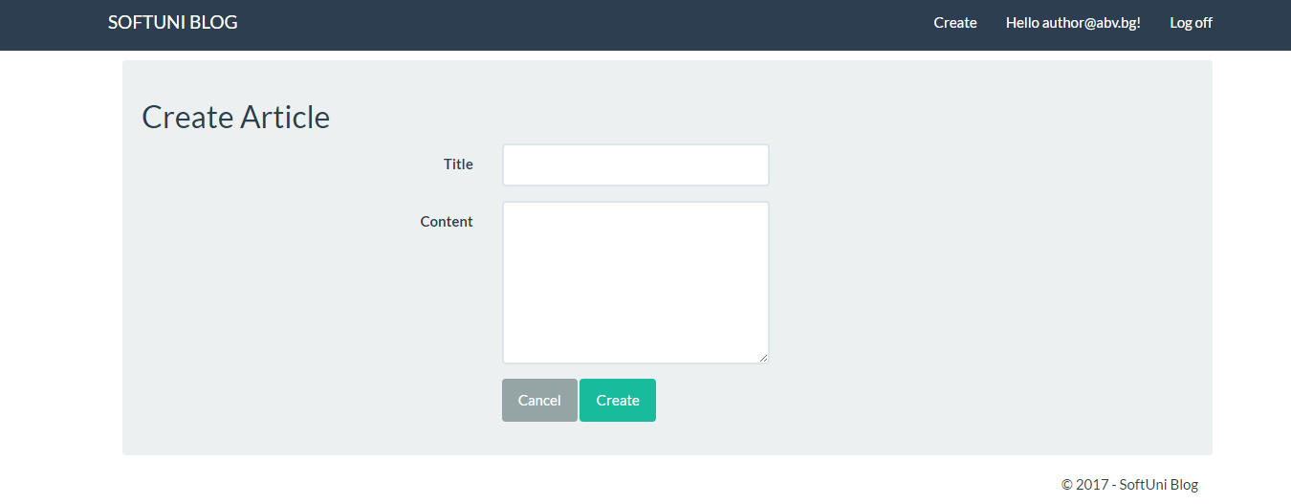
- Update article

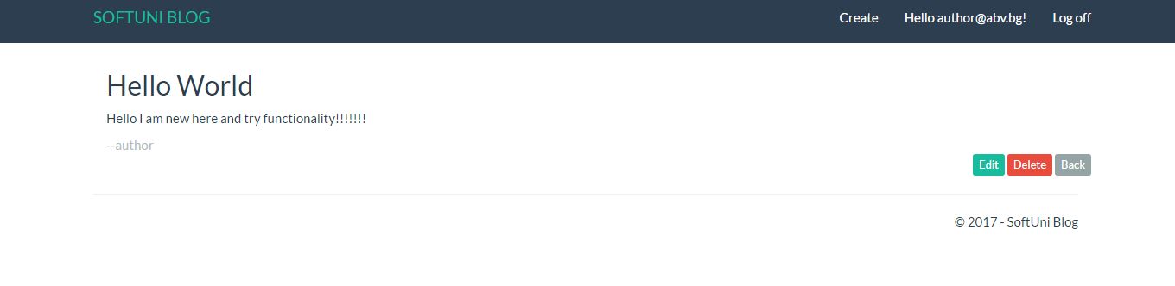

Manage Users

- View users

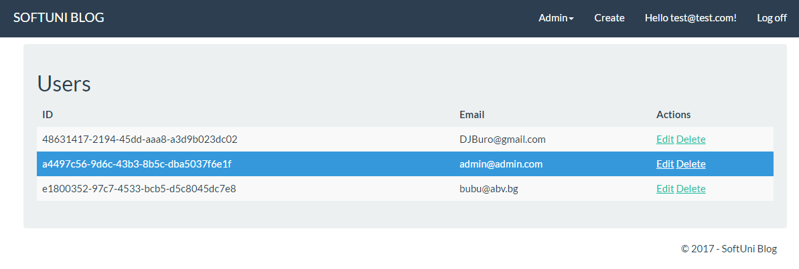

- Edit users

