Project
Reminder

Software Requirements Specification

Version 1.0
April 23, 2016

Document created by:

Team Spyro

Table of Contents
1. Introduction 1
1.1 Purpose 1
1.2 Scope 1
1.3 Definitions, Acronyms, and Abbreviations 2
1.4 . Overview 2
2. Overall Description 2
2.1. Product Perspective 2
2.2. Product Functions 3
2.3. General Constraints 3
2.4. Format Fields Constrains: 3
2.5. Assumptions and Dependencies: 5
2.6. Flow Chart 5
3. Specific Requirements 5
3.1. Functional Requirements 5
3.1.1. Use cases related to System Authentication: 7
3.1.2. Use cases related to User Profile: 14
3.1.3. Use cases related to Events: 18
3.1.4 Related to "Calendar View Tabs" 23
3.1.5 Related to Navigation in the Calendar 24
3.2 Non-Functional Requirements 25
3.2.1 Performance 25
3.2.2 Availability 25
3.2.3 Supportability 26
3.2.4 Security 26
3.2.5 Portability 27
4 Mock-ups 28
4.1 Login: 28
4.2 User Account 29
4.3 Calendar View 30
4.3 Event View 31

Introduction
One of our new Clients have requested from “Spyro” to create a new web application. The main goal of the application is to be used by customers as a to-do list. For the purpose of this project the application will be called “Reminder”.

Purpose
The purpose of the document is define the application, its requirements, how this product will be used. The futures that will be developed and document the concept of the project. In short, the purpose of this SRS document is to provide a detailed overview of our software product, its parameters and goals. This document describes the application’s functionalities and software specifications. It defines how our client, team and audience see the product and its functionality.
A detailed description of the new Web Application “Reminder”. It will explain the purpose and features of the system, the interfaces of the system, what the system will do, the constraints under which it must operate and how the system will react to external stimuli. This document is intended for both the stakeholders and the developers of the system and will be send to the Client for its approval before “Spyro” starts with actual development.

Scope
This SRS is aimed at specifying requirements of software to be developed. The application will be developed to maximize the user’s productivity by providing tools to assist him by giving the chance to keep all his tasks in one place excluding the need of manually taking notes and looking in more than one application to synchronize all tasks and make schedule . By maximizing the user’s work efficiency and production the application will meet the user’s needs while remaining easy to understand and use.
More specifically, this application is designed to allow user to manage and keep record of his future meeting, remaining tasks and overall acting plan. The application will send reminders via email and will notify for close events set by him.

Definitions, Acronyms, and Abbreviations

. Overview
The remaining sections of this document provide an overall description including functional and data requirements of the product. We are going to focus on describing the system in terms of product perspective, product functions, user characteristics and dependencies on the following sections of this document. Next, we will address specific requirements of the system, performance requirements, and other requirements.

2. Overall Description

2.1. Product Perspective
This application product is eventually intended for all users who have internet browser.
Product will be deployed to web site and all users of the product will access by use of the website. Website will be main user interface where users can operate all the provided functionality.
To use product, users are required to register through the web interface. Whenever a new user registered, all the required data will be created in the database and a predefined workspace will be assigned for the user. Later, user will be able to login and logout the system anytime he wants.
From the user point of view, user will have to functionality to create and edit events in his own workspace.
Since this is a work tool, the app main purpose is to be efficient and easy to use. User must be able to create tasks with deadlines and get an overview fast.
The application will be able to keep track of all user tasks. User will be able to know the date and time of task is due, and will receive email alert in advance. The application will also keep a history log of the tasks uses has completed.
All tasks will appear on a calendar where he can immediately find free blocks to set new task and easily see when a task should be started and completed. The calendar will allows him to plan several days, weeks or months in advance.
Calendar view should consist of 3 separate views - Calendar View Day, Calendar View Week and Calendar View Month. User should be able to navigate between the 3 views via tabs above the default view. The default view is set to Week.

-Calendar View Day should consist of fields, arranged in a single column, each corresponding to the time off the day.
-Calendar View Week should consist of fields, arranged in a table, where columns correspond to the days of the week, and rows correspond to the hours of the day. This will be the default view.
-Calendar View Month should consist of fields, arranged as boxes, corresponding to the days of the month.

All three views should allow the user to create, navigate and edit event. All events should appear in all three views simultaneous in the fields corresponding to their set times.

2.2. Product Functions
Keep track of all your tasks
Synchronize all user tasks in one place
Receive notifications via email for upcoming events/tasks
Remember meetings, schedule visits, remind birthdays
To do list perspective

2.3. General Constraints
- Application requires Internet connection.
- The application must be Web-based.
- The product will only work within a particular network environment
- The system should be up 24/7
- The application will always require user authentication

2.4. Format Fields Constrains:
“Username” field:
- Username is a sequence of letters and digits, where '.', '-' and '_' can appear between them
- Small and capital letters from Latin alphabet
- Special symbols “_ . -”
- Digits 0-9
- A minimum of 6 characters is required.
- Maximum length of 30 characters
- Each username must start with small or capital letter
- Two symbols can’t be used one after the other
“Email address” field:
Emails are considered to be in format <user>@<host>, where:
- <user> is a sequence of letters and digits, where '.', '-' and '_' can appear between them.
- <host> is a sequence of at least two words, separated by dots '.'. Each word is sequence of letters and can have hyphens '-' between the letters
“Password” field:
- A minimum of 6 characters is required.
- Maximum length of 30 characters
- Small and capital letters from Latin alphabet
- Punctuation marks
- Digits 0-9
- Password must be mix of uppercase and lowercase characters, numbers and punctuation.
- If you change an existing password, the new one must be different from the last password
“Confirm password” field:
- Exact match with “Password” field
“Event Name” field:
- Minimum length of 5 characters
- Maximum length of 30 characters
“Description Name” field:
- Minimum length of 5 characters
- Maximum length of 500 characters

2.5. Assumptions and Dependencies:
The availability and load time of the Reminder depends on user’s internet connection strength which also depends on the media from which the product is run.
The performance depend upon hardware components of the user’s machine.

2.6. Flow Chart

UML Use case Diagram:
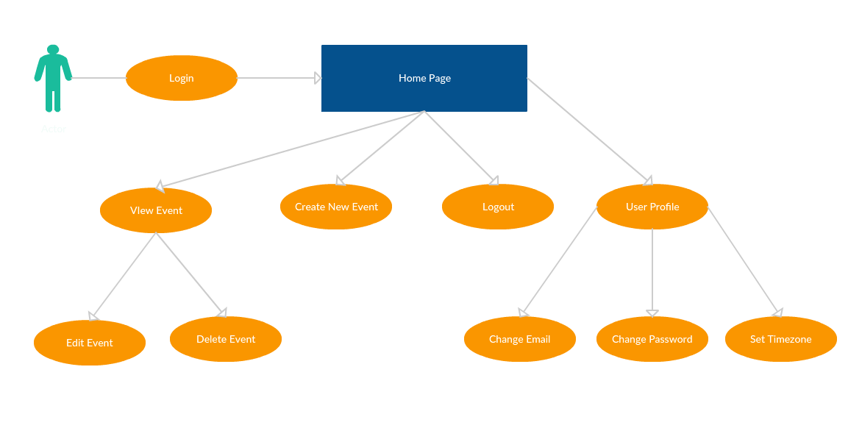

3. Specific Requirements

3.1. Functional Requirements
Reminder application should support the following use cases:

CLASS OF USE CASES | № | USE CASES | DESCRIPTION OF USE CASES
Related to System Authentication | 1 | Register | Register in the Reminder
Related to System Authentication | 2 | Log in | Login in the Reminder
 | 3 | Forgot Password | User enters email he used for registration and receives new password on that email
Related to User Profile | 4 | Change Password | Change current password with new one
 | 5 | Change Email | Change the initial email address where notifications will be send
 | 6 | Set Time Zone | Set time zone in order to have accurate time set for the reminder
Related to Events | 7 | Create Event | Different ways to create new event
 | 8 | New Event | Create an event in reminder application
 | 9 | Edit Event | Edit existing event in reminder application
 | 10 | Delete Event | Delete existing event in reminder application
 | 11 | View Event | View information and description of existing event
Related to "Calendar View Tabs" | 12 | Day View | Calendar view by days
 | 13 | Week View | Calendar view by weeks
 | 14 | Month View | Calendar view by months
Related to Navigation in the Calendar | 15 | Left Arrow Navigation | Returns to previous period of time
 | 16 | Right Arrow Navigation | Goes to next period of time

3.1.1. Use cases related to System Authentication:
Use Case №1: Register
Primary Actor: User/Registered User
Pre Condition: Installed browser and active internet connection. User hits Reminder url in the address bar. User is redirected to Reminder main page. From there user hits “Register” (Refer to prototype)

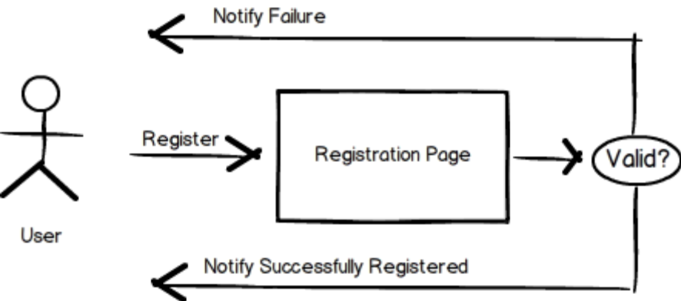

Main scenario:
- User types his desired username in “Username” filed
- User types his email address in “Email address” filed
- User types his desired password in “Password” filed
- User confirms his desired password in “Confirm password” filed
- System does authentication
- User is redirected to new page with message: ”To complete the registration, please confirm you details send on your email address.”
- Once he click on the link from the message send to email address upon registration he will be redirected to his Home page. In this email will be described the T&C that he accept upon hit.

Alternate scenario:
- Authorization fails – User hits the “Register now” button with blank:
- “Username” field
- “Email address” field
- “Password” field
- “Confirm password” field
  - System does Authentication
  - Prompt the user error messages
- “Enter username”
- “Enter email address”
- “Enter password”
- “Confirm password”
  - User is allowed to enter all details

- Authorization fails – User hits the “Register now” button with one or more blank fields
  - System does Authentication
  - Prompt error message to enter the data where fields are left blank
  - Information in “Username” and “Email address” fields if there is such provided is been saved
  - Information in “Enter password” and “Confirm password” fields if there is such provided in been deleted
  - User is allowed to enter the details

- Authorization fails – User hits the “Register now” button with details in all fields.
  - System does Authentication
    - If one or more fields are not in the right format
      - Prompt error messages for incorrect credentials
      - Information in all field where data is not in the right format is deleted including the “Enter password” and “Confirm password” fields no matter if they are in the right format
      - User is allowed to enter new details

    - If there is a registration with both the username typed in “Username” and the email typed in “Email address”
      - Prompt error messages “Username is already taken” and “Email address is already used for registration”
      - Information in “Username” is deleted.
      - Information in “Email address” field is deleted
      - Information in “Enter password” and “Confirm password” fields is deleted
      - User is allowed to enter new details

    - If there is a registration with the username typed in “Username” and all other fields are completed correctly
      - Prompt error messages “Username is already taken”
      - Information in “Username” is deleted.
      - Information in “Email address” field is deleted
      - Information in “Enter password” and “Confirm password” fields is deleted
      - User is allowed to enter new details

    - If there is a registration with the email typed in “Email address” field and all other fields are completed correctly
      - Prompt error messages “Email address is already used for registration”
      - Information in “Username” is kept.
      - Information in “Email address” field is deleted
      - Information in “Enter password” and “Confirm password” fields is deleted
      - User is allowed to enter new details
  - Authorization fails – User hits the “Register now” button with different passwords in “Password” and “Confirm password” fields
    - If information in “Username”, “Email address” and “Password” fields is valid
      - Prompt error message “Password not match”
      - Information in “Username” is kept.
      - Information in “Email address” is kept
      - Information in “ “Confirm password” field is deleted
      - User is allowed to enter new details
    - If information in one or more of “Username”, “Email address” and “Password” fields is not valid
      - Prompt error messages for incorrect fields
      - Information in “Username” is deleted if not valid.
      - Information in “Email address” is deleted if not valid
      - Information in “ “Confirm password” field is deleted
      - User is allowed to enter new details

Use Case №2: Login
Primary Actor: User/Registered User
Pre Condition: Installed browser and active internet connection. User hits Reminder url in the address bar. User is redirected to Reminder main page. User select the “Log in” button and is redirected to “Log in” page (Refer to prototype).

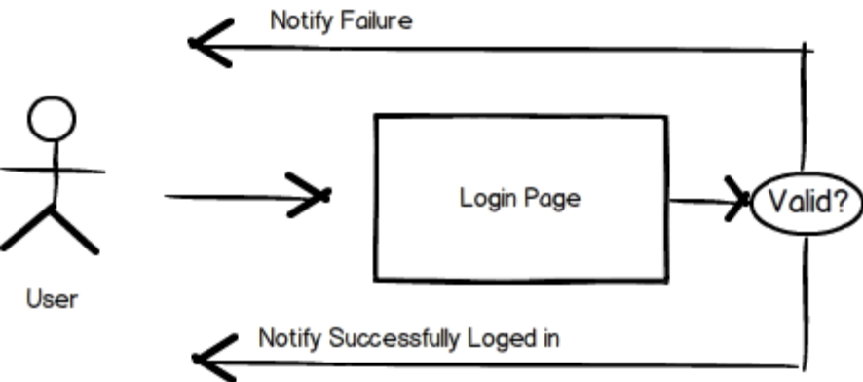
Main scenario:
- User types valid username or email address in “Username or email address” field and valid password in “Password” field
- User hits the “Log in” button
- System does authentication
- Reminder Home page is displayed

Alternate scenario:
- Authorization fails – User hits the “Log in” button with blank “Username or email address” field and blank “Password” field.
  - System does authentication
  - Prompt the user error messages “Enter username” and “Enter password”
  - User is allowed to enter username or email address and password

- Authorization fails – User hits the “Log in” button with blank “Username or email address” field and any password typed in “Password” field.
  - System does authentication
  - Prompt the user error message “Enter username”
  - Typed in the “Password” field is deleted and field is returned to its initial state - blank
  - User is allowed to enter username or email address and password

- Authorization fails – User hits the “Log in” button with typed registered/not registered username or email address in “Username or email address” field and blank “Password” field.
  - System does authentication
  - Prompt the user error message “Enter password”
  - User is allowed to enter password. “Username or email address” field keeps the information

- Authorization fails – User hits the “Log in” button with typed not registered username or email address in “Username or email address” field and any password typed in “Password” field.
  - System does authentication
  - Prompt the user error message “Incorrect username”
  - Typed in the “Password” and in “Username or email address” fields is deleted and fields are returned to their initial state - blank
  - User is allowed to enter password. “Username or email address” field keeps the information

- Authorization fails – User hits the “Log in” button with typed registered username or email address in “Username or email address” field and incorrect password typed in “Password” field.
  - System does authentication
  - Prompt the user error messages “Incorrect password”
  - User is allowed to re-enter password. “Username or email address” field keeps the information
  - If user tried 5 times with wrong passwords, the account will be closed for log in and email will be send to users email address. He will be redirected to different page with information about that.

- Authorization fails – User hits the “Log in” button with typed correct password for some registered user or for the user entered in “Password” field in “Username or email address” field and valid registered username or email address typed in “Password” field.
  - System does authentication
  - If typed in “Username or email address” doesn’t match any registered username or email address
    - Prompt the user error messages “Incorrect User”
    - Typed in the “Password” and in “Username or email address” fields is deleted and fields are returned to their initial state - blank
    - User is allowed to re-enter username.
  - If typed in “Username or email address” matches registered username or email address
    - Prompt the user error messages “Incorrect Password”
    - Typed in the “Password” field is deleted and field is returned to its initial state - blank
    - User is allowed to re-enter username.
Use Case №3: Forgot password
Primary Actor: User/Registered User
Pre Condition: Installed browser and active internet connection. User hits Reminder url in the address bar. User is redirected to Reminder main page. User selects the “Log in” button and is redirected to “Log in” page. User selects “Forgot password” label and is redirected to “Forgotten password” page (Refer to prototype).
Main scenario:
- User types valid email address in “Email address” field
- User hits the “Send new password” button
- System does authentication
- User is redirected to different page that confirms a new password is sent to his email.

Alternate scenario:
- Authorization fails – User hits the “Send new password” button with blank “Email address” field
  - System does authentication
  - Prompt the user error message “Enter email”
  - User is allowed to enter email address

- Authorization fails – User hits the “Send new password” button with email in invalid format written in “Email address” field
  - System does authentication
  - Prompt the user error message “Invalid email format”
  - User is allowed to enter email address

- Authorization fails – User hits the “Send new password” button with not registered email written in “Email address” field
  - System does authentication
  - Prompt the user error message “Not registered email”
  - User is allowed to enter email address

3.1.2. Use cases related to User Profile:

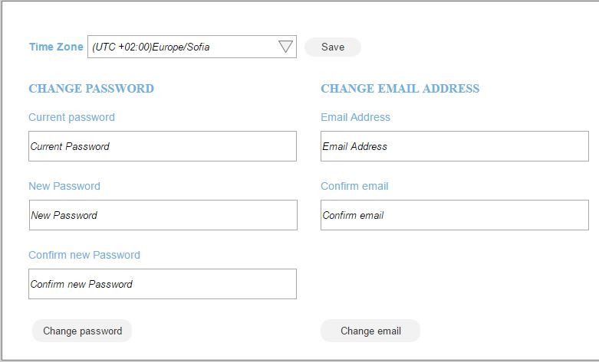
Use Case №4: Change password
Primary Actor: Registered User
Pre Condition: User is logged in in the Reminder. User selects “Account” menu. User is redirected to new page where he can change his current password.
Main scenario:
- User types his current password in “Current password” field
- User types his desired new password in valid format in “New password” field
- User confirms his new password in “Confirm new password” field
- User hits the “Change password” button
- System does authentication
- A password conformation message is shown on the same page in transparent pop-up

Alternate scenario:
- Authorization fails – User hits the ““Change password” button with blank one or more of the fields “Current password”, “New password”, “Confirm new password”
  - System does authentication
  - Prompt the user error message where field/s is/are blank
  - Information in all fields is deleted
  - User is allowed to enter email address

- Authorization fails – User hits the ““Change password” button with password in invalid format in or more of the fields “Current password”, “New password”, “Confirm new password”
  - System does authentication
  - Prompt the user error message where field/s is/are not in the right format
  - Information in all fields is deleted
  - User is allowed to enter email address

- Authorization fails – User hits the ““Change password” button with password that doesn’t match his current password in “Current password” field, and any or bland information in or more of the fields “New password”, “Confirm new password”
  - System does authentication
  - Prompt the user error message “Invalid password” for “Current password” field
  - Information in all fields is deleted
  - User is allowed to enter email address

- Authorization fails – User hits the ““Change password” button with password that matches his current password in “Current password” field, and password in invalid format in “New password” and “Confirm new password” fields
  - System does authentication
  - Prompt the user error message “Invalid password format” for “New password” field and/or “Confirm new password” field
  - Information in all fields is deleted
  - User is allowed to enter email address

- Authorization fails – User hits the ““Change password” button with password that matches his current password in “Current password” field, and different passwords in valid format in “New password” and “Confirm new password” fields
  - System does authentication
  - Prompt the user error message “Password not match” for “Confirm new password” field
  - Information in all fields is deleted
  - User is allowed to enter email address

- User hits the ““Change password” button with password that matches his current password in “Current password” field, and same password for “New password” and “Confirm new password” fields
  - System does authentication
  - Prompt the user error message “Incorrect password”
  - Information in all fields is deleted
  - User is allowed to enter email address

- User hits the ““Change password” button with password that doesn’t match his current password in “Current password” field, his current password in “New password” and “Confirm new password” fields
  - System does authentication
  - Prompt the user error message “Invalid password”
  - Information in all fields is deleted
  - User is allowed to enter email address

Use Case №5: Change email
Primary Actor: Registered User
Pre Condition: User is logged in in the Reminder. User selects “Account” menu. User is redirected to new page where he can change his current email.
Main scenario:
- User types his desired new email address in valid format in “Email address” field
- User confirms his new email in “Confirm email” field
- User hits the “Change email” button
- System does authentication
- An email conformation message is shown on the same page in transparent pop-up. Confirmation is sent to new email address
Alternate scenario:
- Authorization fails – User hits the ““Change email” button with blank “Email address” and “Confirm email” fields.
  - System does authentication
  - Prompt the user error message “enter email”
  - User is allowed to enter email address
- Authorization fails – User hits the ““Change email” button with email in invalid format typed in “Email address” field and any/no information in “Confirm email”
  - System does authentication
  - Prompt the user error message “Invalid email format”
  - User is allowed to enter email address
- Authorization fails – User hits the “Change email” button with email in correct format in “Email address” field and different data in the “Confirm email” field.
  - System does authentication
  - Prompt the user error message “Emails not match”
  - User is allowed to enter email address

Use Case №6: Set time zone
Primary Actor: Registered User
Pre Condition: User is logged in in the Reminder. User selects “Account” menu. User is redirected to new page where he can set the time zone.
Main scenario:
- User clicks either on the time zone dropdown or the triangle on the right of the dropdown
- User navigates up and down in the dropdown and selects his desired time zone
- User select the “Save” button
- A conformation message is shown on the same page in transparent pop-up

3.1.3. Use cases related to Events:

Use case №7: Create Event
Primary Actor: User
Pre Condition: User logged in reminder application.
Main scenario:
  - .User clicks the "Create Event" button
  - -user is shown the "Create Event" form, where it is possible to set the new event.
  - -Default date and time are set to current date and time

Alternate Scenario:
- User selects an “Hour” field, from “Calendar View- Day”
-User is shown the "Create Event" form, where it is possible to set the new event.
-Default date and time are set to date and time, corresponding to selected field

- User selects an “Hour” field, from “Calendar View- Week”
-User is shown the "Create Event" form, where it is possible to set the new event.
-Default date and time are set to date and time, corresponding to selected field

- User selects a “Day” field, from “Calendar View- Week”
-User is shown the "Create Event" form, where it is possible to set the new event.
-Default date and time are set to date and time, corresponding to selected field

Use Case №8: New Event
Primary Actor: User
Pre Condition: User logged in reminder application.
Main scenario:
- User initiates the “Create Event” button
- System loads create event form
- User enters a name for the event. (by default, system sets “My new event” as name)
- User enters the description of the event in “description” field
- User specifies start date of event (by default date is set to default date). User can initiate calendar, by pressing “start date” field and select a date. Date can be only selected from calendar. Field is not editable for writing.
- User specifies start hour of event (by default start time is set to default hour). User can initiate a popup, by pressing “set time” field. In the shown popup user can select hour from hour dropdown field (0-23 options) and minutes from minutes dropdown field (0-59).
- User specifies end date of event (by default date is set to default date). User can initiate calendar, by “End Date” field. Date can be only selected from calendar. Field is not editable for writing.
- User specifies end hour of event (by default is set to default hour + 1 hour ). User can initiate a popup, by pressing “End time” field. In the shown popup user can select hour from hour dropdown field (0-23 options) and minutes from minutes dropdown field (0-59).
- User click on “Set Reminder” checkbox
- System unlock fields for reminder time.
- User specifies desired reminder time. (for example 1 hour or 15 minutes before the time of the event). User specifies positive integer number or 0 for period and selects type of period from a dropdown menu (minutes/hours/dates).
- User initiate “Save” button or “Enter” button on keyboard
- Event is created
- System creates and add the event in customer's calendar

Alternate scenario:

- New Event “Start time” later than “End time”
  - User initiates the “Create Event” button
  - User specifies start date of event
  - User specifies start time of event
  - User specifies end date of event
  - User specifies end time of event, but selects time earlier than the start time
  - System change end time to start time + 1 hour
  - User initiate “Save” button or “Enter” button on keyboard
  - Event is created
  - System creates and add the event in customer's calendar

- New Event “Start date” later than “End date”
  - User initiates the “Create Event” button
  - User specifies start date of event
  - User specifies start time of event
  - User specifies end date of event, selecting date earlier than the start date
  - System change end date and time to start date + 1 hour
  - User initiate “Save” button or “Enter” button on keyboard
  - Event is created
  - System creates and add the event in customer's calendar

- New Event cancellation initiating “Cancel” button
  - User initiates the “Create Event” button
  - User fills data in desired fields
  - User initiates “Cancel” button
  - New Event form is canceled
  - System does not store event

- New Event cancellation initiating “Escape” button on keyboard
  - User press the “Create Event” button
  - User fills data in desired fields
  - User initiate “Escape” button on keyboard
  - New Event form is canceled
  - System does not store event

- New Event “Start date” set in past
  - User initiates the “Create Event” button
  - User specifies start date of event which is in the past
  - System change start date to current date and time
  - User initiate “Save” button
  - Event is created
  - System creates and add the event in customer's calendar

- New Event “Start time” set in past
  - User initiates the “Create Event” button
  - User specifies start time of event which is in the past
  - System change start time to current date and time
  - User initiate “Save” button
  - Event is created
  - System creates and add the event in customer's calendar

- Create new event, without reminder
  - User initiates the “Create Event” button
  - System loads create event form
  - User enters a name for the event. (by default, system sets “My new event” as name)
  - User enters the description of the event in “description” field
  - User specifies start date of event (by default date is set to default date). User can initiate calendar, by pressing “set date” field and select a date.
  - User specifies start hour of event (by default start time is set to default hour). User can initiate a popup, by pressing “set time” field. In the shown popup user can select hour from hour dropdown field (0-23 options) and minutes from minutes dropdown field (0-59).
  - User specifies end date of event (by default date is set to default date). User can initiate calendar, by “End Date” field.
  - User specifies end hour of event (by default is set to default hour + 1 hour ). User can initiate a popup, by pressing “End time” field. In the shown popup user can select hour from hour dropdown field (0-23 options) and minutes from minutes dropdown field (0-59).
  - User initiate “Save” button
  - Event is created
  - System creates and add the event in customer's calendar

Use Case №9: Edit Event
Primary Actor: User
Pre Condition: User logged in reminder application. User navigates to “Calendar View” page (home page). User select specific event.
Main scenario:

- User initiates the “Edit Event” button
- System loads “Create Event” form
- User change one or more of the fields in the form
- User initiate “Save”
- System saves changes
- System change the event in customer's calendar
Alternate scenario:

- Edit Event cancellation initiating “Cancel” button
  - User initiate the “Edit Event” button
  - System loads “Create Event” form
  - User change one or more of the fields in the form
  - User initiate “Cancel” button
  - System dismiss changes

- Edit Event cancellation initiating “Escape” button on keyboard
  - User initiate the “Edit Event” button
  - System loads “Create Event” form
  - User change one or more of the fields in the form
  - User initiates “Cancel” button
  - System dismiss changes

- Edit Event “Start time” later than “End time”
  - User initiates the “Edit Event” button
  - User specifies end time of event, but selects time earlier than the start time
  - System changes end time to start time + 1 hour
  - User initiate “Save”
  - System saves changes
  - System change the event in customer's calendar

- Edit Event “Start Date” later than “End Date”
  - User initiates the “Edit Event” button
  - User specifies end date of event, selecting date earlier than the start date
  - System changes end date and time to start date + 1 hour
  - User initiate “Save”
  - System saves changes
  - System change the event in customer's calendar

Use Case №10: Delete Event
Primary Actor: User
Pre Condition: User logged in reminder application. User is navigated to “Calendar View” page (home page). User hover specific event.
Main scenario:

- User initiates the “Delete Event” button
- System asks for confirmation. Popup with test - “Are you sure you want to delete this message?” with option “OK” and “Cancel” shown
- User confirm by pressing “OK” button or button “Enter” from keyboard
- System delete selected event
- System remove event from customer's calendar

Alternate scenario:

- Delete Event cancellation initiating “Cancel” button
  - User initiates the “Delete Event” button
    - System asks for confirmation. Popup with test - “Are you sure you want to delete this message?” with option “OK” and “Cancel” shown
  - User initiate “Cancel” button
  - System dismiss changes and event is not deleted

Use Case №11: View Event
Primary Actor: User
Pre Condition: User logged in reminder application. User navigates to page (home page). User hover specific event.
Main scenario:
- User click on event
- System loads “View Event” form
- User views start date icon, start time, end date and time
- User views information and press “Cancel” button
- System return user to “Calendar View”

Alternate scenario:

- View Event click “Edit” button
  - User clicks on event
  - System loads “View Event” form
  - User clicks on “Edit” button
  - System open “Edit Event form”
- View Event click “Delete” button
  - User clicks on event
  - System loads “View Event” form
  - User clicks on “Delete” button
  - System asks for confirmation. Popup with option “OK” and “Cancelled” shown
  - User confirm by pressing “OK” button or button “Enter” from keyboard
  - System deletes selected event
  - System removes event from customer's calendar

3.1.4 Related to "Calendar View Tabs"

Use Case №12: Day View
Primary Actor: User
Pre Condition: User logged in reminder application.
Main scenario:
Use case: Click on tab "Day"
-Displays "Calendar view- day" of current day in the "Calendar view" panel. It should contain column of fields, representing the hour of the day.
-Changes field "navigation calendar" to "Day"

Use Case №13: Week View
Primary Actor: User
Pre Condition: User logged in reminder application.
Main scenario:
-Shows "Calendar view- week" of current week in the "Calendar view" panel. It should contain a table of fields, representing the days of the week, as columns, and the hours of the day, in rows.
-Changes field "navigation calendar" to "Week"

Use Case №14: Month View
Primary Actor: User
Pre Condition: User logged in reminder application.
Main scenario:
-Shows "Calendar view- Month" of current week in the "Calendar view" panel. It should contain a table of fields representing the days of the month.
-Changes field "navigation calendar" to "Month"

3.1.5 Related to Navigation in the Calendar

Use Case №15: Left Arrow Navigation
Primary Actor: User
Pre Condition: User logged in reminder application.

Main scenario:
- User clicks on "arrow left"
  - Calendar view is set to "Day"
  - Moves currently selected "Calendar View", one day back
  - Changes field "navigation calendar" to display selected day of week
- Calendar view is set to "Week"
  - Moves currently selected "Calendar View", one week back
  - Changes field "navigation calendar" to display selected week's Monday date and Sunday date
- Calendar view is set to "Month"
  - Moves currently selected "Calendar View", one month back
  - Changes field "navigation calendar" to display selected month

Use Case №16: Right Arrow Navigation
Primary Actor: User
Pre Condition: User logged in reminder application.

Main scenario:
- User clicks on "arrow right"
  - Calendar view is set to "Day"
  - Moves currently selected "Calendar View", one day forward
  - Changes field "navigation calendar" to display selected day of week
- Calendar view is set to "Week"
  - Moves currently selected "Calendar View", one week forward
  - Changes field "navigation calendar" to display selected day of week
- Calendar view is set to "Month"
  - Moves currently selected "Calendar View", one month forward
  - Changes field "navigation calendar" to display selected month

3.2 Non-Functional Requirements
In this section, last group of the requirements which is non-functional requirements will be explained in detail. Non-functional requirements include performance, availability, supportability, security and portability.

3.2.1 Performance
Since this software is going to be web – based, it does require a powerful server machine with high band internet access.
Server machine should have a powerful CPU and high speed internet access so that it can handle multiple users at the same time. Another performance requirement is the storage space. Higher storage space means more user and bigger workspace per user so higher the storage, better the performance.
Performance requirement by the user side is, web application should be developed as a lightweight web app so that it can work on almost any platform even with slower internet connections.
The product shall take initial load time depending on internet connection strength which also depends on the media from which the product is run.
The performance shall depend upon hardware components of the user.
Expected number of simultaneous user should be at least 500. System should be able to deal with 500 users at the same time. Also database of the system should handle at least a thousand of users at any periods.

3.2.2 Availability
Reminder should be available 24 hours per day, 7 days per week.
The system shall provide a contractual agreement with an internet service provider who can provide 99.99% - 52 minutes/year availability through their network facilities onto the internet.
Maintenance access period should be no more than a week overall for the year.

3.2.3 Supportability
Compatible with Browsers
- Microsoft Internet Explorer
- Mozilla Firefox
- Google Chrome
- Opera mini
- Safari

3.2.4 Security
Since this software will be hosted on cloud server, all the user data will be kept on the cloud server. Product should be able to protect privacy of user data. Workspace of the user should only be accessed through user own credentials and any other user should not be able to access to the user private data.
Since execution will also be done in the machine in the cloud, user should be restricted in terms of user rights. User should only access to his own workspace and should not access to any other workspace with the programs they run on the cloud. Also rights of the user should be restricted so that user can not harm to system by the programs they run or by the commands they run on terminal.
Since all the data will be transferred on the web, system should also use an encryption and decryption mechanism only intended user can decode the data and work on the data.
Data Transfer
The system shall automatically log out all customers after a period of inactivity.
Data Storage
The customer’s web browser shall never display a customer’s password. It shall always be echoed with special characters representing typed characters.
The system’s back-end servers shall never display a customer’s password. The customer’s password may be reset but never shown.
The system’s back-end databases shall be encrypted.

3.2.5 Portability
As explained in the performance requirements section, software should be lightweight so that it can run on a machine with slow internet connection. To make the web application lightweight, simple libraries and tools should be used at developing phase. Such as using JavaScript and HTML5. Portability also means running on most number of different platform without an additional effort. To achieve this, web application should be developed by using the common technologies and tools which are provided by all common web browsers and operating system such as HTML5, JQuery etc.

Mock-ups

Login:
    - Customer Journey:
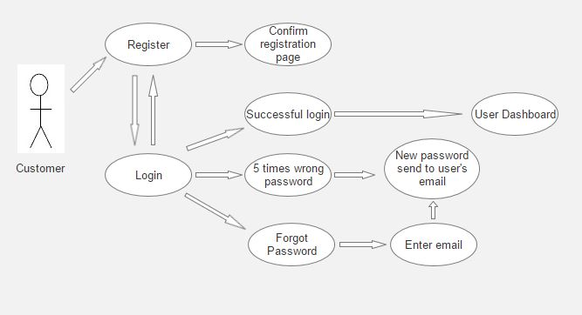

User Account

Calendar View
    - Day View:
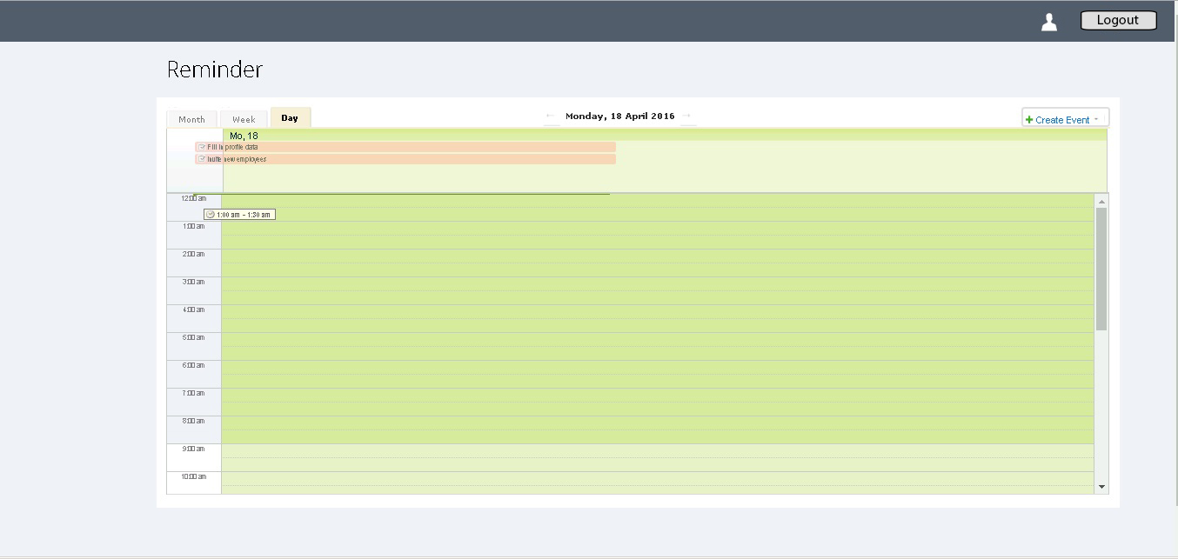

    - Week View:
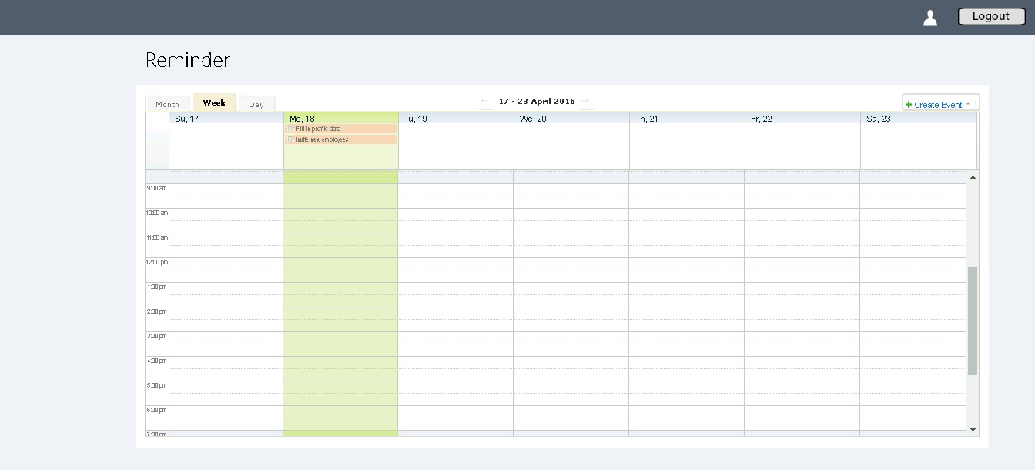

    - Month View:
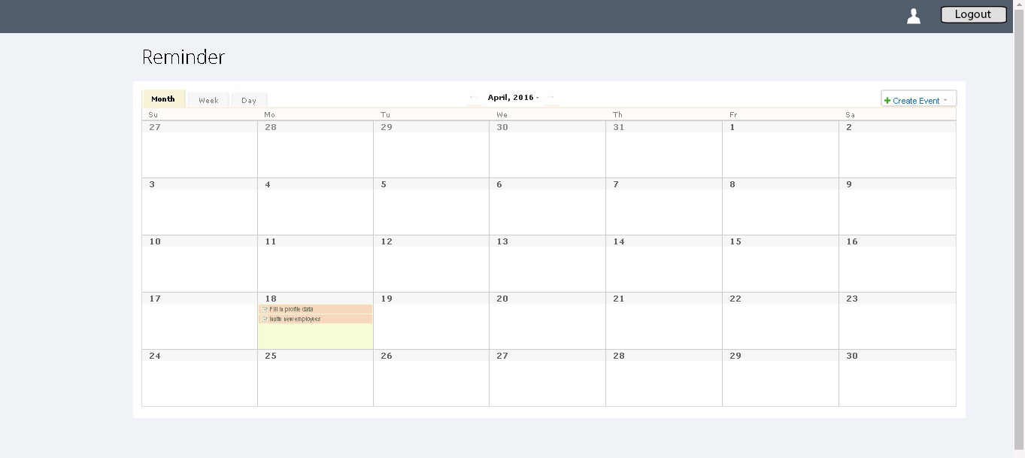

4.3 Event View
