**Deliverables out of the Assignment**

## Micro services Architecture diagram- SubmissionReport folder

## Application (Solution file)

## Cloud platform URL’s where the application is hosted along with the screenshots- SubmissionReport folder

## Coding Standard report- codeStandard Folder

## Vulnerability report- FINAL.PDF

## Performance test report

## Code profiling report

## If applicable, script file for Continuous Build, Continuous Integration, Continuous Deployment- SubmissionReport folder

Application Host URL:

<http://AWSS2Classic-112320063.us-east-2.elb.amazonaws.com:4200>

Screen shot:

Login screen:

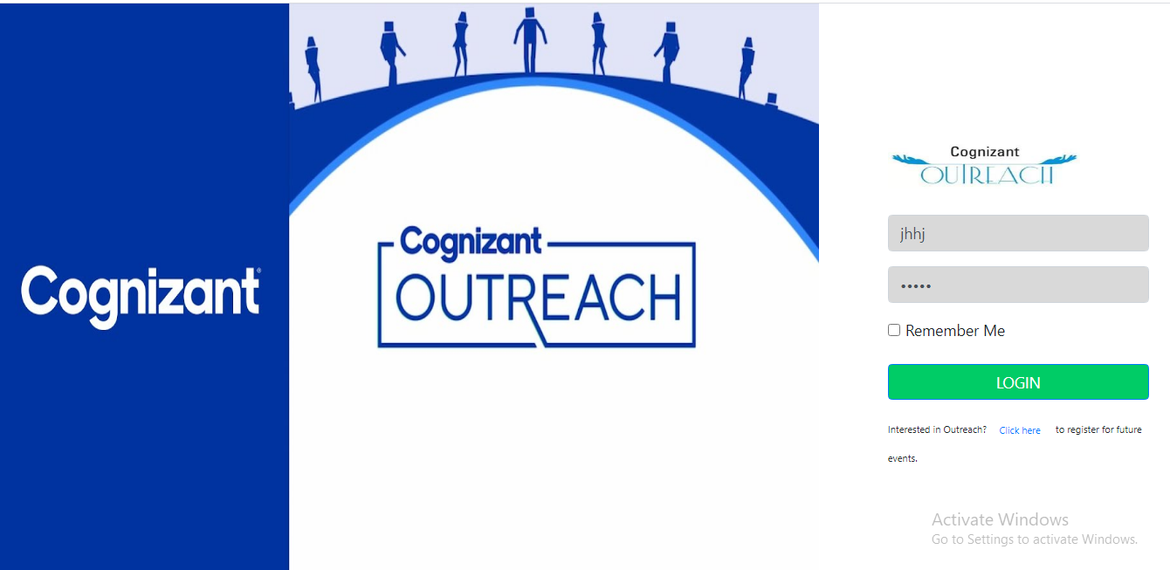

Dashboard:

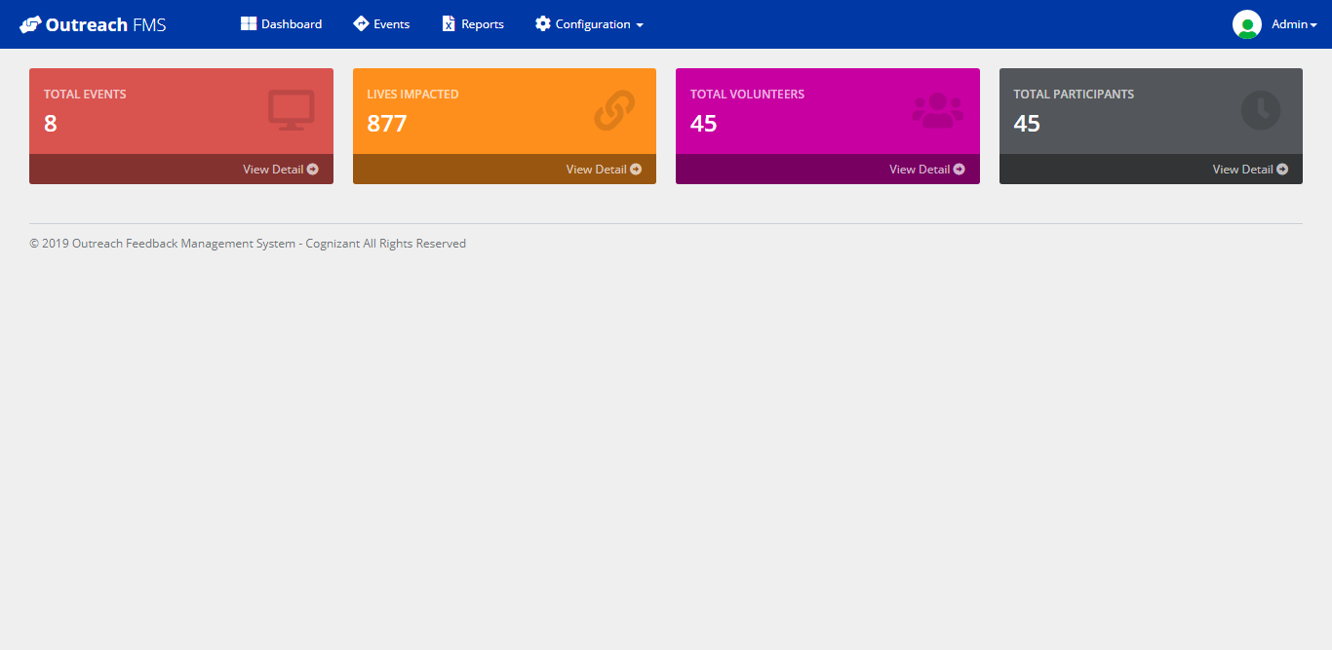

Event Lists:

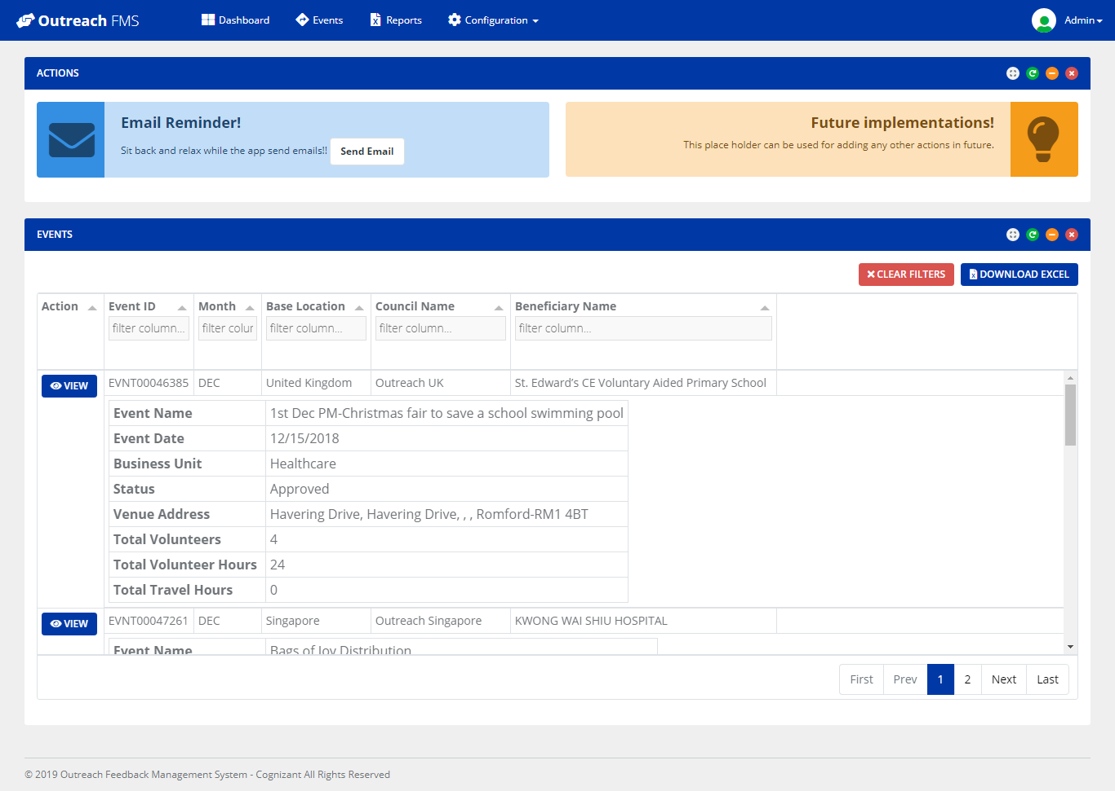

Event Details:

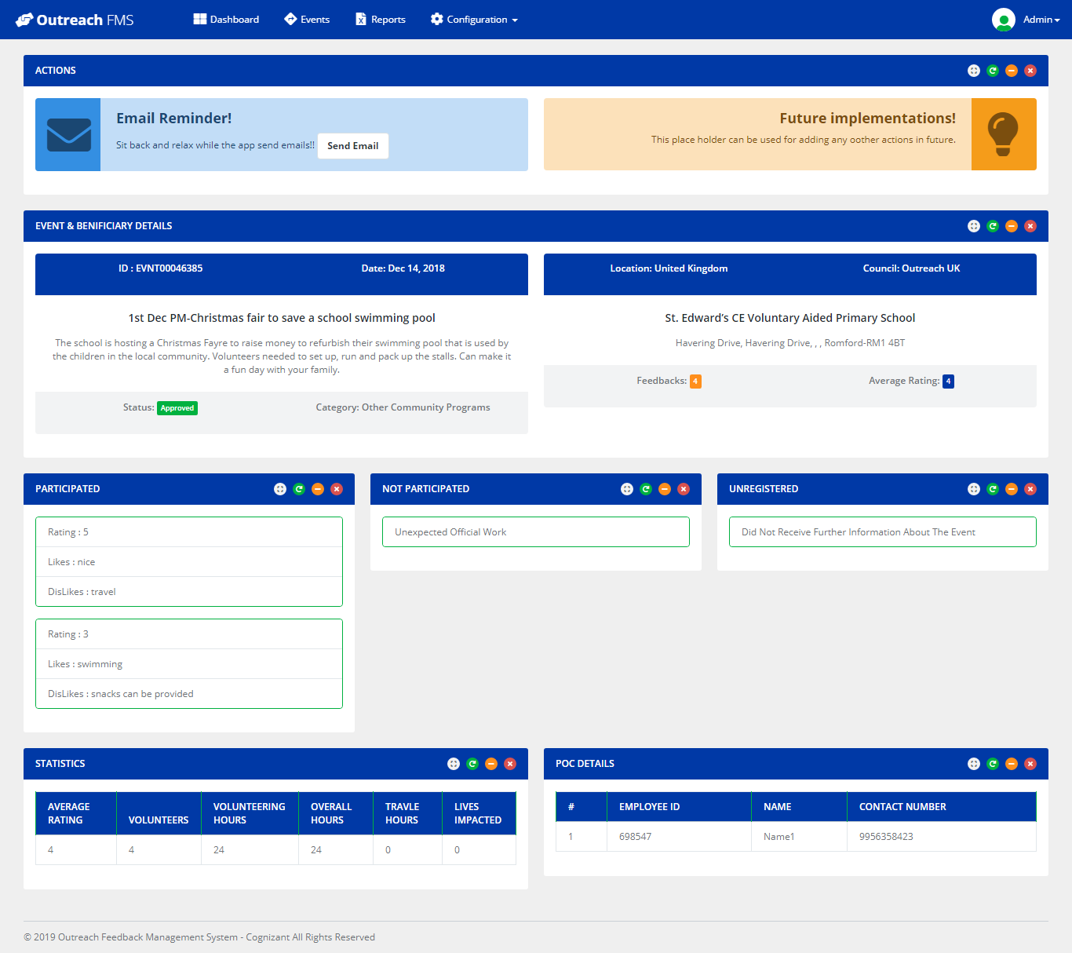

Reports:

