Employee Hub HR portal

- Login Flow – Success case
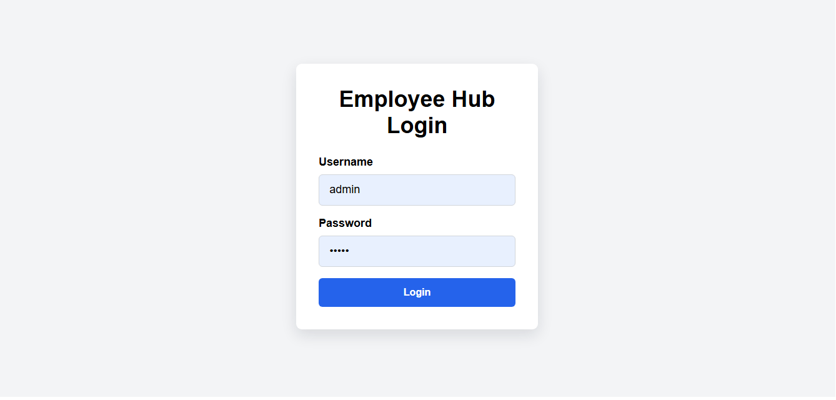
- Login Flow – invalid user flow
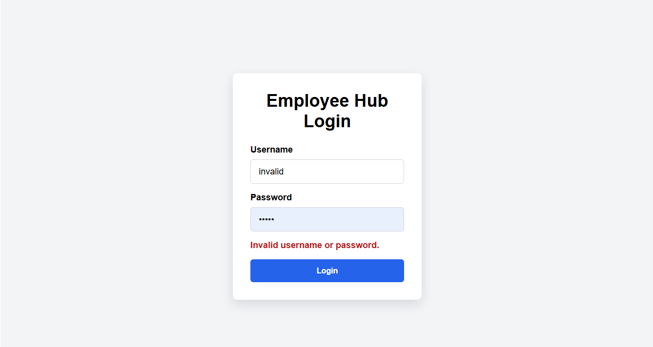

- Dashboard Page –
  - Employee Data retrieval success case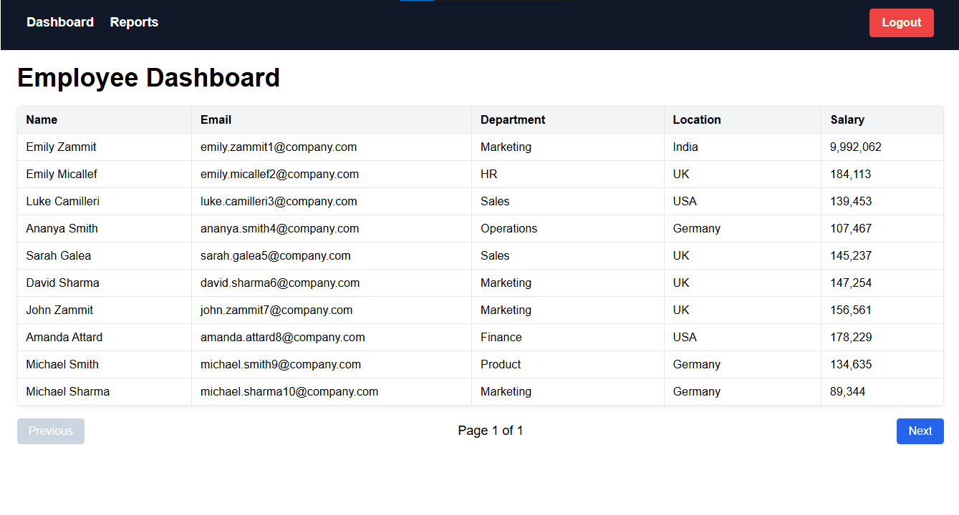
  - Downstream Employee retrieval API Failure case
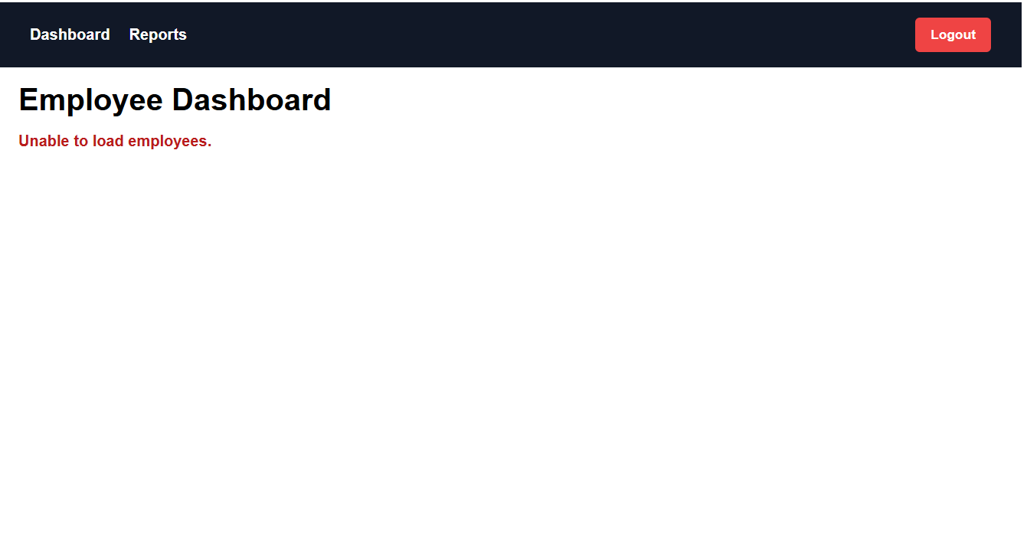
- Employee Report page – [sub Tab]
  - Employee count by location Success case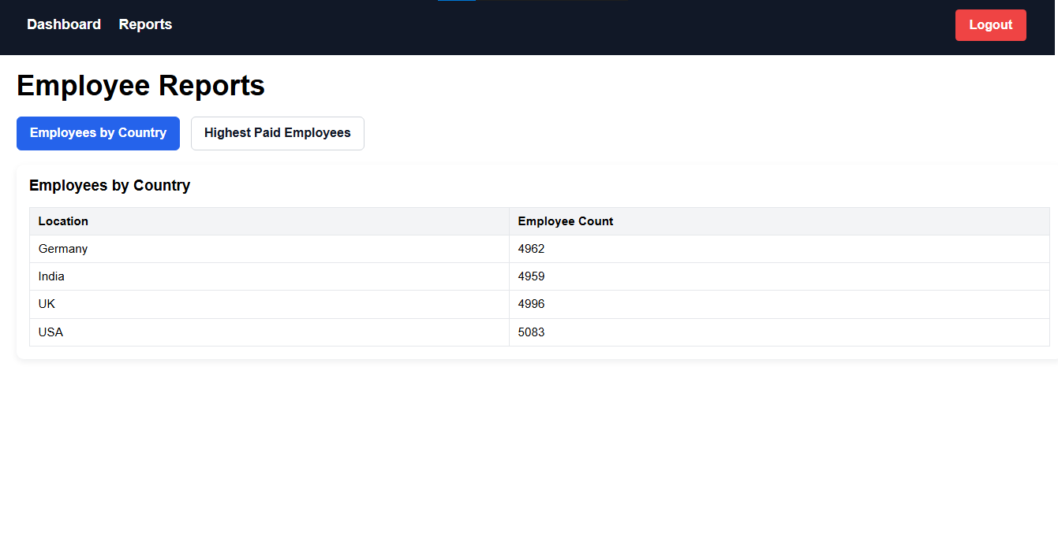
  - Employee Api Failure use case
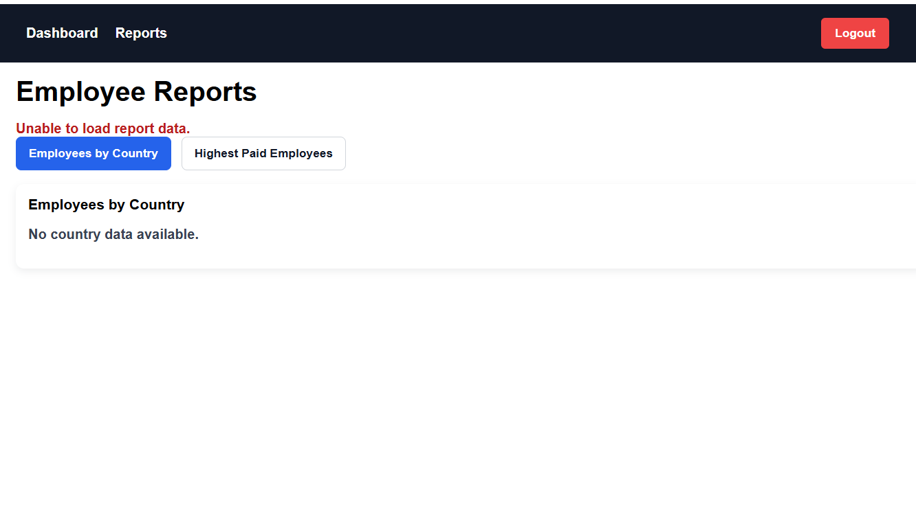

- Employee Report page –[sub tab]
  - Highest Paid Employee success case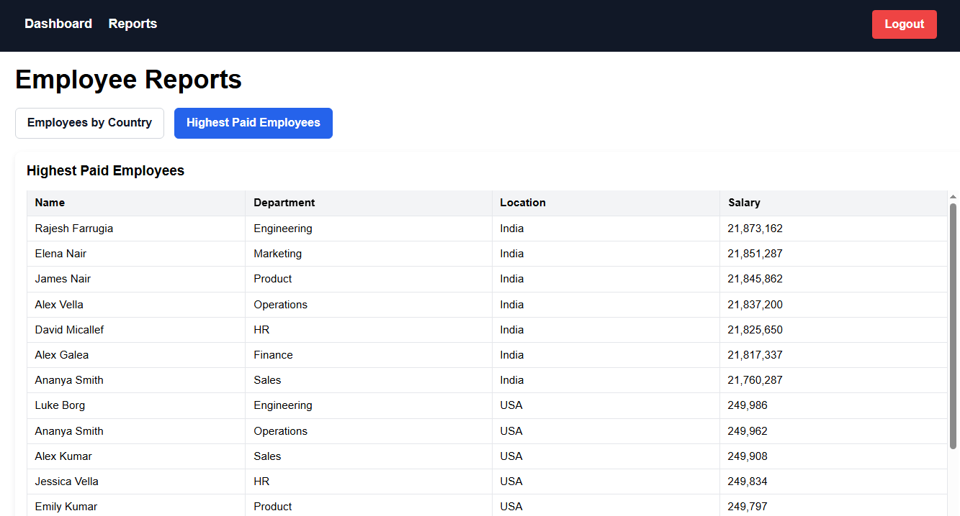
  - Highest Pay API failure case
