**FIFTH PROJECT: FIX BUGS OF THE APPLICATION**

OUTPUT SCREENSHOTS:

Sort Expenses in Ascending Order using Bubble Sort Algorithm:

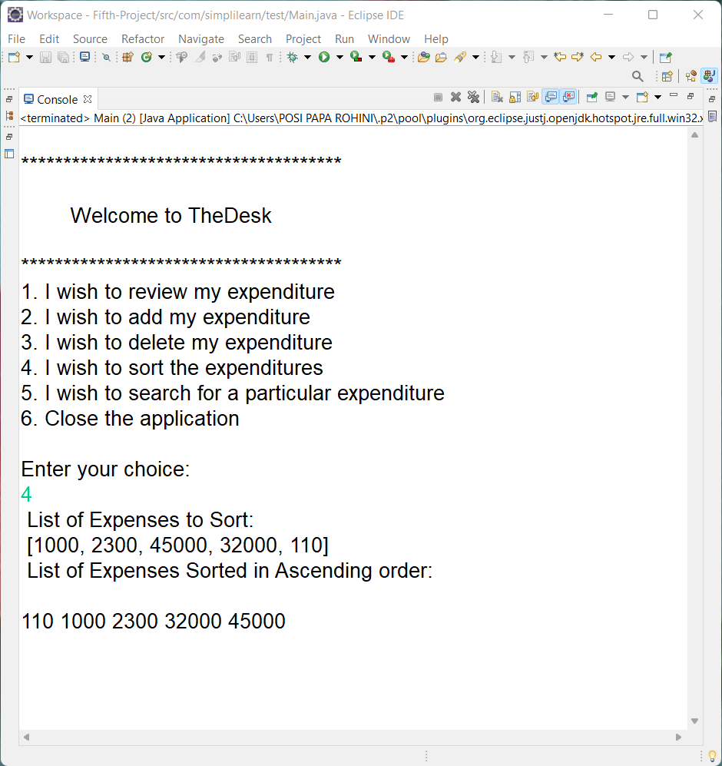

Search particular expenditure using Linear Search Algorithm:

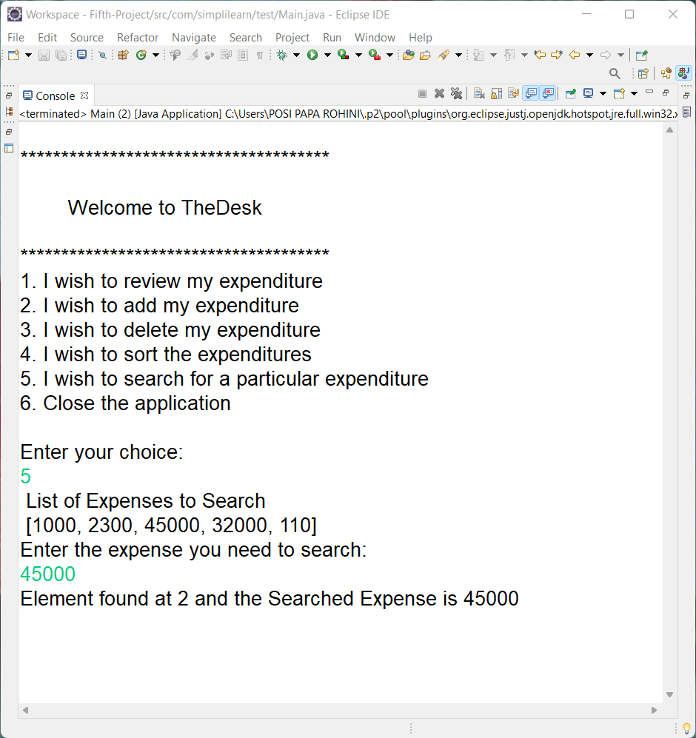

Closing the application:

