Second-Project: Emailid Validation

Output Screenshots for the given user emailid:

**Case1:**

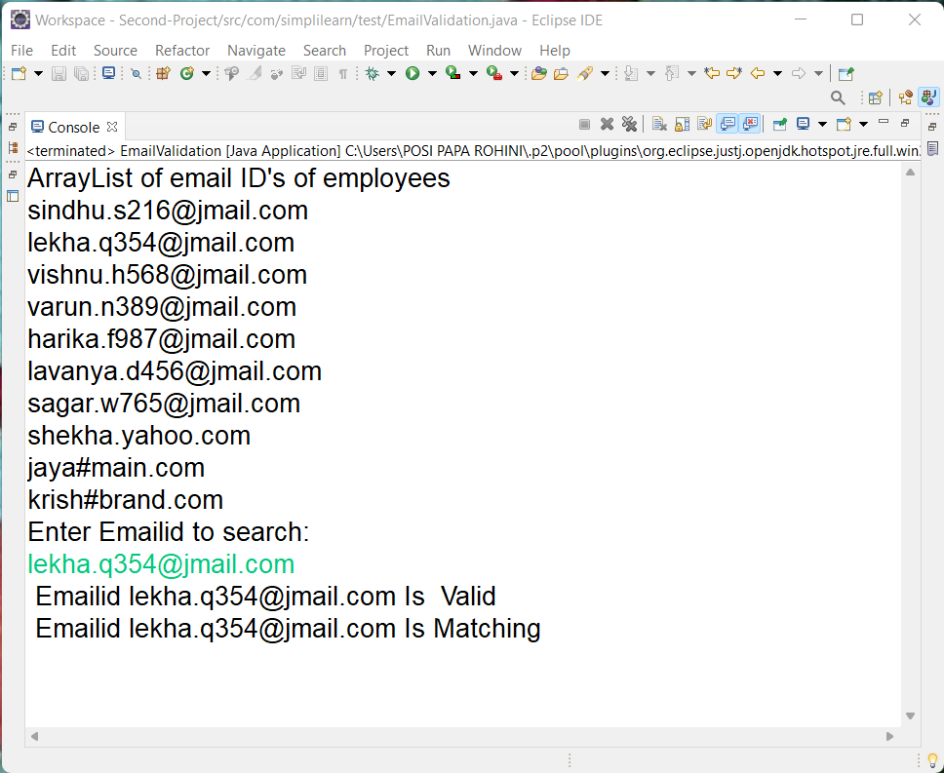

Output:

The emailid given by the user is in the list

The emailid is valid and matching

**Case2:**

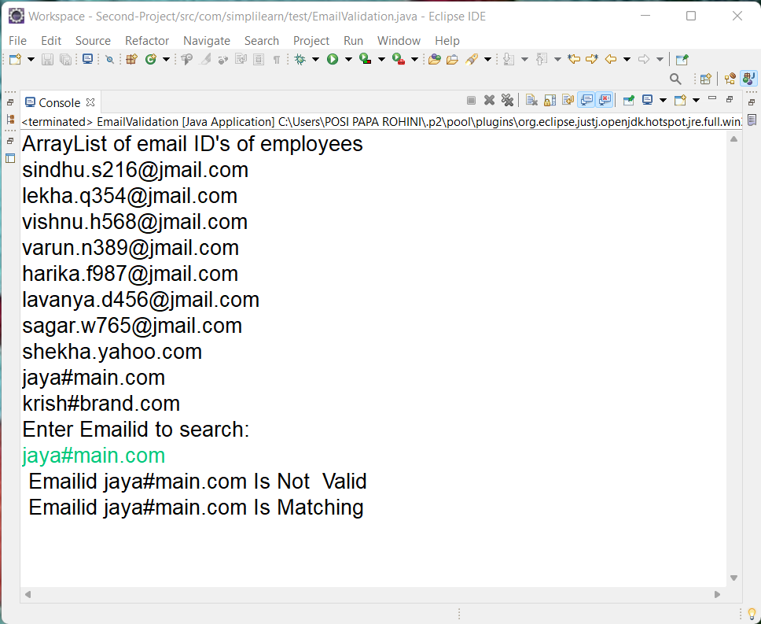

Output:

The emailid given by the user is in the list

The emailid is matching but it is not valid.

**Case3:**

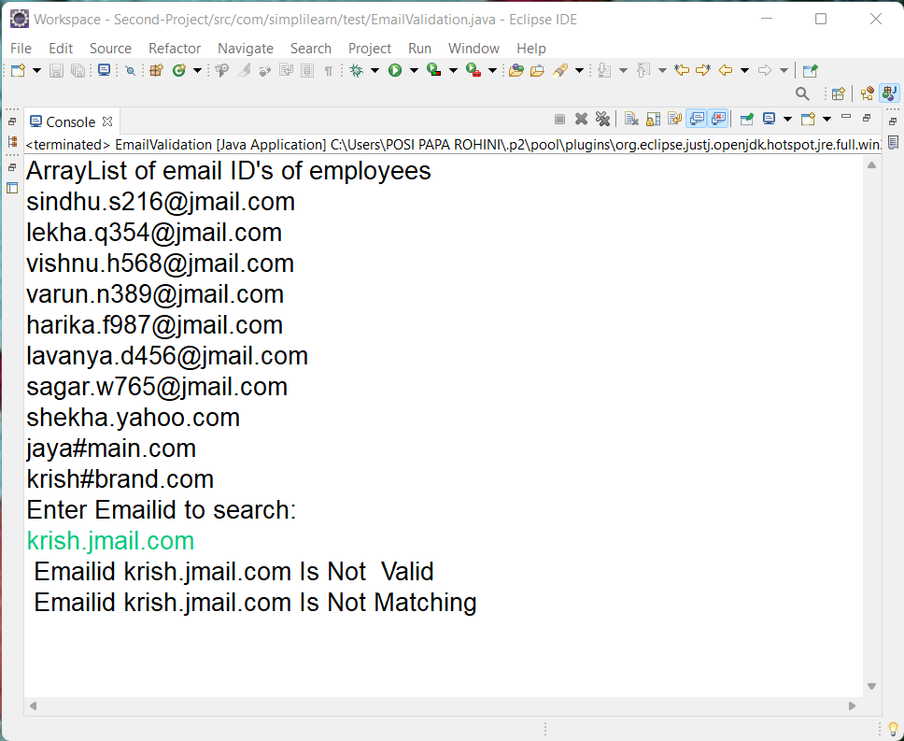

Output:

The emailid given by the user is not in the list

The emailid is not valid also not matching