**To Create a File and to write in it:**

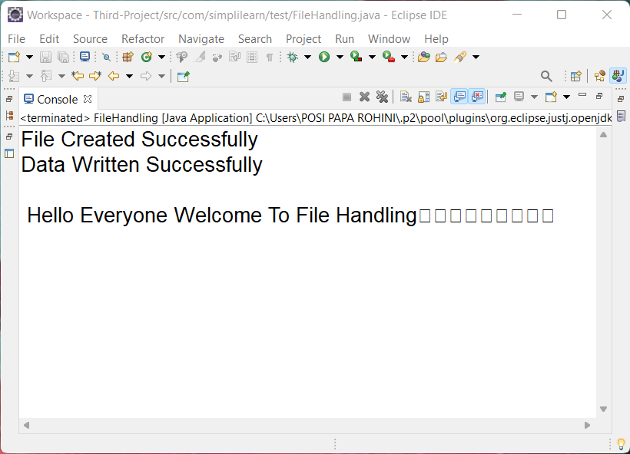

**To Read the contents in the File and To Append Data into the File:**

