PHASE-4 FINAL PROJECT-1

OUTPUT SCREENSHOTS

When the online quizapp is run the start will show up as below

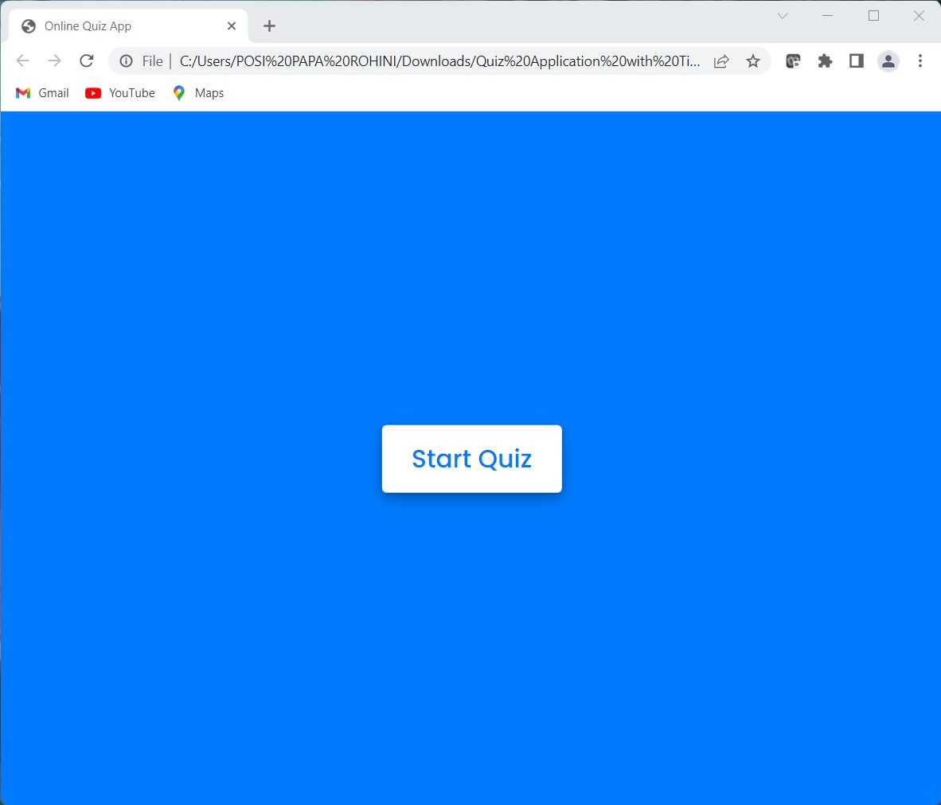

After clicking start button the output is as shown below

First, the rules for the quiz are shown. After that the **Exit Quiz** button and **Continue** button are shown

If the user clicks **Exit Quiz** button, then it will go back to start page,

Else If the user clicks **Continue** button, then the Quiz will start

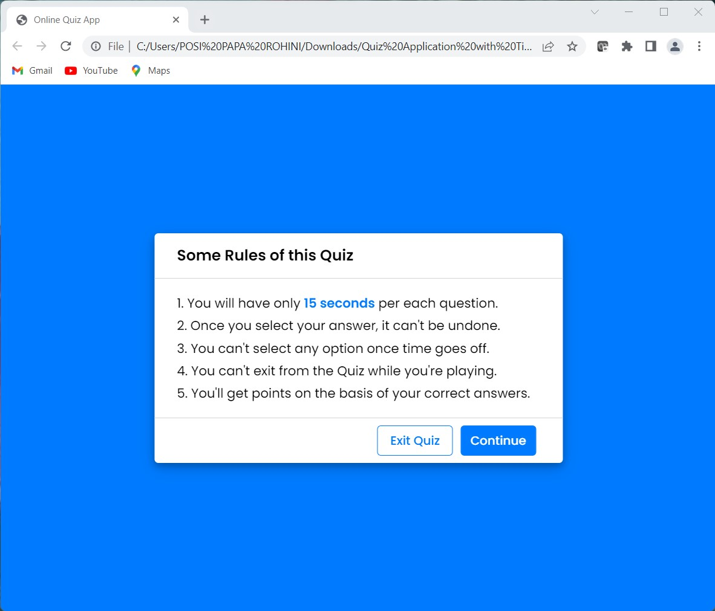

The timer starts the moment the quiz starts.

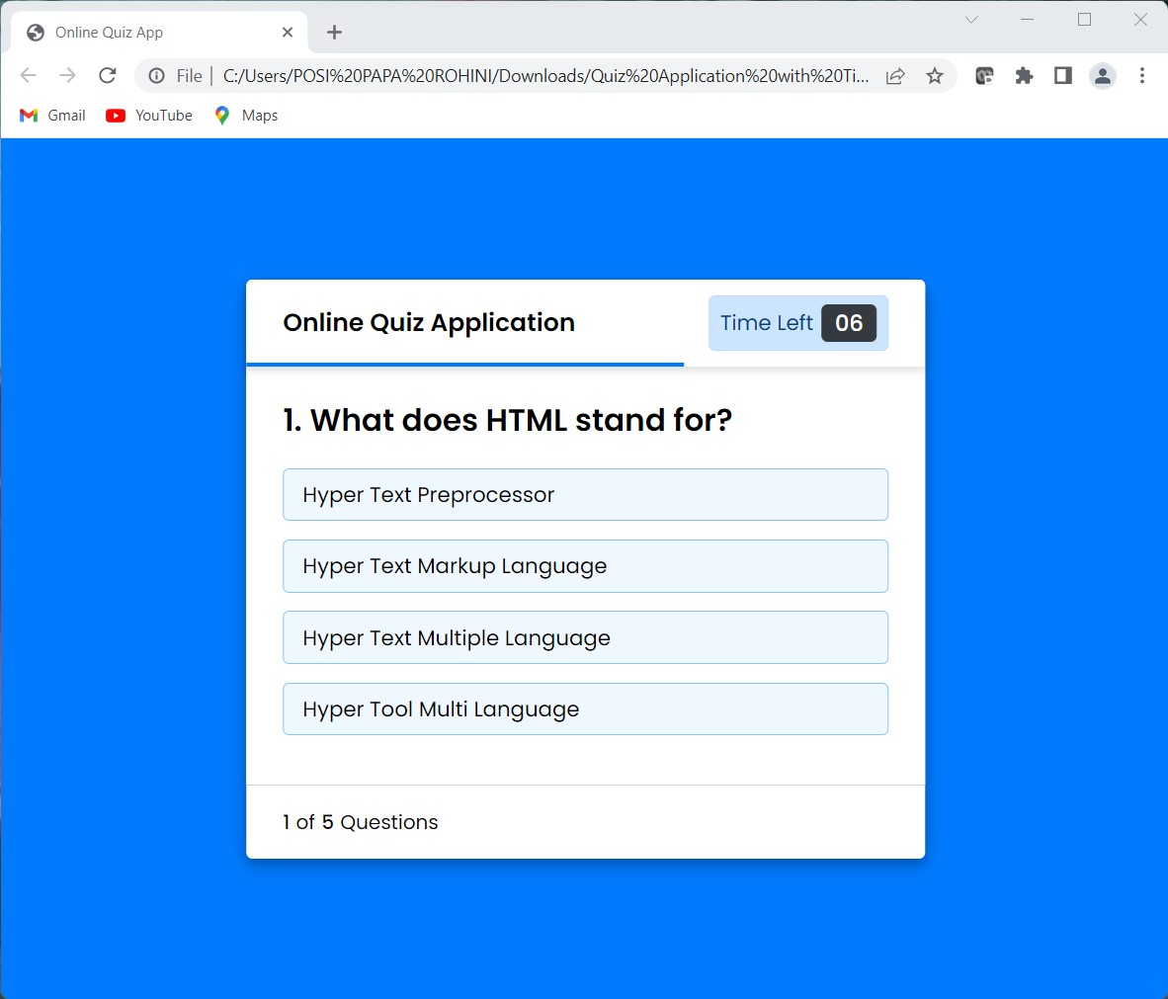

If the answered question is correct then the output is as below

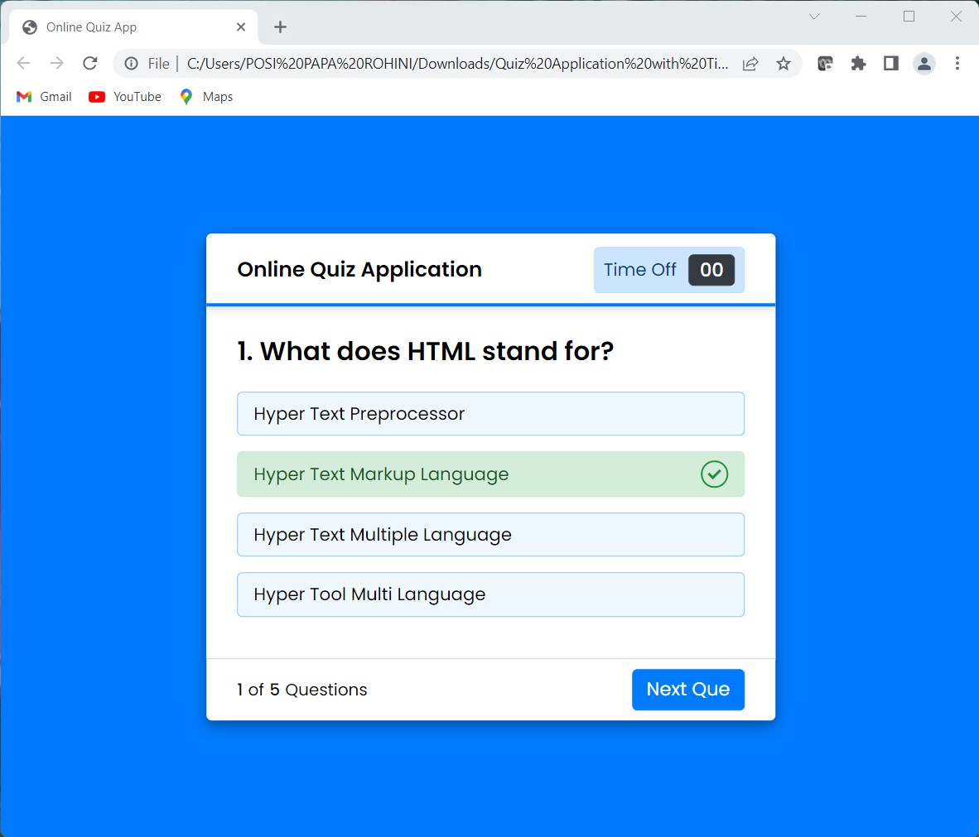

If the answered question is wrong then the output is as below

It will automatically show the correct answer

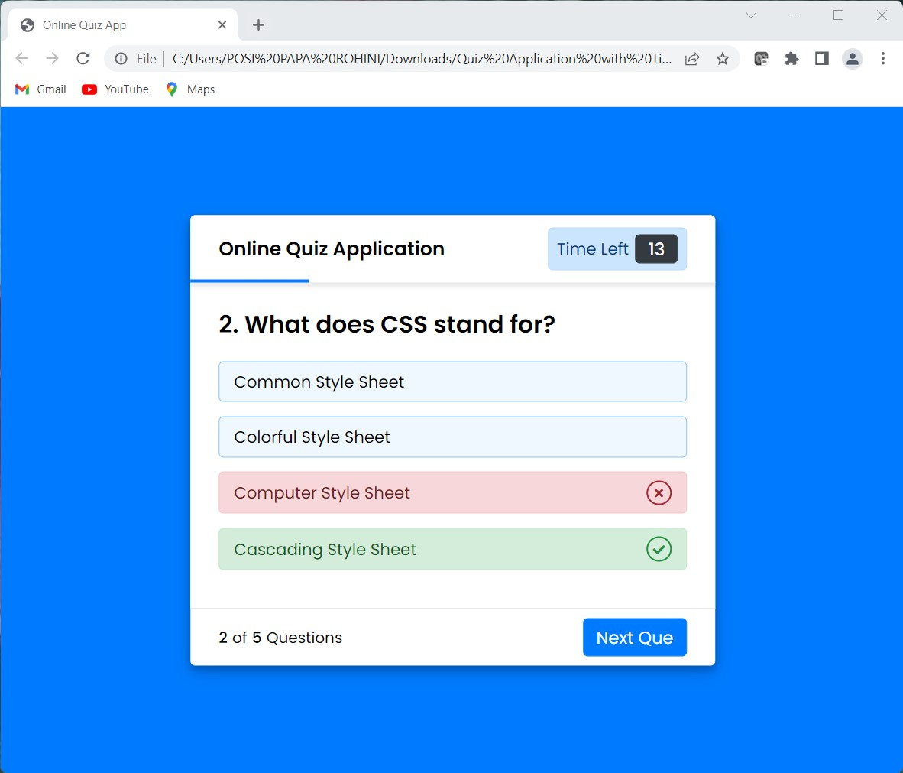

After the end of the quiz the output is as shown below

It shows the result of the quiz and next it will show two buttons **Replay Quiz** button and **Quit Quiz** button

If the user clicks **Replay Quiz** button, then the quiz automatically starts again and if the user clicks **Quit Quiz** button, then it will go to the start page

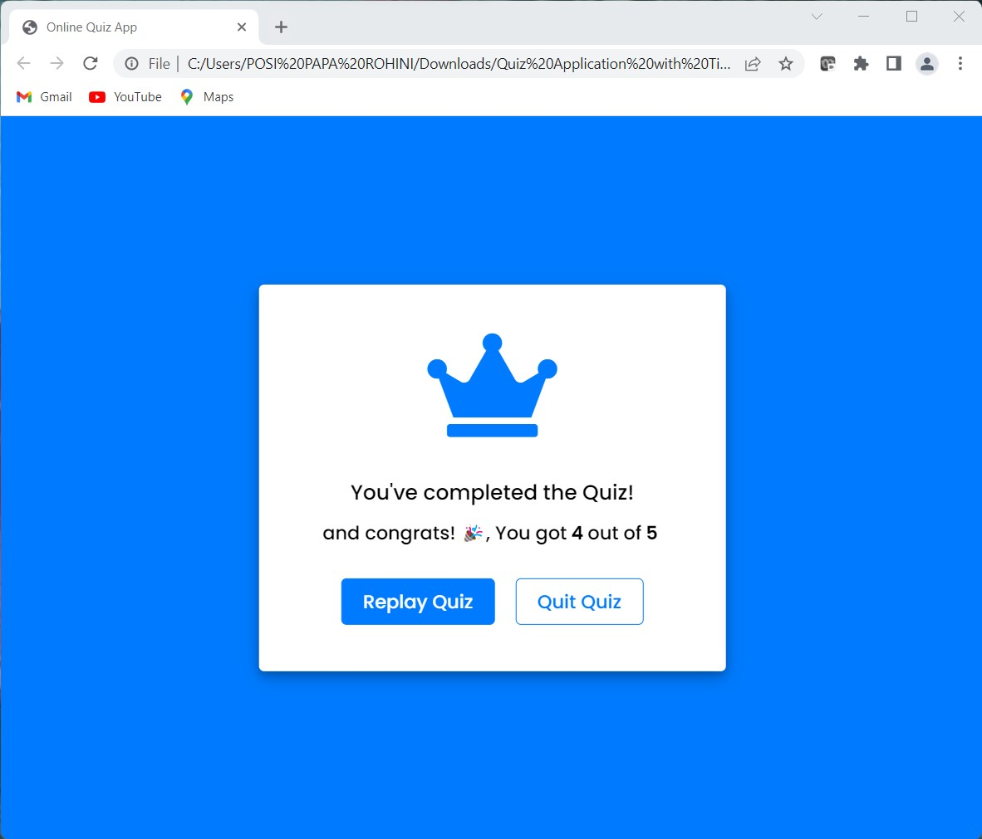

If the user clicks **Replay Quiz** button, then the quiz automatically starts again. The output is as below



If the user clicks **Quit Quiz** button, then it will go to the start page

