PHASE2-FINAL-PROJECT OUTPUT SCREENSHOTS

Students

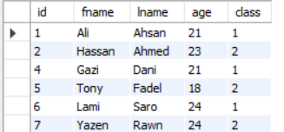

Classes

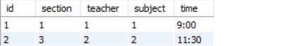

Subjects

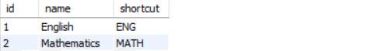

Teachers

