**PHASE2-First-Project Output Screenshots:**

Opening of webpage after running the server

It will show as follows

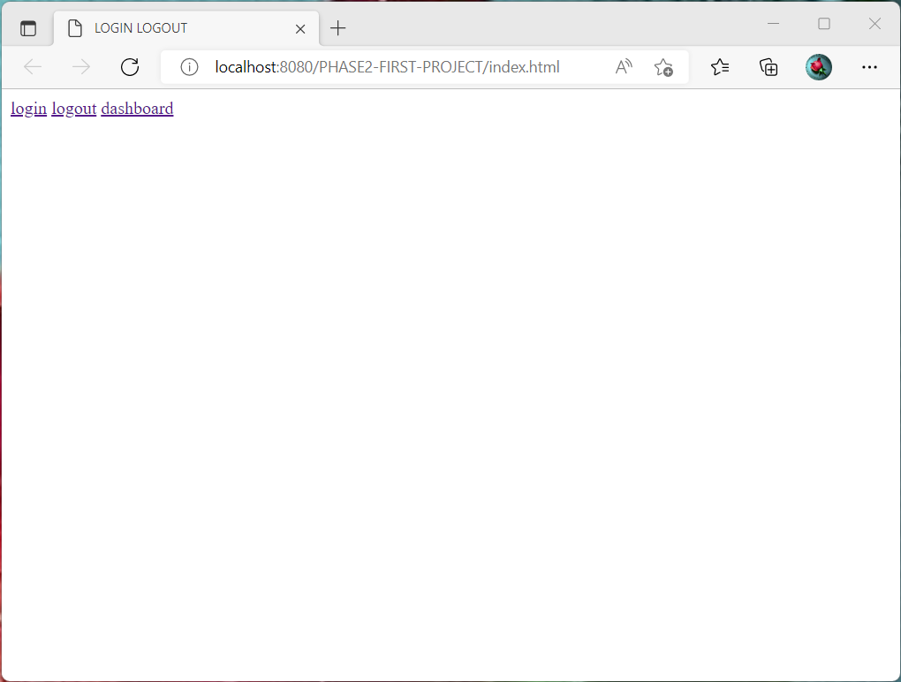

When you click login button it will show as follows.

Here we will enter Username and Password

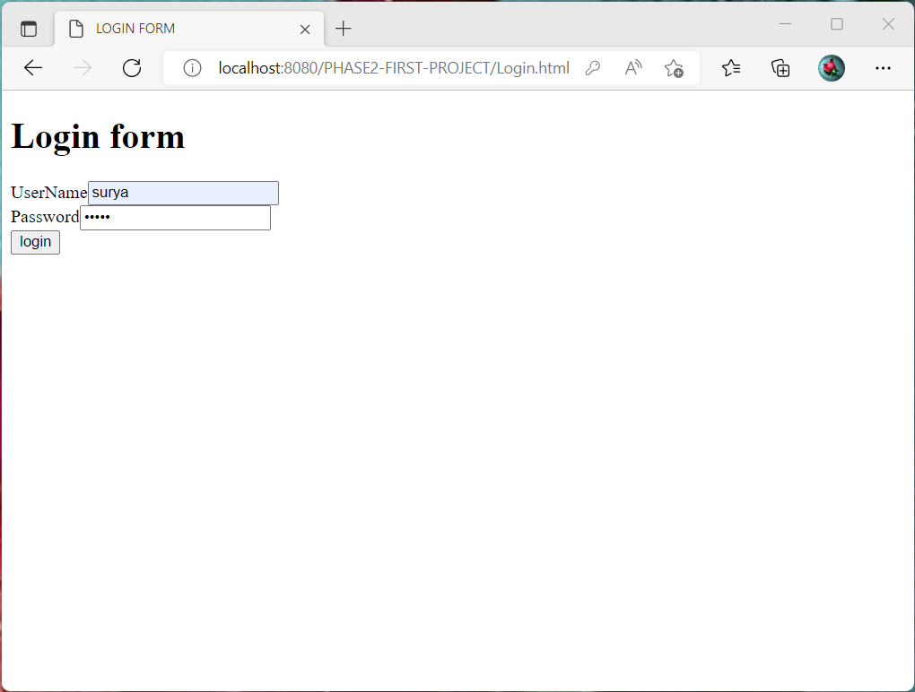

After Entering username and password, if the username=password

Then the following output is as shown below

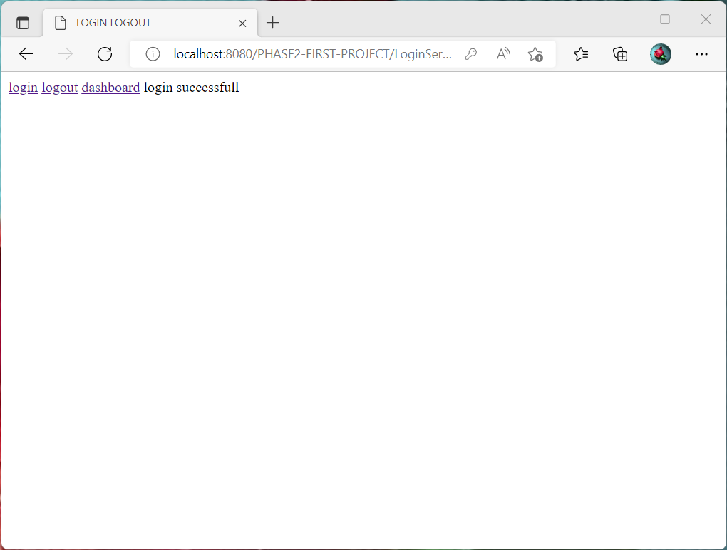

After successful login if we press dashboard button then the output will appear like this

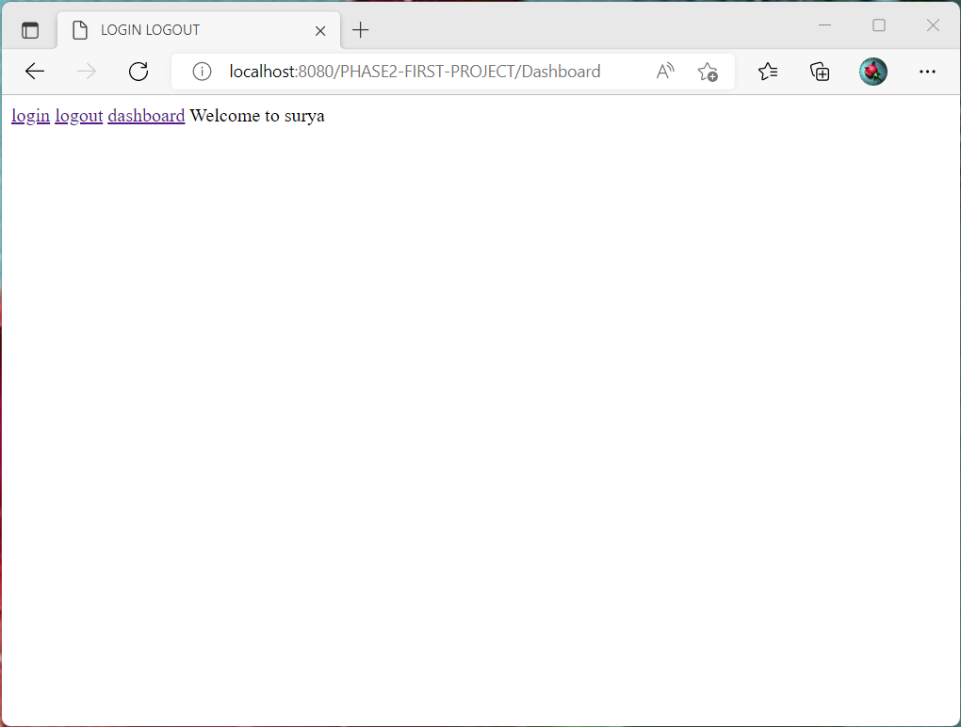

If we press Logout button the output will be like below

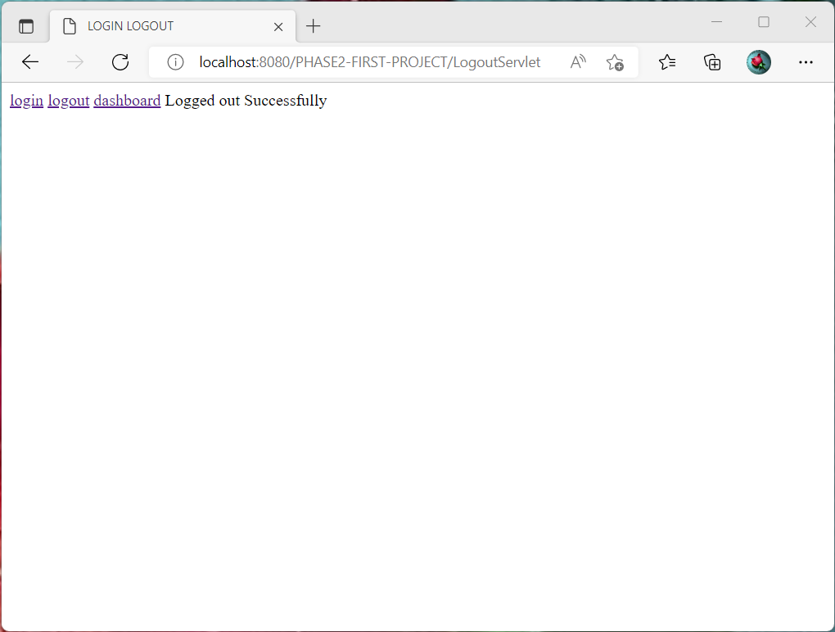

After successful logout again if we press dashboard button then the output will appear like below

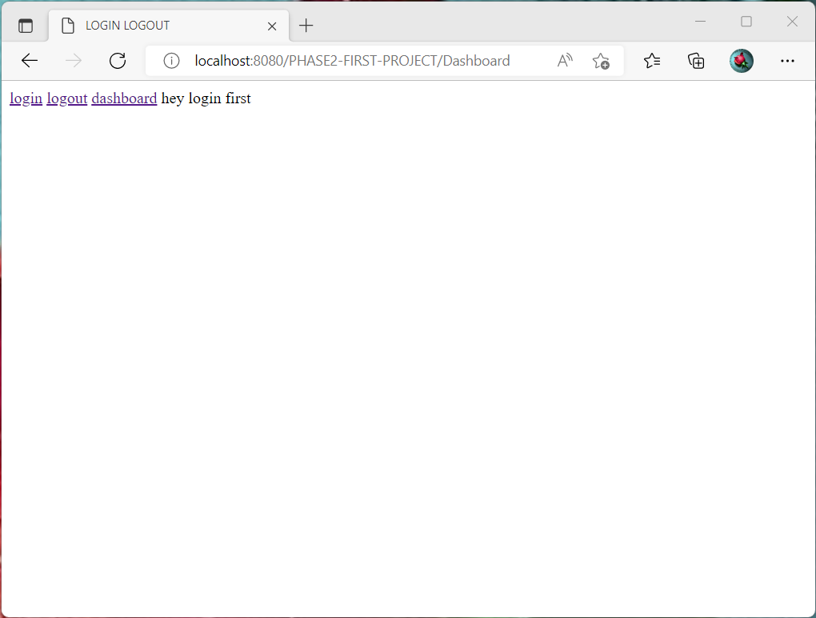

Again Enter username and password, this time enter password different from username

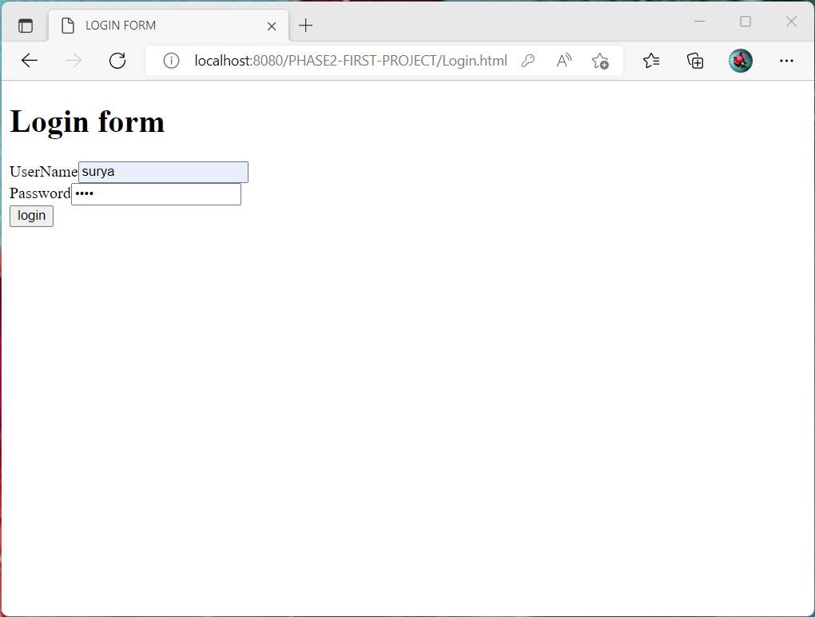

After Entering username and password, if the username not equals password. Then the following output is as shown below

