**PHASE2-FOURTH-PROJECT**

**OUTPUT SCREENSHOTS**

**The product details are entered is as shown below**

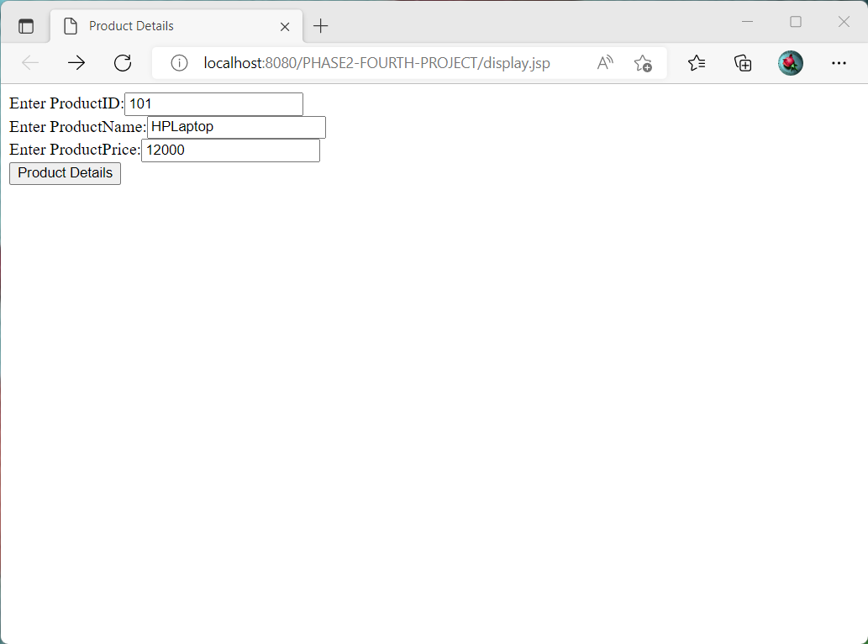

**After we click product details button, the output is as shown below**

