PHASE2-SECOND-PROJECT OUTPUT SCREENSHOTS

**Enter the ProductID to search**

**It is as shown below**

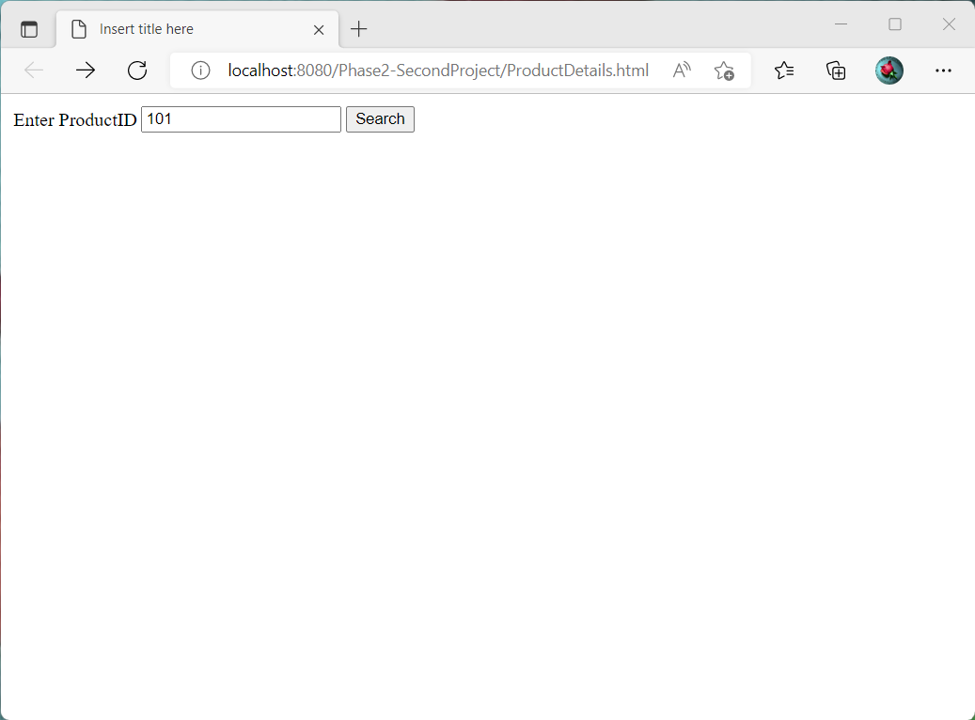

**The Product Details for the given ProductID is as below**

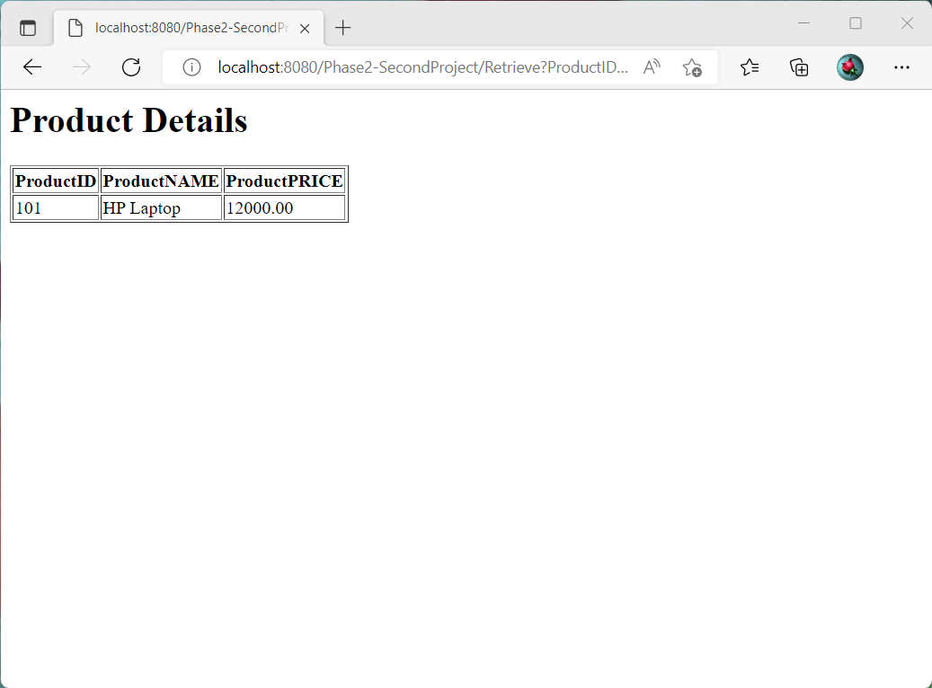

**The Product Details are taken from the below product Table**

