**PHASE2-THIRD-PROJECT-OUTPUTSCREENSHOTS**

The Product Info Page is as shown below

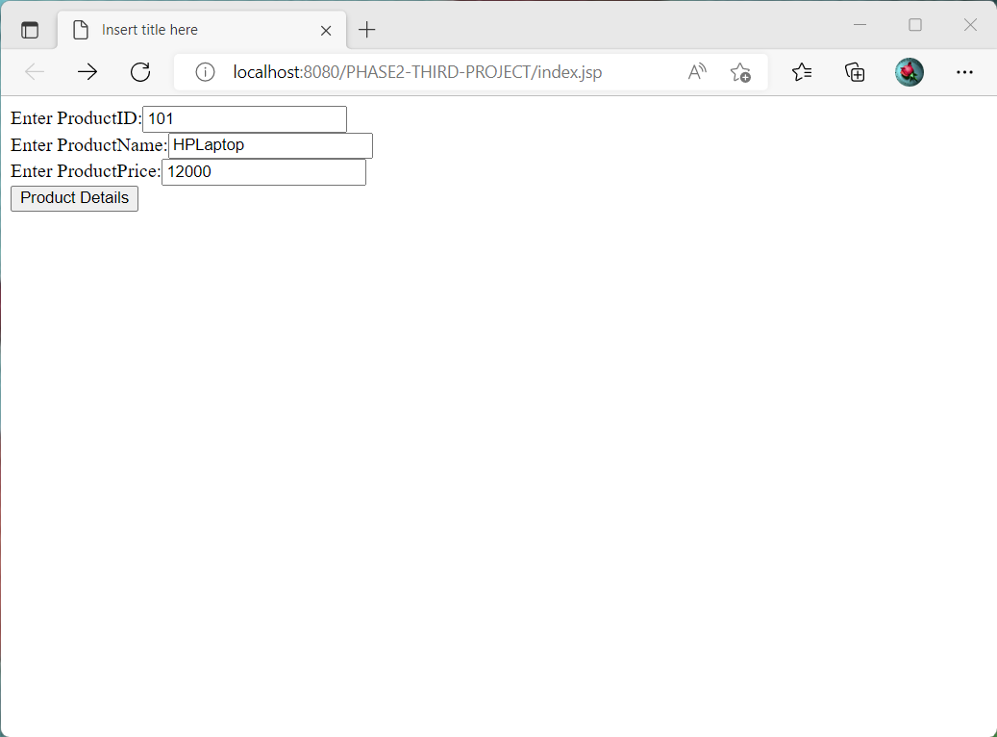

**The Output for Product Details that are entered**

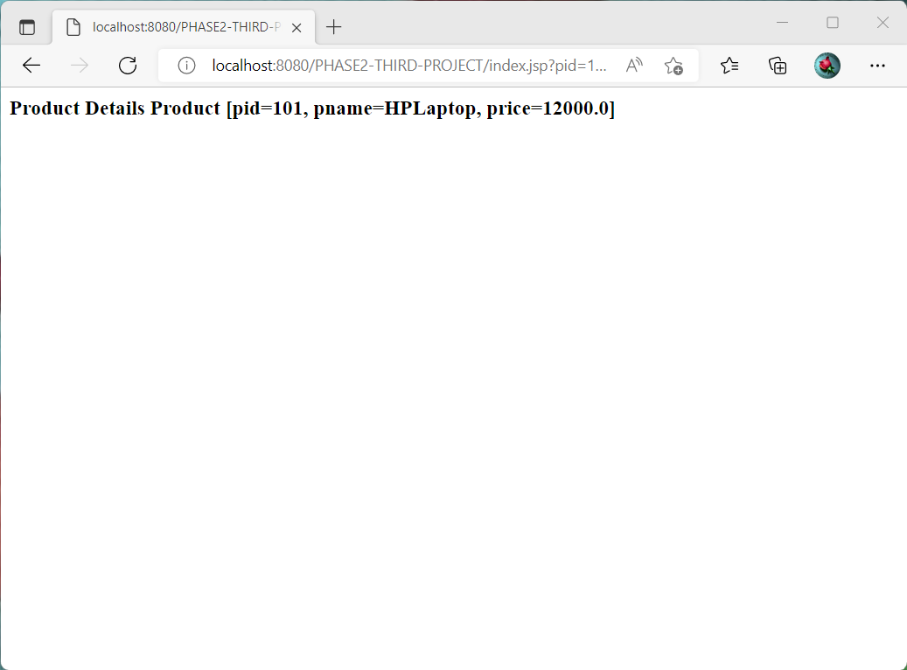

**The Product Details that are stored in Table in MYSQL is as below**

