**PHASE3-FINALPROJECT-OUTPUTSCREENSHOTS**

**The below output shows the Login Page**

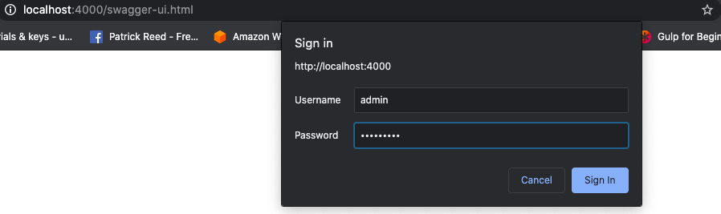

**The below output shows the controllers**

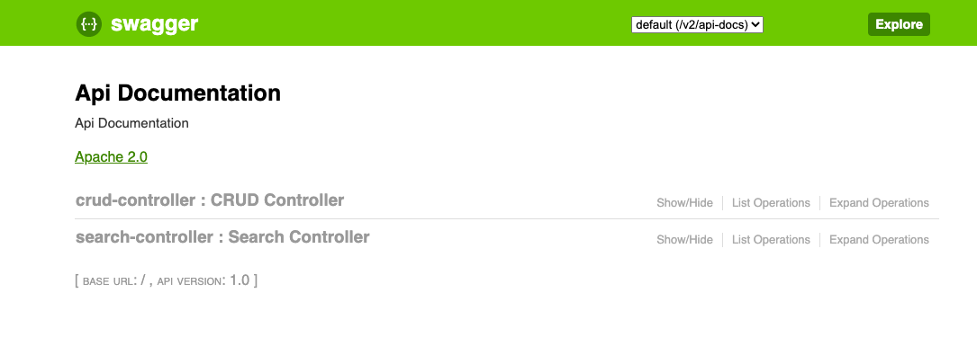

**The below output shows the controller operations**

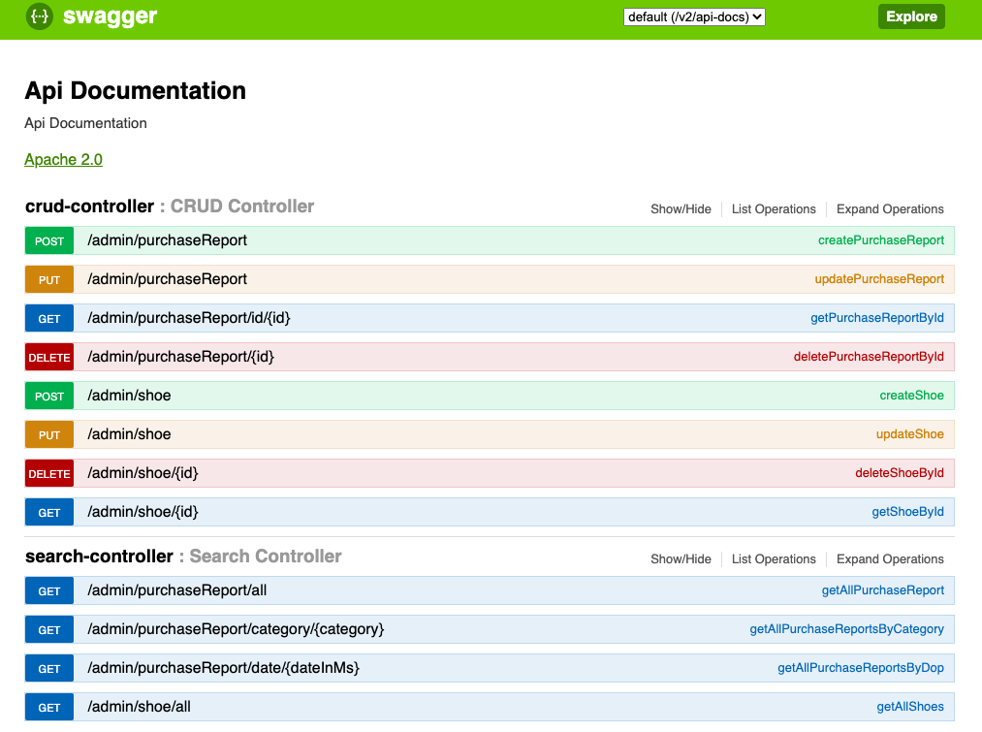

**The below output shows the purchase report of all the shoes**

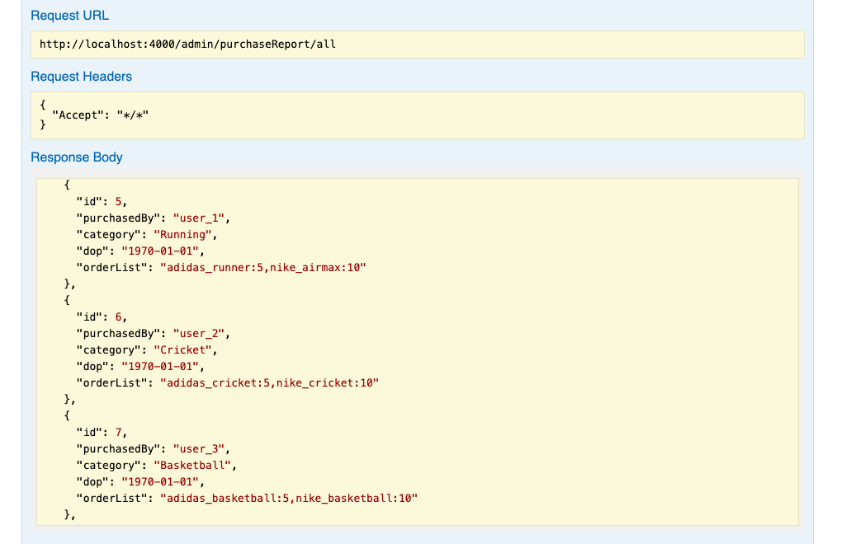

**The below output shows how to add the purchase report of the shoe**

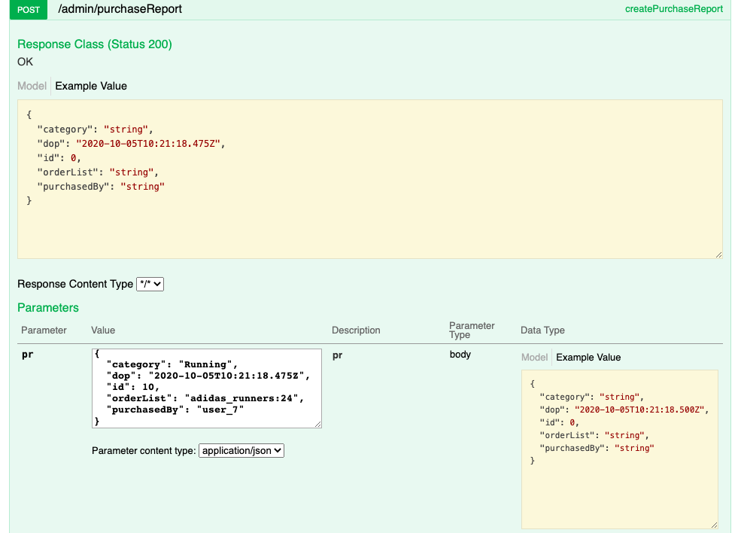

**The below output shows the purchase report of the shoe added**

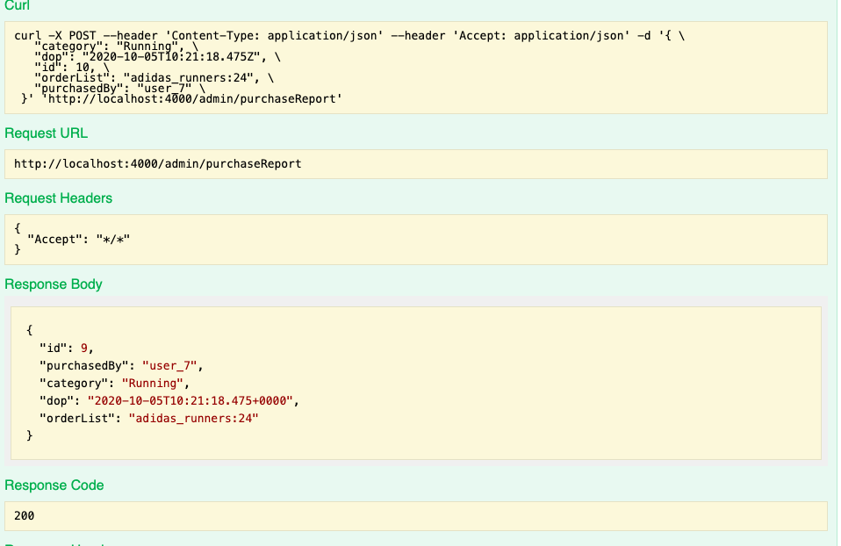

**The below output shows how to get all the purchase report of the shoes by category**

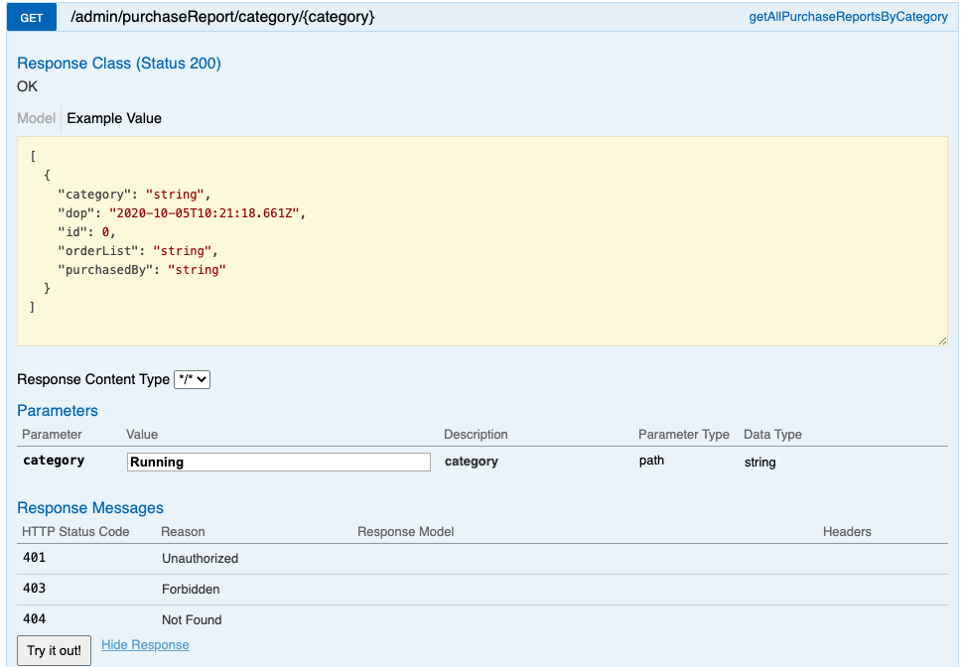

**The below output shows the purchase report of the shoes by category**

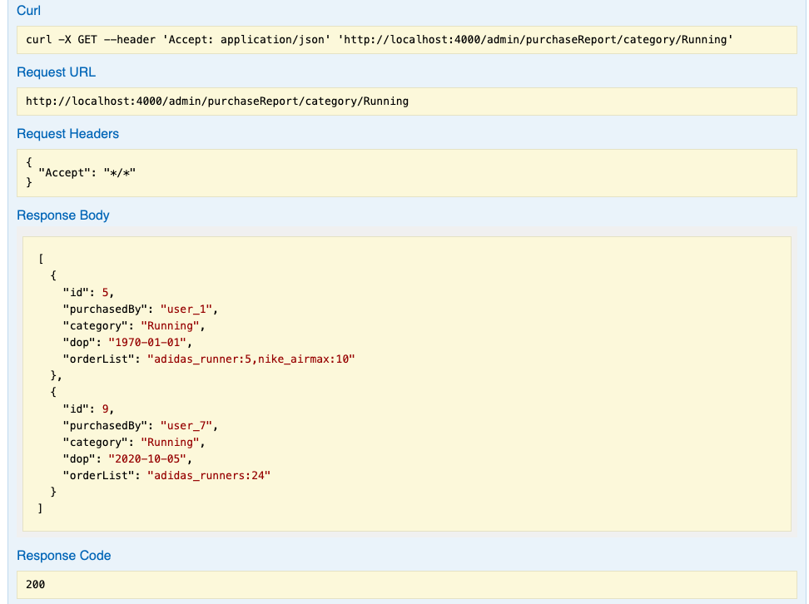

**The below output shows how to get the shoe by id=3**

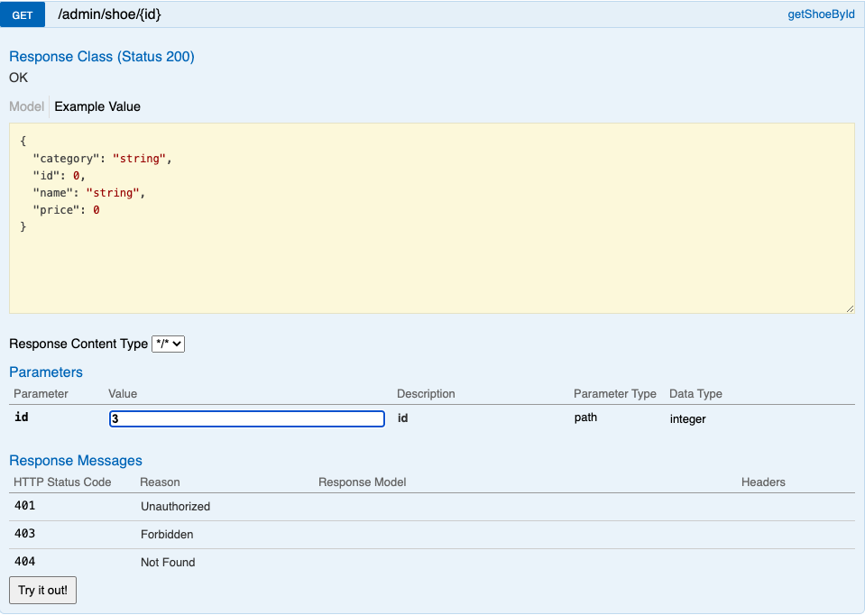

**The below output shows the shoe by id=3 by entering id=3**

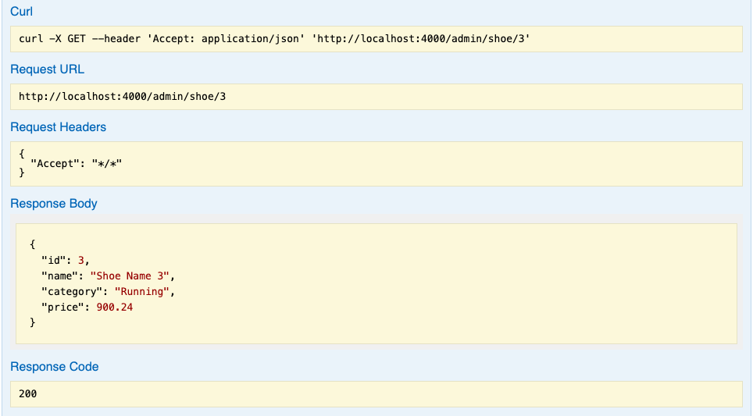

**The below output shows how the shoe by id=3 is deleted by entering id=3**

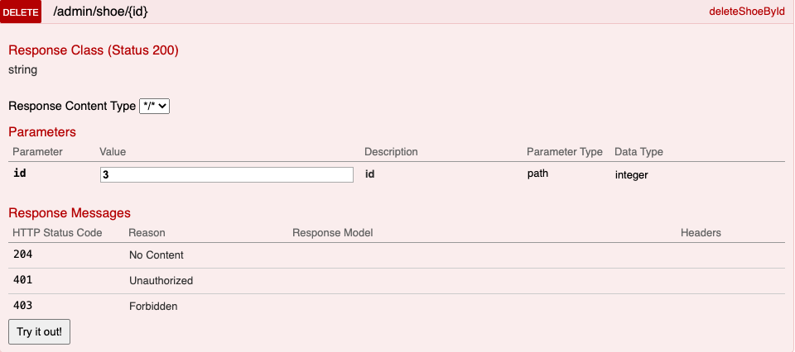

**The below output shows the shoe by id=3 successfully deleted**

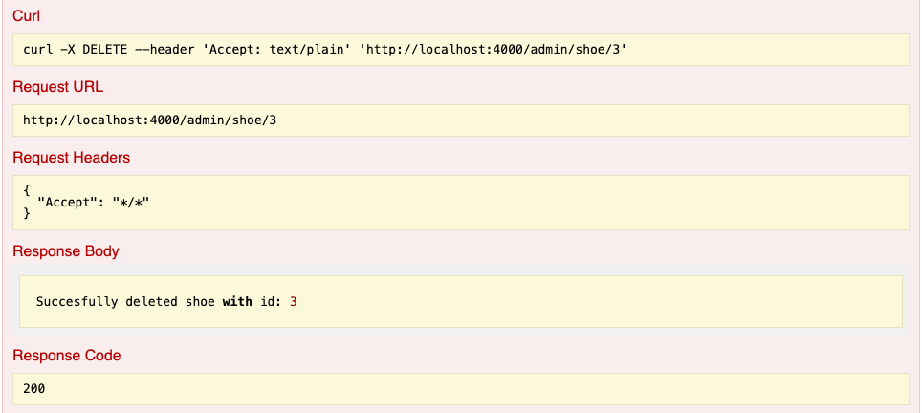

**The below output shows after deleting the shoe by id=3**

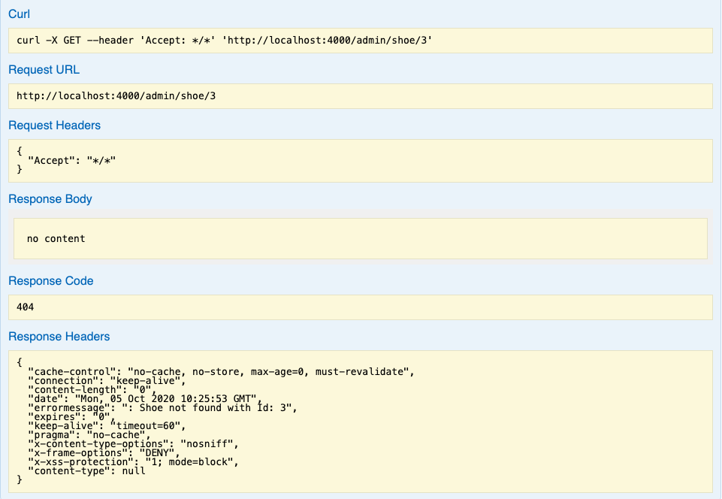

**The below output shows all shoes after deleting the shoe by id=3**

