**PHASE3-FIRSTPROJECT-OUTPUTSCREENSHOTS**

**User can input an id number from the table or view the table by clicking the link**

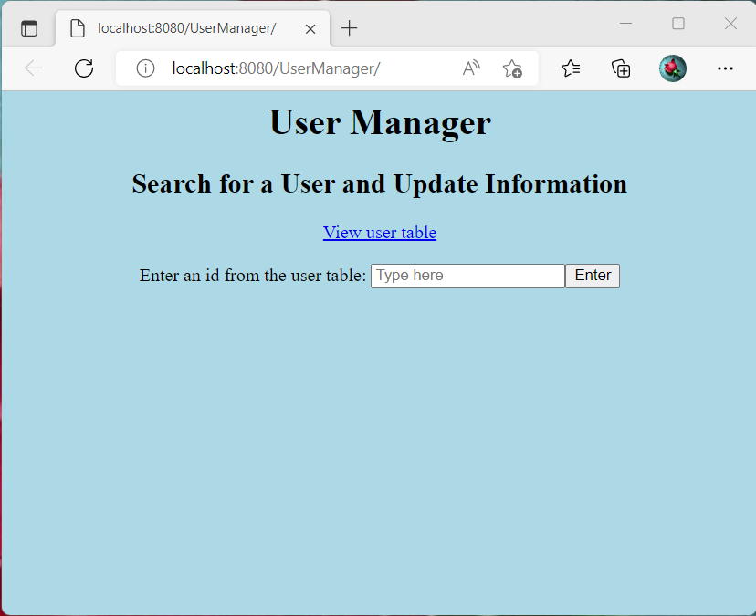

**Output all users from the SQL database**

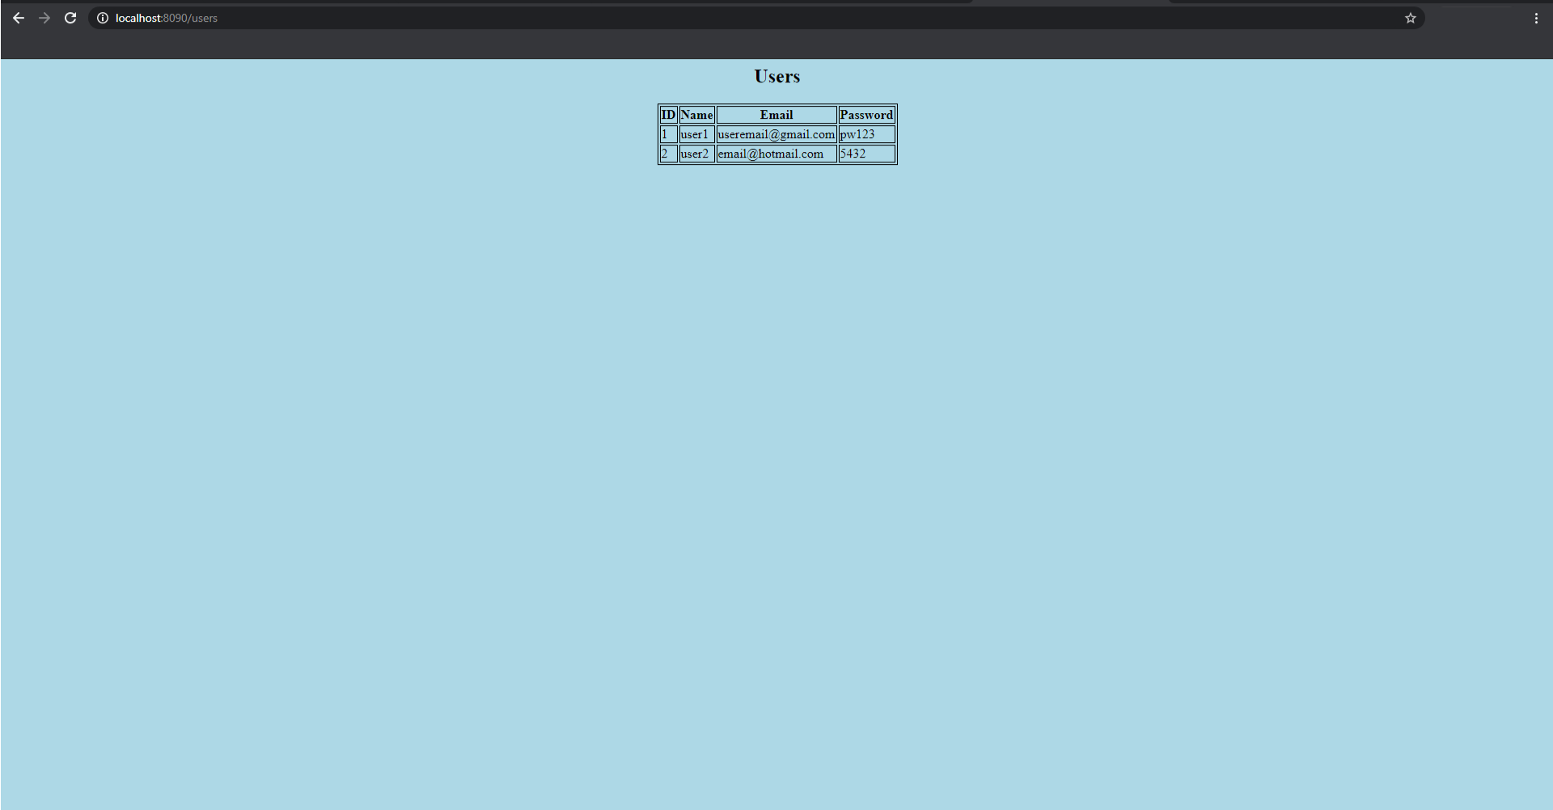

**Displays the information of the specific user with the given ID**

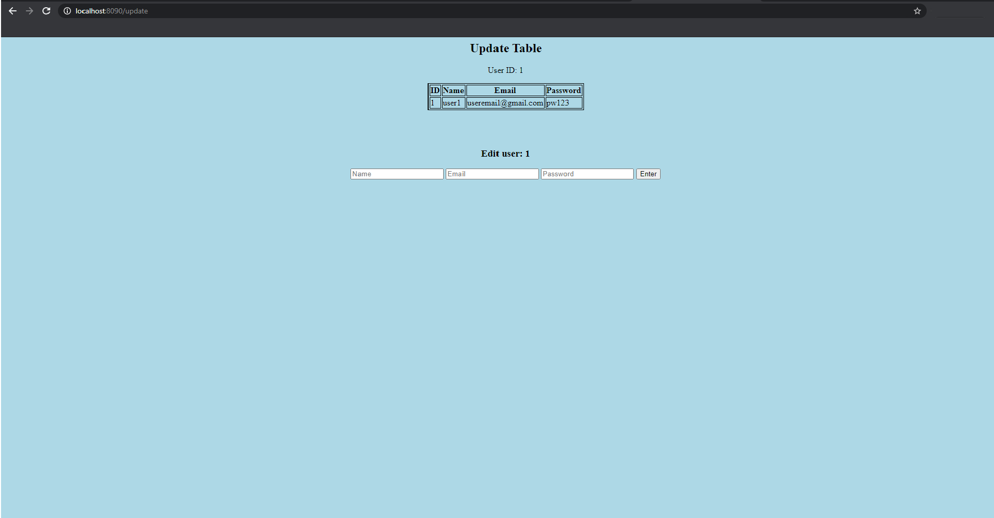

**If User not found, it will show the following error message**

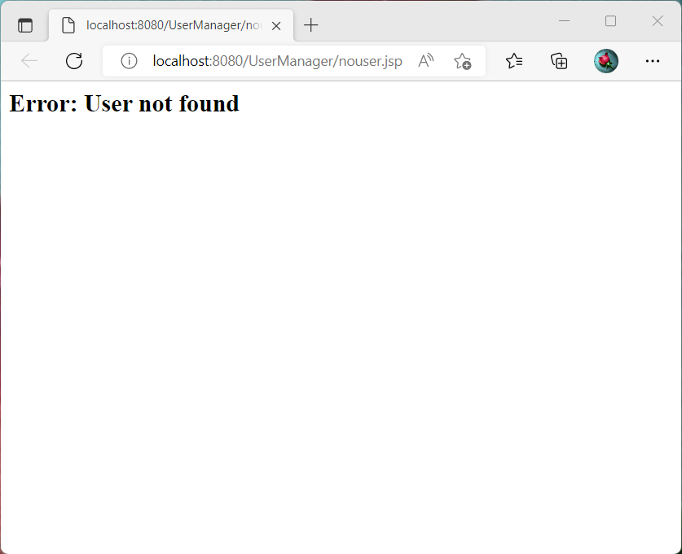

**Edit user with ID 1**

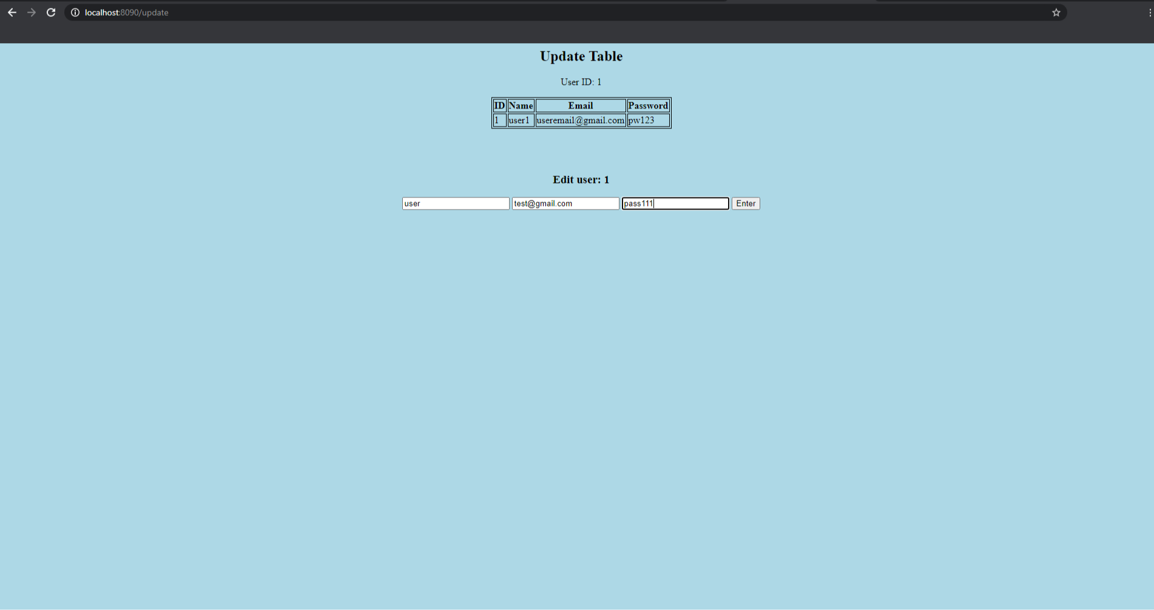

**After updating the following success page will be shown**

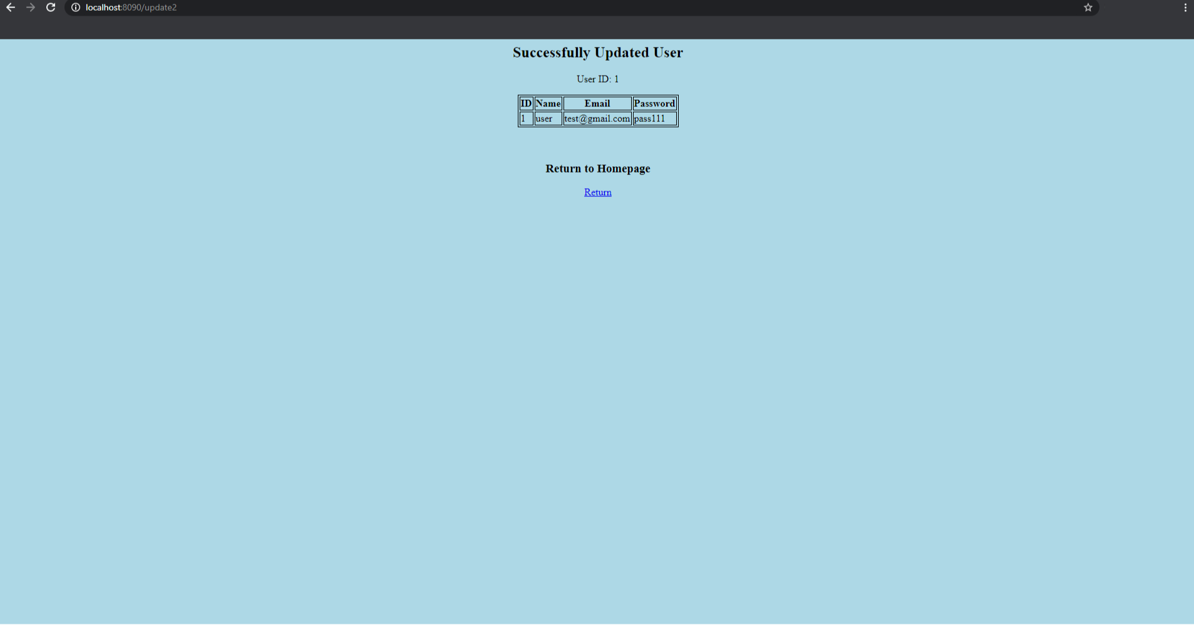

**SQL table is also updated**

