**PHASE3-FOURTHPROJECT-OUTPUTSCREENSHOTS**

When the application is started, if we enter localhost:8080 in the browser

It will show output as

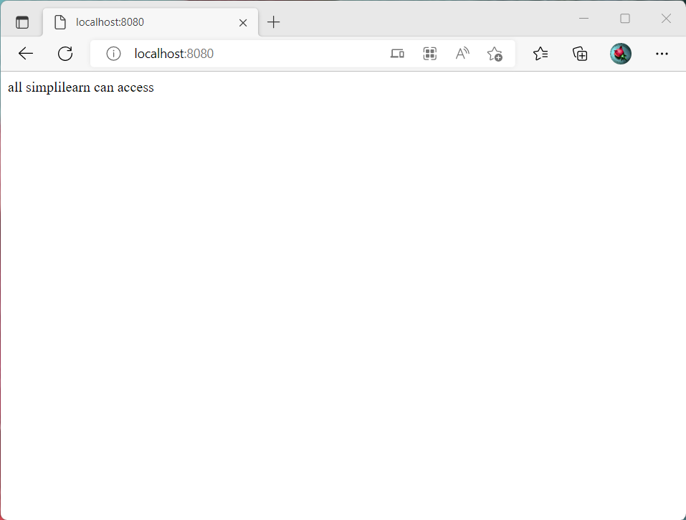

Entering admin credentials to sign in

It will show output as

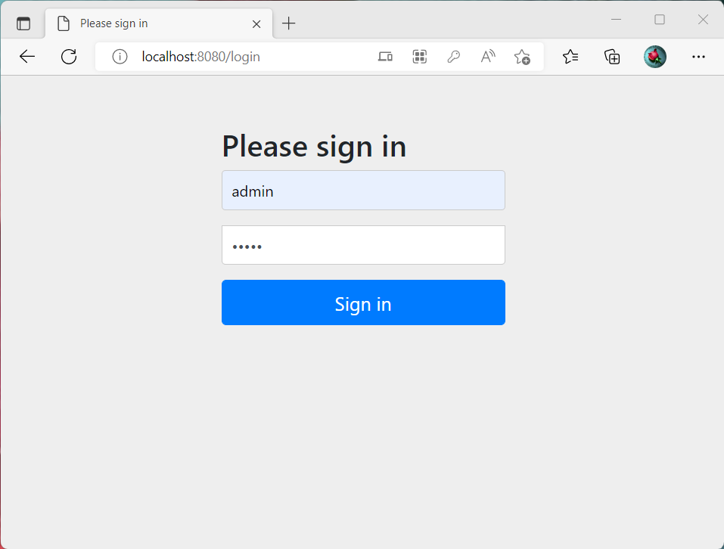

Entering admin

It will show output as admin

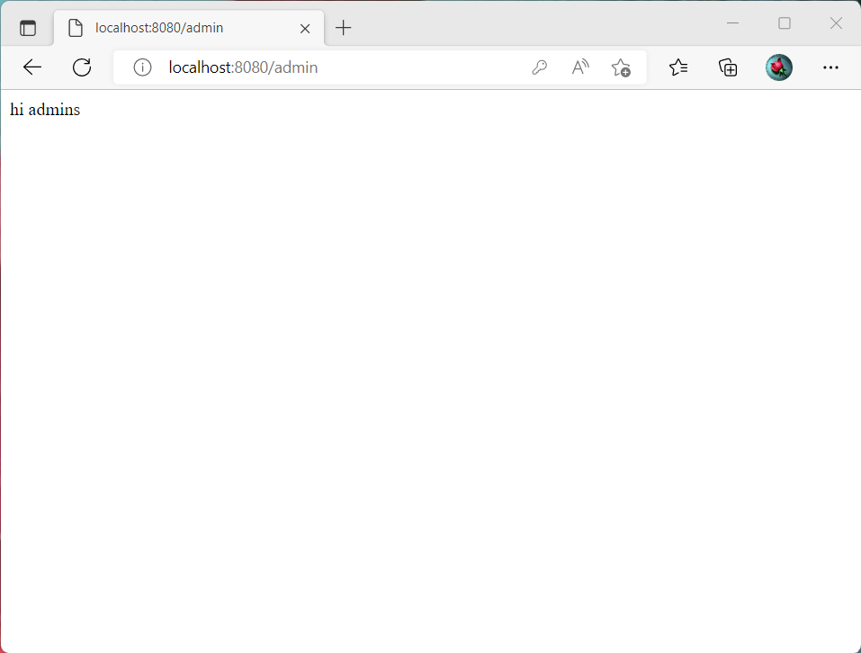

Entering admin

It will show output as user

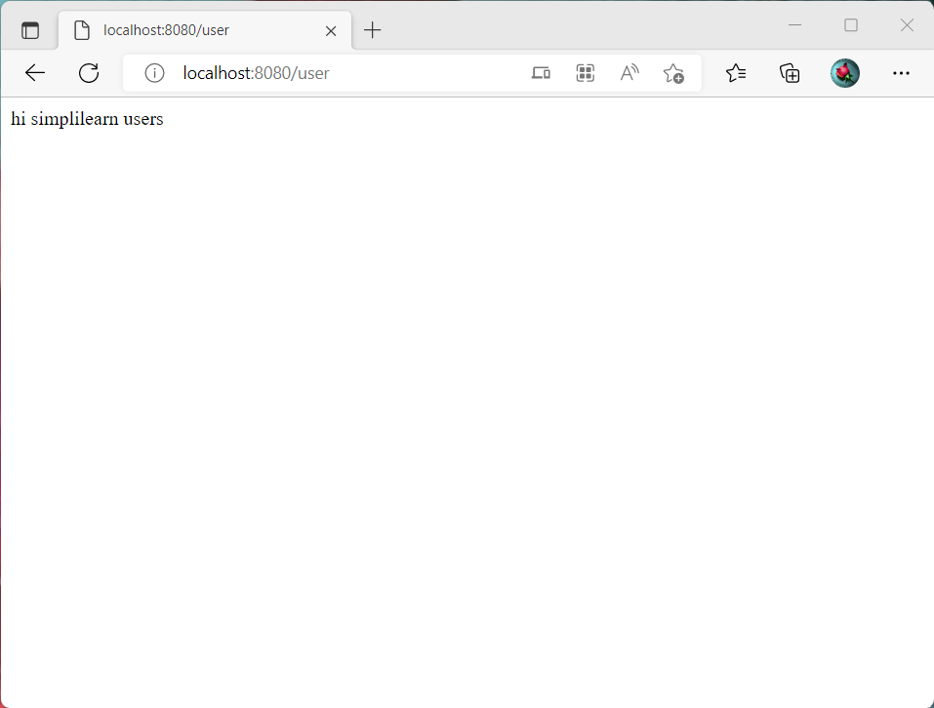

Entering admin

It will show output as user1

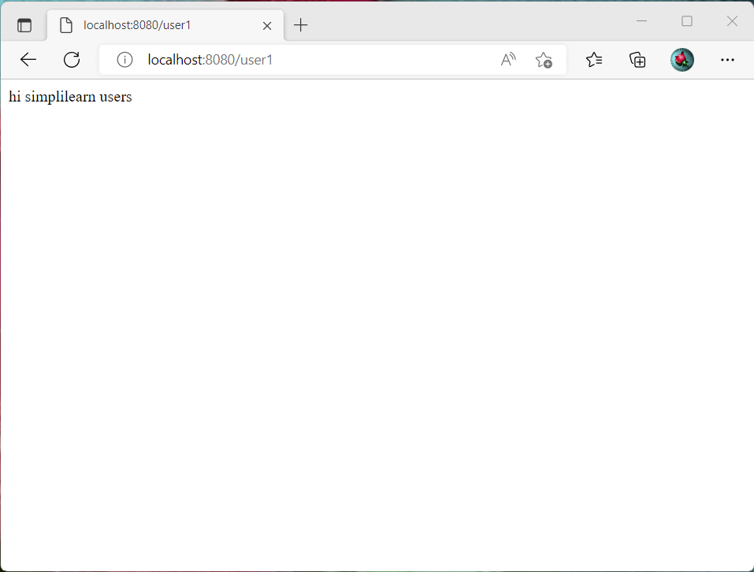

It will show output to confirm logout as

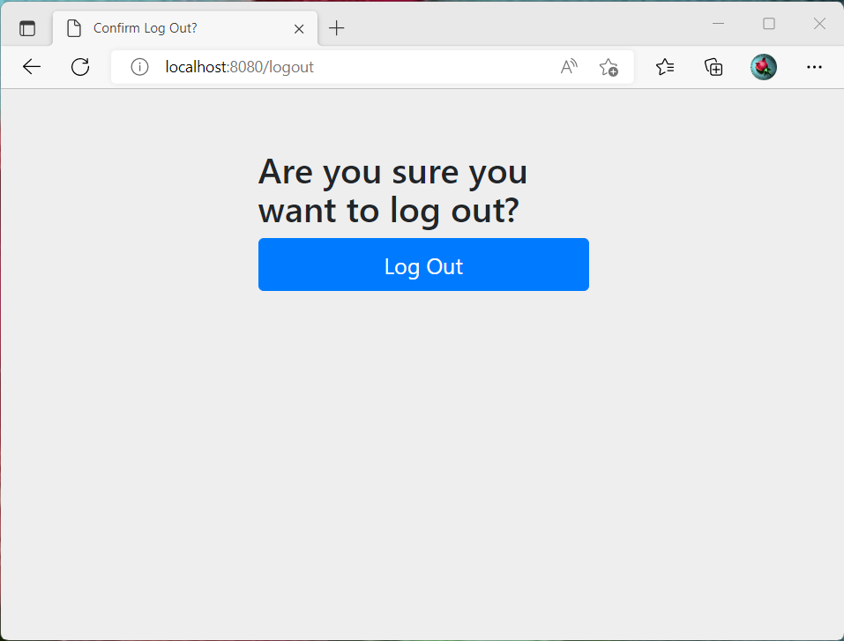

Entering credentials to sign out

It will show output as

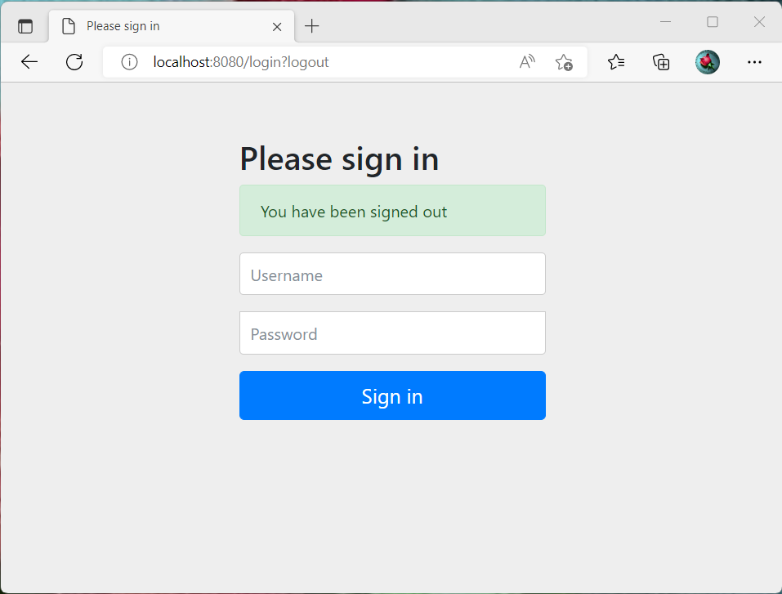

It will show output as



Entering user credentials to sign in

It will show output as

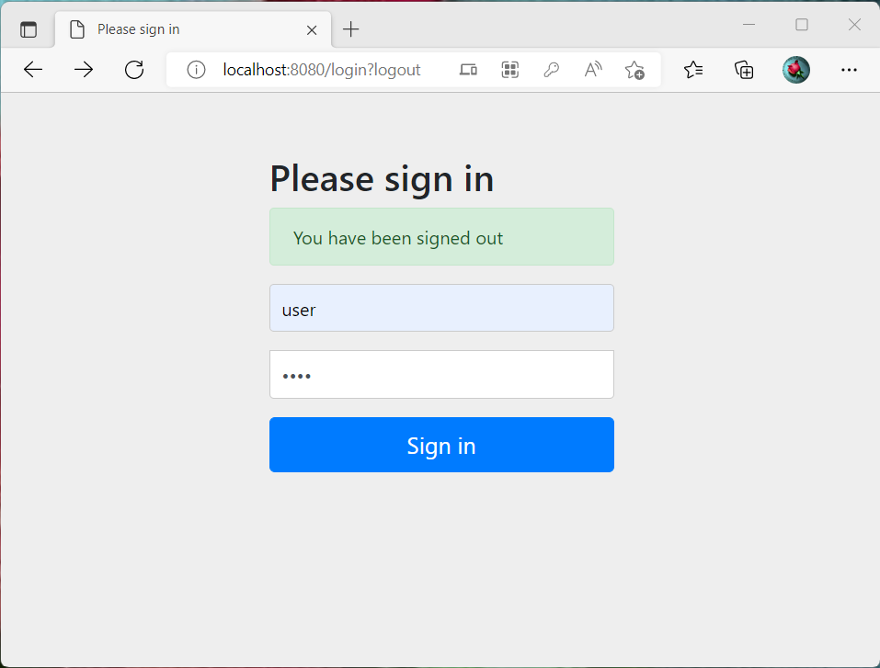

It will show output as



Entering user1 credentials to sign in

It will show output as

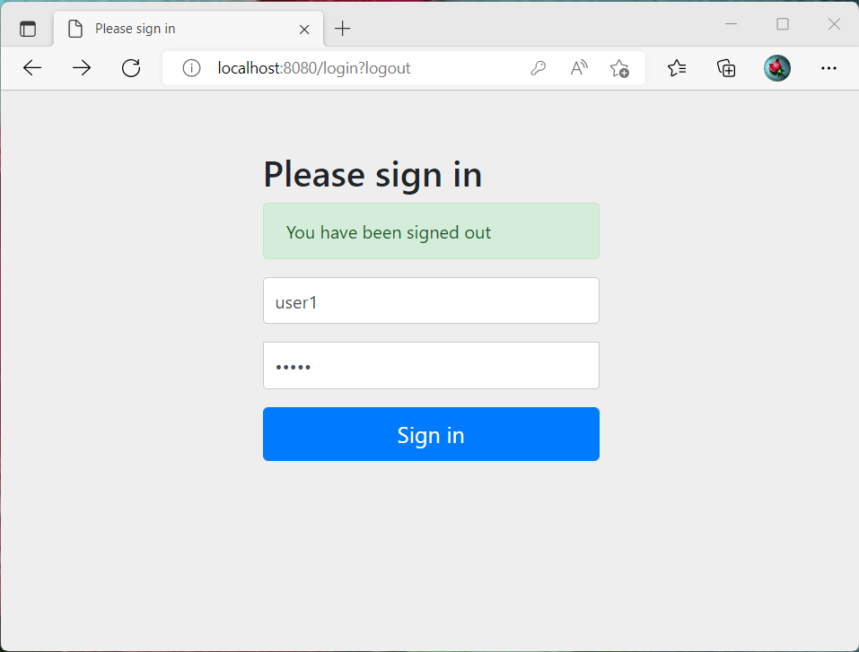

It will show output as

