**PHASE3-SECONDPROJECT-OUTPUTSCREENSHOTS**

**Homepage: User Feedback Page**

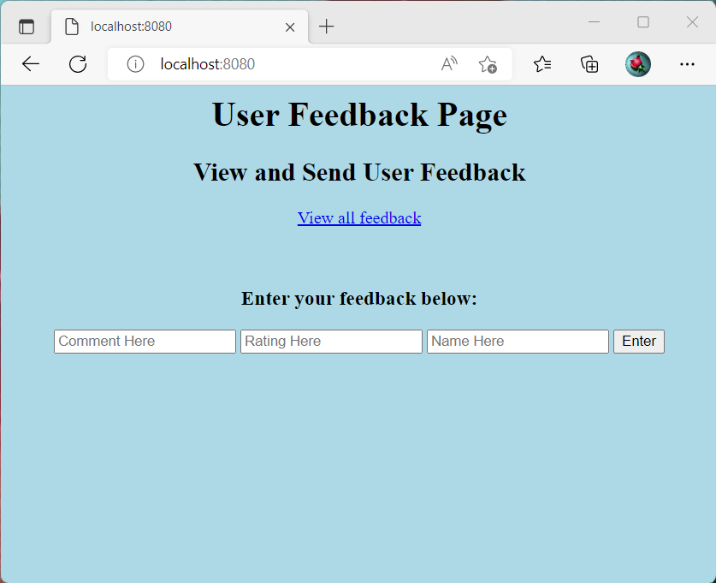

**User views the Feedback Table**

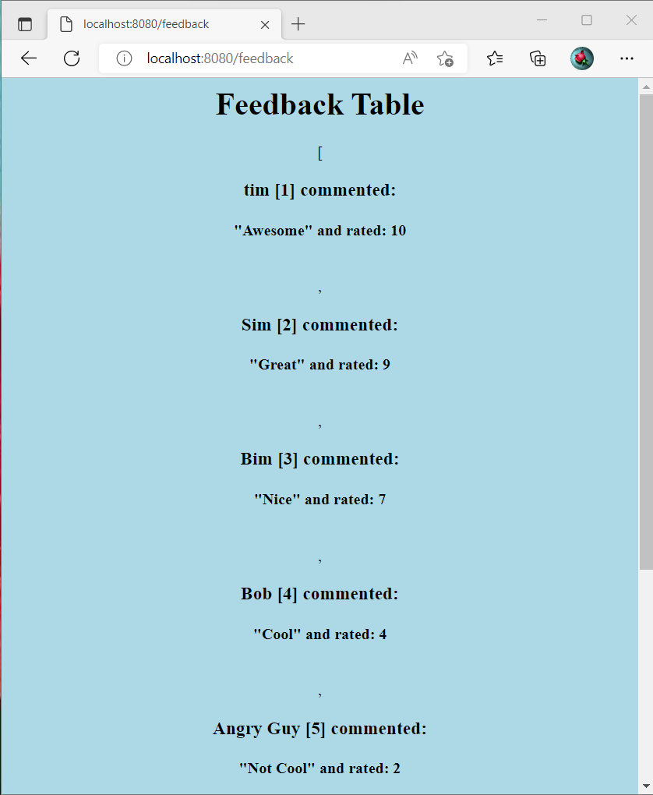

**User inputs Feedback is shown as**

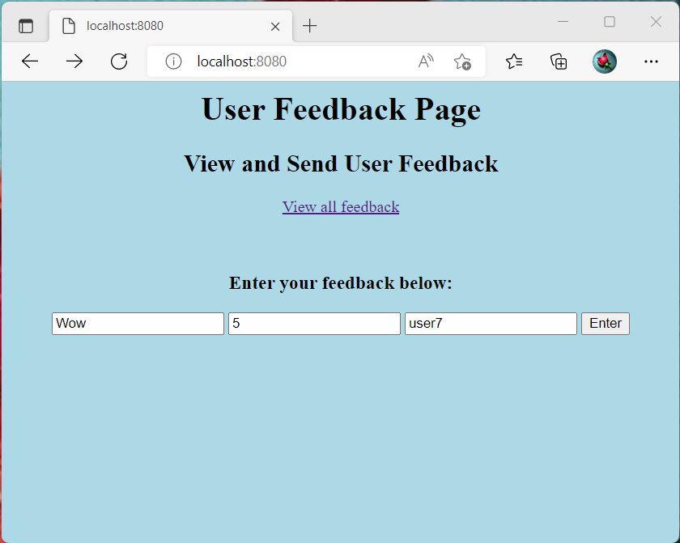

**Shows that feedback was successfully added**

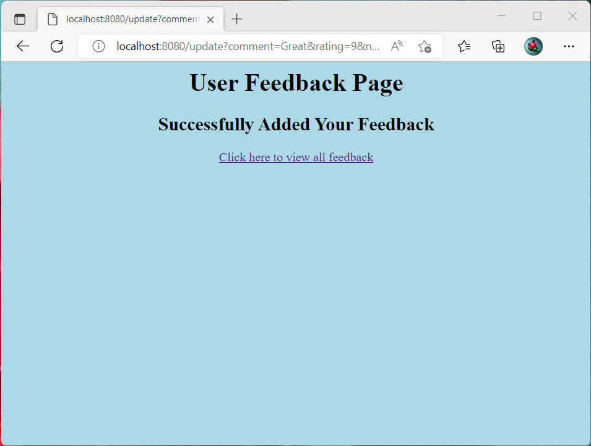

**Updated Feedback Table**



**MYSQL Workbench showing Table**

