**PHASE3-THIRDPROJECT-OUTPUTSCREENSHOTS**

**User Login Page:**

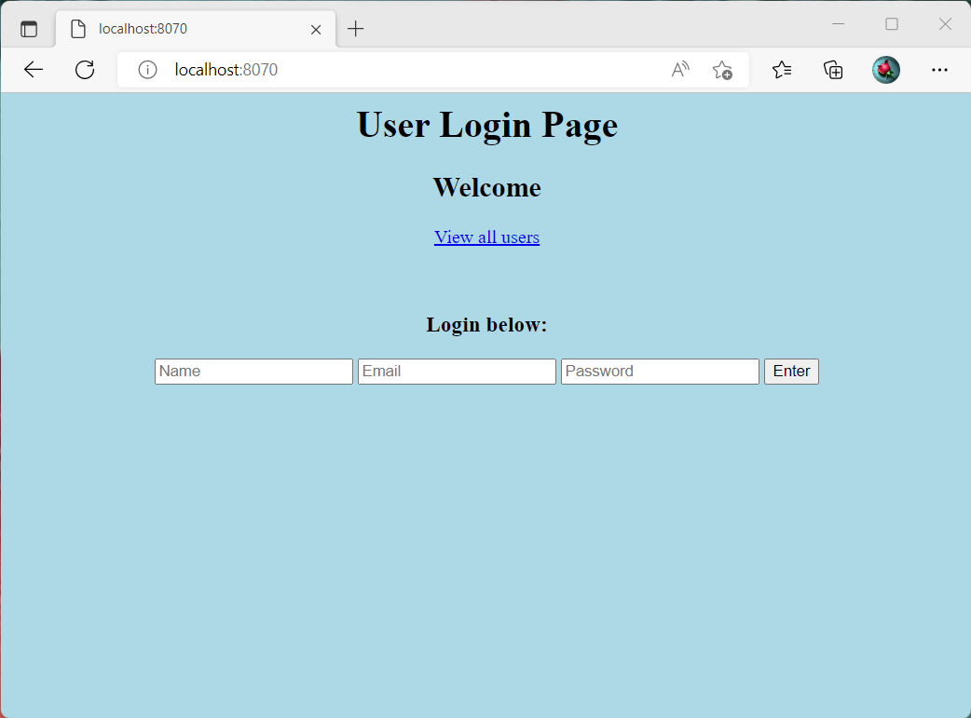

Logged In Page after adding information Successfully

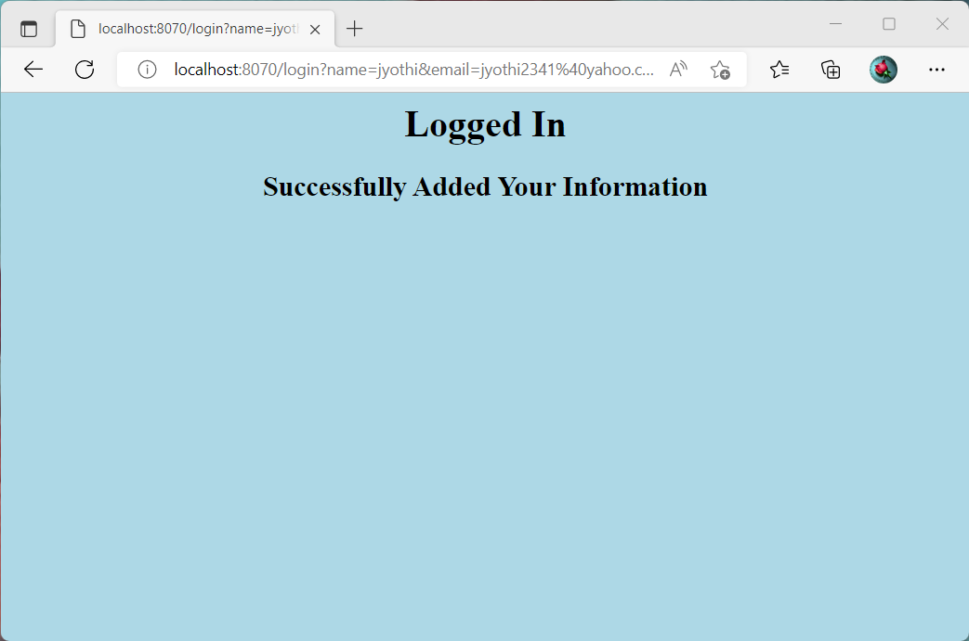

**Allusers:**

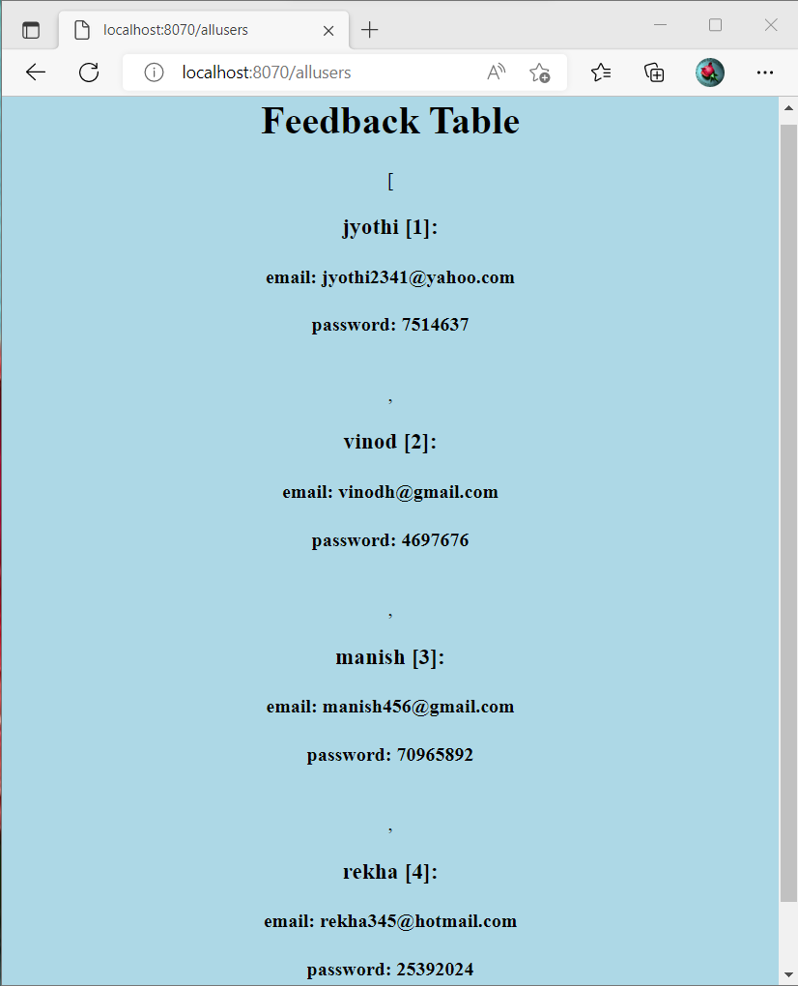

MYSQL TABLE:

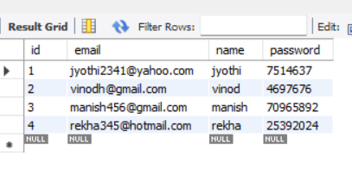

AutheniticationApplicationTests:

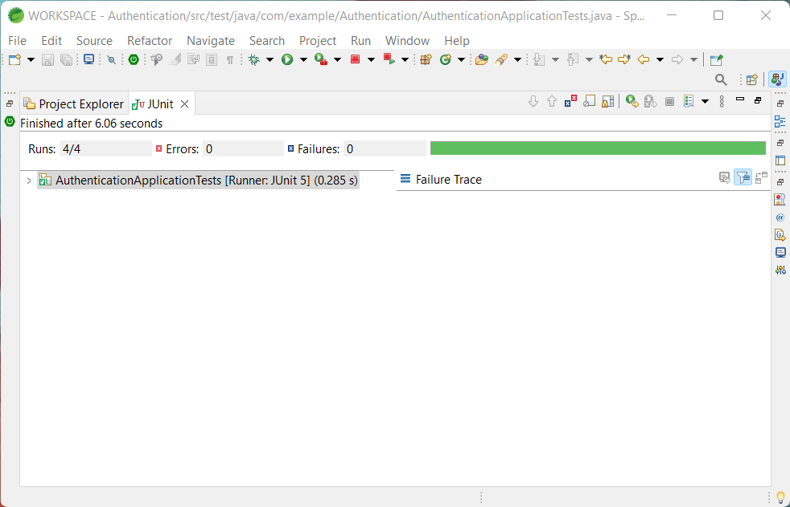

AutheniticationTests:

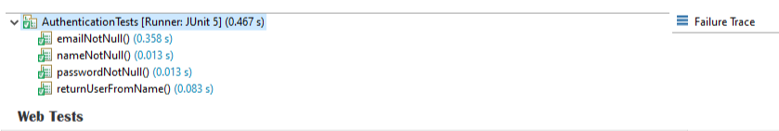

AutheniticationWebTests:

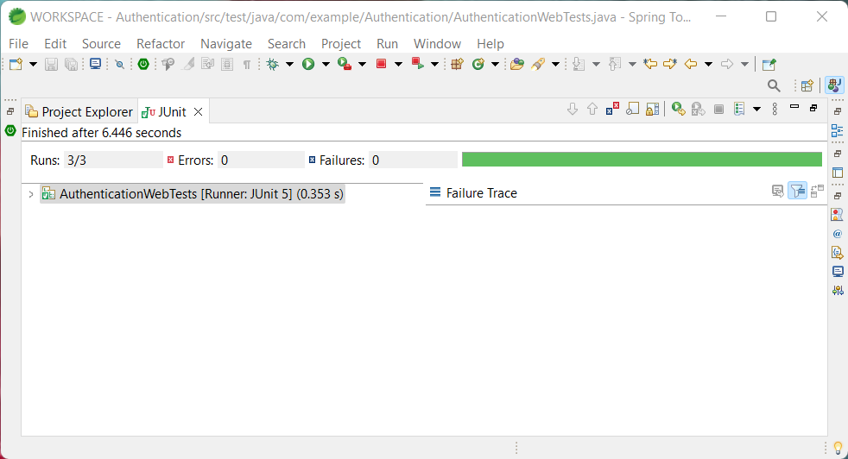

EntityTests:

