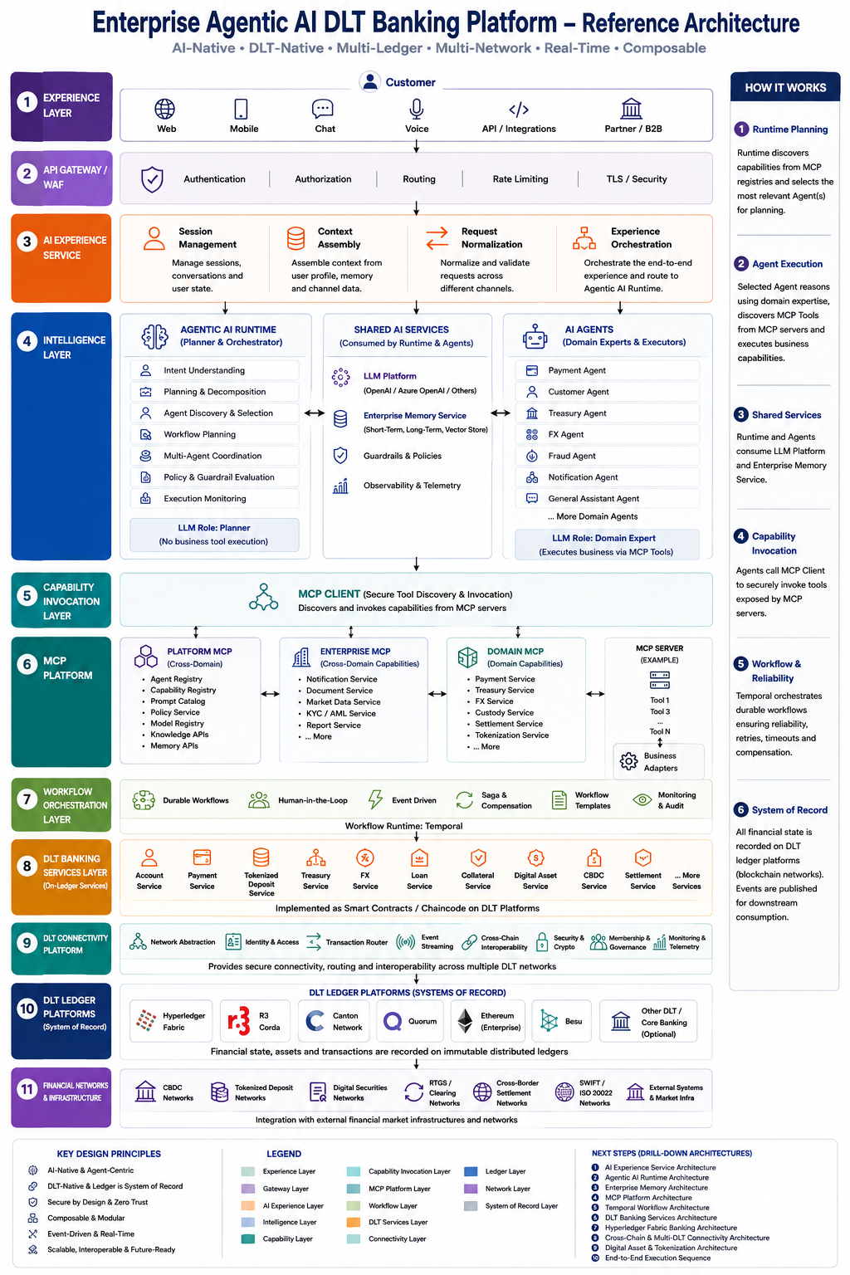

Chapter 3 – Architecture Layers
3.1 Introduction
The Enterprise Agentic AI DLT Banking Platform is organized into a set of logical architectural layers, each responsible for a specific function within the overall solution.
The layered architecture promotes clear separation of responsibilities, independent scalability, maintainability, and technology flexibility. Each layer interacts only with adjacent layers through well-defined interfaces, ensuring loose coupling and simplifying future enhancements.
The platform consists of the following eleven layers:
Layer | Purpose
Experience Layer | Customer interaction channels
API Gateway / WAF | Secure entry point
AI Experience Service | AI request preparation
Intelligence Layer | AI reasoning and planning
Capability Invocation Layer | Secure capability invocation
MCP Platform | Enterprise capability exposure
Workflow Orchestration | Business workflow execution
DLT Banking Services | Banking business capabilities
DLT Connectivity Platform | Blockchain connectivity
DLT Ledger Platform | Distributed ledger infrastructure
Financial Networks | External financial ecosystem
The following sections describe each layer in detail.

3.2 Experience Layer
Purpose
The Experience Layer provides the primary interaction point between customers, business users, partner organizations, and the banking platform.
It delivers a consistent digital experience across multiple communication channels while remaining independent of backend business processing.
This layer is responsible only for presenting information to users and collecting requests. All business processing is delegated to downstream services.

Responsibilities
- Provide customer-facing digital channels.
- Capture customer requests.
- Display business responses.
- Support multiple interaction methods.
- Forward requests securely to the API Gateway.

Components
Component | Description
Web Portal | Browser-based banking application.
Mobile Application | Mobile banking application for Android and iOS.
Chat Interface | Conversational interface supporting AI interactions.
Voice Assistant | Voice-based banking interactions.
Partner APIs | APIs for enterprise and third-party integrations.

Input
- Customer Requests
- Partner Requests
- Voice Commands
- Chat Messages

Output
- Requests forwarded to API Gateway

Benefits
- Consistent customer experience.
- Multiple interaction channels.
- Channel-independent business processing.
- Simplified user interface development.

3.3 API Gateway / Web Application Firewall Layer
Purpose
The API Gateway acts as the secure entry point for all incoming requests. Every request entering the banking platform passes through this layer before reaching backend services.
It enforces security, authentication, authorization, routing, and request validation policies.

Responsibilities
- Authenticate users.
- Authorize requests.
- Validate incoming requests.
- Route traffic to backend services.
- Protect against malicious traffic.
- Enforce API policies.

Components
Component | Description
Authentication | Verifies user identity.
Authorization | Validates user permissions.
Routing Engine | Routes requests to the correct backend service.
Rate Limiting | Protects services from excessive requests.
TLS Security | Secures communication using encryption.
Web Application Firewall | Protects against common web attacks.

Input
- Requests from digital channels.

Output
- Authenticated and authorized requests.

Benefits
- Centralized security.
- Simplified API management.
- Protection against malicious traffic.
- Consistent request routing.

3.4 AI Experience Service Layer
Purpose
The AI Experience Service prepares customer requests before they are processed by the Intelligence Layer.
This layer enriches incoming requests with contextual information, maintains conversational continuity, and determines how requests should be processed.
It acts as the AI Front Office, ensuring that AI receives complete and consistent context for decision-making.

Responsibilities
- Maintain conversational sessions.
- Assemble enterprise context.
- Normalize requests.
- Coordinate AI request processing.
- Improve AI response quality.

Components
Component | Description
Session Management | Maintains conversation state across multiple interactions.
Context Assembly | Collects customer profile, conversation history, preferences, and business context.
Request Normalization | Converts incoming requests into a standardized internal format.
Experience Orchestration | Determines the appropriate processing path for each request.

Input
- Authenticated customer requests.

Output
- Context-enriched AI requests.

Benefits
- Better AI accuracy.
- Improved customer experience.
- Consistent request processing.
- Reusable conversational context.

3.5 Intelligence Layer
Purpose
The Intelligence Layer is the decision-making engine of the platform.
It interprets customer intent, creates execution plans, coordinates AI agents, applies enterprise policies, and supervises execution.
Unlike traditional systems where execution logic is predefined, this layer dynamically determines the optimal execution strategy based on customer intent and available enterprise capabilities.

Responsibilities
- Interpret customer intent.
- Generate execution plans.
- Discover AI agents.
- Coordinate multiple AI agents.
- Apply enterprise policies.
- Monitor execution.

Major Components
Agentic AI Runtime
Responsible for planning and coordinating business execution.
Component | Description
Intent Understanding | Identifies customer intent.
Planning Engine | Decomposes business requests into executable tasks.
Agent Discovery | Selects the appropriate AI agents.
Workflow Planning | Determines workflow requirements.
Policy Evaluation | Applies enterprise governance and compliance policies.
Execution Monitoring | Tracks execution progress and system health.

Shared AI Services
Reusable enterprise AI capabilities shared by all AI agents.
Component | Description
LLM Platform | Enterprise Large Language Model integration.
Enterprise Memory | Stores conversation history and contextual knowledge.
Guardrails | Enforces AI safety, security, and compliance policies.
Observability | Provides logging, monitoring, metrics, and tracing.

Domain AI Agents
Specialized AI agents responsible for executing business capabilities.
Examples include:
- Payment Agent
- Treasury Agent
- FX Agent
- Customer Agent
- Fraud Agent
- Notification Agent

Benefits
- Intelligent request interpretation.
- Dynamic execution planning.
- Reusable AI capabilities.
- Enterprise policy enforcement.
- Multi-agent collaboration.

3.6 Capability Invocation Layer
Purpose
The Capability Invocation Layer provides a standardized mechanism for AI agents to invoke enterprise business capabilities.
Rather than directly calling backend services, AI agents use this layer to discover and securely invoke capabilities exposed through the Model Context Protocol (MCP).
This abstraction simplifies AI integration and enables consistent communication with enterprise services.

Responsibilities
- Discover enterprise capabilities.
- Invoke business tools.
- Authenticate tool requests.
- Manage tool responses.
- Standardize capability invocation.

Components
Component | Description
MCP Client | Discovers and invokes enterprise business capabilities exposed by MCP Servers.
Benefits
- Standardized AI integration.
- Loose coupling between AI and backend services.
- Improved scalability.
- Simplified enterprise capability discovery.

3.7 MCP Platform Layer
Purpose
The Model Context Protocol (MCP) Platform serves as the standardized integration layer between AI Agents and enterprise business capabilities.
Instead of allowing AI Agents to directly invoke backend services, the MCP Platform exposes business capabilities as standardized AI tools. This approach provides a consistent mechanism for capability discovery, invocation, governance, and future extensibility.
The MCP Platform enables enterprise services to be reused across multiple AI Agents while keeping implementation details hidden from the AI Runtime.

Responsibilities
- Publish enterprise capabilities as AI tools.
- Register and manage reusable capabilities.
- Standardize capability invocation.
- Enable secure communication between AI Agents and enterprise services.
- Support capability discovery and future extensibility.

Components
Platform MCP
Provides reusable platform-level capabilities shared across the enterprise.
Examples include:
Capability | Description
Knowledge Service | Enterprise knowledge retrieval.
Prompt Registry | Centralized prompt management.
Model Registry | Maintains approved enterprise AI models.
Agent Registry | Registers available AI Agents.
Policy Service | Enterprise governance and policy management.

Enterprise MCP
Provides enterprise-wide shared business capabilities.
Examples include:
Capability | Description
Notification Service | Email, SMS and push notifications.
Document Service | Document generation and storage.
KYC Service | Customer verification services.
Reporting Service | Enterprise reporting capabilities.
Market Data Service | Financial market information.

Domain MCP
Provides domain-specific banking capabilities.
Examples include:
Banking Domain | Example Capabilities
Payments | Fund Transfer, Balance Inquiry
Treasury | Liquidity Management
FX | Foreign Exchange
Settlement | Transaction Settlement
CBDC | Digital Currency Processing
Tokenized Deposits | Token Lifecycle Management
Customer | Customer Management

MCP Server
The MCP Server exposes business capabilities as standardized AI tools.
Each MCP Server acts as an adapter between AI Agents and backend Spring Boot microservices.

Inputs
- Requests from MCP Client

Outputs
- Requests to Business Microservices

Benefits
- Standardized AI capability invocation.
- Reusable enterprise business services.
- Loose coupling between AI and backend systems.
- Simplified onboarding of new business capabilities.
- Improved governance and maintainability.

3.8 Workflow Orchestration Layer
Purpose
The Workflow Orchestration Layer coordinates long-running business processes involving multiple services and systems.
Rather than embedding workflow logic within individual services, the platform uses a dedicated workflow engine to manage execution, retries, compensations, approvals, and monitoring.
This approach improves reliability while simplifying business process management.

Responsibilities
- Execute long-running workflows.
- Coordinate multiple business services.
- Manage retries and timeouts.
- Perform compensation activities.
- Support manual approval steps.
- Maintain workflow state.

Components
Component | Description
Workflow Engine | Coordinates business process execution.
Workflow Activities | Individual business tasks executed by microservices.
Retry Engine | Handles temporary failures automatically.
Compensation Engine | Executes rollback operations when required.
Human Task Integration | Supports manual approvals and interventions.

Technology
Temporal is proposed as the enterprise workflow orchestration platform.

Inputs
- Requests from Banking Services.
- AI Execution Plans.

Outputs
- Workflow Activities.
- Business Events.
- Workflow Completion Status.

Benefits
- Reliable workflow execution.
- Automatic retries.
- Compensation support.
- Centralized workflow management.
- Improved operational visibility.

3.9 DLT Banking Services Layer
Purpose
The DLT Banking Services Layer contains the core business capabilities of the banking platform.
Each business capability is implemented as an independent Spring Boot microservice aligned with Domain-Driven Design principles.
These services execute business rules, process customer transactions, and integrate with both workflow orchestration and distributed ledger platforms.

Responsibilities
- Execute business logic.
- Validate banking rules.
- Process customer transactions.
- Manage digital assets.
- Publish business events.
- Invoke blockchain services when required.

Components
Business Service | Description
Payment Service | Executes payment processing.
Treasury Service | Manages liquidity and treasury operations.
FX Service | Processes foreign exchange transactions.
Settlement Service | Coordinates settlement activities.
Customer Service | Customer profile management.
Loan Service | Loan processing.
CBDC Service | Central Bank Digital Currency operations.
Tokenized Deposit Service | Token issuance and redemption.

Inputs
- Requests from MCP Servers.
- Workflow Activities.

Outputs
- Business Results.
- Business Events.
- Blockchain Transactions.

Benefits
- Domain-driven implementation.
- Independent deployment.
- Independent scaling.
- High maintainability.
- Reusable enterprise capabilities.

3.10 DLT Connectivity Platform Layer
Purpose
The DLT Connectivity Platform provides a unified integration layer between banking services and distributed ledger platforms.
It abstracts blockchain-specific implementation details, allowing business services to remain independent of any particular blockchain technology.

Responsibilities
- Blockchain connectivity.
- Identity management.
- Network routing.
- Ledger abstraction.
- Blockchain monitoring.

Components
Component | Description
DLT Gateway | Entry point for blockchain communication.
Identity Manager | Manages blockchain identities and certificates.
Network Router | Routes requests to the correct ledger network.
Ledger Adapter | Converts business operations into blockchain-specific transactions.
Monitoring Services | Monitors blockchain connectivity and health.

Inputs
- Banking Service Requests.

Outputs
- Blockchain Transactions.

Benefits
- Blockchain independence.
- Simplified integration.
- Multi-ledger support.
- Improved maintainability.
- Future-ready architecture.

3.11 DLT Ledger Platform Layer
Purpose
The DLT Ledger Platform hosts distributed ledger networks responsible for maintaining immutable records, executing smart contracts, and managing digital assets.
Multiple ledger technologies may coexist within the enterprise, allowing the most appropriate platform to be selected for each business use case.

Responsibilities
- Maintain immutable ledgers.
- Execute smart contracts.
- Validate blockchain transactions.
- Store digital assets.
- Maintain distributed consensus.

Supported Platforms
Platform | Purpose
Hyperledger Fabric | Enterprise permissioned blockchain.
Hyperledger Besu | Enterprise Ethereum platform.
Ethereum | Public and enterprise smart contracts.
Corda | Financial agreement platform.
Quorum | Enterprise Ethereum implementation.

Inputs
- Requests from DLT Gateway.

Outputs
- Blockchain Transactions.
- Smart Contract Results.
- Ledger Events.

Benefits
- Immutable transaction history.
- Distributed trust.
- Smart contract execution.
- Digital asset management.
- Multi-platform support.

3.12 Financial Networks Layer
Purpose
The Financial Networks Layer represents external payment, settlement, and financial market infrastructures connected to the banking platform.
It enables interoperability with existing financial ecosystems while supporting both traditional and digital financial services.

Responsibilities
- External payment processing.
- Settlement.
- Securities integration.
- CBDC interoperability.
- Market connectivity.

Connected Networks
Network | Purpose
SWIFT | International payment messaging.
RTGS | Real-time gross settlement.
CBDC Networks | Digital currency integration.
Securities Infrastructure | Digital securities processing.
Market Infrastructure | Market connectivity.
External Banking Systems | Legacy banking integration.

Inputs
- Settlement Requests.
- Payment Requests.

Outputs
- External Confirmations.
- Settlement Responses.
- Network Events.

Benefits
- Financial interoperability.
- Standards-based integration.
- Support for traditional and digital financial ecosystems.
- Future-ready external connectivity.

