 | MINISTRY OF EDUCATION AND TRAINING

FPT UNIVERSITY
Capstone Project Document
CREDIT RANKING SYSTEM
FBD GROUP
Group Members | Nguyen Thanh Long 00455  Phan Le Quang Chinh  Pham Thi Phuong Thao  Dao Mai Ly  Tran Thi Huong Giang
Supervisor | Mr. QuangLT
Ext Supervisor
Capstone Project code | FBD

- Hanoi, March, 2011 -

REPORT 4 DESIGN DESCRIPTION

INTRODUCTION

Design overview
The purpose of the document is to provide a high-level to very detailed description of System Design Specification.
It is mainly aimed for system engineers, system developers and system maintenance.
First, the document will explain architectural design of the system, which is a very high-level of system specification to get best understand of general components that will be building blocks.
Later, it provides detailed specification of each module in each component, which is class-level description to help develop system in ease. Each module will be mapped to each feature in Software Requirements Specification carefully in the form of MVC style. Reader can easily find information about each feature processing in each module description, they are modular and traceable.
Finally, database diagram will be specified as well as table list explanation.

Requirements traceability matrix

SYSTEM ARCHITECTURAL DESIGN

Chosen of System Architecture

Deployment diagram
The system will be deployed as three-tier architecture.
As the diagram below, the tier 1 is client-side, users connect to Web interface and access the system by requests to Server at tier 2.
The Server then access Database server at tier 3 to handle or retrieve data then send back to client-side.
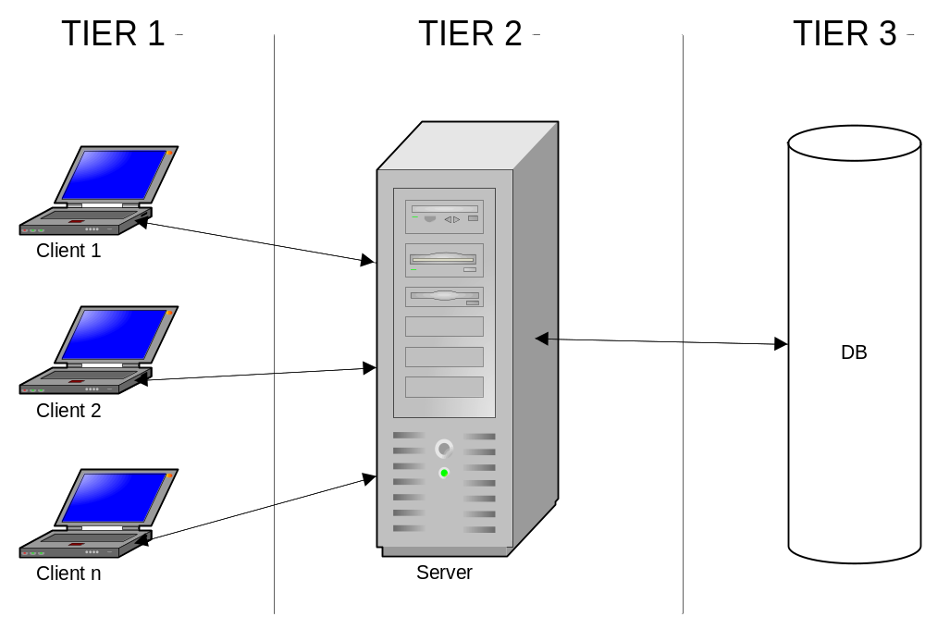
Figure 2.1.1. System deployment diagram

Architecture at Application Server

At application Server, the system will be developed using Model-View-Controller architectural style.
The client send a request to Server, Controller will receive request, retrieve or handle information using Data Model, then choose a View to return to Client-side.

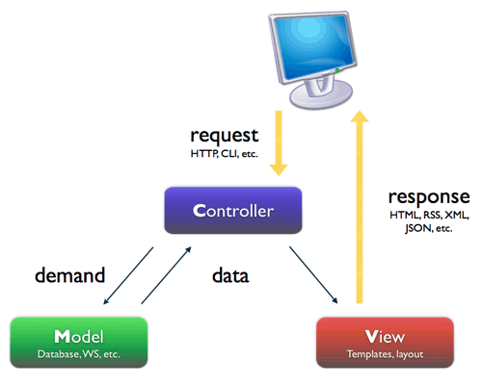
Figure 2.1.2 Application Architecture diagram

Discussion of alternative Design

An alternative method for this system architecture is three-layers style which is explained in the following figure.
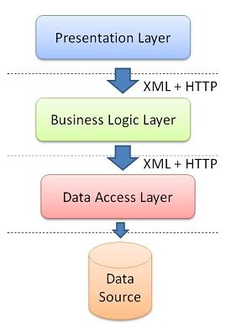
Figure 2.2 Layer architecture diagram
The system could be decomposed into three layers from high-level to low.
Presentation layer: Responsible for displaying User Interface, receive and send requests to Business Logic layer
Business Logic layer: Handle Domain logic and related business utilities
Data Access Layer: In charge of connecting to Database, handle and retrieve data directly
The architecture is so easy to develop, each layer is responsible for a specific job which can make separation of components but to build the system from this style, it can take longer time due to lacking of supportability
We still choose MVC model because of fast development and .NET Framework already provided MVC template which supports developers better in designing and implementation. With MVC, the components of system can be decomposed to specific modules which show clearly each business process and the relations between requirements specification and design.

System interface description

GENERAL SYSTEM COMPONENTS

Components diagram

Diagram below will demonstrate high-level components of Credit Ranking System which will be the building blocks of the system.
For explanation, refer to section 3.2 to read brief explanation
For more details of these components, refer to section 4

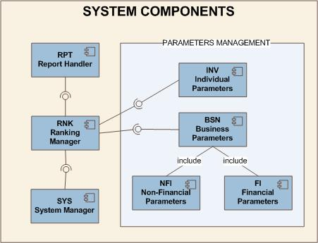
Figure 3.1 General components diagram

Brief explanation of Components

This is table describing the 7 system’s components in the Figure 3.1. Component BSN, INV, FI and NFI are belong to Parameters management block which can be thought of a subsystem.

ID | COMPONENT NAME | COMPONENT DESCRIPTION
INV | Individual Parameters | The component contains modules responsible for managing individual customers parameters such as: Basic index management, collateral index management…
BSN | Business Parameters | Contains modules of managing business customer parameters such as: business industries, business types, business lines, business scales…
FI | Financial Parameters | Manages financial parameters including financial index, financial proportion, financial score, which is thought of a part of BSN, but so complex that it is separated as a single component
NFI | Non-Financial Parameters | Manages non-financial parameters including non-financial index, non-financial proportion, non-financial score, which is thought of a part of BSN, but so complex that it is separated as a single component
SYS | System Manager | Modules in charge of managing System parameters, login, logout, accounts management, log management…
RNK | Ranking Manager | Receive services provided by Parameters Management block to rank credit for customers:  To rank for individual customers, they need information provided by INV module  To rank for business customers, they need information provided by BSN module
RPT | Report Handler | Contains modules that handle exporting results of customers’ credit ranking

DETAILED DESCRIPTION OF COMPONENTS

Section Reading Guide Introduction

Component BSN: Business Parameters Management

Component FI: Financial Parameters Management

MODULE: FINANCIAL INDEX
SRS Mapping: Feature 25

Module’s Class diagram

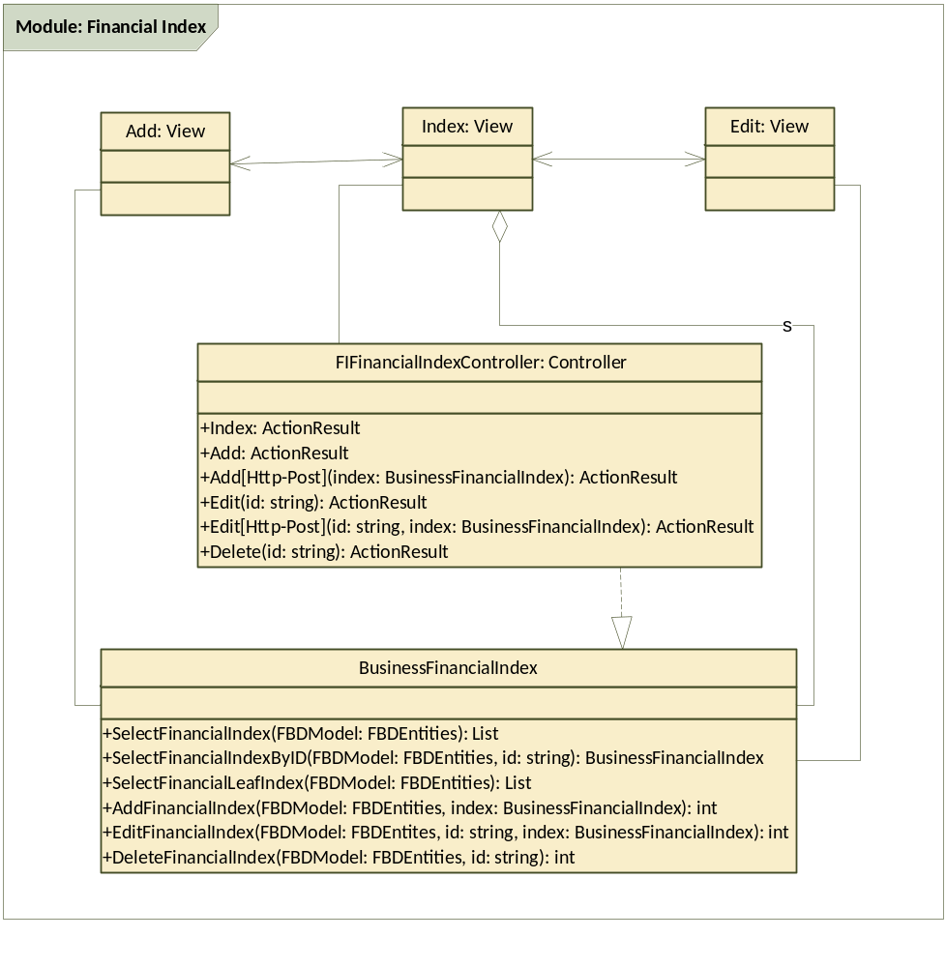

Class explanation

Class Index: View

Screen Image

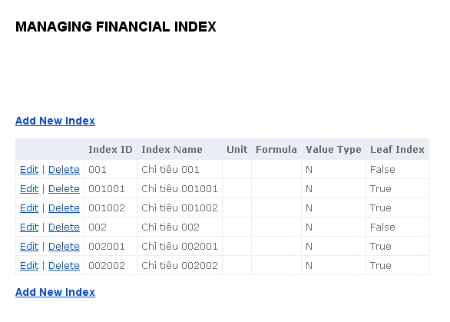

Screen Description
COMPONENT NAME | COMPONENT TYPE | DESCRIPTION
Page name | Label | The text describes the responsibility of the page: managing financial indexes
Create a Financial Index button x 2 | Button | The button for creating a Financial Index, clicking this will move to Adding page
List of financial indexes | Table | List all the financial indexes available in the database, each item will have a button [Edit] and [Delete]  Click [Edit] will move to Edit view  Click [Delete] will display dialog to verify the deleting the selected a Financial Index

Class Add: View
Screen Image
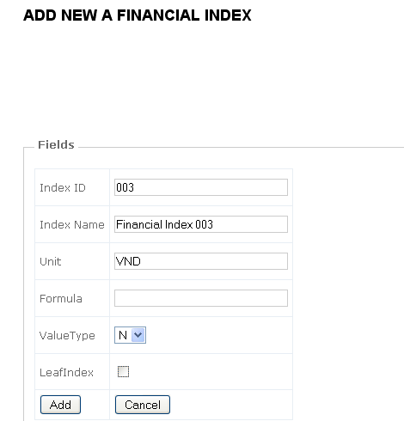
Screen Description
No | COMPONENT NAME | COMPONENT TYPE | DESCRIPTION
1 | Page name | Label | The text describes the responsibility of the page: adding a new financial index
2 | lblIndexID | Label | Display "Index ID"
3 | lblIndexName | Label | Display "Index Name"
4 | lblUnit | Label | Display "Unit"
5 | lblFormula | Label | Display "Formula"
6 | lblValueType | Label | Display "Value Type"
7 | txtIndexID | textbox | user can enter the index id of the financial index
8 | txtIndexName | textbox | text box for entering Index Name
9 | txtUnit | textbox | text box for entering Unit
10 | txtFormula | textbox | text box for entering formular
11 | cmbValueType | combo box | combobox to enter value type (number or text)
12 | chkLeafIndex | checkbox | check box to check whether this is leafindex or not
13 | btnAddIndex | Button | After clicking on the button, display verify dialog then add a new FinancialIndex to the system with the entered information then back to the Index View
14 | btnCancel | Button | After clicking on the button, back to the Index View

Class Edit: View
Screen Image
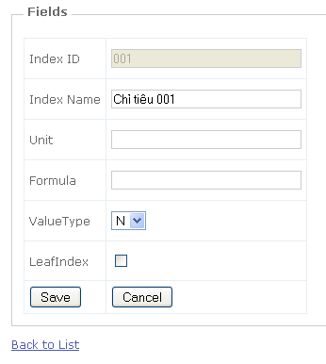
Screen Description
No | COMPONENT NAME | COMPONENT TYPE | DESCRIPTION
1 | Page name | Label | The text describes the responsibility of the page: editing a Financial Index, also display the ID that is being edited
2 | lblIndexID | Label | Display "Index ID"
3 | lblIndexName | Label | Display "Index Name"
4 | lblUnit | Label | Display "Unit"
5 | lblFormula | Label | Display "Formula"
6 | lblValueType | Label | Display "Value Type"
7 | txtIndexID | textbox | user can enter the index id of the financial index
8 | txtIndexName | textbox | text box for entering Index Name
9 | txtUnit | textbox | text box for entering Unit
10 | txtFormula | textbox | text box for entering formular
11 | cmbValueType | combo box | combobox to enter value type (number or text)
12 | chkLeafIndex | checkbox | check box to check whether this is leafindex or not
13 | btnSave | Button | After clicking on the button, display verify dialog then update the editted index to the DB with entered information, if successful then back to the Index View
14 | btnCancel | Button | After clicking on the button, back to the Index View

Class FIFinancialIndexController: Controller

GENERAL INFORMATION
CLASS NAME | DESCRIPTION | INHERITANCE | REQUIREMENT ID | RELATED DB TABLE | MAKER
FIFinancialIndexController | The class is responsible for receive requests from View to handle Add, Edit and Delete data | Controller | FI004  FI005  FI006 | Business.FinancialIndex | LyDM

METHODS
NAME | ACCESS LEVEL | INPUT | PROCESS | OUTPUT | EXCEPTION
Index | public |  | if this user has sufficient right to use this function:  - Use FIFinancialIndexLogic class to select all the financial indexes in the table Business.FinancialIndex then display to the [Index] View | ActionResult (Index View ) | Return Error message
Add | public |  | 1.Check User right  2. Forward to [Add] View | ActionResult (Index View ) | Return Error message
Add [Http-Post] | public | a new Financial Index information | 1. Receive information from parameter  2. Check user right and input validation.  3. Use Logic class to insert new Financial Index  3. Redirect to [Index] View with label displaying: "A new Financial Index has been added successfully" | ActionResult (Index View ) | Return the Add View  Display error
Edit | public | ID of the Financial Index editted | 1. Receive ID from parameter  2. Use Logic class to select appropriate Financial Index from Business.FinancialIndex table  3. Display in [Edit] view | ActionResult (Edit View ) | Return Error message
Edit [Http-Post] | public | 1. ID of the Financial index input  2. The information of the Financial Index editted | 1. Receive ID from parameter  2. Use Logic class to update appropriate Financial Index with ID selected in DB  3. Display in [Index] view with label displaying: "The Financial Index with ID xyz has been editted successfully" | ActionResult (Index View ) | Return the Edit View  Display error
Delete [Http-Post] | public | ID of the Financial Index selected | 1. Receive ID from parameter  2. Use Logic class to delete the Financial Index with selected ID from the Business.FinancialIndex table  3. Back to [Index] view with label displaying: "A Financial Index has been deleted successfully" | Index View | Return the Index view with error label.

Class BusinessFinancialIndex

GENERAL INFORMATION
CLASS NAME | DESCRIPTION | INHERITANCE | REQUIREMENT ID | RELATED DB TABLE | MAKER
BusinessFinancialIndex | Work as DB interface and handle logic process for the controller |  | FI004  FI005  FI006 | Business.FinancialIndex | LyDM

METHODS
NAME | ACCESS LEVEL | INPUT | PROCESS | OUTPUT | EXCEPTION
SelectFinancialIndex | public static | FBDEntities FBD | Select all the Financial Index in the table Business.FinancialIndex | List<BusinessFinancialIndex>
SelectFinancialIndexByID | public static | 1. FBDEntities FBD  2. string ID | Select the Financial Index in the table Business.FinancialIndex with input ID | BusinessFinancialIndex | Return null
SelectFinancialLeafIndex | public static | FBDEntities | Select all the Financial Indexes which is leaf index (index used to calculate) in BusinessFinancialIndex table | List<BusinessFinancialIndex>
AddFinancialIndex | public static | 1. FBDEntities FBD  2. A new FinancialIndex information | 1. Receive information from parameter  2. Insert new index into the Database  3. If successful, return 1 otherwise return 0 | int | Return 0
EditFinancialIndex | public static | 1. FBDEntities FBD  2. ID  3. Information of the FinancialIndex editted | 1. Receive ID from parameter  2. Update appropriate data to table in DB  3. If successful, return 1 otherwise return 0 | int | Return 0
DeleteFinancialIndex | public static | 1. FBDEntities FBD  2 ID of the Financial Index selected | 1. Receive ID from parameter  2. Delete the Financial Index with selected ID from database  3. If successful, return 1 otherwise return 0 | int | Return 0

Sequence diagrams

View Financial Index list

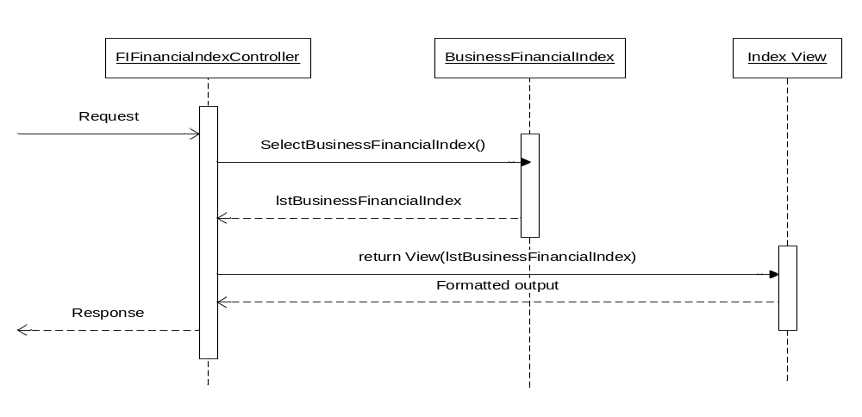

Add Financial Index
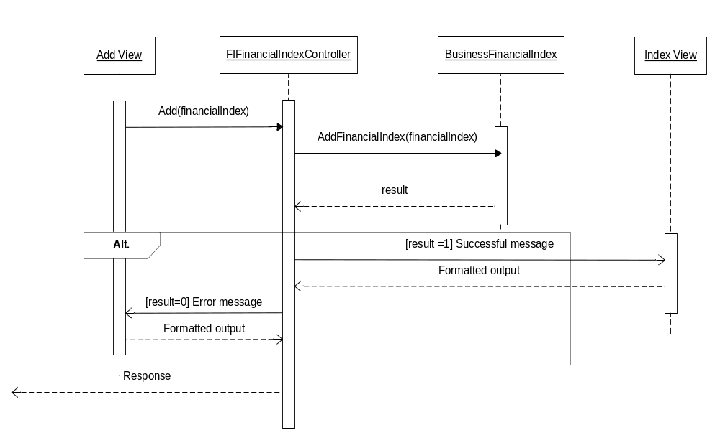

Edit Financial Index

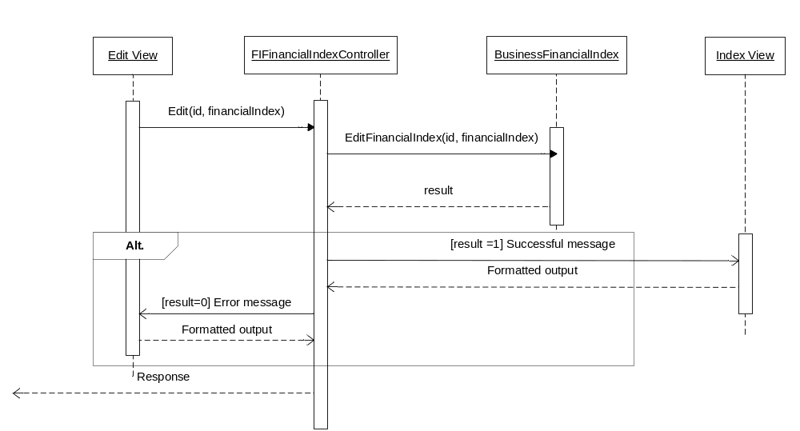

Delete Financial Index

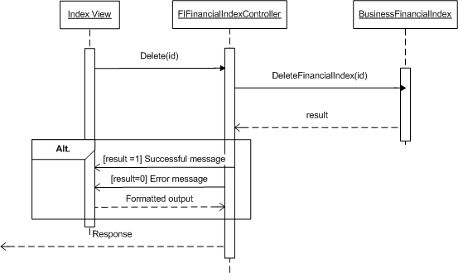

MODULE: FINANCIAL INDEX LEVELS
SRS Mapping: Feature

Module’s class diagram

Class explanation

Sequence diagrams

Component NFI: Non-Financial Parameters Management

Component INV : Individual Parameters Management

Component SYS : System Manager

Component RNK : Ranking Manager

Component RPT : Report Handler

DATABASE DESIGN

