 | MINISTRY OF EDUCATION AND TRAINING

FPT UNIVERSITY
Capstone Project Document
CREDIT RANKING SYSTEM
FBD GROUP
Group Members | Nguyen Thanh Long 00455  Phan Le Quang Chinh  Pham Thi Phuong Thao  Dao Mai Ly  Tran Thi Huong Giang
Supervisor | Mr. QuangLT
Ext Supervisor
Capstone Project code | FBD

- Hanoi, January, 2011 -

REPORT 2: PROJECT PLAN

- PROBLEM DEFINITION

  - The proposed system

The new system called Credit Ranking System (CRS).
This mainly helps credit staff of HaBuBank to rank for their customers when they want to borrow money from the bank.
The customers are divided into two categories: Business and individuals.
With business customers, the system follows from inputting their information, process scale, financial then non-financial mark to provide their ranks and report.
With individual customers, the system also allows to input data, then process basic and collateral information of customers, finally provide their ranks and report.

  - Boundaries of the system

The system that has been proposed must satisfy the following general requirements:
_Allowing system administrator to manage all the parameters of the system which include financial & non-financial parameters, business parameters, individual parameters.
_Allowing administrator to manage system information such as: accounts, system rights…
_Credit staff can input customers data, process ranking credit for the customer and create report electrically.
_The proposed system must guarantee to reuse all the data the old system has processed over 3 years.
_The system should follow the business domain requirements proposed

  - Development environment
Software requirement:
Microsoft Windows xp/ windows 7
Microsoft Visual Studio 2008 sp1
Microsoft SQL Server 2005
Microsoft Office 2003/2007
Tortoise SVN

Hardware requirement:
2.2 GHz or higher CPU
1024 MB or more RAM
1280x1024 display
7200 RPM or higher hard disk
> 1 GB of hard disk free.

- PROJECT ORGANIZATION

2.1 Software process model
We choose the Waterfall model for the software development
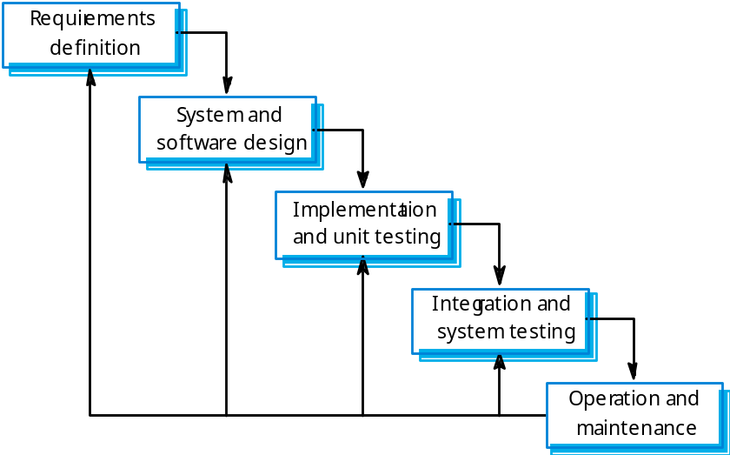

2.2 Roles and responsibilities

Member | Role | Responsibilies
LongNT | PM | Manage and control the project, project planning, business requirements and resources allocation
LyDM | Developer, Business analyst | Research business domain, system architecture, detailed design and implementation
ChinhPLQ | Developer, Database analyst | Research business domain, DB designing and loading data, detailed design and implementation
ThaoPTP | Developer, QA & tester | Detailed design, implementation, creating test cases, perform testing
GiangTTH | Developer, QA & tester | Detailed design, implementation, creating test cases, perform testing

2.3 Tools and techniques

Communication: Email using Microsoft Office Outlook 2003 and 2007, phone calls, Yahoo Messenger and Skype
Sharing resources: SVN – Subversion

- PROJECT MANAGEMENT PLAN

Task Name | Duration | Start | Finish | Predessor | Description | Resource Name
A. MODULE A | 117.2 days? | 10/13/2010 8:00 | 2/7/2011 9:36 |  | The module of ranking credit for customers. That's the operational work
1. BUSINESS ANALYSIS | 11 days? | 10/13/2010 8:00 | 10/23/2010 17:00
1.1 Understand Habubank's Documents | 9 days? | 10/13/2010 8:00 | 10/21/2010 17:00 |  | HabuBank provides documents for the project team. All team members must understand those to get the knowledge of domain logic | Long,Ly,Chính,Giang,Thảo
1.2 Understand EPI's Document | 1.6 days? | 10/22/2010 11:12 | 10/23/2010 17:00 |  | The old system has document before: Using guide to the old system". Understanding this will helps main functions of the proposed system | Long,Ly,Chính,Giang,Thảo
BUSINESS ANALYSIS REPORT | 0 days | 10/23/2010 8:00 | 10/23/2010 8:00 |  | Members report the researching works
2. SYSTEM ANALYSIS | 32 days? | 10/25/2010 8:00 | 11/25/2010 17:00 | 2
2.1 ELICITATION | 22 days? | 10/25/2010 8:00 | 11/15/2010 17:00 |  | Discovering the requirements
2.1.0 Approach determination | 1.4 days? | 10/30/2010 13:48 | 10/31/2010 17:00 |  | Meeting to help determine the approach for requirements engineering | Long,Ly,Chính,Giang,Thảo
2.1.1 Account Management Module | 5 days? | 11/1/2010 8:00 | 11/5/2010 17:00 |  | Study requirements of system accounts management | Chính,Thảo
2.1.2 Parameter Management Module | 12 days? | 10/25/2010 8:00 | 11/5/2010 17:00 |  | Study requirements of system parameters management | Long,Ly,Giang
2.1.3 Input Module | 5 days? | 11/6/2010 8:00 | 11/10/2010 17:00 |  | Study requirements of inputting information to the system: what data should or should not be inputted | Chính,Thảo
2.1.4 Credit Ranking Module | 10 days? | 11/6/2010 8:00 | 11/15/2010 17:00 |  | Study requirements for processing ranking credit for a customer | Long,Ly,Giang
2.1.5 Reports Module | 5 days? | 11/11/2010 8:00 | 11/15/2010 17:00 |  | Study what is required when creating reports of credit ranking | Chính,Thảo
2.2 ANALYSIS AND NEGOTIATION | 22 days? | 10/25/2010 8:00 | 11/15/2010 17:00 |  | Analyze all the requirements collected and discuss in team and customer | Long,Ly,Chính,Giang,Thảo
REQUIREMENTS COLLECTION | 0 days | 11/15/2010 17:00 | 11/15/2010 17:00 | 14 | All the requirements of functionality and non-functionality that have been collected and analyzed
2.3 VALIDATION | 5 days? | 11/16/2010 8:00 | 11/20/2010 17:00 | 15 | Validate again all the requirements collected | Long
2.4 DESCRIBE REQUIREMENTS | 5 days? | 11/21/2010 8:00 | 11/25/2010 17:00 | 16 | Describe requirements in SRS form provided by university | Long
SYSTEM SPECIFICATION | 0 days | 11/25/2010 8:00 | 11/25/2010 8:00 |  | Completed SRS for the sytem (module A)
3. SYSTEM DESIGN | 56 days? | 11/26/2010 8:00 | 1/20/2011 17:00 | 6
3.1 ARCHITECTURE DESIGN | 13 days? | 11/26/2010 8:00 | 12/8/2010 17:00 |  | Create architecture for the system | Long,Ly,Chính
3.2 ERD DESIGN | 23 days? | 12/9/2010 8:00 | 12/31/2010 17:00 | 20 | List entities needed and create diagram as well as fields for each entity | Long,Ly,Chính
LIST OF TABLES DESIGNED | 0 days | 12/31/2010 17:00 | 12/31/2010 17:00 | 21 | Database designed for the system | Long,Ly,Chính
3.3 DETAILED DESIGN | 20 days? | 1/1/2011 8:00 | 1/20/2011 17:00 | 22 |  | Long,Ly,Chính,Giang
3.3.1 BSN module | 20 days? | 1/1/2011 8:00 | 1/20/2011 17:00 |  | Business module: industries, type, lines… | Thảo,Giang
3.3.2 FI & NFI module | 20 days? | 1/1/2011 8:00 | 1/20/2011 17:00 |  | Financial & non-financial index process design | Ly
3.3.3 INV module | 20 days? | 1/1/2011 8:00 | 1/20/2011 17:00 |  | Individual parameters management design | Chính
3.3.4 SYS module | 20 days? | 1/1/2011 8:00 | 1/20/2011 17:00 |  | System management classes design | Long
3.3.5 RNK module | 20 days? | 1/1/2011 8:00 | 1/20/2011 17:00 |  | detailed design for process ranking for customers | Long
3.3.6 RPT module | 20 days? | 1/1/2011 8:00 | 1/20/2011 17:00 |  | Detailed design for report requirements | Ly
4. IMPLEMENTATION | 11 days? | 1/21/2011 8:00 | 1/31/2011 17:00 | 19 |  | Long,Ly,Chính,Giang,Thảo
5. TESTING | 73.2 days? | 11/26/2010 8:00 | 2/7/2011 9:36 | 18
Integration Test Design | 51 days? | 11/26/2010 8:00 | 1/15/2011 17:00 |  |  | Giang,Thảo
Unit Test Design | 20 days? | 1/1/2011 8:00 | 1/20/2011 17:00 |  |  | Designers
Perform Uniit Test | 15 days? | 1/21/2011 8:00 | 2/4/2011 17:00 | 33 |  | Coders
Perform Integration Test | 2.2 days? | 2/5/2011 8:00 | 2/7/2011 9:36 | 34 |  | Long,Ly,Chính,Giang,Thảo
B. MODULE B | 1 day? | 12/1/2010 8:00 | 12/1/2010 17:00 |  | Module of Data mining

- MEETING MINUTES

