 | MINISTRY OF EDUCATION AND TRAINING

FPT UNIVERSITY
Capstone Project Document
CREDIT RANKING SYSTEM
FBD GROUP
Group Members | Nguyen Thanh Long  Phan Le Quang Chinh  Pham Thi Phuong Thao  Dao Mai Ly  Tran Thi Huong Giang
Supervisor | Mr. QuangLT
Ext Supervisor
Capstone Project code | FBD

- Hanoi, March, 2011 -

REPORT 6 USERS MANUAL

OVERVIEW

INTRODUCTION

Purpose

Scope

APPLICATION OVERVIEW

What this application is used for?

How many modules it has?

ABBREVIATION

RANKING MANAGEMENT

BUSINESS RANKING
Business ranking process:
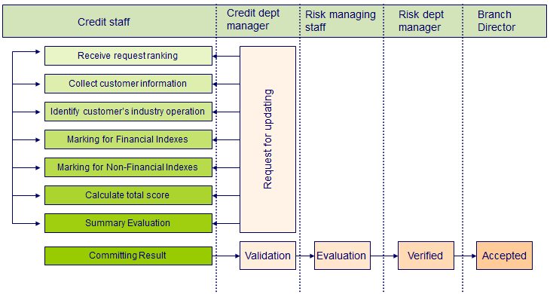

BUSINESS CUSTOMER LIST
Path: Credit Management\Business Customers\Business Customer List
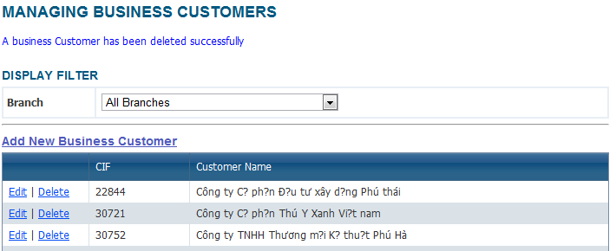
Business customer list is where user stores all business customers with their general information. Select a branch to start filtering customer by branch. User also can add new customer into this list.
To add new customer, choose [Add new Business Customer] link at the beginning or the end of [Business Customer] table, then input all required information:
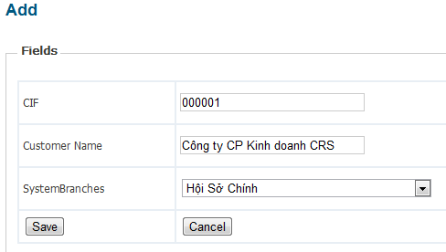
- CIF: (required) can be considered as ID of the customer, maximum length is 50
- Customer Name: (optional) Name of the customer, maximum length is 255
- Branch: select the branch that the customer is belong to from the combo box
After that, click [Add] button to add new customer. Or [Cancel] button to cancel saving.
To edit information of an existing customer, choose [Edit] link in the same row of the selected customer in [Customer list] screen. List of the editable fields:
- Customer name
- Branch
To delete an existing customer, choose [Delete] link in the same row of the selected customer in [Customer list] screen.

NEW CUSTOMER RANKING PROCESS
Path: Credit Management\Business Customers\Business Ranking
In this system, customer who has been ranked already will be displayed in the list in the [Business ranking management] screen.
To rank a new customer who has never been ranked before, choose [Rank new customer] button at the end of this page. In [Add customer ranking] screen, user choose Reporting period and choose a business customer from the combo box. This combo box contains the whole business customer list. If the customer has not been added to the list yet, user can add it into list, refer to the index 2.1.1.
After selecting a business customer, user click button [Choose this customer] to move to the next step: [Input general info]
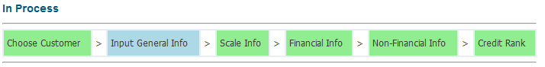

Business general determination
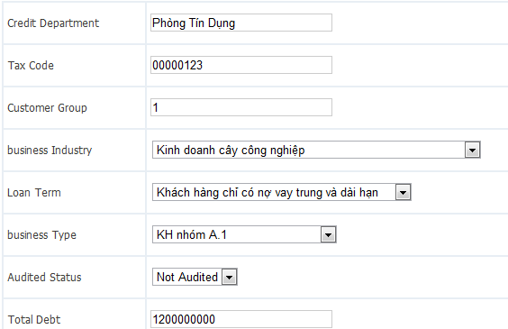
- Credit department: (Optional) Name of the department that in charge of ranking this customer.
- Tax code: Tax code of the business
- Customer group: Group of the business customer
- Business industry: Industry that The business work in
- Loan term: (Optional) define the duration that the customer borrows those amout of money. User select from the combo box.
- Business type: Business type which is runed by the business
- Audited status: Not audited/ Audited
- Total debt: (Optional) define the amount of money that the customer is currently borrowing. This field must be numeric
- Customer type: Business is typed by debt ability
- There are some other fields which automatically filled, so user does not need to consider about them.
Then, click [Save] button to save information and move to the next step: Scale information
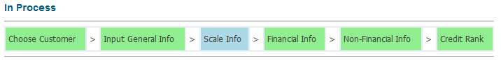

Business scale determination
Scale information is including many criterias and user respond to input all value of the customer into correlative criteria.
There are value fields for user input the scores of each criterias.
User need to pay attention to input valid value, in order to be returned a correct scale rank.
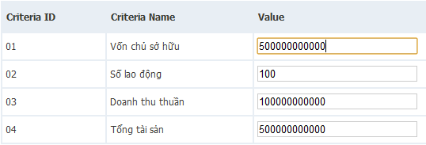
Then, click [Calculate result] button to get Scale score
In the next page, inputed value will be covert to the correlative score, and timed by proportion, be summed to calculate scale score.
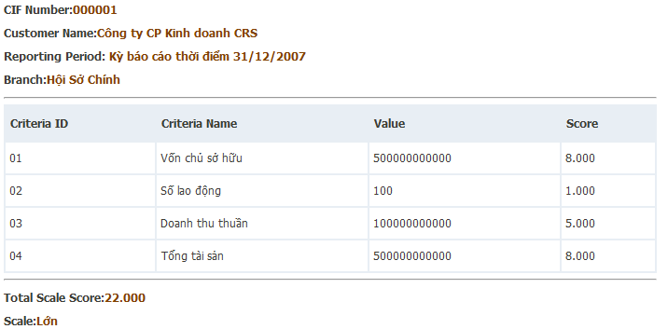
Then, user has 3 options:
- Save result only: choose this button to only save the inputed information, and back to [Ranking Business Customer] screen.
- Save result and continue: choose this button to save the information and then, move to the next step in ranking process.
- Back: Choose this button to back to [Ranking Business Customer] screen without saving.
Choose Save result and continue to move to the next step: Financial information
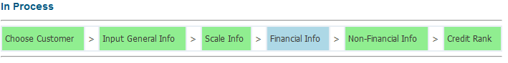

Financial score determination
Financial criterias includes several cirterias; all of them are numeric data type, so that user just has to be careful to enter valid value in order to have the exactly result.
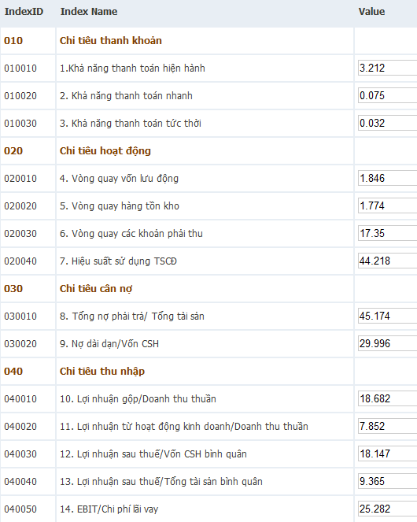
After fill all value, click [Calculate Result] button to get Financial score.
In the next page, inputed value will be covert to the correlative score, and timed by proportion, be summed to calculate financial score.
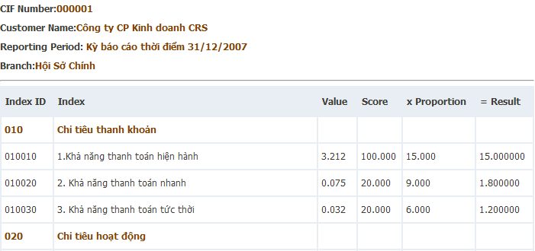
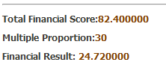
Then, user has 3 options:
- Save result only: choose this button to only save the inputed information, and back to [Customer ranking management] screen.
- Save result and continue: choose this button to save the information and then, move to the next step in ranking process.
- Back: Choose this button to back to [Customer ranking management] screen without saving.
Choose Save result and continue to move to the next step: Input Non-financial information
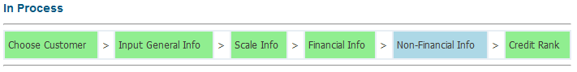

Non-Financial score determination
Non-financial information is including many criterias and user respond to input all value of the customer into correlative criteria.
Fields having character data type will be displayed as combo box and user just has to select the mostly correct value.
Other fields, which have numeric data type, user need to pay attention to input valid value, in order to be returned a correct score and rank.
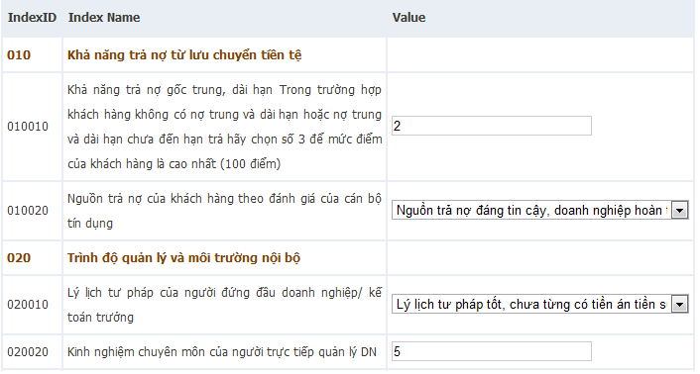
After select all value, click [Calculate Result] button to get Non-financial score
In the next page, inputed value will be covert to the correlative score, and timed by proportion, be summed to calculate non-financial score.
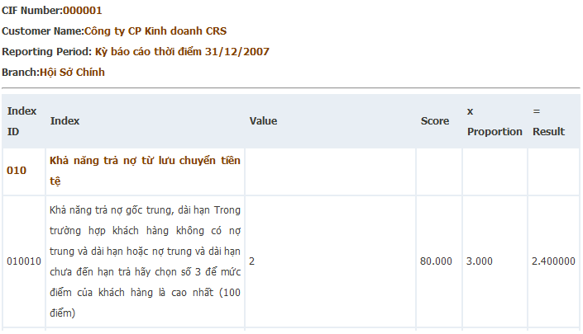
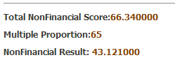
Then, user has 3 options:
- Save result only: choose this button to only save the inputed information, and back to [Customer ranking management] screen.
- Save result and continue: choose this button to save the information and then, move to the next step in ranking process.
- Back: Choose this button to back to [Customer ranking management] screen without saving.
Choose Save result and continue to move to the next step: Credit Rank
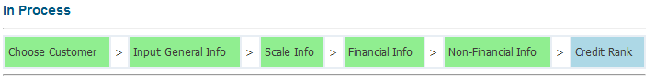

Calculate summary score and rank
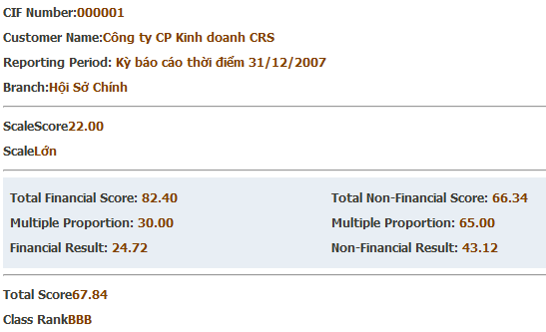
Click [OK] to back to Customer Ranking list
Click [Calculate clustering rank] to see the clustering rank, includes this new customer.

PROCESS WITH A RANKED CUSTOMER
Path: Credit Management\Business Customers\Business Ranking
In this system, customer who has been ranked already will be displayed in the list in the [Individual ranking management] screen.

Search, view detail and edit information
To find a customer or a group of customer, user can filter by selecting a reporting period, or by branch or by CIF code, and then click [Search] button.
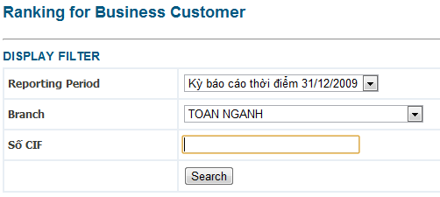
To view detail information of a customer, choose a customer and click [Detail] link in the same row.
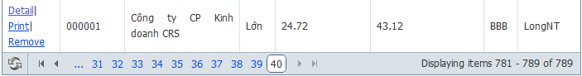
User can view General information, Scale information, Financial information and Non-financial information by clicking buttons above.
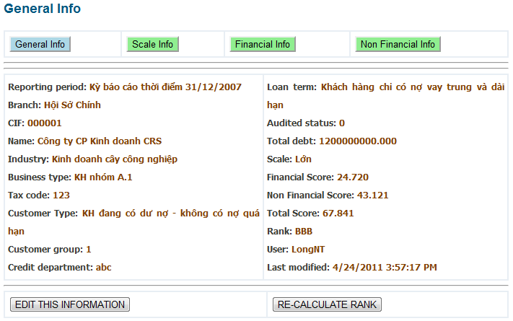
User can edit those information by clicking [Edit this information].

Re-rank a customer
In detail information, user click [Re-Calculate rank] button to re-rank the customer. There is a confirmation popup displayed to get user’s confirmation. Click [OK] to continue re-ranking. If there is any change in General information, Scale information, Financial information and Non-financial information, the score will be changed and rank may be different.

INDIVIDUAL RANKING
Individual ranking process:
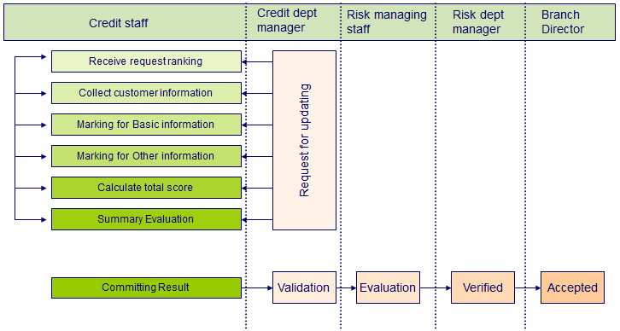

INDIVIDUAL CUSTOMER LIST
Path: Credit Management\Individual Customers\Individual Customer List
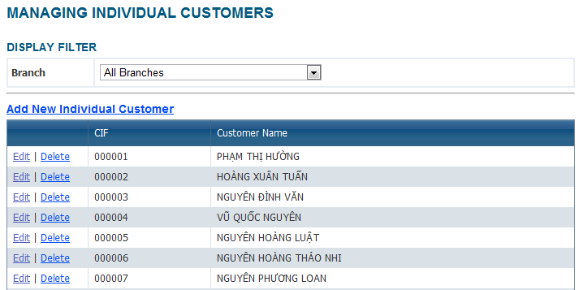
Individual customer list is where user stores all individual customers with their general information. Select a branch to start filtering customer by branch. User also can add new customer into this list.
To add new customer, choose [Add new Individual Customer] link at the beginning or the end of [Individual Customer] table, then input all required information:
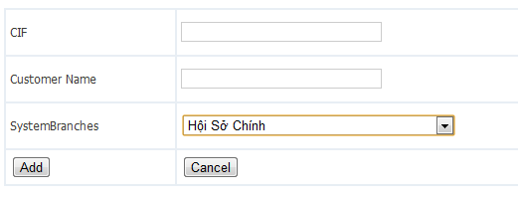
- CIF: (required) can be considered as ID of the customer, maximum length is 50
- Customer Name: (optional) Name of the customer, maximum length is 255
- Branch: select the branch that the customer is belong to from the combo box
After that, click [Add] button to add new customer. Or [Cancel] button to cancel saving.
To edit information of an existing customer, choose [Edit] link in the same row of the selected customer in [Customer list] screen. List of the editable fields:
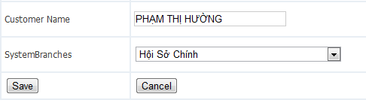
- Customer name
- Branch
To delete an existing customer, choose [Delete] link in the same row of the selected customer in [Customer list] screen.

NEW CUSTOMER RANKING PROCESS
Path: Credit Management\Individual Customers\Individual Ranking
In this system, customer who has been ranked already will be displayed in the list in the [Individual ranking management] screen.
To rank a new customer who has never been ranked before, choose [Rank new customer] button at the end of this page. In [Add individual ranking] screen, user choose currently day and choose a customer from the combo box. This combo box contains the whole individual customer list. If the customer has not been added to the list yet, user can add it into list, refer to the index 2.2.1. After selecting a customer, user click button [Rank this customer] to move to the next step: [Input general info]
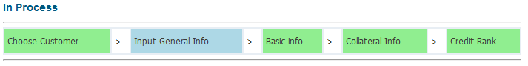

Input general information
General information is including:
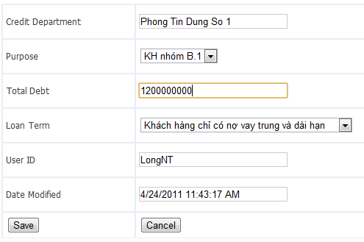
- Credit department: (Optional) Name of the department that in charge of ranking this customer.
- Borrowing purpose: (Required) define which purpose that cause user to borrow money from the bank. User can select from list of purpose in the combo box.
- Total debt: (Optional) define the amount of money that the customer is currently borrowing. This field must be numeric.
- Loan term: (Optional) define the duration that the customer borrows those amout of money. User select from the combo box.
- There are some other fields which automatically filled, so user does not need to consider about them.
Then, click [Save] button to save information and move to the next step: Input basic information
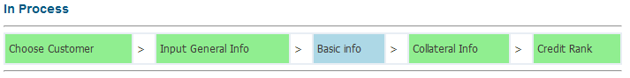

Input basic information and calculate Basic score
Basic information is including many criterias and user respond to input all value of the customer into correlative criteria.
Fields having character data type will be displayed as combo box and user just has to select the mostly correct value.
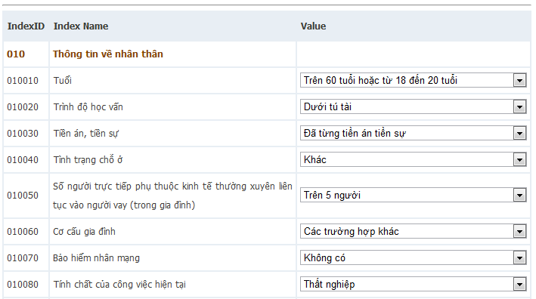
Other fields, which have numeric data type, user need to pay attention to input valid value, in order to be returned a correct score and rank.
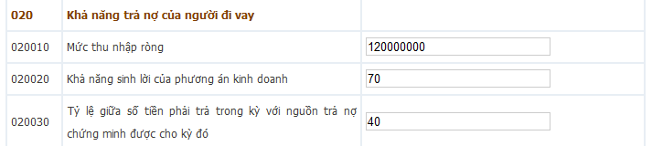
Then, click [Calculate result] button to get basic score
In the next page, inputed value will be covert to the correlative score, and timed by proportion, be summed to calculate basic score.
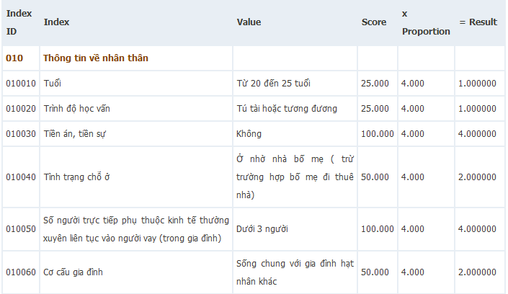
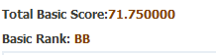
Then, user has 3 options:
- Save result only: choose this button to only save the inputed information, and back to [Customer ranking management] screen.
- Save result and continue: choose this button to save the information and then, move to the next step in ranking process.
- Back: Choose this button to back to [Customer ranking management] screen without saving.
Choose Save result and continue to move to the next step: Input Collateral information
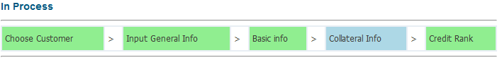

Input collateral information and calculate Collateral score
Collateral criterias includes several cirterias; all of them are Character data type, so that user just has to select the mostly correct item from combo box.
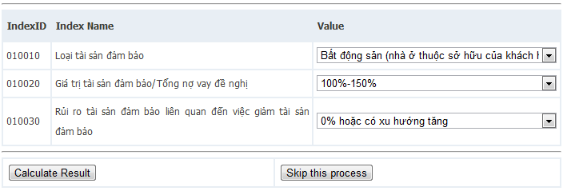
After select all value, click [Calculate Result] button to get Collateral score
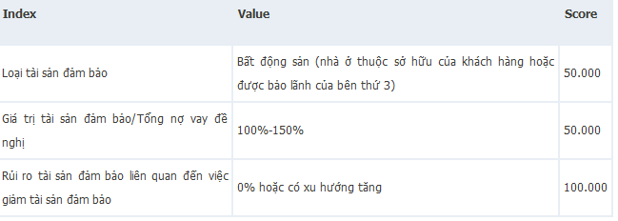
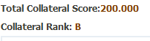
Collateral score is sum of all criteria scores (all criterias have equaly proportions) .
Then, user has 3 options:
- Save result only: choose this button to only save the inputed information, and back to [Customer ranking management] screen.
- Save result and continue: choose this button to save the information and then, move to the next step in ranking process.
- Back: Choose this button to back to [Customer ranking management] screen without saving.
Choose Save result and continue to move to the next step: Credit Rank
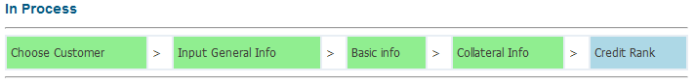

Calculate Summary score and rank
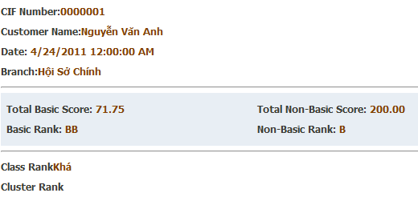
Click [OK] to back to Customer Ranking list
Click [Calculate clustering rank] to see the clustering rank, includes this new customer.

PROCESS WITH A RANKED CUSTOMER
Path: Credit Management\Individual Customers\Individual Ranking
In this system, customer who has been ranked already will be displayed in the list in the [Individual ranking management] screen.

Search, view detail and edit information
To find a customer or a group of customer, user can filter by selecting a range of date and/or by branch and/or by CIF code, and then click [Search] button.
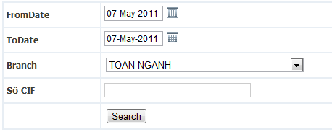
To view detail information of a customer, choose a customer and click [Detail] link in the same row. User can view General information, Basic information and Collateral information by clicking buttons above.
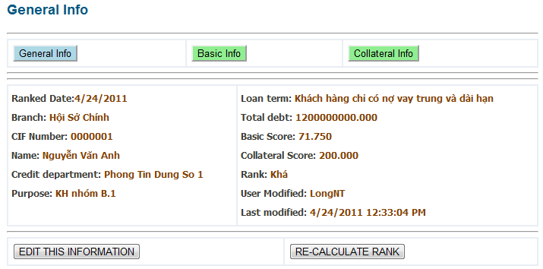
User can edit those information by clicking [Edit this information].

Re-rank a customer
In detail information, user click [Re-Calculate rank] button to re-rank the customer. There is a confirmation popup displayed to get user’s confirmation. Click [OK] to continue re-ranking. If there is any change in General information, Basic information, Collateral information, the score will be changed and rank may be different.

