Maimoona Anwar
Resturant Management System
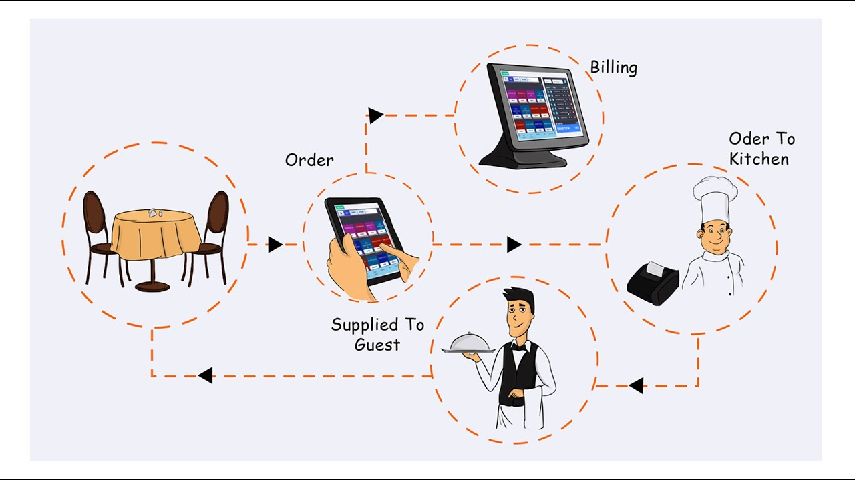

Table of Contents

- Description
- Features
- Classes and their attributes:
1. RMS 2
Attributes: 2
Methods: 2
2. Person 2
Attributes: 2
Methods: 2
3. Customer 3
Attributes: 3
Methods: 3
4. Employee 3
Attributes: 3
Methods: 3
5. Admin 3
Attributes: 3
Methods: 3
6. Menu 4
Attributes: 4
Methods: 4
7. Order 4
Attributes: 4
Methods: 4
8. Item 4
Attributes: 4
Methods: 4
9. Payment 5
Attributes: 5
Methods: 5
10. Cash 5
Attributes: 5
Methods: 5
11. Card 5
Attributes: 5
Methods: 5
- Uml diagram
Description :
The Restaurant Management System (RMS) facilitates seamless collaboration among various stakeholders within a restaurant, ensuring operational efficiency and customer satisfaction. Customers interact with the RMS to browse the menu, place orders, and track their order statuses in real-time, enhancing their dining experience. They can also make reservations for dining and provide feedback through the integrated review system. Restaurant Managers utilize the system to update restaurant details , employees details and check feedbacks to track performance metrics. Waitstaff use the system to record and manage customer orders, ensuring accurate and timely service. Chefs rely on the inventory module to monitor ingredient levels, update stock usage, and request replenishments. Cashiers handle payment processing via multiple methods such as cash, credit cards, and digital wallets, ensuring a smooth checkout process. Delivery Personnel schedule deliveries, update delivery statuses, and provide real-time tracking for takeout orders.
Features:
Restaurant Information Management:
- Display and update restaurant details like name, address, phone number, and email.
Menu Management:
- Display menu items categorized by type.
Add, update, or remove menu items.
- Manage menu categories with descriptions.
Order Management:
- Place and track orders with status updates.
- Manage order items with references to menu items.
- Calculate total costs of orders.
Customer Management:
- Display and update customer information.
- Maintain and review customer order history.
- Allow customers to place orders and make reservations.
Employee Management:
- Display and update employee details such as name, role, and shift schedules.
- Manage orders assigned to employees.
Payment Processing:
- Handle payments through various methods like cash, card, and digital wallets.
- Update and track payment statuses.
Inventory Management:
- Monitor and update inventory stock levels.
- Manage inventory items with quantities and unit prices.
- Generate inventory reports and manage stock replenishments.
Delivery Management:
- Schedule and update delivery details like address and time.
- Provide real-time tracking for deliveries.
Reservation System:
- Make and update reservations with dates and times.
- Associate reservations with customer details.
Report Generation:
- Generate detailed reports on sales, inventory, and performance.
- Display and export report data as needed.
Feedback System:
- Collect and manage customer feedback.
- Use feedback to enhance service quality.
Data Analytics:
- Analyze sales trends, popular items, and operational efficiency.
- Optimize operations using data insights.
Classes And Their Attributes:

RMS

Attributes:
RMSID: int
Name: String
Location: String

Methods:
AddRMS(): void
DeleteRMS(): void
UpdateRMS(): void
GetRMS(): RMS

Person

Attributes:
PersonID: int
Name: String
Address: String
PhoneNo: String

Methods:
AddPerson(): void
DeletePerson(): void
UpdatePerson(): void
GetPerson(): Person

Customer

Attributes:
CustomerID: int
LoyaltyPoints: int

Methods:
AddCustomer(): void
DeleteCustomer(): void
UpdateCustomer(): void
GetCustomer(): Customer
EarnLoyaltyPoints(): void
RedeemLoyaltyPoints(): void

Employee

Attributes:
EmployeeID: int
JobTitle: String

Methods:
AddEmployee(): void
DeleteEmployee(): void
UpdateEmployee(): void
GetEmployee(): Employee

Admin

Attributes:
AdminID: int

Methods:
AddAdmin(): void
DeleteAdmin(): void
UpdateAdmin(): void
GetAdmin(): Admin

Menu

Attributes:
MenuID: int

Methods:
AddMenuItem(): void
DeleteMenuItem(): void
UpdateMenuItem(): void
GetMenuItem(): Menu

Order

Attributes:
OrderID: int
OrderDate: Date
TotalAmount: double

Methods:
CreateOrder(): void
CancelOrder(): void
UpdateOrder(): void
GetOrder(): Order

Item

Attributes:
ItemID: int
ItemName: String
ItemPrice: double

Methods:
AddItem(): void
RemoveItem(): void
UpdateItem(): void
GetItemDetails(): Item

Payment

Attributes:
PaymentID: int
Amount: double
PaymentMethod: String

Methods:
ProcessPayment(): void
GetPaymentDetails(): Payment
RefundPayment(): void

Cash

Attributes:
CashAmount: double

Methods:
MakeCashPayment(): void

Card

Attributes:
CardNumber: String
ExpiryDate: String
CVV: String

Methods:
MakeCardPayment(): void
Uml Diagram:
