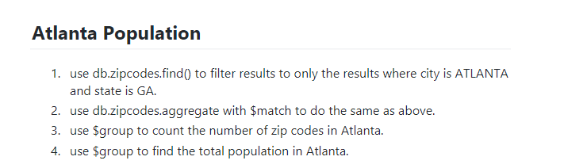

1 db.zipcodes.find({"city" : "ATLANTA","state":"GA"})

2. db.zipcodes.aggregate([{$match:{"city" : "ATLANTA","state":"GA"}}])

3. db.zipcodes.aggregate([

{$match:{"city" : "ATLANTA"}

},

{$group:{_id:"$city",zipcodes:{$sum:1}}}

])

4. db.zipcodes.aggregate([

{$match:{"city" : "ATLANTA"}

},

{$group:{_id:"$city",totalpop:{$sum:"$pop"}}}

])

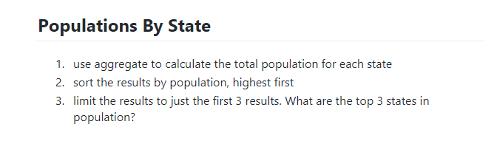

1. db.zipcodes.aggregate([

{

$group:{_id:"$state",totalpop:{$sum:"$pop"}}

}

])

1. db.zipcodes.aggregate( [

{$unwind:"$state"},

{ $group: { _id: "$state", totalpop: { $sum: "$pop" } } },

{$sort:{totalpop:-1}}

] )

1. db.zipcodes.aggregate( [

{$unwind:"$state"},

{ $group: { _id: "$state", totalpop: { $sum: "$pop" } } },

{$sort:{totalpop:-1}},{$limit :3}

] )

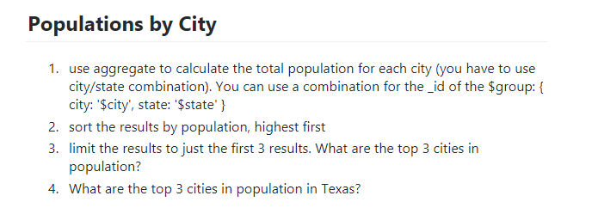

1. db.zipcodes.aggregate([

{$unwind:"$state"},

{

$group:{_id:{city:"$city",state:"$state"},totalpop:{$sum:"$pop"}}

}

])

2. db.zipcodes.aggregate([

{$unwind:"$state"},

{

$group:{_id:{city:"$city",state:"$state"},totalpop:{$sum:"$pop"}}

},

{$sort:{totalpop:-1}}

])

3. db.zipcodes.aggregate([

{$unwind:"$state"},

{

$group:{_id:{city:"$city",state:"$state"},totalpop:{$sum:"$pop"}}

}

,

{$sort:{totalpop:-1}},{$limit:3}

])

4. db.zipcodes.aggregate([

{$match:{"state":"TX"}},

{$group:{_id:"$city",totalpop:{$sum:"$pop"}}},

{$sort:{totalpop:-1}},

{$limit:3}

])



1. db.zipcodes.aggregate([

{$group:{_id:{city:"$city",state:"$state"},totalpop:{$avg:"$pop"}}},

{$sort:{totalpop:-1}}

])

2.