Codebook for df

Autogenerated data summary from dataMaid

2022-05-18 02:24:51

# Data report overview

The dataset examined has the following dimensions:

| Feature | Result |
| --- | --- |
| Number of observations | 649 |
| Number of variables | 33 |

# Codebook summary table

| Label | Variable | Class | # unique values | Missing | Description |
| --- | --- | --- | --- | --- | --- |
|  | **school** | character | 2 | 0.00 % |  |
|  | **sex** | character | 2 | 0.00 % |  |
|  | **age** | integer | 8 | 0.00 % |  |
|  | **address** | character | 2 | 0.00 % |  |
|  | **famsize** | character | 2 | 0.00 % |  |
|  | **Pstatus** | character | 2 | 0.00 % |  |
|  | **Medu** | integer | 5 | 0.00 % |  |
|  | **Fedu** | integer | 5 | 0.00 % |  |
|  | **Mjob** | character | 5 | 0.00 % |  |
|  | **Fjob** | character | 5 | 0.00 % |  |
|  | **reason** | character | 4 | 0.00 % |  |
|  | **guardian** | character | 3 | 0.00 % |  |
|  | **traveltime** | integer | 4 | 0.00 % |  |
|  | **studytime** | integer | 4 | 0.00 % |  |
|  | **failures** | integer | 4 | 0.00 % |  |
|  | **schoolsup** | character | 2 | 0.00 % |  |
|  | **famsup** | character | 2 | 0.00 % |  |
|  | **paid** | character | 2 | 0.00 % |  |
|  | **activities** | character | 2 | 0.00 % |  |
|  | **nursery** | character | 2 | 0.00 % |  |
|  | **higher** | character | 2 | 0.00 % |  |
|  | **internet** | character | 2 | 0.00 % |  |
|  | **romantic** | character | 2 | 0.00 % |  |
|  | **famrel** | integer | 5 | 0.00 % |  |
|  | **freetime** | integer | 5 | 0.00 % |  |
|  | **goout** | integer | 5 | 0.00 % |  |
|  | **Dalc** | integer | 5 | 0.00 % |  |
|  | **Walc** | integer | 5 | 0.00 % |  |
|  | **health** | integer | 5 | 0.00 % |  |
|  | **absences** | integer | 24 | 0.00 % |  |
|  | **G1** | integer | 17 | 0.00 % |  |
|  | **G2** | integer | 16 | 0.00 % |  |
|  | **G3** | integer | 17 | 0.00 % |  |

# Variable list

## school

| Feature | Result |
| --- | --- |
| Variable type | character |
| Number of missing obs. | 0 (0 %) |
| Number of unique values | 2 |
| Mode | “GP” |

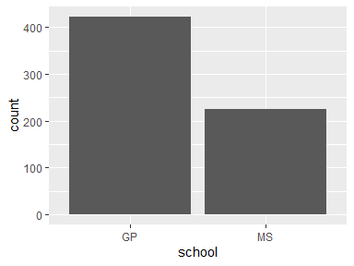

* Observed factor levels: "GP", "MS".

## sex

| Feature | Result |
| --- | --- |
| Variable type | character |
| Number of missing obs. | 0 (0 %) |
| Number of unique values | 2 |
| Mode | “F” |

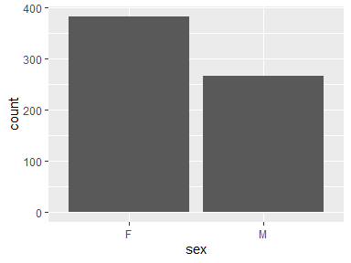

* Observed factor levels: "F", "M".

## age

| Feature | Result |
| --- | --- |
| Variable type | integer |
| Number of missing obs. | 0 (0 %) |
| Number of unique values | 8 |
| Median | 17 |
| 1st and 3rd quartiles | 16; 18 |
| Min. and max. | 15; 22 |

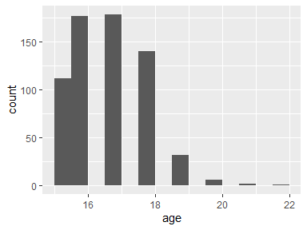

## address

| Feature | Result |
| --- | --- |
| Variable type | character |
| Number of missing obs. | 0 (0 %) |
| Number of unique values | 2 |
| Mode | “U” |

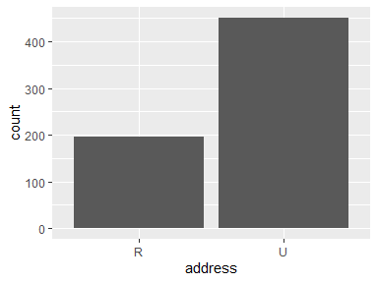

* Observed factor levels: "R", "U".

## famsize

| Feature | Result |
| --- | --- |
| Variable type | character |
| Number of missing obs. | 0 (0 %) |
| Number of unique values | 2 |
| Mode | “GT3” |

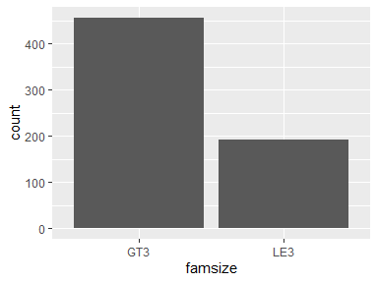

* Observed factor levels: "GT3", "LE3".

## Pstatus

| Feature | Result |
| --- | --- |
| Variable type | character |
| Number of missing obs. | 0 (0 %) |
| Number of unique values | 2 |
| Mode | “T” |

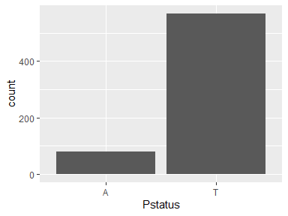

* Observed factor levels: "A", "T".

## Medu

| Feature | Result |
| --- | --- |
| Variable type | integer |
| Number of missing obs. | 0 (0 %) |
| Number of unique values | 5 |
| Median | 2 |
| 1st and 3rd quartiles | 2; 4 |
| Min. and max. | 0; 4 |

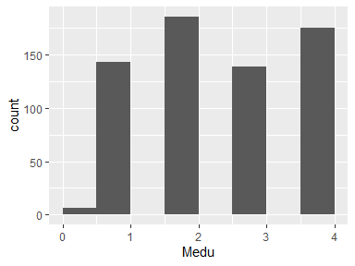

## Fedu

| Feature | Result |
| --- | --- |
| Variable type | integer |
| Number of missing obs. | 0 (0 %) |
| Number of unique values | 5 |
| Median | 2 |
| 1st and 3rd quartiles | 1; 3 |
| Min. and max. | 0; 4 |

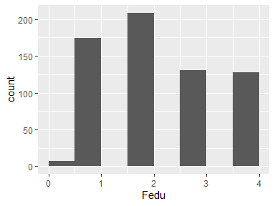

## Mjob

| Feature | Result |
| --- | --- |
| Variable type | character |
| Number of missing obs. | 0 (0 %) |
| Number of unique values | 5 |
| Mode | “other” |

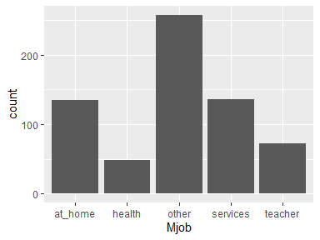

* Observed factor levels: "at_home", "health", "other", "services", "teacher".

## Fjob

| Feature | Result |
| --- | --- |
| Variable type | character |
| Number of missing obs. | 0 (0 %) |
| Number of unique values | 5 |
| Mode | “other” |

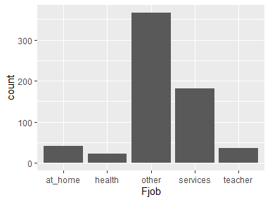

* Observed factor levels: "at_home", "health", "other", "services", "teacher".

## reason

| Feature | Result |
| --- | --- |
| Variable type | character |
| Number of missing obs. | 0 (0 %) |
| Number of unique values | 4 |
| Mode | “course” |

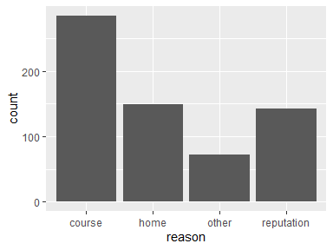

* Observed factor levels: "course", "home", "other", "reputation".

## guardian

| Feature | Result |
| --- | --- |
| Variable type | character |
| Number of missing obs. | 0 (0 %) |
| Number of unique values | 3 |
| Mode | “mother” |

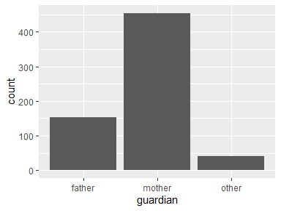

* Observed factor levels: "father", "mother", "other".

## traveltime

| Feature | Result |
| --- | --- |
| Variable type | integer |
| Number of missing obs. | 0 (0 %) |
| Number of unique values | 4 |
| Median | 1 |
| 1st and 3rd quartiles | 1; 2 |
| Min. and max. | 1; 4 |

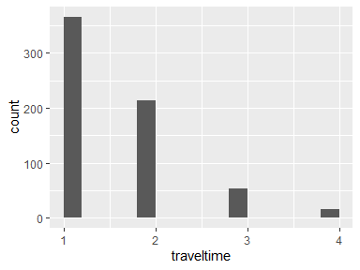

## studytime

| Feature | Result |
| --- | --- |
| Variable type | integer |
| Number of missing obs. | 0 (0 %) |
| Number of unique values | 4 |
| Median | 2 |
| 1st and 3rd quartiles | 1; 2 |
| Min. and max. | 1; 4 |

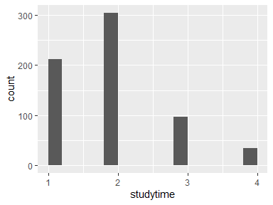

## failures

| Feature | Result |
| --- | --- |
| Variable type | integer |
| Number of missing obs. | 0 (0 %) |
| Number of unique values | 4 |
| Median | 0 |
| 1st and 3rd quartiles | 0; 0 |
| Min. and max. | 0; 3 |

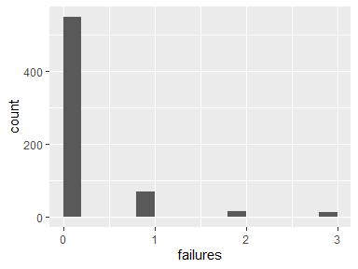

## schoolsup

| Feature | Result |
| --- | --- |
| Variable type | character |
| Number of missing obs. | 0 (0 %) |
| Number of unique values | 2 |
| Mode | “no” |

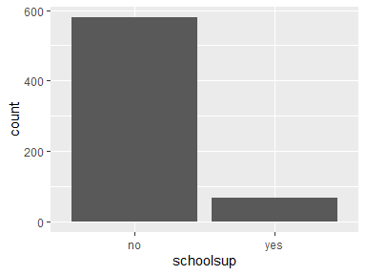

* Observed factor levels: "no", "yes".

## famsup

| Feature | Result |
| --- | --- |
| Variable type | character |
| Number of missing obs. | 0 (0 %) |
| Number of unique values | 2 |
| Mode | “yes” |

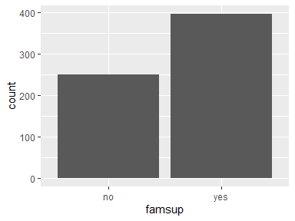

* Observed factor levels: "no", "yes".

## paid

| Feature | Result |
| --- | --- |
| Variable type | character |
| Number of missing obs. | 0 (0 %) |
| Number of unique values | 2 |
| Mode | “no” |

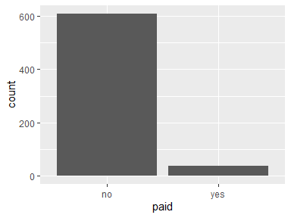

* Observed factor levels: "no", "yes".

## activities

| Feature | Result |
| --- | --- |
| Variable type | character |
| Number of missing obs. | 0 (0 %) |
| Number of unique values | 2 |
| Mode | “no” |

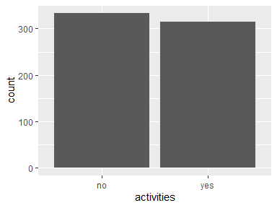

* Observed factor levels: "no", "yes".

## nursery

| Feature | Result |
| --- | --- |
| Variable type | character |
| Number of missing obs. | 0 (0 %) |
| Number of unique values | 2 |
| Mode | “yes” |

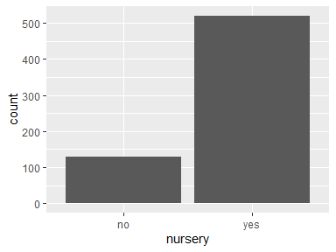

* Observed factor levels: "no", "yes".

## higher

| Feature | Result |
| --- | --- |
| Variable type | character |
| Number of missing obs. | 0 (0 %) |
| Number of unique values | 2 |
| Mode | “yes” |

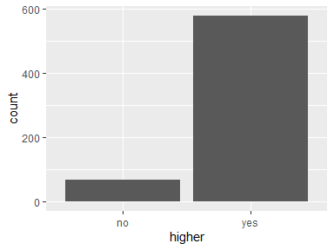

* Observed factor levels: "no", "yes".

## internet

| Feature | Result |
| --- | --- |
| Variable type | character |
| Number of missing obs. | 0 (0 %) |
| Number of unique values | 2 |
| Mode | “yes” |

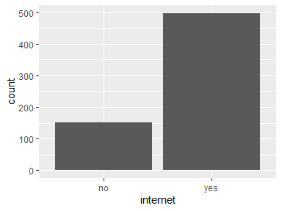

* Observed factor levels: "no", "yes".

## romantic

| Feature | Result |
| --- | --- |
| Variable type | character |
| Number of missing obs. | 0 (0 %) |
| Number of unique values | 2 |
| Mode | “no” |

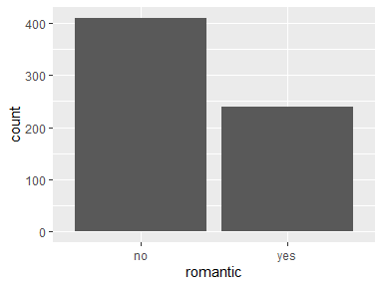

* Observed factor levels: "no", "yes".

## famrel

| Feature | Result |
| --- | --- |
| Variable type | integer |
| Number of missing obs. | 0 (0 %) |
| Number of unique values | 5 |
| Median | 4 |
| 1st and 3rd quartiles | 4; 5 |
| Min. and max. | 1; 5 |

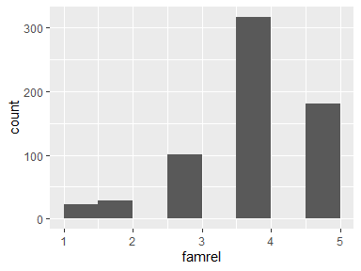

## freetime

| Feature | Result |
| --- | --- |
| Variable type | integer |
| Number of missing obs. | 0 (0 %) |
| Number of unique values | 5 |
| Median | 3 |
| 1st and 3rd quartiles | 3; 4 |
| Min. and max. | 1; 5 |

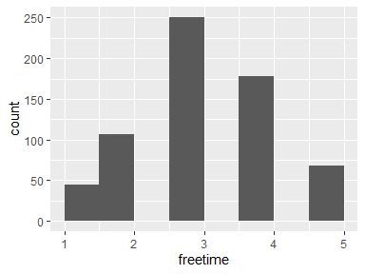

## goout

| Feature | Result |
| --- | --- |
| Variable type | integer |
| Number of missing obs. | 0 (0 %) |
| Number of unique values | 5 |
| Median | 3 |
| 1st and 3rd quartiles | 2; 4 |
| Min. and max. | 1; 5 |

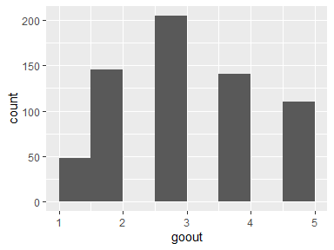

## Dalc

| Feature | Result |
| --- | --- |
| Variable type | integer |
| Number of missing obs. | 0 (0 %) |
| Number of unique values | 5 |
| Median | 1 |
| 1st and 3rd quartiles | 1; 2 |
| Min. and max. | 1; 5 |

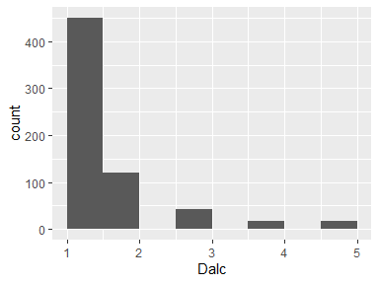

## Walc

| Feature | Result |
| --- | --- |
| Variable type | integer |
| Number of missing obs. | 0 (0 %) |
| Number of unique values | 5 |
| Median | 2 |
| 1st and 3rd quartiles | 1; 3 |
| Min. and max. | 1; 5 |

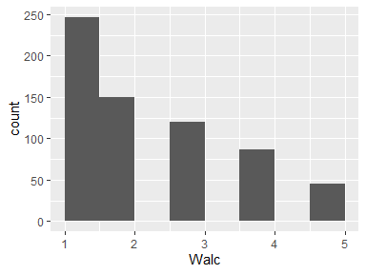

## health

| Feature | Result |
| --- | --- |
| Variable type | integer |
| Number of missing obs. | 0 (0 %) |
| Number of unique values | 5 |
| Median | 4 |
| 1st and 3rd quartiles | 2; 5 |
| Min. and max. | 1; 5 |

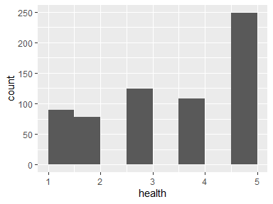

## absences

| Feature | Result |
| --- | --- |
| Variable type | integer |
| Number of missing obs. | 0 (0 %) |
| Number of unique values | 24 |
| Median | 2 |
| 1st and 3rd quartiles | 0; 6 |
| Min. and max. | 0; 32 |

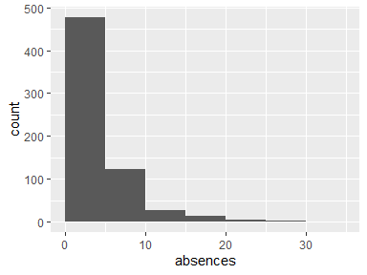

## G1

| Feature | Result |
| --- | --- |
| Variable type | integer |
| Number of missing obs. | 0 (0 %) |
| Number of unique values | 17 |
| Median | 11 |
| 1st and 3rd quartiles | 10; 13 |
| Min. and max. | 0; 19 |

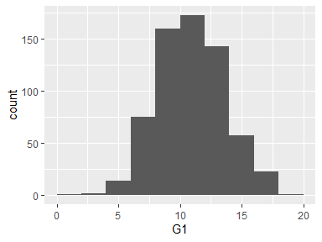

## G2

| Feature | Result |
| --- | --- |
| Variable type | integer |
| Number of missing obs. | 0 (0 %) |
| Number of unique values | 16 |
| Median | 11 |
| 1st and 3rd quartiles | 10; 13 |
| Min. and max. | 0; 19 |

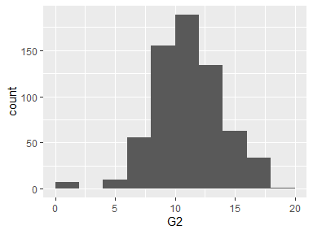

## G3

| Feature | Result |
| --- | --- |
| Variable type | integer |
| Number of missing obs. | 0 (0 %) |
| Number of unique values | 17 |
| Median | 12 |
| 1st and 3rd quartiles | 10; 14 |
| Min. and max. | 0; 19 |

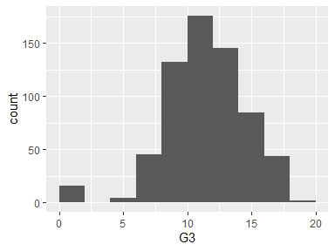

Report generation information:

* Created by: error: invalid key: Tiong/.gitconfig (username: Rose Tiong).
* Report creation time: Wed May 18 2022 02:24:52
* Report was run from directory: C:/Users/Rose Tiong/Desktop/Data/data/WQD7001
* dataMaid v1.4.1 [Pkg: 2021-10-08 from CRAN (R 4.1.3)]
* R version 4.1.3 (2022-03-10).
* Platform: x86_64-w64-mingw32/x64 (64-bit)(Windows 8.1 x64 (build 9600)).
* Function call: dataMaid::makeDataReport(data = df, mode = c("summarize", "visualize", "check"), smartNum = FALSE, file = "codebook_df.Rmd", checks = list( character = "showAllFactorLevels", factor = "showAllFactorLevels", labelled = "showAllFactorLevels", haven_labelled = "showAllFactorLevels", numeric = NULL, integer = NULL, logical = NULL, Date = NULL), listChecks = FALSE, maxProbVals = Inf, codebook = TRUE, reportTitle = "Codebook for df")