Software Engineering and

Information System Design Sessional

CSE-308

Traffic Control System

>Sequence diagram

>State chart

>Activity diagram

Group 4

1005099

1005105

1005110

1005112

1005114

**Abstract:**

A sequence diagram is a kind of interaction diagram that shows how processes operate with one another and in what order. It shows object interactions arranged in time sequence.

A state chart diagram is a view of a state machine that models the changing behavior of a state. State chart diagrams show the various states that an object goes through, as well as the events that cause a transition from one state to another.

Activity diagram is basically a flow chart to represent the flow form one activity to another activity. The activity can be described as an operation of the system.

**Introduction:**

The main objective of traffic control system is to provide users the privilege of getting help while travelling.

The whole system has been divided into 4 subsystems:

* Crowd sourcing
  + Route suggestion
    - Complaint filing
      * + Case filing

Subsystem: Crowd Sourcing

* Use Case name :

1. Route maintenance

Actor: DP

Route maintenance

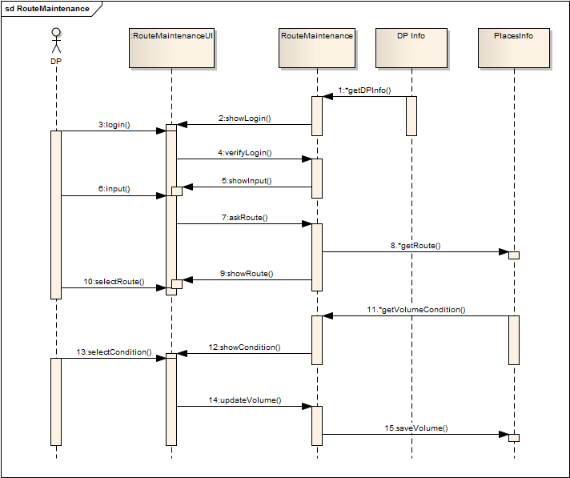

Figure : Sequence Diagram of Route Maintenance

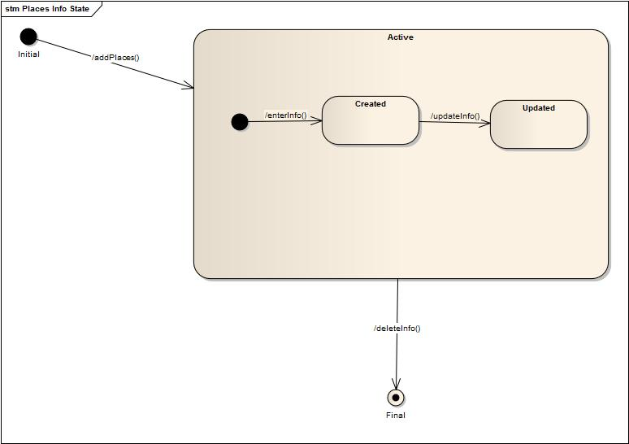

Figure : State Chart Diagram of Places Info

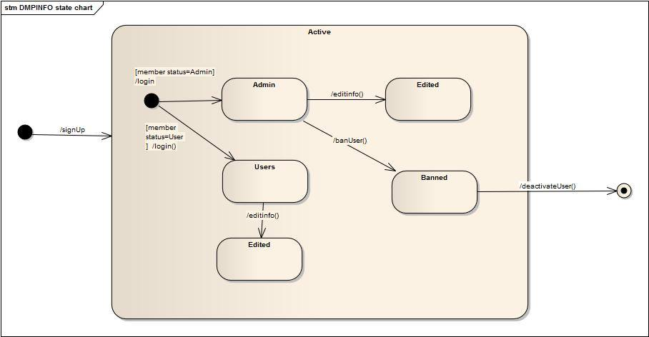

Figure : State Chart Diagram of DP Info

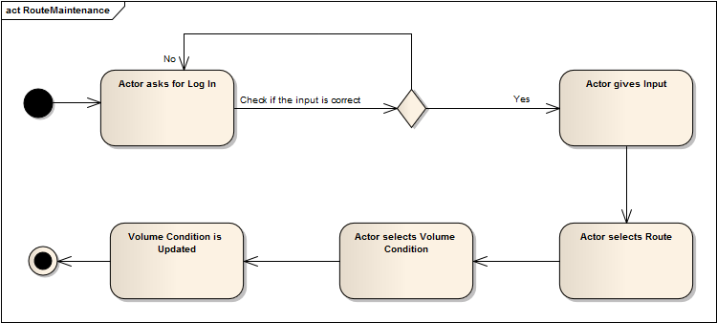

Figure : Activity Diagram of Route Maintenance

Subsystem: Optimal Route Suggestion

* Use Case name :
  1. Route Query
  2. Route Suggestion

Actor: MP

Route Query

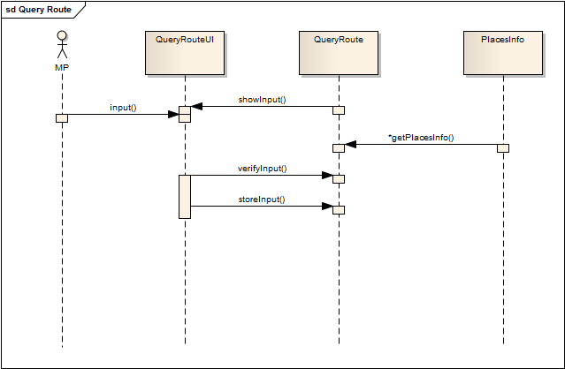

Figure : Sequence Diagram of Route Query



Figure : State Chart Diagram of Places Info

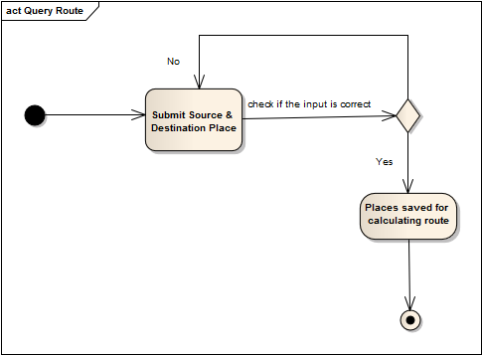

Figure : Activity Diagram of Route Query

Route Suggestion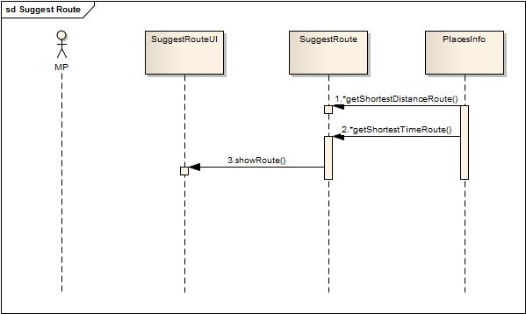

Figure : Sequence Diagram of Route Suggestion



Figure : State Chart of Places Info

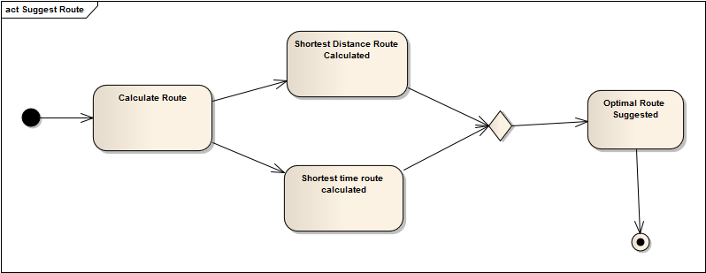

Figure : Activity Diagram of Route Suggestion

Subsystem: Complaint Filing

* Use Case name :
  1. File Complaint
  2. View complaint
  3. Decision making
  4. Action phase

Actor: Complainant, DMP, TP, P

File Complaint

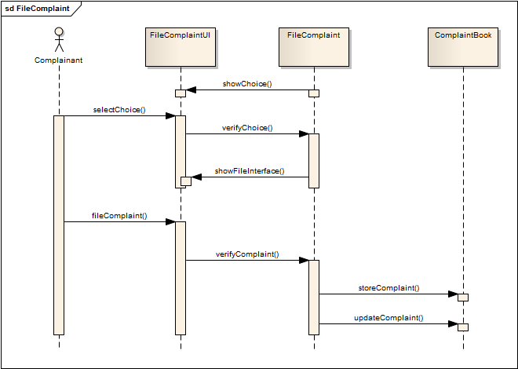

Figure : Sequence Diagram of File Complaint

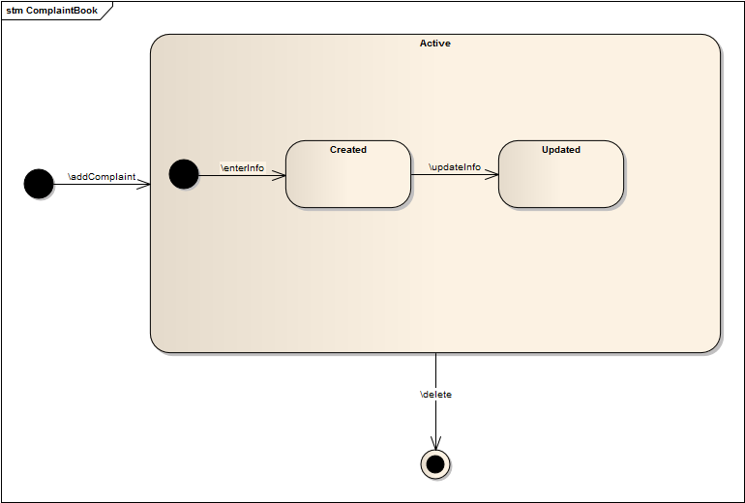

Figure : State Chart Diagram of Complaint Book

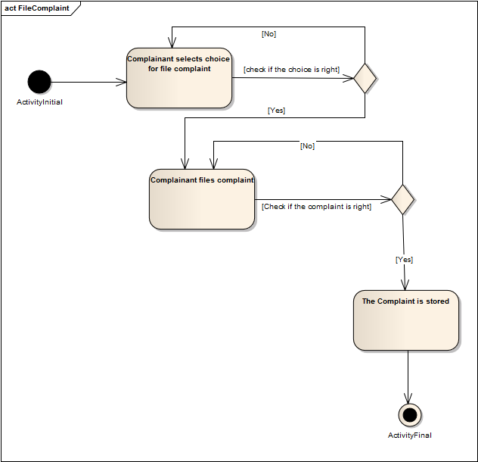

Figure : Activity Diagram of File Complaint

View Complaint 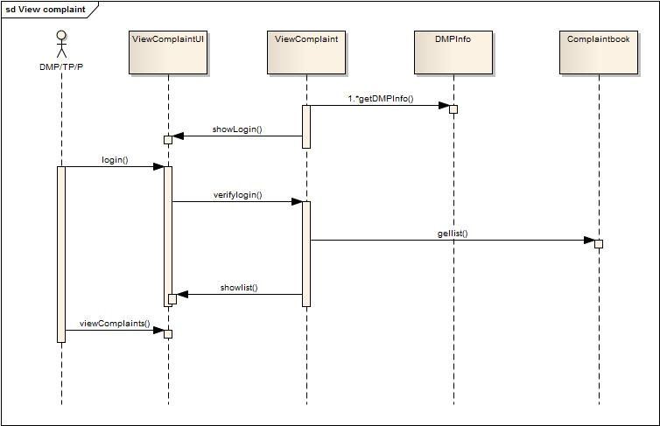

Figure : Sequence Diagram of View Complaint



Figure : State Chart Diagram of DMP Info



Figure : State Chart Diagram of Complaint Book

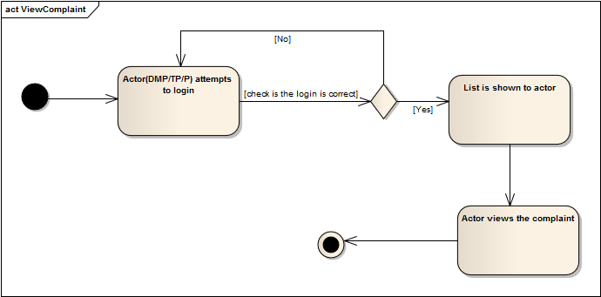

Figure : Activity Diagram of View Complaint

Decision Making 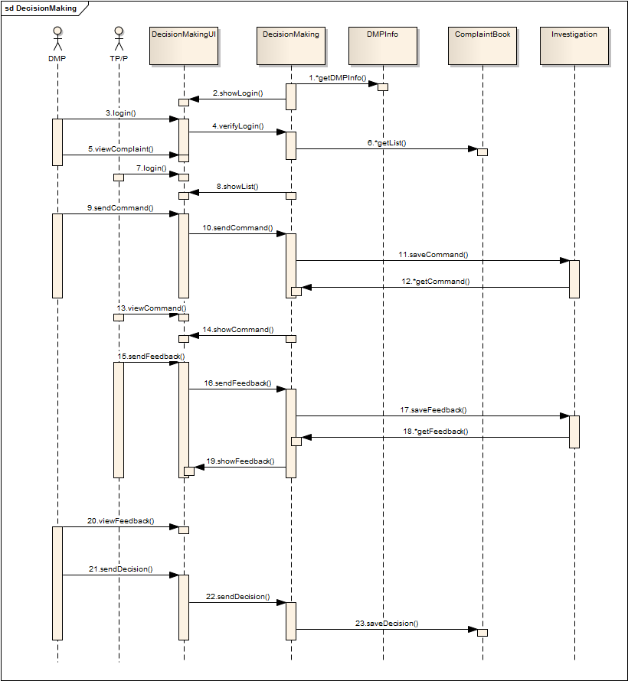

Figure : Sequence Diagram of Decision Making



Figure : State Chart Diagram of DMP Info



Figure : State Chart Diagram of Complaint Book

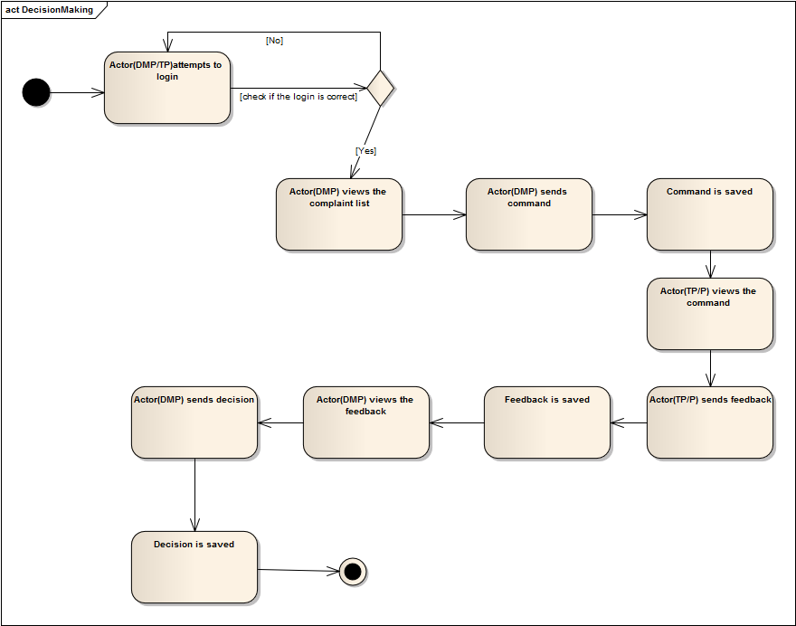

Figure : Activity Diagram of Decision Making

Action Phase 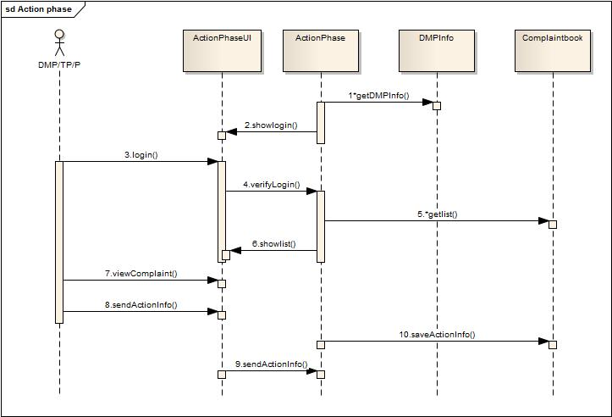

Figure : Sequence Diagram of Action Phase



Figure : State Chart Diagram of Complaint Book



Figure : State Chart Diagram of DMP Info

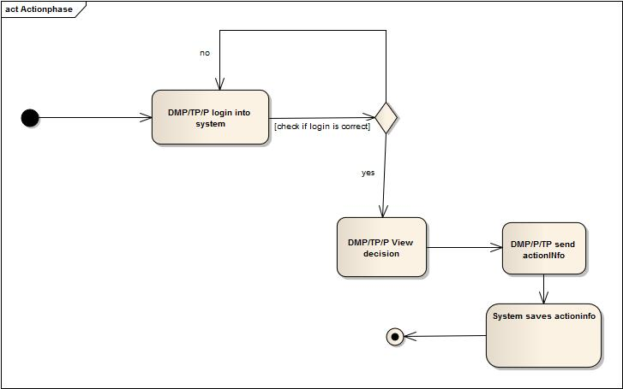

Figure : Activity Diagram of Action Phase

Subsystem: Case Filing

* Use Case name :
  + 1. File Case

b)Show List

Actor: DMP, TP, User

File Case 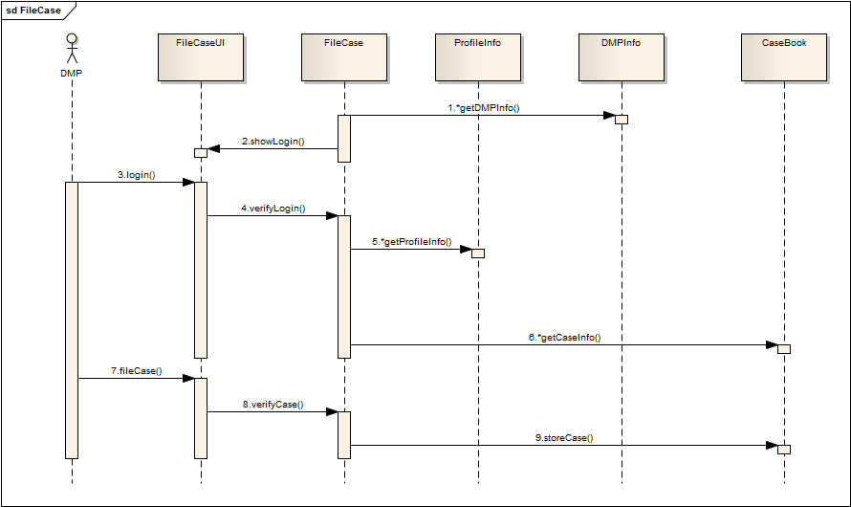

Figure : Sequence Diagram of File Case

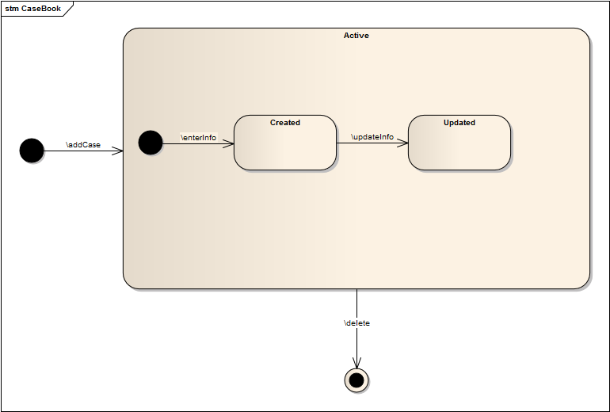

Figure : State Chart Diagram of Case Book



Figure : State Chart Diagram of DMP Info

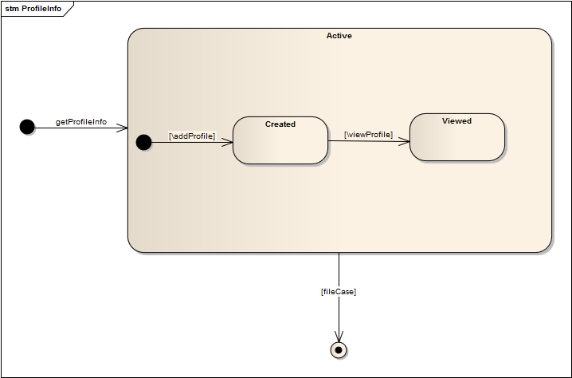

Figure : State Chart Diagram of Profile Info

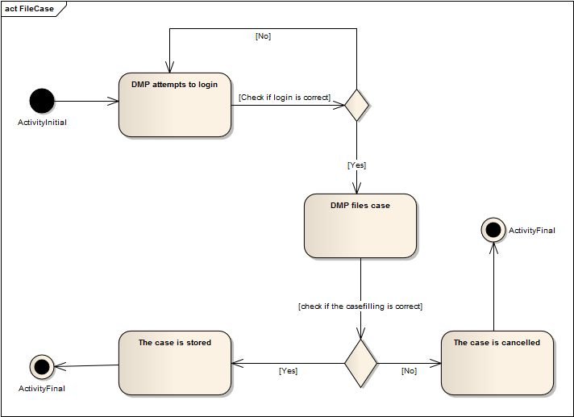

Figure : Activity Diagram of File Case

Show List 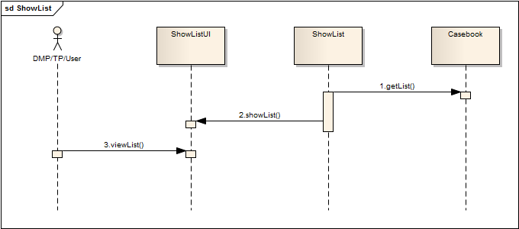

Figure : Sequence Diagram of Show List



Figure : State Chart Diagram of Case Book

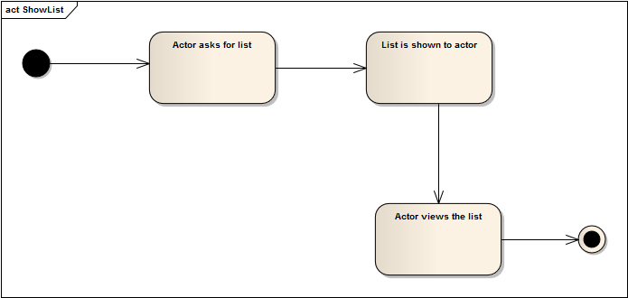

Figure : Activity Diagram of Show List