Описание сайта “UberEats”.

Страница входа для уже имеющихся в базе данных пользователей или для авторизация новых. Описана в auth.html и auth.css.

header и main часть контента сайта. Описана в index.html и index.css.

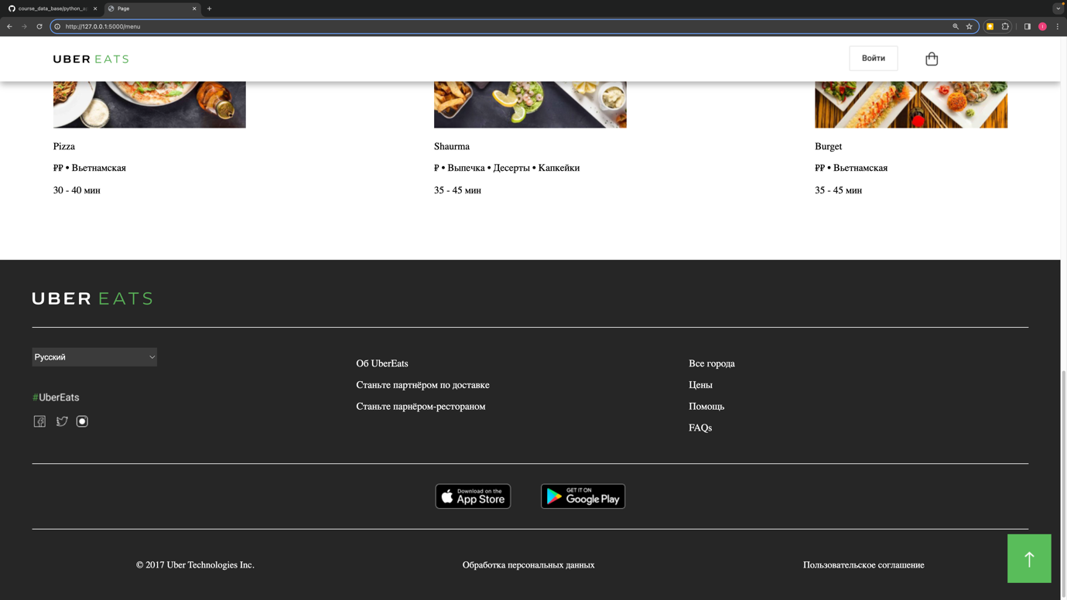

footer сайта. Описана в index.html и index.css.

Для разработки сайта использовался framework Flask.

Файл main.py отвечает за маршрутизацию между страницами и Front Office логику сайта.

Файл SQL.py отвечает за подключение к базе данных и работу с ней.  
СУБД mysql запускается из docker контейнера общение между сервером сайта  и СУБД осуществляется на localhost на порте 3306 при помощи библиотеки mysql-connector-python.

Таблицы в базе данных:

basket

|  |  |  |  |  |  |
| --- | --- | --- | --- | --- | --- |
| **Column** | **Type** | **Comment** | **PK** | **Nullable** | **Default** |
| uuid | varchar(36) |  | YES | NO |  |
| customer_id | varchar(36) |  |  | NO |  |
| amount_of_product | int |  |  | YES |  |
| sum_of_product | float |  |  | YES |  |

categories

|  |  |  |  |  |  |
| --- | --- | --- | --- | --- | --- |
| **Column** | **Type** | **Comment** | **PK** | **Nullable** | **Default** |
| id | int |  | YES | NO |  |
| name | varchar(16) |  |  | YES |  |

customers

|  |  |  |  |  |  |
| --- | --- | --- | --- | --- | --- |
| **Column** | **Type** | **Comment** | **PK** | **Nullable** | **Default** |
| id | int |  | YES | NO |  |
| name | varchar(16) |  |  | NO |  |
| surname | varchar(32) |  |  | NO |  |
| password | varchar(32) |  |  | NO |  |
| email | varchar(64) |  |  | NO |  |

deliveries

|  |  |  |  |  |  |
| --- | --- | --- | --- | --- | --- |
| **Column** | **Type** | **Comment** | **PK** | **Nullable** | **Default** |
| uuid | varchar(36) |  | YES | NO |  |
| delivery_system | int |  |  | NO |  |
| postcode | varchar(16) |  |  | NO |  |
| city | varchar(32) |  |  | NO |  |
| address | varchar(128) |  |  | NO |  |

delivery_systems

|  |  |  |  |  |  |
| --- | --- | --- | --- | --- | --- |
| **Column** | **Type** | **Comment** | **PK** | **Nullable** | **Default** |
| id | int |  | YES | NO |  |
| name | varchar(16) |  |  | NO |  |
| cost | float |  |  | NO |  |

invoices

|  |  |  |  |  |  |
| --- | --- | --- | --- | --- | --- |
| **Column** | **Type** | **Comment** | **PK** | **Nullable** | **Default** |
| uuid | varchar(36) |  | YES | NO |  |
| customer_id | varchar(36) |  |  | NO |  |
| seller_id | varchar(36) |  |  | NO |  |
| order_id | varchar(36) |  |  | NO |  |
| create_at | datetime |  |  | YES |  |
| cost | float |  |  | YES |  |
| cost_tax | float |  |  | YES |  |
| payment_system | int |  |  | NO |  |

orders

|  |  |  |  |  |  |
| --- | --- | --- | --- | --- | --- |
| **Column** | **Type** | **Comment** | **PK** | **Nullable** | **Default** |
| uuid | varchar(36) |  | YES | NO |  |
| customer_id | varchar(36) |  |  | NO |  |
| delivery_id | varchar(36) |  |  | NO |  |
| date | datetime |  |  | YES |  |
| cost | int |  |  | YES |  |

orders_products

|  |  |  |  |  |  |
| --- | --- | --- | --- | --- | --- |
| **Column** | **Type** | **Comment** | **PK** | **Nullable** | **Default** |
| uuid | varchar(36) |  | YES | NO |  |
| orders_id | varchar(36) |  |  | NO |  |
| product_id | varchar(36) |  |  | NO |  |

payment_systems

|  |  |  |  |  |  |
| --- | --- | --- | --- | --- | --- |
| **Column** | **Type** | **Comment** | **PK** | **Nullable** | **Default** |
| id | int |  | YES | NO |  |
| type | varchar(16) |  |  | NO |  |
| tax | float |  |  | NO |  |

product_reviews

|  |  |  |  |  |  |
| --- | --- | --- | --- | --- | --- |
| **Column** | **Type** | **Comment** | **PK** | **Nullable** | **Default** |
| uuid | varchar(36) |  | YES | NO |  |
| customer_id | varchar(36) |  |  | YES |  |
| product_id | varchar(36) |  |  | YES |  |
| review | varchar(1024) |  |  | YES |  |

products

|  |  |  |  |  |  |
| --- | --- | --- | --- | --- | --- |
| **Column** | **Type** | **Comment** | **PK** | **Nullable** | **Default** |
| id | int |  | YES | NO |  |
| name | varchar(32) |  |  | NO |  |
| description | varchar(256) |  |  | NO |  |
| cost | decimal(10,2) |  |  | YES |  |

products_basket

|  |  |  |  |  |  |
| --- | --- | --- | --- | --- | --- |
| **Column** | **Type** | **Comment** | **PK** | **Nullable** | **Default** |
| uuid | varchar(36) |  | YES | NO |  |
| basket_id | varchar(36) |  |  | YES |  |
| product_id | varchar(36) |  |  | YES |  |

sellers

|  |  |  |  |  |  |
| --- | --- | --- | --- | --- | --- |
| **Column** | **Type** | **Comment** | **PK** | **Nullable** | **Default** |
| uuid | varchar(36) |  | YES | NO |  |
| name | varchar(16) |  |  | NO |  |
| surname | varchar(32) |  |  | NO |  |
| password | varchar(32) |  |  | NO |  |
| name_of_shop | varchar(128) |  |  | NO |  |
| email | varchar(64) |  |  | NO |  |
| phone | varchar(32) |  |  | YES |  |
| sex | tinyint(1) |  |  | YES |  |
| country | varchar(32) |  |  | NO |  |
| city | varchar(32) |  |  | NO |  |
| address | varchar(32) |  |  | NO |  |
| postcode | varchar(32) |  |  | NO |  |
| amount_of_sales | int |  |  | YES |  |
| cost_of_sales | float |  |  | YES |  |
| Rating | float |  |  | YES |  |