NOVA OS
The Complete Build Guide
One phase per day, start to finish -- 85 days from a clean checkout to a tagged Nova OS 1.0 release.
Complete every day's Definition of Done honestly, in order, and the OS works when you finish -- that is what this guide is built to deliver, checked against Section 20's literal completion checklist at the end, not a looser sense of "done."
Built from: Nova_OS_Full_Project_Roadmap.docx (v1.0, Aug 2026) and Nova-OS-Guide.docx

1. How to Use This Guide
The direct answer to "will the OS work when I finish": yes, provided every day's Definition of Done is met honestly, in order, and Day 85's final check against Section 20 (reproduced at the end of this document) is run and passes. That final check is the actual, literal meaning of "the OS is working" in this project -- not a milestone tag, not "it boots in QEMU," but every item on that list checked off against a real test you ran, on the real reference device chosen in M12.
Every row in the tables below is one day's work: a focused chunk of the roadmap, a task list, and a concrete Definition of Done. Don't move to the next day until the current day's Definition of Done is actually true -- this mirrors the project's own stated discipline: "start the next milestone only after acceptance" (Roadmap, Section 24), applied here at daily granularity instead of milestone granularity. Skipping or fudging a Definition of Done doesn't just create a gap in that one day -- every later day assumes the ones before it actually hold, all the way to Day 85.
Some days will legitimately take longer than a calendar day, especially in hardware bring-up (M12) and the long-duration stability test (M16) -- those are flagged explicitly where they occur. Treat the day numbers as a sequence and a pace-setting target, not a rigid deadline that overrides doing the work correctly.
This guide has 85 days across 15 milestones. It ends when Section 20's Nova OS 1.0 definition (reproduced at the end of this document) is fully, honestly checked off -- that is the actual meaning of "the OS will be working," not just "it boots."
Governing hardware target, added to this guide: Nova is being built for low-end devices -- the 1GB-2GB RAM class, not the 4GB+ class most Linux-derived phone stacks quietly assume. 1GB is the real target, not a stretch goal, and 2GB is the comfortable case. Every milestone below should be read with that constraint attached, whether or not each day's table row says so explicitly -- see Section 21 for the concrete memory budget per subsystem and the required 1GB test methodology, and Section 22 for how this connects to Nova's own longer-term kernel plans.

2. Reconciling the Two Source Documents
You uploaded two planning documents that don't fully agree with each other, and this guide is honest about that rather than picking one silently:
- Nova_OS_Full_Project_Roadmap.docx (version 1.0, dated August 2026) is the newer, more complete engineering plan -- it defines milestones M0 through M17, an immediate priority (M4: Core OS), and an explicit process discipline. This guide follows its milestone numbering and sequencing throughout, because it is the most recently dated, most structurally complete document, and because it explicitly addresses how to integrate work already in progress.
- Nova-OS-Guide.docx uses a different, earlier milestone scheme (M0-M6 across four quarters) and contains real product context the Roadmap doesn't cover at all: the Kenya low-RAM-device market thesis, the health-service differentiation strategy, and specific architecture choices (Rust throughout, direct DRM/KMS, wlroots-based compositor, zero-copy DMA-BUF). This guide folds that context in at the points where it's actually relevant (M7's compositor choice, M12's reference-device selection, M6/M14's product-differentiation framing) rather than treating it as a competing day-by-day schedule.
- The two documents' milestone numbers mean different things -- e.g. the Guide's "M6" is a differentiator health app, while the Roadmap's "M6" is the Nova SDK. Wherever this guide says "M6," it means the Roadmap's M6, and it flags any place the Guide's content is being folded in under a different number.
The most important reconciliation point: the app-level work already built in an earlier session (nova-ipc, nova-app.toml manifests, and the Settings/Contacts/Messages/Dialer/Camera apps, plus the nova-v4l2 camera driver) was built assuming a generic Linux/Wayland userspace already existed underneath it. It does not yet run on top of the Roadmap's M4 Core OS, because M4 doesn't exist yet in this project. The Roadmap says this directly: "Integrate the existing M5 package with M4 instead of developing two disconnected systems." This guide's M5 phase (Days 11-17) is built entirely around that reconciliation -- it is not optional integration polish, it is required work, and skipping it means the apps you already have will keep running as a disconnected prototype rather than becoming part of Nova OS.
One more honest note carried over from the camera driver's own documentation: nova-v4l2 was written without access to a Rust toolchain or real camera hardware, and has never been compiled or tested against either. This guide schedules the first real compile-and-test of that code on M9's Camera HAL day, and its first real-hardware verification on M12's camera bring-up day -- both are called out explicitly below, not glossed over.

3. Milestone Overview
A quick-reference map from milestone to day range before the full day-by-day detail.
Milestone | Name | Day Range | # Days
M0 | Boot Foundation (v0.07) | Day 1 | 1
M4 | Core OS (Immediate Priority) (v0.13) | Days 2-10 | 9
M5 | IPC, Applications & Sandboxing (integrate with M4) (v0.20) | Days 11-17 | 7
M6 | Nova SDK & Application Framework (v0.27) | Days 18-22 | 5
M7 | GUI & Window System (v0.33) | Days 23-28 | 6
M8 | Networking (v0.40) | Days 29-33 | 5
M9 | Hardware Abstraction (v0.47) | Days 34-39 | 6
M10 | Security (v0.53) | Days 40-45 | 6
M11 | Package Ecosystem (v0.60) | Days 46-49 | 4
M12 | ARM64 Reference-Device Port (v0.67) | Days 50-65 | 16
M13 | Hardware Integration (v0.73) | Days 66-68 | 3
M14 | Phone UX & System Apps (v0.80) | Days 69-71 | 3
M15 | Power, Recovery & Update System (v0.87) | Days 72-75 | 4
M16 | Stability & Security Testing (v0.93) | Days 76-80 | 5
M17 | Release Engineering (v1.00) | Days 81-85 | 5
This table covers M0-M17 only -- the 85-day Nova OS 1.0 track on the existing Linux kernel. The separate, gated custom-kernel track (Section 22's preconditions, K1-K14's own day-by-day plan) is laid out starting at Section 23, numbered K1-K14 rather than M-numbers so the two tracks are never confused.

4. M0 — Boot Foundation (v0.07)
Per the Roadmap's Section 2, M0-M3 are already marked as your current position. Days 1 is a verification/documentation pass, not a rebuild -- do not redo work that already boots. Everything through M17 in this guide runs on top of the existing Linux kernel, by design -- Nova's own custom kernel is a deliberately later, separate track; see Section 22.
Day | Focus | Tasks | Definition of Done
Day 1 | Verify & document M0-M3 | - Rebuild the existing M0-M3 work from a clean checkout on a fresh machine or container -- this is the actual acceptance test for M0 ("a clean environment can build the image and boot it reproducibly"), not just re-running it on your existing dev box.  - Confirm it boots in QEMU to visible framebuffer output / early console (M1) and that Nova Init (Rust) is PID 1 and reaches a controlled shutdown/restart path (M2).  - Confirm the display abstraction from M3 is usable by something other than the boot logo itself (a second test consumer, even a trivial one).  - Write down the actual interfaces M0-M3 currently expose -- this becomes the input to M4's Device Manager and Display service work. | A clean checkout builds and boots to the same visible state on a machine that never had your dev environment on it. If it doesn't, that gap is Day 1's real finding -- fix it before M4 starts, since every later milestone depends on this foundation being reproducible, not just "working on my machine."

5. M4 — Core OS (Immediate Priority) (v0.13)
This is the Roadmap's actual next milestone. Everything built so far in the Wayland-app track (Settings/Contacts/Messages/Dialer/Camera) sits above this layer and does not yet consume it -- see the reconciliation note earlier in this document.
Day | Focus | Tasks | Definition of Done
Day 2 | Process Manager | - Process IDs, creation/termination.  - Process states (running/sleeping/zombie/stopped, matching what Linux already tracks -- Nova's Process Manager is a supervising layer over Linux processes, not a new scheduler).  - Parent/child relationships.  - Monitoring hooks (a process's state must be queryable, not just visible in logs).  - Service supervision hooks -- the seam M4.5 (Service Manager) will attach to. | From a test client: create a process, list it with correct PID/state/parent, terminate it, and observe the state transition -- all through Nova's Process Manager API, not `ps`/`kill` directly.
Day 3 | Memory Manager | - Allocation interfaces.  - Memory accounting (per-process, queryable).  - Virtual-memory interface.  - Process isolation/protection.  - Allocation failure handling -- define and test the out-of-memory path explicitly, don't leave it to whatever Linux's OOM killer does by default.  Per-subsystem RAM budget (Section 21): decide now, in writing, roughly how much of a 1GB device's memory Nova Init + the seven M4 subsystems are allowed to hold at idle, since every later milestone's own budget is a slice of whatever's left after this one. | A test process can query its own and another process's memory accounting; a deliberate allocation-failure test exercises the failure path without crashing the Memory Manager itself. The idle RAM budget from today's Tasks is written down somewhere a later day can be checked against.
Day 4 | Filesystem Manager | - Standard directories (define Nova's own FHS-equivalent layout -- this becomes Section 21's repo/deploy structure).  - Open/read/write/close.  - Create/delete/rename.  - Mounting.  - Use ext4 (or another mature filesystem) initially -- per Section 25, do not build a custom filesystem at this stage. | A test file can be created, written, read back correctly, renamed, and deleted through Nova's Filesystem Manager API; a second filesystem/mount point can be mounted and unmounted cleanly.
Day 5 | Device Manager | - Common device representation (one struct/trait every device type conforms to).  - Display/input/storage registration against that representation.  - Generic APIs kept separate from hardware implementation -- this is the seam that keeps M9 (Hardware Abstraction) and M12 (ARM64 port) from leaking device-specific code into core services (Section 4's "keep generic Nova code separate from hardware-specific code"). | Register a test/fake device of each of the three types (display, input, storage) and list them back through the Device Manager's generic query API.
Day 6 | Service Manager | - Start/stop/restart.  - Status querying.  - Dependency declarations between services.  - Crash/restart policy (define it explicitly: restart-always, restart-on-failure, or no-restart, per service). | M4's own acceptance test list requires this directly: start/stop a test service, and recover from a deliberately failed test service (verify the crash/restart policy actually fires).
Day 7 | Logging | - DEBUG, INFO, WARNING, ERROR, CRITICAL levels.  - Persistent logs where practical (written through the Filesystem Manager built two days ago, not a bespoke log path).  - Boot and service diagnostics feeding into this same logging path -- retrofit M0-M3's boot messages and M4's own subsystems to log through it rather than raw console prints. | "Produce structured logs" (M4's own acceptance criterion) -- a test emits log lines at each level and they're queryable/filterable afterward, not just scrolling text.
Day 8 | Configuration | - Central configuration format (pick one -- TOML is a reasonable default given Rust's ecosystem and that `nova-app.toml` manifests already use it in the app-level work).  - System/service configuration directory layout.  - Validation and safe defaults -- a malformed config file must fail loudly at load time, not silently fall back to undefined behavior. | A service reads its config from the standard directory; an intentionally malformed config file is rejected with a clear error rather than crashing the service or silently misconfiguring it.
Day 9 | Nova Core API | - Define stable, versioned APIs for processes, memory, files, devices, services, and logging -- this is the contract M5 (IPC + Applications) is required to consume, per Section 9.8.  - Write the API reference doc now, before more consumers exist (Section 4's "document APIs before creating many consumers"). | The API surface is written down (not just implied by the code) and version-tagged; a reviewer unfamiliar with the implementation could write a new M4 consumer from the doc alone.
Day 10 | M4 integration, console, acceptance tests, tag | - Wire all seven subsystems together so a clean boot reaches the M4 console output specified in Section 9.9 (`[ OK ]` lines for Kernel, Nova Init, Memory Manager, Process Manager, Filesystem, Device Manager, Service Manager, Logging, Configuration, Nova API, ending at the `nova#` prompt).  - Run every item on Section 9.10's acceptance list end to end: boot to `nova#`; list processes; start/stop a test service; read/write a test file; show memory statistics; register a test device; produce structured logs; recover from a deliberately failed test service.  - Write M4's documentation (API reference from yesterday, plus a short boot/runtime overview).  - Tag the M4 release in Git. | All of Section 9.10's acceptance tests pass in one clean QEMU boot, the console matches Section 9.9's expected output, and the release is tagged -- this is the actual, non-negotiable exit criterion for M4 per Section 24 ("start the next milestone only after acceptance").

6. M5 — IPC, Applications & Sandboxing (integrate with M4) (v0.20)
This is where the already-built app-level work (nova-ipc, nova-app.toml manifests, the Settings/Contacts/Messages/Dialer/Camera apps) gets reconciled with the M4 Core OS you just built, per the Roadmap's explicit instruction not to develop two disconnected systems.
Day | Focus | Tasks | Definition of Done
Day 11 | Versioned IPC protocol | - Formalize the existing IPC message protocol (Hello/HelloAck/PermissionRequest/PermissionResponse/Lifecycle/ColdStartReport and friends, if that's what already exists) into a versioned, documented spec.  - Decide and document the versioning/compatibility policy (what happens when client and server protocol versions differ). | The IPC spec exists as a standalone document (Section 23's "IPC protocol specification"), separate from any one app's source, with a version number a client can query.
Day 12 | Service discovery + request/response/event messaging | - Service discovery: a client can ask "what services/apps exist" without hardcoding socket paths (the existing `ListApps`/`AppList` messages, if present, formalized and tested).  - Confirm request/response and one-way event messaging both work over the same transport. | A test client discovers the App Manager without a hardcoded path, sends a request and gets a matching response, and separately receives an unsolicited event.
Day 13 | Application lifecycle via M4's Process/Service Manager | - Rebuild App Manager's lifecycle handling (launch/foreground/background/terminate) on top of M4's Process Manager and Service Manager, rather than raw `fork`/`exec` -- this is the actual integration point the Roadmap is asking for.  - Cold-start reporting (`ColdStartReport`-style) now sourced from M4's Process Manager timestamps, not app-side wall-clock guessing. | Launching, backgrounding, and terminating a test app all show up correctly in M4's Process Manager process list and Service Manager status, not just in App Manager's own internal state.
Day 14 | Package manifest + permission declarations | - Formalize the `nova-app.toml` manifest schema (id, name, version, entry point, permissions) as a documented spec (Section 23's "package-format specification", first draft).  - Validate manifests through M4's Configuration subsystem's validation path from three days into M4, rather than ad hoc parsing per app. | A manifest with a missing required field or an unknown permission name is rejected with a clear error at install/launch time, using the same validation path M4's Configuration subsystem already has.
Day 15 | Sandbox boundaries | - Turn declared permissions into actual enforcement: a process without the `camera` permission cannot open camera devices, using M4's Process Manager/Memory Manager isolation primitives from Days 2-3 of M4 as the enforcement mechanism, not just a manifest that's checked once and trusted forever.  - Define what "sandbox boundary" means concretely for this milestone (filesystem access scoping is a reasonable minimum bar; full namespace/seccomp isolation is explicitly M10's job -- don't over-build here). | A deliberately misbehaving test app that tries to access a permission it wasn't granted is blocked and the attempt is logged, not silently allowed.
Day 16 | Reconcile the existing Wayland apps against the new stack | - Rebuild Settings, Contacts, Messages, Dialer, and Camera against the integrated App Manager/IPC/permission stack from the last four days, replacing any standalone/direct-launch assumptions those apps currently make.  - Re-run each app's own prior acceptance checks (cold-start time, permission grants, IPC handshake) against the new stack and note any regressions honestly -- this is exactly the kind of integration work that surfaces gaps the original app-level packages couldn't have caught in isolation. | All five existing apps launch, complete their IPC handshake, and pass their original individual acceptance checks when run through the M4-integrated App Manager -- not just standalone as before.
Day 17 | Hello-world app, full M5 acceptance, tag | - Build (or reuse, if one already exists) a minimal Hello-world app as the canonical "does the whole stack work" smoke test -- deliberately simpler than the five real apps, so failures here point at the platform, not app-specific code.  - Run the Roadmap's own M5 acceptance test: "a packaged test application can launch, communicate through IPC and operate within its permissions."  - Document the IPC spec and package format properly (Section 23), tag M5. | The Hello-world app installs from a package, launches through the App Manager, exchanges at least one real IPC request/response, and is blocked from an action outside its declared permissions -- all in one run.

7. M6 — Nova SDK & Application Framework (v0.27)
Day | Focus | Tasks | Definition of Done
Day 18 | SDK scaffolding + project template | - `nova create my_app` -- generates a working, buildable skeleton app (manifest, entry point, minimal window) from one command.  - Document the template's structure so a third-party developer (even a future you) doesn't have to read App Manager source to understand it. | `nova create test_app` followed by `nova build` (stubbed if needed) produces a package that installs and launches, with zero manual edits to generated files.
Day 19 | Window API + Input API | - Window API: create/resize/close/title, wrapping the xdg-shell-style calls the existing apps already hand-roll, so future apps don't each reimplement `fb.rs`/protocol boilerplate from scratch.  - Input API: the touch/keyboard/pointer plumbing that every app so far has been missing -- expose it as a stable API now even though the actual input pipeline lands in M7. | A test app built against the new Window API renders a window without touching Wayland protocol code directly; the Input API compiles and returns a defined "not yet available" state honestly rather than pretending input works before M7.
Day 20 | Storage API + Networking API stub | - Storage API: a scoped, permission-checked file/data API for apps, built on M4's Filesystem Manager and M5's sandbox boundaries -- not raw filesystem access.  - Networking API: define the interface now; the real implementation waits for M8, so stub it with a clear "network unavailable" response rather than silently failing. | A test app can read/write its own scoped storage but is blocked from another app's data (proving M5's sandboxing is actually wired to the SDK, not bypassed); the Networking API returns an honest "not implemented" rather than crashing.
Day 21 | Notifications + lifecycle callbacks + permission APIs | - Notifications API (even a minimal local-only version -- no push infrastructure needed yet).  - Lifecycle callbacks (on-foreground/on-background/on-terminate) wired to M5's Application lifecycle work.  - Permission-request APIs so an app can ask for a permission at runtime, not just declare it statically in the manifest. | A test app posts a local notification, correctly receives a lifecycle callback when backgrounded, and successfully requests a runtime permission that then shows up as granted in M5's enforcement layer.
Day 22 | Build/package/install/run toolchain, acceptance, tag | - `nova build`, `nova package`, `nova install my_app.npkg`, `nova run my_app` -- the full developer loop, one command per step.  - Documentation: application developer guide (Section 23), first draft.  - Acceptance: build a genuinely new (not previously-existing) test app from `nova create` through `nova run` using only the SDK, no hand-editing of generated boilerplate. | The full `create -> build -> package -> install -> run` loop works end to end for a fresh app on the first try, documented well enough that the steps above could be followed by someone who didn't build the SDK. Tag M6.

8. M7 — GUI & Window System (v0.33)
This is also where the input-pipeline gap flagged repeatedly in every earlier app ("shutter/keypad drawn but not tappable") finally gets closed.
Day | Focus | Tasks | Definition of Done
Day 23 | Window manager / compositor core | - Build (or formalize, if the existing apps' ad hoc xdg_toplevel handling already implies one) the actual compositor: surface management, damage tracking, output configuration.  - Decide explicitly whether this is wlroots-based (per the original architecture guide) or built on "mature graphics facilities" more generally (per the roadmap's more conservative phrasing) -- write the decision down, since it affects every app above this layer. | Two or more existing apps (e.g. Settings and Camera) can run as separate windows composited on the same output simultaneously, each getting correct damage/redraw.
Day 24 | Desktop shell + launcher | - Lock screen and home screen (the original architecture guide's M4 scope, now correctly sequenced after a real compositor exists).  - App launcher listing installed packages via M5's App Manager / package manifest data. | From a cold boot, the lock screen appears, unlocking reaches the home screen, and the launcher lists and can start every currently-installed app (Settings, Contacts, Messages, Dialer, Camera, Hello-world).
Day 25 | Status bar + Settings integration | - Status bar (time, battery placeholder until M9's power HAL exists, connectivity placeholder until M8).  - Wire the existing Settings app into the shell (accessible from status bar / quick settings, not just standalone launch). | The status bar renders live, updating time at minimum, and Settings is reachable from within the shell UI, not only by direct process launch.
Day 26 | File manager | - A minimal file manager app built against M6's SDK (Storage API) -- browse, open, delete within permission scope. | The file manager lists a real directory's contents through the Storage API and can delete a test file, with the deletion actually reflected via M4's Filesystem Manager.
Day 27 | Touch/mouse/keyboard input pipeline | - Implement the input pipeline the M6 Input API was stubbed against -- this is the fix for every "drawn but not tappable" caveat in the Dialer/Camera apps built earlier.  - Wire it through the compositor from Day 1 of this milestone so window focus and hit-testing are correct, not just raw event delivery. | Go back to the existing Dialer app's keypad and Camera app's shutter button (both previously flagged as drawn-but-not-tappable) and confirm they are now actually tappable and produce the expected app behavior -- this is the concrete, checkable payoff of this day's work.
Day 28 | Theme/accessibility foundation, acceptance, tag | - Basic theming (consistent colors/typography across shell and apps -- most existing apps already share this by convention; formalize it as a shared theme resource).  - Accessibility foundation: at minimum, text scaling and a documented plan for what's deferred to a later pass.  - Full-shell acceptance: cold boot -> lock screen -> home screen -> launch each app -> interact via touch -> return home. | The full cold-boot-to-interactive-app flow works using only touch input, with consistent theming across shell and every app. Tag M7.

9. M8 — Networking (v0.40)
Day | Focus | Tasks | Definition of Done
Day 29 | Network abstraction + Ethernet | - Define the network abstraction layer the M6 Networking API stub will finally sit on top of.  - Ethernet support first (simplest to test in QEMU, no wireless stack needed yet). | A QEMU instance with a virtual Ethernet NIC gets a usable network interface visible through Nova's own network abstraction, not just raw Linux `ip`/`ifconfig`.
Day 30 | Wi-Fi | - Wi-Fi scan/associate through the same abstraction layer.  - Settings app UI for Wi-Fi selection (replacing any placeholder from M7 Day 3). | From the Settings app, scan for and connect to a test access point (real hardware or a QEMU-supported virtual Wi-Fi setup).
Day 31 | DHCP + DNS | - DHCP client integration.  - DNS resolution wired through to the Networking API apps will actually call. | A connected interface gets a DHCP-assigned address automatically, and a test app resolves a hostname through the Networking API.
Day 32 | TCP/IP integration + network configuration UI | - Confirm the Networking API (stubbed in M6) now performs real TCP connections for apps.  - Network configuration screen in Settings (view IP/connection status, forget a network). | A test app makes a real TCP connection (e.g. to a local test server) through the M6 Networking API, no longer returning the "not implemented" stub.
Day 33 | Diagnostics, acceptance, tag | - Basic network diagnostics (connectivity check, signal strength if applicable) surfaced in Settings.  - Documentation: networking section of the architecture doc. | From Settings, a user can see current connection status, diagnose a disconnected state, and reconnect -- without a terminal. Tag M8.

10. M9 — Hardware Abstraction (v0.47)
The existing nova-v4l2 camera driver work gets formalized into this layer rather than living as a one-off app dependency.
Day | Focus | Tasks | Definition of Done
Day 34 | Display + Touch HAL | - Formalize display and touch handling behind M4's Device Manager's generic device representation. | Display and touch are each registered and queryable as Device Manager entries, not just implicitly working through the compositor.
Day 35 | Audio HAL | - Audio output (and input, if a target device has a usable mic) behind the same Device Manager pattern. | A test app plays a tone or short clip through the Audio HAL on real or QEMU-emulated audio hardware.
Day 36 | Camera HAL (formalize nova-v4l2) | - Refactor the existing nova-v4l2 driver (built earlier, still flagged as build-unverified in its own README) into this HAL layer: register it as a Device Manager device rather than an app-private dependency.  - This is the day to finally run `cargo check`/`cargo test` against nova-v4l2 on a machine with a real toolchain, per that crate's own outstanding caveat, and fix whatever the compiler finds. | `cargo check -p nova-v4l2` and its test suite pass on a real machine for the first time; the camera driver is registered and discoverable through Device Manager, and the existing Camera app is updated to use it that way instead of opening `/dev/video0` directly.
Day 37 | Sensors + Storage HAL | - Sensor registration (accelerometer etc., if the reference device has any -- otherwise stub honestly, matching every earlier milestone's "shown honestly, not faked" rule).  - Storage HAL formalization (removable storage detection, if applicable). | Whatever sensors are actually present are registered and readable; anything not present reports "not available" rather than fabricated readings.
Day 38 | USB + Wi-Fi/Bluetooth HAL | - USB device detection through Device Manager.  - Bluetooth stack integration (needed later for M6/differentiation's BLE wearable pairing, per the original architecture guide's Section 8). | A USB device plugged into a QEMU instance or real hardware is detected and registered; a Bluetooth adapter can scan and see at least one nearby device.
Day 39 | Battery/power + platform devices, acceptance, tag | - Battery/power reporting wired into the status bar placeholder from M7 Day 3.  - Platform-device catch-all registration for anything device-specific not covered above, kept isolated under platform code per Section 14's own instruction. | The status bar shows real battery percentage (or a real "no battery data" state on desktop/QEMU hardware, not a fake number). Tag M9.

11. M10 — Security (v0.53)
Day | Focus | Tasks | Definition of Done
Day 40 | User/process identity + filesystem permissions | - Formal user/process identity model (even single-user-per-phone still needs a real identity concept for per-app isolation).  - Filesystem permission enforcement tightened beyond M5's scoped-storage minimum. | Two test apps with different identities cannot read each other's files even with a deliberately crafted path traversal attempt.
Day 41 | Application sandboxing hardening | - Move from M5's basic enforcement to real OS-level isolation (Linux namespaces/seccomp, or equivalent) for process, filesystem, and network access. | A deliberately malicious test app cannot escape its sandbox to access another app's data, spawn arbitrary processes outside its permission set, or make unauthorized network connections.
Day 42 | Capability/permission model refinement + secure IPC | - Refine M5's permission model into a proper capability system if gaps were found during hardening.  - Secure IPC: authenticate the endpoints of every IPC channel, not just trust whoever connects to the socket. | An unauthorized process attempting to connect to another app's IPC channel is rejected and the attempt is logged.
Day 43 | Signed packages + package verification | - Package signing in the build/package toolchain from M6.  - Verification at install time through M5's package manifest handling. | An unsigned or tampered `.npkg` is rejected at install time with a clear error; a correctly signed package installs normally.
Day 44 | Secure-boot strategy + security logging | - Document (and where feasible on the target hardware, implement) a secure-boot approach.  - Security-relevant events (failed permission checks, rejected packages, sandbox violations) logged distinctly through M4's logging subsystem. | Security events are queryable separately from general application logs; the secure-boot strategy document exists even if full hardware enforcement waits for M12's specific device.
Day 45 | Least-privilege services audit, acceptance, tag | - Audit every M4/M5 core service and confirm each runs with the minimum permissions it actually needs.  - Documentation: security model (Section 23). | No core service runs with broader permissions than its own audited task list requires; the security model doc is complete enough for an external reviewer to assess. Tag M10.

12. M11 — Package Ecosystem (v0.60)
Per the Roadmap's own caution: build a store/repository only after package integrity and the security model are mature -- which is exactly why this comes after M10, not before.
Day | Focus | Tasks | Definition of Done
Day 46 | nova-pack CLI + metadata/versioning | - `nova-pack install/remove/update/list` as the user-facing package manager, distinct from the developer-facing `nova install` from M6.  - Package metadata and semantic versioning support. | `nova-pack install`, `list`, and `remove` all work correctly against a local test package repository.
Day 47 | Dependencies + permissions integration | - Dependency resolution between packages.  - Confirm permission declarations (M5) and signing (M10) are both enforced through `nova-pack`, not bypassable through this new install path. | Installing a package with an unmet dependency fails with a clear error rather than installing a broken app; permission/signature checks from M5/M10 both fire correctly through `nova-pack`.
Day 48 | Integrity verification + rollback | - Post-install integrity verification (checksums, not just signature-at-install-time).  - Rollback to the previous version of a package after a failed update. | A deliberately corrupted installed package is detected on next check; rolling back a bad update restores the previous working version without manual file surgery.
Day 49 | Repository metadata format, acceptance, tag | - Define the repository metadata format a future store would serve (index, versions, signatures) -- without yet standing up a public store, per the Roadmap's explicit caution.  - Documentation: package-format specification, finalized. | A local test repository following the documented metadata format can be added as a source and packages installed from it via `nova-pack`. Tag M11.

13. M12 — ARM64 Reference-Device Port (v0.67)
Per Section 17: choose ONE reference phone first. Do not attempt universal Android-phone compatibility. Pick the reference device from the 1GB-2GB RAM class specifically (Section 21) -- a 4GB+ device would pass every acceptance test below while hiding exactly the memory-pressure problems Nova is being built to handle, and a mistake made here is expensive to unwind later since M13/M14/M15 all get built and tested against whatever device is chosen this milestone. This is also, realistically, the milestone where daily estimates get least reliable -- hardware bring-up regularly takes longer than planned, and each day below should be read as "the next coherent chunk of bring-up work," not a guaranteed 24-hour box.
Day | Focus | Tasks | Definition of Done
Day 50 | Select reference device + gather documentation | - Choose one specific phone model and commit to it (per the original architecture guide's Section 9 market rationale, a secondhand budget device already in your hands -- e.g. an Itel/Tecno model actually sold in Kenya -- is the recommended starting point, not an OEM partnership).  - Gather every available datasheet, existing kernel source/device tree (postmarketOS's device database is the right place to check for prior driver work, per the original guide's Section 9 sequencing note), and chipset documentation. | You can name the exact device, its SoC, and have located (or confirmed the absence of) existing upstream/postmarketOS driver support for it before writing any ARM64-specific code.
Day 51 | ARM64 boot process research + bring-up plan | - Document the device's actual boot chain (bootloader stages, signing requirements if any, known unlock procedure).  - Write a bring-up plan ordering the remaining days below by real dependency, not just the order listed here -- e.g. storage often needs to work before a usable kernel image can even be flashed. | A written bring-up plan exists, reviewed against what's actually known about this specific device, before flashing anything.
Day 52 | Bootloader integration | - Get Nova's kernel/initramfs booting via the device's actual bootloader (fastboot, or whatever the device uses). | The device boots to at least a serial/UART console with Nova's kernel, even without display output yet.
Day 53 | Device tree / board description | - Write or adapt the device tree for this specific board. | The kernel correctly enumerates the board's core hardware (as seen in boot logs), matching the datasheet from Day 1.
Day 54 | Kernel configuration for target SoC | - Configure the kernel build for this SoC's actual driver requirements, trimming anything QEMU-only from the M0 config. | A kernel built with this configuration boots on the device without configuration-related panics.
Day 55 | Display/GPU bring-up | - Get the display panel and GPU driver working, reconnecting to M3's display abstraction and M7's compositor. | Nova's boot logo (from M1) renders correctly on the physical device's screen.
Day 56 | Touchscreen bring-up | - Wire the device's actual touch controller into M7's input pipeline. | Touch input on the physical screen correctly drives the M7 shell (e.g. unlocking the lock screen by touch).
Day 57 | Storage bring-up | - Get the device's actual storage (eMMC/UFS) working under M4's Filesystem Manager. | Nova boots from and writes persistently to the device's own storage, not a QEMU virtual disk.
Day 58 | Audio bring-up | - Wire the device's real audio codec into M9's Audio HAL. | A test tone plays through the device's actual speaker.
Day 59 | Wi-Fi/Bluetooth bring-up | - Get the device's real Wi-Fi/Bluetooth chipset working under M8/M9's abstractions. | The device associates with a real Wi-Fi network and discovers a real Bluetooth peripheral.
Day 60 | Camera bring-up | - Point the M9-formalized nova-v4l2 driver at the device's real `/dev/videoN` node -- this is the day the driver's long-standing "not exercised against real hardware" caveat finally gets resolved.  - Fix whatever the real hardware's V4L2 quirks expose that the from-spec implementation didn't anticipate (pixel format support, buffer count, timing) -- expect this, don't be surprised by it. | The Camera app captures and saves a real photo from the device's real camera -- the actual, final verification of work that's been flagged as unverified since it was first written.
Day 61 | Sensors bring-up | - Wire real accelerometer/other sensors (if present) into M9's Sensors HAL. | Sensor readings from M9's HAL match physical manipulation of the device (e.g. accelerometer values change when the device is tilted).
Day 62 | Battery/charging + power management bring-up | - Real battery/charging IC integration under M9's power reporting. | The status bar shows the device's real battery percentage and correctly reflects charging state when plugged in.
Day 63 | USB bring-up | - Confirm the device's real USB port works for both data (device detection) and charging. | A USB peripheral plugged into the device is detected through M9's USB HAL.
Day 64 | Cellular/modem integration | - If the reference device has a modem, wire it into the existing AT-command-based modem driver work (built earlier for the Dialer app) against the real modem hardware -- the same kind of "finally exercised against real hardware" day as camera bring-up above. | The Dialer app places and receives a real call or SMS on the physical device's SIM/modem.
Day 65 | Full-stack boot acceptance on real device, tag M12 | - Cold boot the physical device end to end: bootloader -> kernel -> Nova Init -> M4 core services -> M7 shell -> launch and use each app with real touch input.  - Document exactly what works and what's still incomplete on this specific device honestly (Section 23's hardware compatibility matrix, first real entry). | A cold boot on the physical reference device reaches an interactive home screen with working touch, and every M9/M12 hardware component bring-up from this milestone is independently verified working. Tag M12.

14. M13 — Hardware Integration (v0.73)
Day | Focus | Tasks | Definition of Done
Day 66 | Cross-component integration pass | - Run every hardware component from M12 simultaneously under real usage (camera + audio + Wi-Fi + touch all active together) and find the interaction bugs individual bring-up days couldn't catch. | A combined-usage test (e.g. take a photo while on a call while connected to Wi-Fi) doesn't crash or starve any subsystem.
Day 67 | Fix integration bugs found on Day 1 | - Triage and fix whatever the cross-component pass surfaced. | The Day 1 combined-usage test passes cleanly on a repeat run.
Day 68 | Integration acceptance, tag M13 | - Re-run the full M12 acceptance test plus the new cross-component test as one combined check.  - Update the hardware compatibility matrix with final integration-tested status. | Both the M12 solo-component tests and the M13 combined-usage test pass in the same boot session. Tag M13.

15. M14 — Phone UX & System Apps (v0.80)
Day | Focus | Tasks | Definition of Done
Day 69 | Phone-specific UX pass | - Adapt lock screen, home screen, and status bar specifically for phone form-factor usage patterns (one-handed reach, notification shade, quick settings) now that real touch and real hardware both exist. | The shell is usable one-handed on the physical reference device for the core flows (unlock, launch app, return home).
Day 70 | System apps polish | - Final phone-ready pass on Settings, Contacts, Messages, Dialer, and Camera -- closing any remaining placeholder/stub behavior now that networking, security, and real hardware all exist under them. | Each of the five core apps completes its primary task (change a setting, add a contact, send a message, place a call, take a photo) on the physical device without a single placeholder/"not yet implemented" state in the main flow.
Day 71 | Notifications + quick settings UX, acceptance, tag | - Wire M6's notification API into a real notification shade in the M7 shell.  - Quick settings (Wi-Fi/Bluetooth/battery toggles) in the status bar. | A test app's notification appears in the shade and is dismissible; quick settings toggles actually change device state (e.g. Wi-Fi off/on) and reflect it correctly. Tag M14.

16. M15 — Power, Recovery & Update System (v0.87)
Day | Focus | Tasks | Definition of Done
Day 72 | Power/idle/suspend | - Implement actual idle/suspend behavior (per the original architecture guide's Section 2: "aggressive idle/suspend design... a first-class requirement") on the physical reference device. | The device measurably drops power draw when idle and wakes correctly on a real trigger (power button, incoming call/notification).
Day 73 | Recovery environment + factory reset | - A minimal recovery mode reachable even if the main OS fails to boot.  - Factory reset flow. | Recovery mode is reachable via a defined key combination even with a deliberately broken main OS partition; factory reset returns the device to a clean, bootable state.
Day 74 | OTA update system + rollback | - Over-the-air update mechanism.  - Rollback after a failed update, building on M11's package-level rollback but at the OS-image level. | A test OTA update applies correctly; a deliberately corrupted/failing update is detected and the device rolls back to the previous working image automatically.
Day 75 | Backup/restore, acceptance, tag | - User data backup and restore flow.  - Full acceptance: simulate a failed update, confirm automatic rollback, confirm no user data loss via backup/restore. | A backup taken before a deliberately-failed update fully restores user data after the automatic rollback. Tag M15.

17. M16 — Stability & Security Testing (v0.93)
Day 4's soak test is the one item in this whole plan that genuinely cannot be compressed into a single calendar day -- budget real wall-clock time for it, separate from the "one phase, one day" pace of everything else.
Day | Focus | Tasks | Definition of Done
Day 76 | Hardware test suite execution | - Run a structured test pass across every M12/M13 hardware component on the physical device. | Every hardware component has a documented pass/fail result from an explicit test, not an informal "seems to work."
Day 77 | Performance tests | - Boot time, frame latency, and memory footprint, measured against the original architecture guide's Q1-Q3 targets (Section 5, Q4's own instruction to benchmark and tune against those targets). | Boot time, input-to-photon latency, and memory footprint are each measured with real numbers and compared against the targets set back in M1-M3; any miss is documented, not hidden.
Day 78 | Battery/power tests | - Measure real battery drain under idle, active use, and charging on the physical device. | Battery drain numbers exist for at least idle and one representative active-use scenario, with results documented even if they don't meet an aspirational target yet.
Day 79 | Long-duration stability test (soak test) | - Start a multi-day unattended stability run (real elapsed time, not a single working day) covering normal usage patterns, background services, and periodic wake/sleep cycles.  - While the soak test runs in the background, use this day to prepare M17's documentation and release packaging so the wait isn't idle time.  - Run this soak test on the actual 1GB reference device chosen in M12, not a dev machine or a QEMU instance given more RAM than the target -- track memory use over the full run against Section 21's idle/steady-state budget, since a slow leak that looks fine on Day 1 is exactly what a multi-day test on constrained hardware is for. | The device runs unattended for the full planned soak duration without a crash, memory leak requiring reboot, or hung service -- this check completes on its own schedule, not by end of this calendar day. Memory use at the end of the run is at or below Section 21's steady-state budget for the 1GB device, not just \"still running.\"
Day 80 | Security boundary testing, acceptance, tag | - Re-run M10's sandbox-escape and permission-boundary tests against the real device and real apps, not just test harnesses.  - Review the soak test's results once it completes. | No security boundary test from M10 regresses on real hardware, and the soak test from the previous day completed cleanly. Tag M16.

18. M17 — Release Engineering (v1.00)
Day | Focus | Tasks | Definition of Done
Day 81 | Crash reporting + watchdog/recovery finalization | - Finalize crash reporting (what's captured, where it's stored, opt-in/out if relevant).  - Watchdog process that can trigger M15's recovery path automatically on a genuinely hung system. | A deliberately hung test service triggers the watchdog and recovery path automatically, and a deliberate crash produces a usable crash report.
Day 82 | Signed releases pipeline | - Automate the build -> sign -> package pipeline for full OS releases (not just individual app packages from M10/M11). | A release image is produced, signed, and verifiable end to end through one pipeline run, with no manual signing step.
Day 83 | Documentation completion pass | - Complete every document listed in Section 23: architecture, build guide, boot-process doc, Core API reference, IPC protocol spec, package-format spec, security model, HAL/device spec, application developer guide, hardware compatibility matrix, release notes, known issues.  - This is a completion/consistency pass -- most of these were drafted incrementally through earlier milestones; the job today is making sure none were left half-written. | Every document in Section 23's list exists, is current against the actual shipped code, and a reviewer unfamiliar with the project could onboard from them.
Day 84 | Hardware compatibility matrix + known issues + release notes | - Finalize the hardware compatibility matrix specifically for the M12 reference device.  - Write honest known-issues and release notes -- Section 4's "keep a known-issues list for every release" applied to this, the first real release. | The known-issues list is honest and specific (not "minor bugs may exist"); the compatibility matrix names the exact tested device and states plainly that other devices are unverified.
Day 85 | Final Nova OS 1.0 acceptance, tag 1.0 | - Run Section 20's full Nova OS 1.0 definition as a literal checklist: repeatable installation; reliable boot/recovery; stable core services; application isolation; predictable files and permissions; stable networking; responsive GUI; safe updates and rollback; tested security boundaries; documented hardware compatibility; documented limitations.  - Tag the 1.0 release. | Every item in Section 20's list is checked off against real, run tests from this plan (not assumed) -- this is the literal finish line the roadmap defines for "the OS is working."

19. The Finish Line: Nova OS 1.0 Definition of Done
Reproduced from the Roadmap's Section 20, unchanged -- this is the literal, non-negotiable checklist for "the OS is working." Every item should trace back to a specific day above where it was actually built and tested, not assumed.
- Repeatable installation
- Reliable boot/recovery
- Stable core services
- Application isolation
- Predictable files and permissions
- Stable networking
- Responsive GUI
- Safe updates and rollback
- Tested security boundaries
- Documented hardware compatibility
- Runs smoothly on a 1GB RAM reference device (Section 21) -- added to this list, alongside the Roadmap's original Section 20, since a build that only meets these criteria on 4GB+ hardware has not actually met Nova's own stated design goal
- Documented limitations

20. Risks Worth Re-Reading Before You Start
From the Roadmap's Section 27 -- worth a second look now that you have a concrete daily schedule, since a schedule can make some of these easier to fall into, not harder:
- Supporting many phones too early
- Mixing hardware code into core services
- Writing a new kernel before it is necessary -- still true for M0-M17 above; it's exactly why Nova's own planned custom kernel (Section 22) is sequenced after 1.0 ships on Linux, not folded into this schedule
- Unversioned APIs
- Skipping tests
- Confusing emulator success with hardware compatibility
- Underestimating modem/GPU/camera/power work
- Building an app ecosystem before security is mature
- No recovery/rollback path for experimental phone builds

21. Hardware Target & Memory Budget (1GB-2GB RAM)
Added to this guide to make an implicit assumption explicit: Nova targets the 1GB-2GB RAM device class, not the 4GB+ class most Linux-derived phone stacks (including the postmarketOS-adjacent ecosystem the earlier architecture guide references) quietly assume once you install a mainline compositor and a handful of Electron-adjacent apps on top. This is the same low-RAM-device market thesis the original Nova-OS-Guide.docx grounded itself in, carried forward here as a concrete engineering constraint rather than just product framing: 1GB is the real target, and every milestone from M4 onward should be built and tested against it, not discovered as a problem at M16's soak test.
Rough idle/steady-state memory budget for a 1GB device, to be refined (not invented from scratch) starting with Day 3's Memory Manager work and checked at M4's Day 10 acceptance, M7's shell acceptance, and M16's soak test:
- Kernel + Nova Init + M4's seven subsystems, idle, no apps running: this is the floor everything else is a slice of, and it needs to be measured honestly on Day 10, not estimated.
- Compositor + shell (lock screen, home screen, status bar), idle with no foreground app: measured at M7's Day 28 acceptance.
- One typical foreground app (Settings/Contacts/Messages/Dialer/Camera are the known reference points from the existing app-level work): what headroom is actually left for it once the two budgets above are subtracted from 1GB, including a safety margin for the kernel's own page cache and buffers -- not the full remainder.
- Background services headroom (M15's power/update daemons, M8's networking stack) once one foreground app is accounted for -- this is usually the number that gets squeezed first when a budget turns out to be too optimistic, so keep it explicit rather than implicit.
Test methodology -- the same three checks, run at each of the milestones above, not just once at the end:
- Early milestones (M4-M9), before real hardware exists: QEMU capped at `-m 1024`, not whatever the dev machine defaults to -- a build that only boots comfortably with 2GB+ given to the VM has already failed this guide's actual target quietly.
- Once a Linux userspace/dev environment is involved in testing app-level memory limits (M5's sandboxing work): a cgroup `memory.max` set to the relevant budget line above, so an over-budget component fails loudly (OOM) during development instead of only showing up as vague slowness on real hardware later.
- From M12 onward: the actual 1GB reference device, with real measurement (`/proc/meminfo`, `smem`, or Nova's own Memory Manager accounting API from M4 once it's trustworthy) -- QEMU numbers are a useful early warning, not the number that ships.
This section is cross-referenced, not just declared once and forgotten: Day 3 (Memory Manager) sets the first draft of the budget above, M12's reference-device selection requires picking hardware from this class in the first place, M16's Day 79 soak test checks steady-state use against it over a multi-day run, and Section 20's finish-line checklist now includes it as a named item rather than leaving \"responsive GUI\" and \"stable core services\" to imply it.

22. Future Direction: Custom Kernel
Everything in M0 through M17 above runs on the existing Linux kernel, on purpose. Section 20's own risk list is correct that writing a new kernel before it's necessary is a real way to sink months into infrastructure work instead of shipping -- that risk doesn't go away just because a custom kernel is the eventual goal, so this guide's 85-day schedule doesn't include it, and M0-M17's Definition of Done (Section 19/the Finish Line) is unchanged by this section.
The plan, for after Nova OS 1.0 ships: a custom Nova kernel, built once -- not before -- three things are true, because each one is a precondition the earlier milestones exist specifically to establish:
- Section 19's Finish Line has actually been checked off, honestly, on real 1GB reference-device hardware -- a working 1.0 on Linux is the baseline a custom kernel would need to beat, not a hypothetical it gets to be compared against.
- M9 (Hardware Abstraction), M12 (ARM64 reference-device port), and M13 (Hardware Integration) have produced real, hard-won knowledge of exactly which drivers, peripherals, and kernel subsystems the one chosen reference device actually needs -- a custom kernel for a single known device is a fundamentally different, more tractable project than a general-purpose one, and that only becomes true once this device-specific knowledge exists.
- Section 21's memory measurements from a real 1GB device show Linux's own overhead -- not app-level bloat, not an unoptimized compositor, not a missing budget -- as the actual remaining bottleneck. If Section 21's budget is met on Linux, that's evidence a custom kernel isn't buying much yet; if it consistently isn't, and the shortfall traces to the kernel layer specifically, that's the signal this track is justified rather than premature.
What a Nova kernel would be for, once those three hold: a scheduler and memory manager tuned for one known device and one known workload (a single-foreground-app phone UI) instead of Linux's general-purpose defaults, and the ability to drop kernel subsystems the reference device will never use rather than carrying their footprint indefinitely. None of that is scoped or scheduled into the 85-day plan above -- it is not Day 86 of *that* timeline, since committing real days to it before the preconditions hold is precisely the mistake Section 20's risk list already warns against. Section 23 lays out this track's own day-by-day plan for once those preconditions actually hold, kept deliberately separate from M0-M17's schedule rather than appended to it.

23. Nova Kernel Track -- Overview & Preconditions
Section 22 already sets the rule: a custom Nova kernel is a later, separate track, gated on three preconditions (Section 19's Finish Line checked off honestly on real hardware, M9/M12/M13's device-specific driver knowledge, and Section 21's memory measurements pointing at Linux overhead specifically as the remaining bottleneck). This section and the fourteen that follow it turn that gated direction into the same kind of day-by-day plan M0-M17 used for Nova OS 1.0 itself -- built from Nova_OS_Kernel_Writing_Guideline.docx's fourteen phases, each phase broken into days with a Focus, Tasks, and a Definition of Done, in the same table format as the rest of this guide.
Day numbering continues from Day 85 for consistency with the rest of this guide, but Day 86 is not the day after Day 85 on a calendar. It is the first day of a track that only starts once Section 22's three preconditions are actually met -- which in practice means after Nova OS 1.0 has shipped on Linux and been running in the field long enough for Section 21's measurements to be trustworthy. Treat every day below the same way Section 1 asks you to treat Days 1-85: a pace-setting sequence and a concrete Definition of Done to actually meet, not a deadline that overrides doing the work correctly -- and, per the Recommended Development Rule this track inherits from its source guideline, advance a phase only when it is functional, tested, documented, and stable, not simply because it boots or compiles.
This track keeps the Kernel Writing Guideline's 14 phases as 14 milestones, K1 through K14, numbered separately from M0-M17 so the two tracks are never confused with each other. Where a K-milestone's work depends on something the M0-M17 track already built or measured -- the reference device from M12, the SDK from M6, Section 21's memory budget -- the relevant day says so explicitly, the same way M5's days point back at M4.

Kernel Milestone Overview
Milestone | Name | Day Range | # Days
K1 | Hardware & Architecture Foundation | Days 86-87 | 2
K2 | Bootable Nova Kernel | Days 88-90 | 3
K3 | Memory Management | Days 91-93 | 3
K4 | Interrupts, Exceptions & Timers | Days 94-95 | 2
K5 | Processes, Threads & Scheduling | Days 96-98 | 3
K6 | System Calls & Kernel/User Boundary | Days 99-101 | 3
K7 | Storage & Filesystem | Days 102-104 | 3
K8 | Device Driver Framework | Days 105-108 | 4
K9 | Networking & Communication | Days 109-111 | 3
K10 | Security & Reliability | Days 112-114 | 3
K11 | Nova Userspace Integration | Days 115-117 | 3
K12 | Smartphone Platform Integration | Days 118-121 | 4
K13 | Gradual Linux Independence | Days 122-125 | 4
K14 | Nova Kernel Production Release | Days 126-128 | 3

24. K1 -- Hardware & Architecture Foundation (Days 86-87)
The architecture decision here is not open -- M12 already chose and bring-up-tested a real ARM64 reference device. K1 studies that device's own CPU, not ARM64 in the abstract.
Day | Focus | Tasks | Definition of Done
Day 86 | Target Architecture & CPU Fundamentals | - Confirm ARM64 as the primary target architecture, matching the M12/M13 reference device rather than re-opening the choice.  - Study CPU privilege levels (EL0-EL3), registers, exceptions, interrupts, timers, and memory architecture (MMU, translation tables) for that device's specific SoC, not ARM64 generically.  - Study boot flow and firmware/bootloader responsibilities on the reference device (what runs before the kernel gets control, and what state it leaves the CPU in). | A written architecture decision record names the reference device's SoC and cites M12/M13's own bring-up notes rather than assuming a generic ARM64 profile, plus a short summary of that SoC's privilege levels, exception model, and timer model that K2-K4 will build against.
Day 87 | Boot Flow & Kernel Conventions | - Trace the actual power-on-to-first-kernel-instruction sequence on the reference device, including what the bootloader hands off (device tree, memory map, CPU state).  - Define the initial Nova kernel architecture (monolithic vs. hybrid, Rust as the implementation language, consistent with the rest of Nova OS) and coding conventions (module layout, panic/error-handling policy, review discipline). | A committed boot-flow document traces power-on to first kernel instruction on the real reference device, and a committed coding-conventions document exists that every later K-phase's code is written against, the same way M0's interfaces became the input M4 built on.

25. K2 -- Bootable Nova Kernel (Days 88-90)
Day | Focus | Tasks | Definition of Done
Day 88 | Minimal Entry Point | - Create the minimal kernel entry point (assembly stub handing off to Rust).  - Initialize the CPU into a known state at boot (exception level, stack pointer, caches/MMU left as expected by the next stage). | The entry point runs in QEMU's aarch64 virt machine and reaches Rust code without faulting, on a fresh checkout, not just the developer's own build.
Day 89 | Kernel Stack & Early Console | - Establish a kernel stack.  - Implement early console/logging over UART, independent of any later driver-framework work (K8). | A boot log line, produced by the new logging path itself and not a firmware message, is visible over UART/QEMU serial from a freshly booting kernel.
Day 90 | Repeatable Build & Boot/Test Loop | - Create a repeatable build script and a boot/test process: build, boot in QEMU, assert the startup message programmatically.  - Boot the Nova kernel and verify the basic startup message end-to-end through that process. | One command builds the kernel image and boots it in QEMU, asserting the startup message in the test itself rather than by a person reading the console -- the same standard M0's Day 1 held the rest of Nova OS to.

26. K3 -- Memory Management (Days 91-93)
Day | Focus | Tasks | Definition of Done
Day 91 | Physical Memory Management | - Implement a physical frame allocator.  - Parse the memory map handed off by the bootloader/device tree so the allocator knows what's actually available, not a hardcoded figure. | The kernel allocates and frees physical frames correctly, and a deliberate exhaustion test runs the allocator out of frames without corrupting kernel state.
Day 92 | Virtual Memory, Page Tables & Kernel Heap | - Implement virtual memory and page tables (MMU enablement, identity mapping plus the kernel's own higher-half mapping).  - Create a kernel heap allocator on top of the virtual-memory layer. | The MMU is enabled and the kernel runs entirely in its mapped virtual address range; a heap allocation test (alloc/free/realloc across many iterations) passes with no leaks.
Day 93 | Protection, Address-Space Management & Test Suite | - Add memory protection (read-only and no-execute enforcement where the hardware supports it).  - Add address-space management primitives.  - Write and run the allocation/mapping/protection/cleanup test suite this phase's guideline calls for. | A deliberate write-to-read-only-page test faults correctly instead of corrupting memory, and the full allocation/mapping/protection/cleanup suite passes -- the K3 equivalent of M4's Day 3 Memory Manager acceptance bar.

27. K4 -- Interrupts, Exceptions & Timers (Days 94-95)
Day | Focus | Tasks | Definition of Done
Day 94 | Exception & Interrupt Handling | - Build the exception vector table and interrupt handling (the reference device's interrupt controller).  - Handle faults (page fault, undefined instruction, alignment fault) safely instead of hanging. | A deliberately triggered fault (e.g. a null-pointer access) is caught, logged with useful register/context state, and the system recovers or halts cleanly rather than hanging silently.
Day 95 | System Timer | - Configure the system timer (the ARM generic timer) and a periodic tick.  - Confirm the tick is a usable foundation for K5's scheduler -- not just firing, but firing at a known, stable rate. | A timer interrupt fires at the configured rate and increments a kernel-visible counter, verified over a sustained run rather than just the first tick.

28. K5 -- Processes, Threads & Scheduling (Days 96-98)
Day | Focus | Tasks | Definition of Done
Day 96 | Threads & Context Switching | - Implement thread/execution-context data structures.  - Implement context switching (saving and restoring register state). | Two hand-written test threads context-switch back and forth a fixed number of times, with each thread's register state verified intact immediately after every switch.
Day 97 | Basic Scheduler | - Create a basic scheduler (round-robin to start).  - Wire K4's timer tick into preemption so the scheduler runs without cooperative yielding. | Three or more test threads run concurrently under timer-driven preemption, each provably making forward progress via a counter it increments.
Day 98 | Process & Address-Space Management | - Add process/address-space management -- each process gets its own page tables, built on K3's virtual-memory layer.  - Test multiple tasks running safely, meaning isolated from each other, not just concurrent. | Two processes that each map the same virtual address to different physical memory never observe each other's data -- proven by a cross-process isolation test, not assumed from the page-table code being present.

29. K6 -- System Calls & Kernel/User Boundary (Days 99-101)
Day | Focus | Tasks | Definition of Done
Day 99 | Syscall ABI & User/Kernel Transition | - Define the Nova syscall ABI (calling convention, syscall numbers).  - Create controlled transitions between user space and kernel space (the SVC/exception path on ARM64). | A minimal userspace binary makes one syscall (e.g. a no-op "get kernel version") and receives a correct response, round-tripping the full user-to-kernel-to-user boundary.
Day 100 | Basic Kernel Services | - Implement basic services as syscalls: process (spawn/exit), memory (map/unmap), file (open/read/write stub), and time (get time) operations.  - Add permission and isolation mechanisms around these calls. | A userspace test program exercises all four service categories through syscalls and gets correct results for each; a call with invalid or unauthorized arguments is rejected with a defined error rather than crashing or being silently accepted.
Day 101 | Boundary Hardening | - Extend the syscall permission and isolation work with the argument-validation and privilege-check cases the Day 100 pass didn't cover.  - Document the finished syscall ABI as the contract K11's Nova system API and K13's Linux-independence work will both depend on. | A written, versioned syscall ABI document exists, and a fuzz-style pass of malformed syscall arguments produces defined errors in every case rather than a crash.

30. K7 -- Storage & Filesystem (Days 102-104)
Day | Focus | Tasks | Definition of Done
Day 102 | Storage Abstraction | - Create storage abstractions -- a block-device interface -- over the reference device's storage controller (eMMC/UFS as applicable), tested first against a QEMU-emulated block device. | The kernel reads a known block from the emulated device and verifies its contents against an expected value.
Day 103 | Filesystem Layer | - Add a filesystem layer and basic operations (create/read/write/delete/list).  - Reuse or adapt an existing simple on-disk format rather than inventing a new one from scratch. | A test creates a file, writes known data, reads it back byte-for-byte correct, deletes it, and confirms it no longer appears in a directory listing.
Day 104 | Block-Storage Hardening & Recovery | - Add block-storage reliability work (write ordering/barriers).  - Test corruption handling and recovery with a simulated power-loss / torn-write scenario. | A simulated torn-write test (interrupting a multi-block write mid-way) leaves the filesystem in a state the kernel can detect and either repair or safely refuse to mount, rather than silently corrupting data.

31. K8 -- Device Driver Framework (Days 105-108)
Every driver day below targets the same M12/M13 reference device the OS-1.0 track already brought up on Linux -- the hardware is known; what's new is driving it from the Nova kernel directly.
Day | Focus | Tasks | Definition of Done
Day 105 | Driver Model | - Design a consistent Nova driver model (registration, probe/attach, lifecycle).  - Separate hardware-specific code from the kernel core through that interface, rather than special-casing each driver in core kernel code. | A trivial reference driver (a virtual/null device) registers, probes, and attaches through the model, and a second driver of the same class can be added with no changes to kernel-core code.
Day 106 | Display & Touchscreen Drivers | - Implement the display driver for the reference device.  - Implement the touchscreen driver for the reference device. | The kernel drives the reference device's display to a visible test pattern and reports real touch coordinates from the touchscreen, both through the K8 driver model.
Day 107 | Storage, USB & Audio Drivers | - Implement the reference device's storage controller driver, USB driver, and audio driver. | The kernel enumerates a USB device and plays a test tone through the audio driver, and K7's storage tests still pass through the new driver-model interface rather than the K7-era shortcut.
Day 108 | Sensor & Networking Drivers | - Implement sensor drivers (accelerometer and others as present on the reference device).  - Implement the networking interface driver(s) (Wi-Fi/cellular as hardware permits). | Sensor readings are visible through a kernel test interface, and the network driver brings a link up (link-detect; full stack is K9), both on real reference-device hardware.

32. K9 -- Networking & Communication (Days 109-111)
Day | Focus | Tasks | Definition of Done
Day 109 | Network Stack Foundation | - Build the network stack foundation (packet buffers, basic protocol dispatch). | A loopback packet is sent and received through the new stack with correct contents, entirely in-kernel.
Day 110 | Protocols, Wi-Fi & Bluetooth | - Add required networking interfaces and protocols (IP at minimum, TCP/UDP as scoped).  - Integrate Wi-Fi and Bluetooth through K8's hardware interfaces and drivers. | The reference device associates to a real Wi-Fi access point and completes a basic exchange (DHCP lease plus a successful ping) using Nova's own stack, not a Linux fallback.
Day 111 | Network Security & Isolation | - Add security and isolation around network services (per-process network permission, basic filtering). | A process without network permission is verifiably blocked from sending or receiving -- tested the same way K6's syscall permission tests were, by attempting the disallowed action and confirming rejection.

33. K10 -- Security & Reliability (Days 112-114)
Day | Focus | Tasks | Definition of Done
Day 112 | Privilege Separation & Access Control | - Implement privilege separation.  - Add process isolation and access controls beyond what K5/K6 already established. | A privilege-escalation attempt from an unprivileged test process (e.g. trying to map another process's memory) is rejected and logged.
Day 113 | Kernel Memory Protection & Secure Boot | - Protect kernel memory and critical resources (write-XOR-execute enforcement where supported).  - Add secure/verified-boot concepts where the reference device's hardware actually supports them. | An attempt to execute from a writable page is blocked by the kernel, and the boot chain's verification step (where hardware supports it) is documented with what it actually checks, not assumed from the SoC datasheet.
Day 114 | Crash Handling & Diagnostics | - Build crash handling, logging, diagnostics, and recovery mechanisms (kernel panic path, crash dump/log persistence). | A deliberately triggered kernel panic produces a diagnosable log/dump that survives a real reboot and points at the actual faulting code, verified by reading it back after that reboot.

34. K11 -- Nova Userspace Integration (Days 115-117)
This is where the kernel track has to actually meet the app-level work from M5-M7 and M14, the same reconciliation this guide's Section 2 insisted on for M4/M5 -- integration is required work here too, not optional polish.
Day | Focus | Tasks | Definition of Done
Day 115 | Init & Core System Services | - Create the init/system manager -- the Nova kernel's own PID 1, replacing the Linux-hosted Nova Init (M2) on this track.  - Build core system services on top of K6-K10's syscalls. | The Nova kernel boots to its own init as PID 1 and starts at least one supervised service, checked the same way M4's Process Manager acceptance test worked.
Day 116 | Nova System API/Framework | - Create the Nova system API/framework bridging kernel services to the existing Nova SDK (M6) so app-level code doesn't need to change. | An existing M6 SDK-based test app runs unmodified against the Nova-kernel-backed system API, not just the Linux-backed one it was originally built against.
Day 117 | GUI, Packages & Core Apps | - Integrate the GUI (M7's compositor), package management (M11), and the core applications (Settings/Contacts/Messages/Dialer/Camera) on top of the Nova kernel.  - Define stable interfaces between kernel and userspace. | At least one real M14 system app, not a test stub, runs end-to-end on the Nova kernel, and the kernel/userspace interface it depends on is written down as a stable, versioned contract.

35. K12 -- Smartphone Platform Integration (Days 118-121)
Day | Focus | Tasks | Definition of Done
Day 118 | Reference-Device Bring-Up | - Bring up the Nova kernel on the selected phone hardware -- the same reference device as M12 -- with display, touch, and storage working end-to-end on real hardware, not QEMU. | The Nova kernel boots to a visible, touch-responsive screen on the real reference device, storage-backed, with no Linux kernel involved anywhere in the boot path.
Day 119 | Power, Sensors, Audio & Cameras | - Integrate power management, sensors, audio, and cameras on real hardware. | Battery status is readable, at least one sensor reports live data, audio plays and records, and the camera captures a frame -- all on real hardware through the Nova kernel.
Day 120 | GPU, Storage, Connectivity & Modem | - Integrate the GPU path required by the compositor.  - Integrate the storage performance path, connectivity (Wi-Fi/Bluetooth), and modem support as hardware permits. | K11's compositor renders through the real GPU path, and connectivity (Wi-Fi at minimum) works on real hardware, matching the level of function M12 already achieved on Linux.
Day 121 | Optimization & Real-World Testing | - Optimize boot time, memory use, power consumption, and responsiveness against Section 21's 1GB budget.  - Test real-world phone functions systematically (calls/messages/camera/etc., as far as the M14 apps support). | Boot time, idle memory, and one full charge/discharge cycle are measured on real hardware and compared against Section 21's Linux-based numbers from M16's soak test, with any regression explained rather than just noted.

36. K13 -- Gradual Linux Independence (Days 122-125)
Day | Focus | Tasks | Definition of Done
Day 122 | Dual-Track Operation | - Run Nova kernel components alongside the existing Linux-based implementation during development -- a dual-boot or dual-target build, not a single irreversible switch. | The same device boots into either the Linux-backed Nova OS 1.0 or the in-progress Nova-kernel build, selectable at boot, with both remaining independently testable.
Day 123 | Subsystem Replacement, First Pass | - Replace low-level dependencies one subsystem at a time, starting with the least-risky subsystem already proven in K8 (e.g. storage), not everything at once. | One named subsystem runs entirely on the Nova kernel path in a build that still boots to a usable UI, with the Linux-backed build kept as the still-working fallback.
Day 124 | Port Remaining Services & Drivers | - Port or recreate the remaining required services and drivers for Nova.  - Continuously test compatibility and stability against the M14-M17 app set as each piece moves over. | The M14 system app set (Settings/Contacts/Messages/Dialer/Camera) passes the same acceptance checks it did on Linux, now running on the ported subsystems.
Day 125 | Removing Linux Dependencies | - Remove Linux dependencies only where Nova now provides a reliable replacement, subsystem by subsystem, in the order K8/K11's actual readiness supports -- not all at once because a deadline says so. | A written subsystem-by-subsystem cutover log shows, for each Linux dependency removed, what replaced it and what test proved the replacement reliable before removal -- the same honest, checked-not-assumed standard Section 19's checklist held M0-M17 to.

37. K14 -- Nova Kernel Production Release (Days 126-128)
Day | Focus | Tasks | Definition of Done
Day 126 | Freeze & Document Stable Interfaces | - Freeze and document stable kernel interfaces (the syscall ABI from K6, the driver model from K8, the userspace API from K11). | A versioned interface document exists, and a compatibility test suite runs against it -- the kernel track's equivalent of M6's SDK contract.
Day 127 | Extensive Testing | - Perform extensive hardware, security, performance, and reliability testing -- the kernel track's equivalent of M16's stability/security pass and Section 21's soak test, now against a Nova-kernel-only build. | A multi-day soak test on real reference-device hardware, running Nova-kernel-only, passes with steady-state memory inside Section 21's 1GB budget and no crashes, checked with the same rigor as M16's Day 79 soak test.
Day 128 | Maintenance, Documentation & Release | - Establish long-term maintenance and update procedures.  - Create developer documentation and a reproducible build system.  - Release the first production-ready Nova kernel/platform. | A clean checkout builds and boots the Nova-kernel platform reproducibly -- the kernel track's equivalent of M0's Day 1 standard -- tagged as a release, with maintenance and update docs published alongside it.

38. Product Concept Renders (Nova A01 / Nova OS Branding)
Four marketing/concept renders for the Nova A01 device and Nova OS branding, added here as the product’s visual reference point -- what the finished device and OS are meant to look and feel like, alongside the day-by-day engineering plan above. These are concept art, not screenshots of a running build: nothing in M0-M17 above has produced a working Settings/About-phone screen, boot animation, or physical device yet.
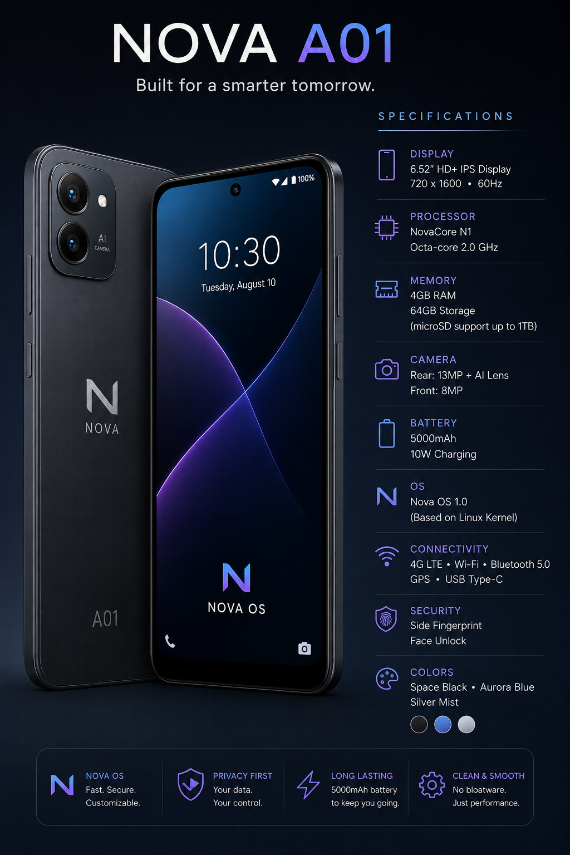
Nova A01 hardware spec sheet and brand positioning.
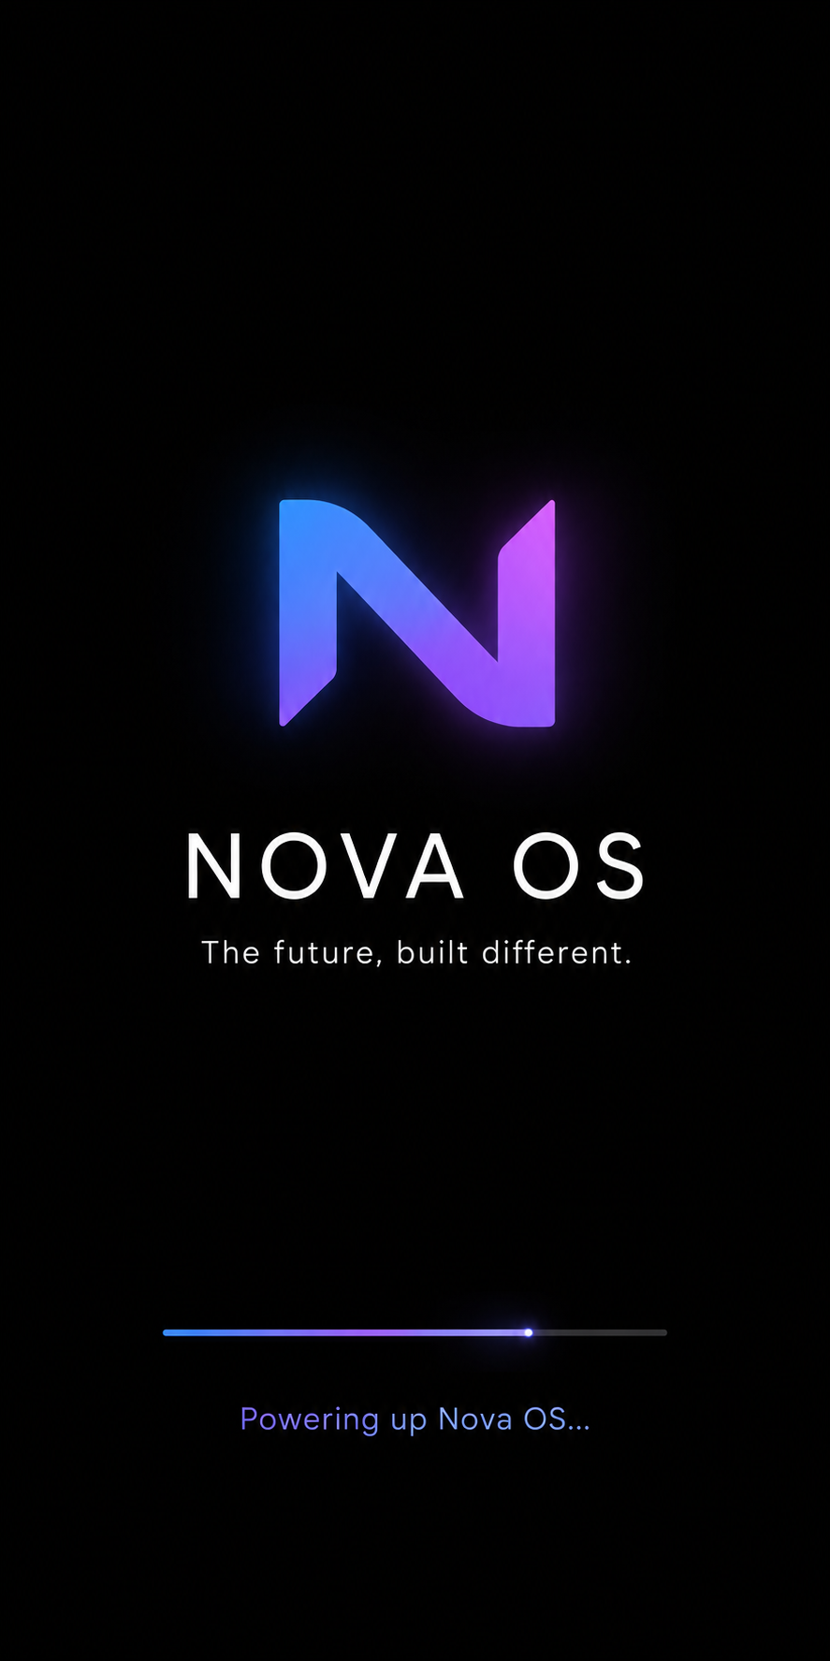
Nova OS boot screen concept.
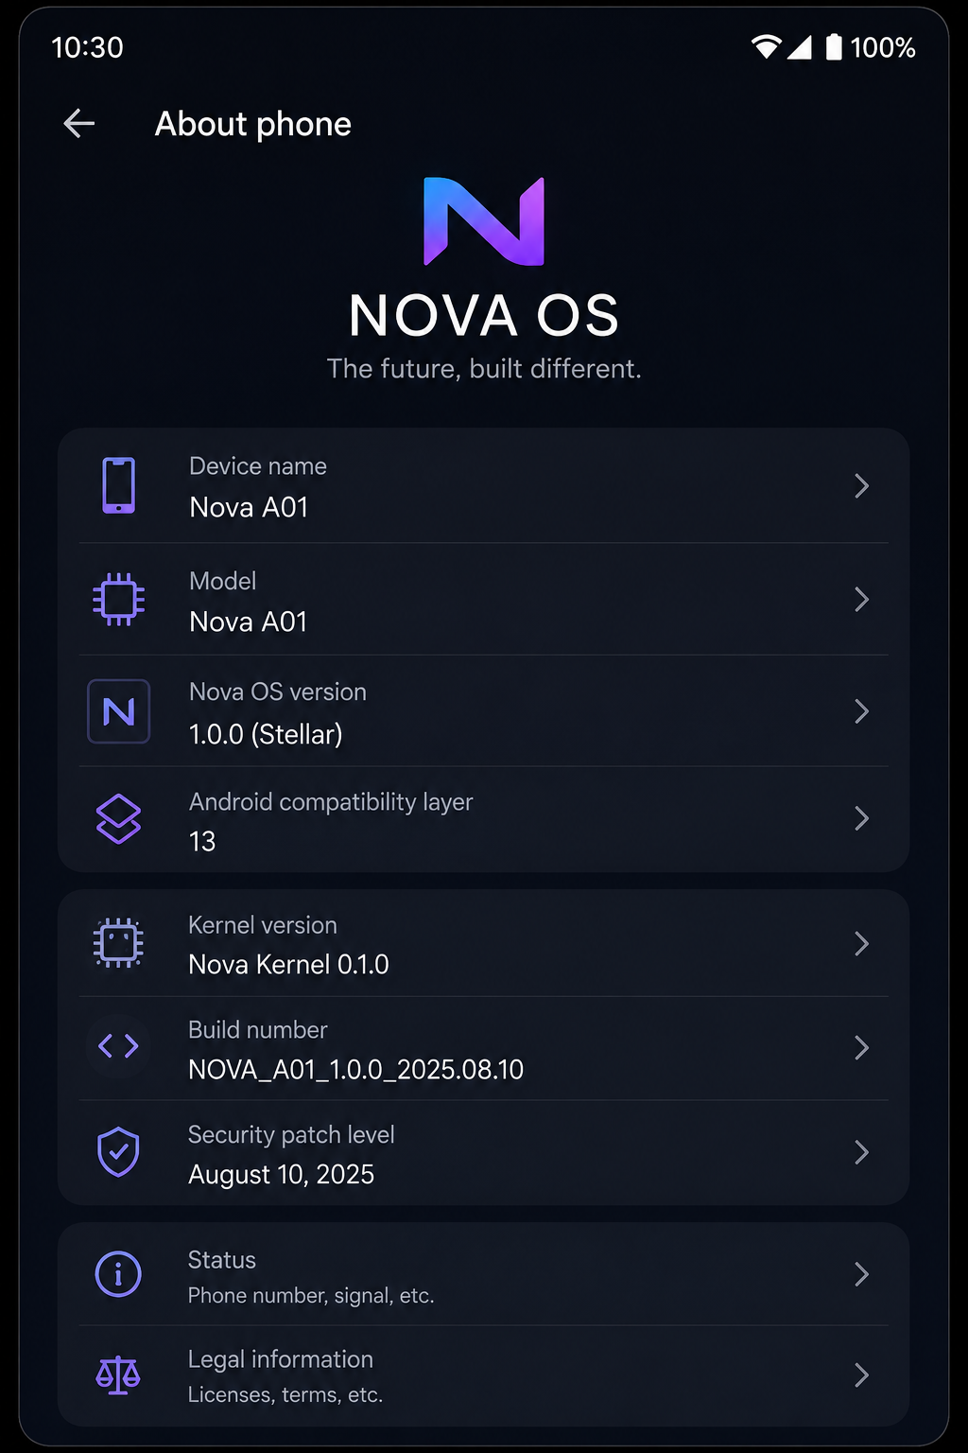
Nova OS “About phone” screen concept.
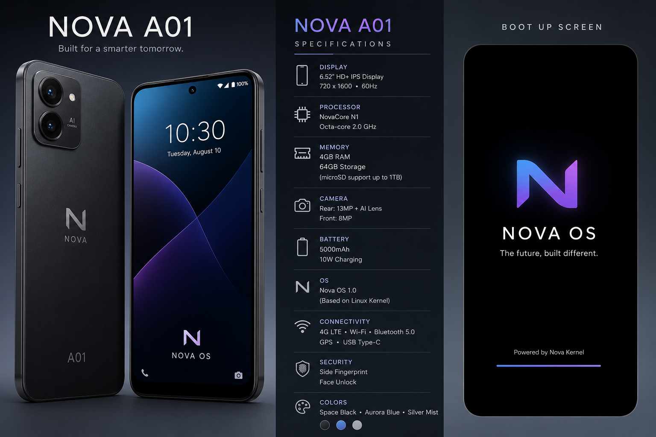
Combined device + spec sheet + boot screen layout.
Three things worth reconciling against the plan above, honestly, rather than letting the concept art quietly set expectations the schedule doesn’t match:
- Memory: the spec sheet lists 4GB RAM. Section 21 sets Nova’s actual target at 1GB-2GB. Either the spec sheet is aspirational/a higher launch SKU and 1GB-2GB stays the floor Section 21’s budget is built against, or the target device changes -- worth deciding explicitly rather than having two numbers in the same project.
- Kernel: the About-phone concept already shows “Kernel version: Nova Kernel 0.1.0.” Section 22 is explicit that a custom Nova kernel is a later track, gated on 1.0 shipping on Linux first -- through M17, the real About-phone screen (once M14 builds it) should honestly report the Linux kernel version it’s actually running, not this concept’s value, until Section 22’s preconditions are met.
- Dates: the concept renders show August 2025 (build number, security patch level). This guide’s own source Roadmap is dated August 2026. Cosmetic in a mockup, but worth fixing before it’s reused as a real build’s About-phone content.

