--------Checking for existing SSH keys--------
1. $ ls -al ~/.ssh
# Lists the files in your .ssh directory, if they exist

2. Check the directory listing to see if you already have a public SSH key. By default, the filenames of the public keys are one of the following:
id_rsa.pub
id_ecdsa.pub
id_ed25519.pub

--------Generating a new SSH-key--------
1. $ ssh-keygen -t rsa -b 4096 -C "your_email@example.com"
This creates a new ssh key, using the provided email as a label.
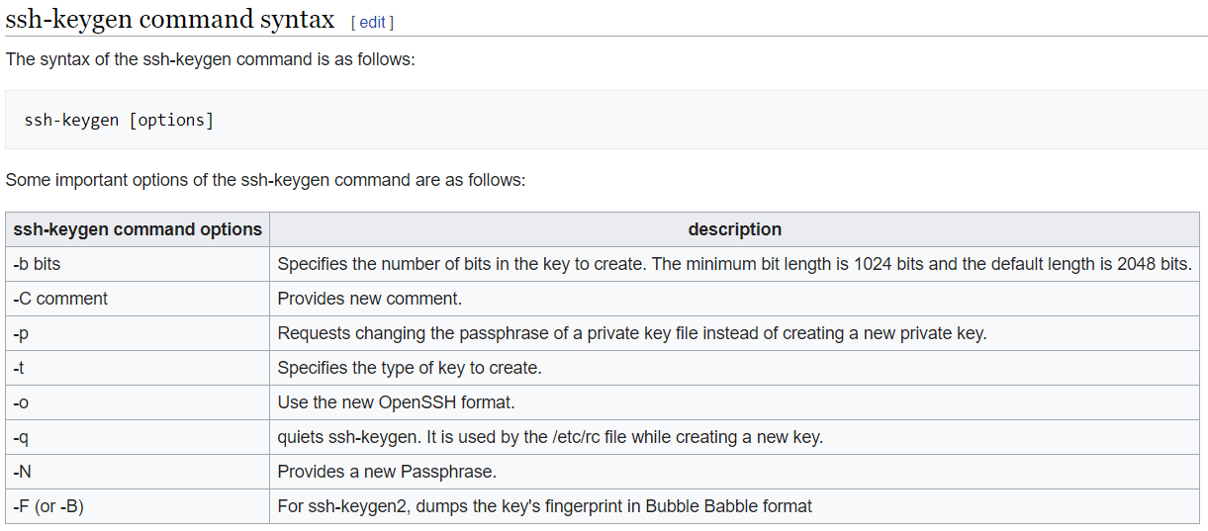

2. When you're prompted to "Enter a file in which to save the key," press Enter. This accepts the default file location.
> Enter a file in which to save the key (/c/Users/you/.ssh/id_rsa):[Press enter]

3. At the prompt, type a secure passphrase. (Don’t type anything and press Enter for no password)
> Enter passphrase (empty for no passphrase): [Type a passphrase]
> Enter same passphrase again: [Type passphrase again]

--------Adding your SSH key to the ssh-agent--------
1. Starting ssh-agent
$ eval $(ssh-agent -s)
> Agent pid 59566

2. Add your SSH private key to the ssh-agent. If you created your key with a different name, or if you are adding an existing key that has a different name, replace id_rsa in the command with the name of your private key file.
$ ssh-add ~/.ssh/id_rsa

--------Adding a new SSH key to your GitHub account--------
1. $ clip < ~/.ssh/id_rsa.pub
# Copies the contents of the id_rsa.pub file to your clipboard

2. Add them to your Github account

--------Cloning a repository using the command line--------
1. $ git clone https://github.com/YOUR-USERNAME/YOUR-REPOSITORY

--------Branches--------
1. git branch / git branch --list
>Lists all branches in repository

2. git branch <branch>
>Create a new branch called <branch>. This does not check out the new branch.

3. git branch -d
>Delete the specified branch. This is a “safe” operation in that Git prevents you from deleting the branch if it has unmerged changes.

4. git branch -D <branch>
>Force delete the specified branch, even if it has unmerged changes. This is the command to use if you want to permanently throw away all of the commits associated with a particular line of development.

5. git branch -m <branch>
>Rename the current branch to <branch>

6. git branch -a
>List all remote branches

