Creating Google Cloud Function

Go to MyFirstProject and search Cloud Functions

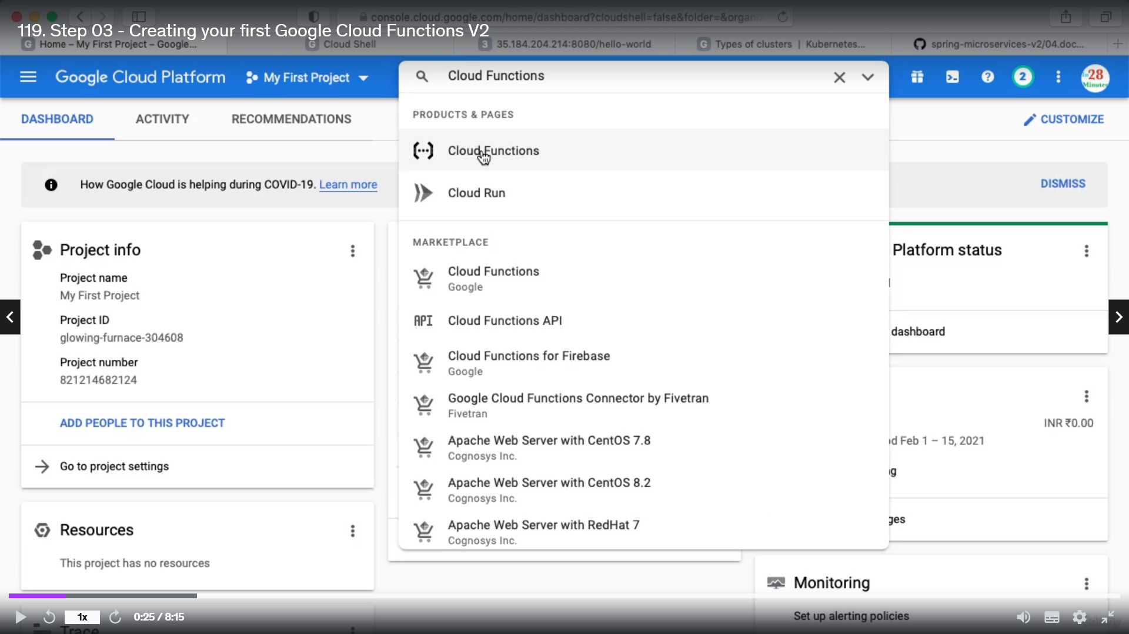

This will enable the Cloud Functions API and now click create Function and Fill below details

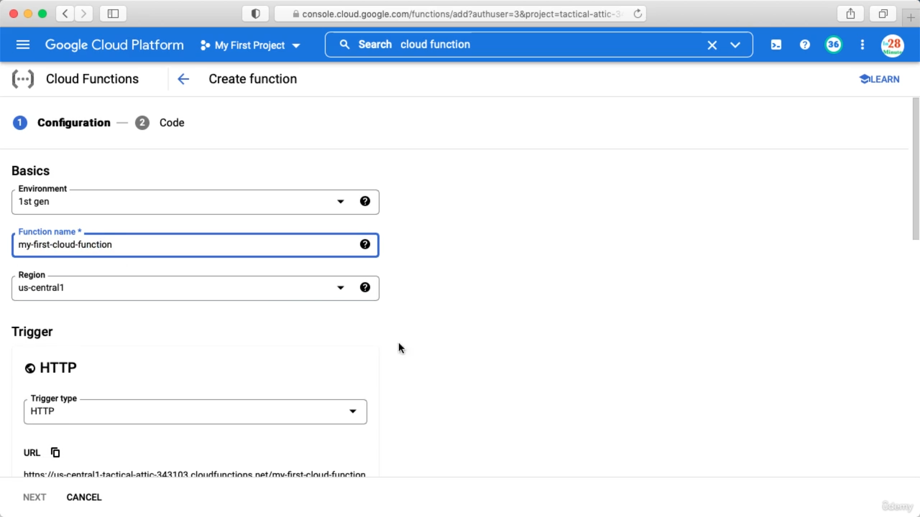

Copy the url for future use

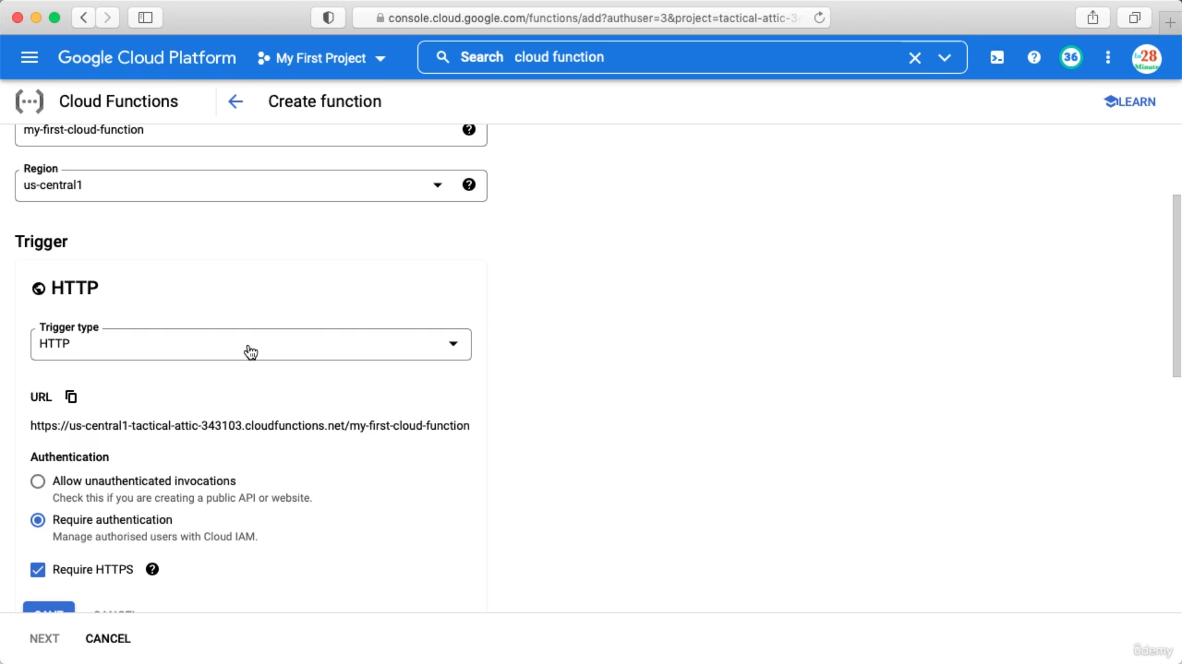

Trigger type is from where you want to trigger this function.

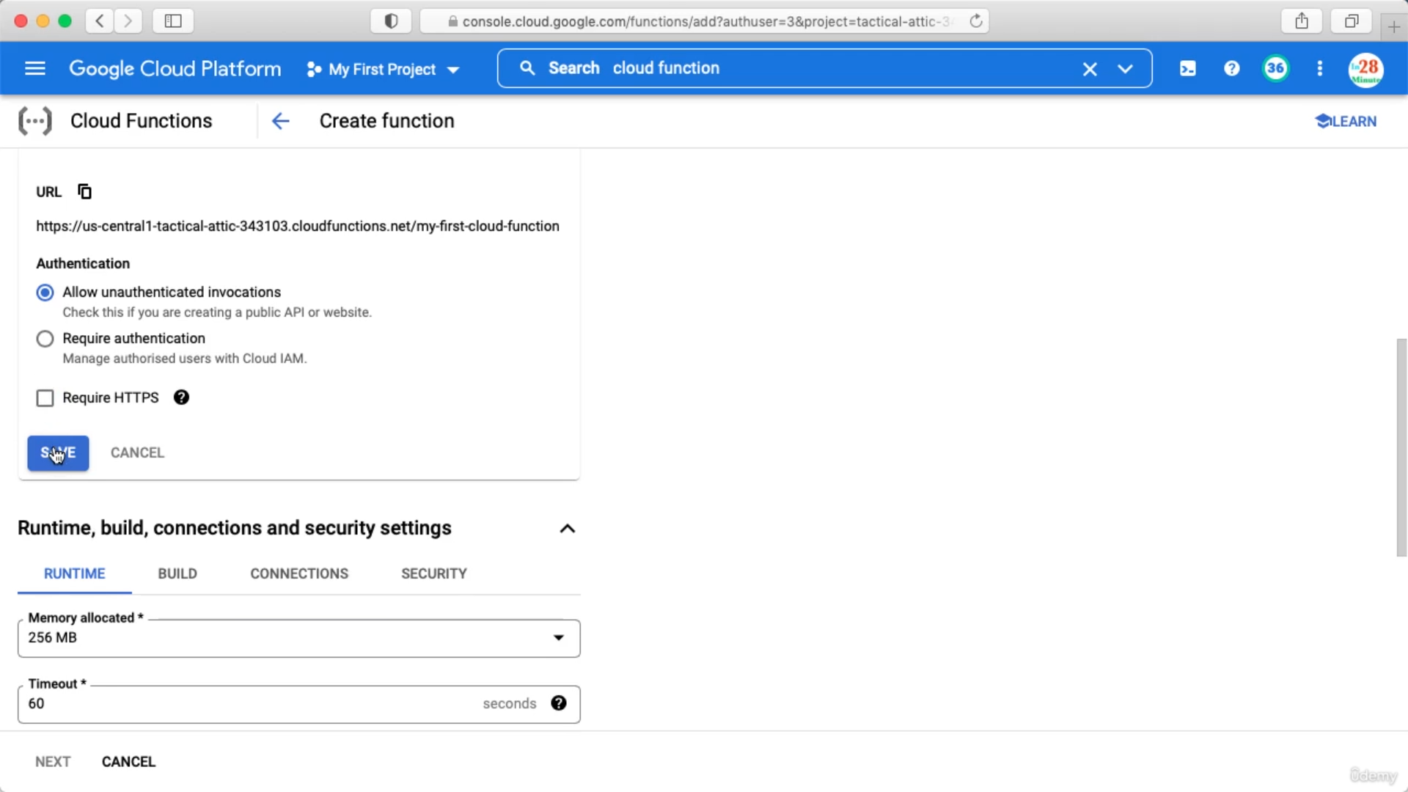

For now follow the Authentication section as above. On clicking Next we have to enable cloud build API. Just click enable.

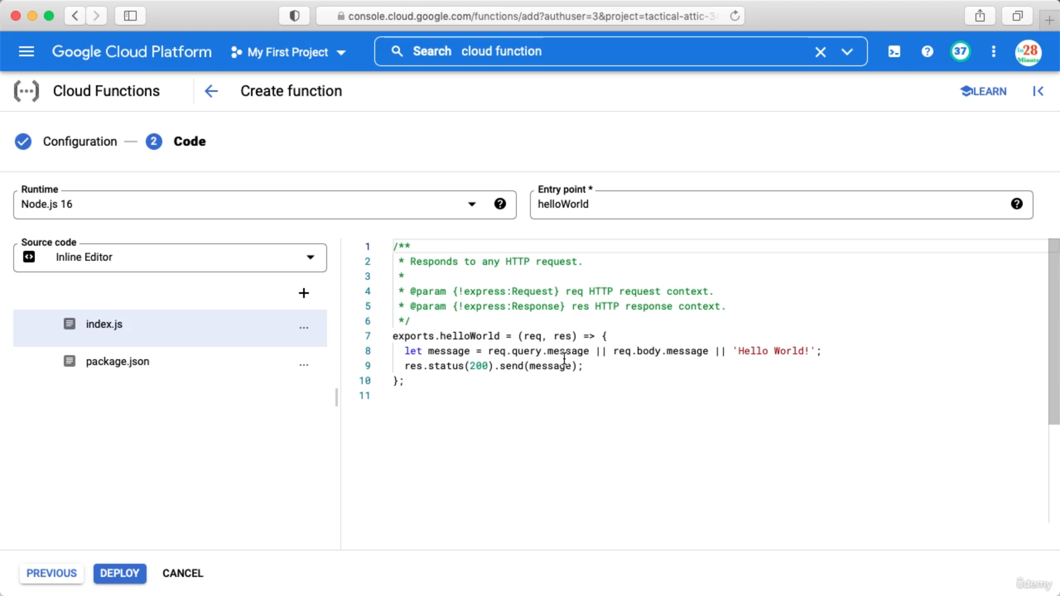

After clicking Next above page will apear and we have to write the Function and click DEPLOY.

After the deployment is completed you can click the Function and go to Testing Tab

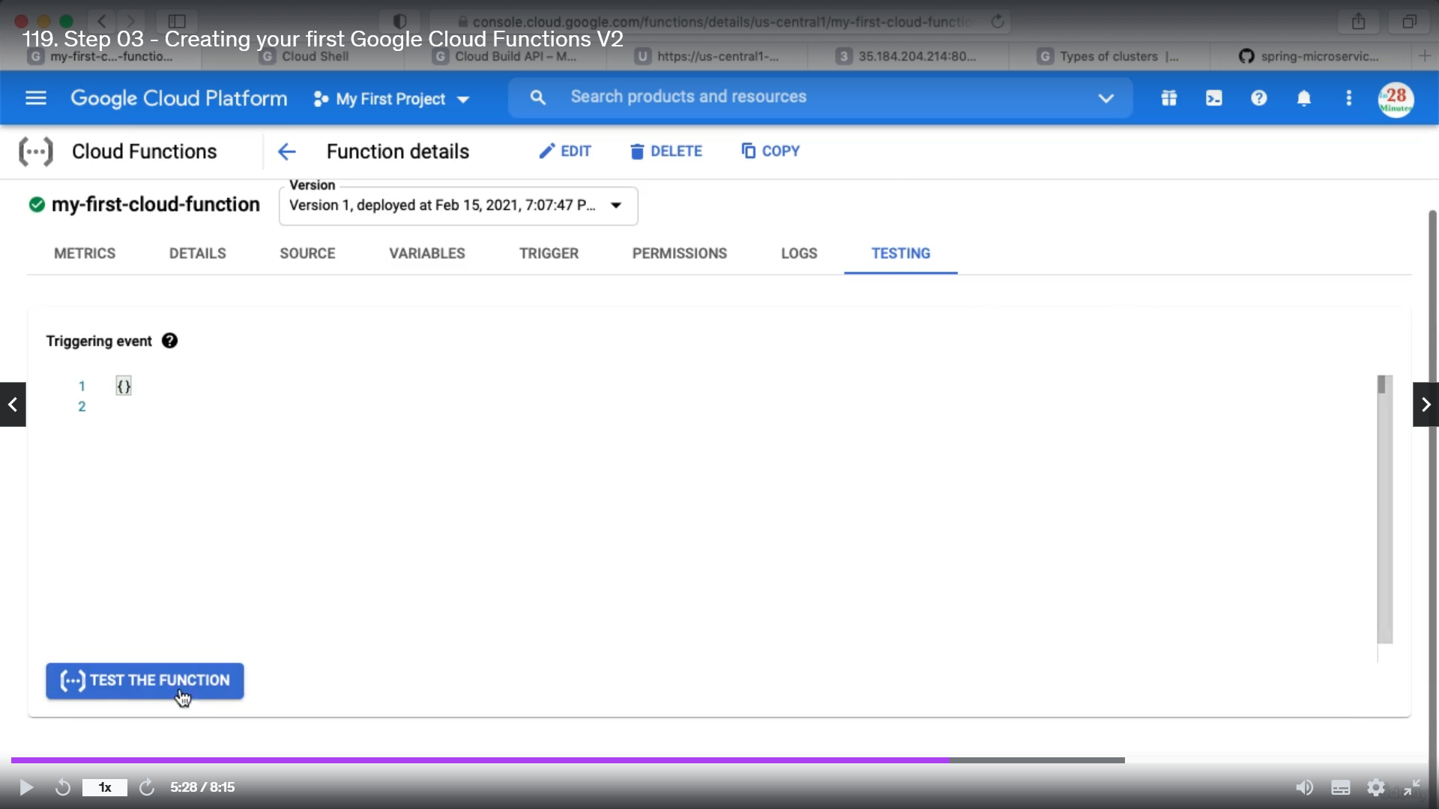

Section 12: Google Cloud Run

For deploying a service from Kubernetes we need to create a cluster first. Easier way to deploy a MS is using cloud run.

From My First Project -> Click Cloud Run -> Click Create Service (This will enable Cloud Run API)

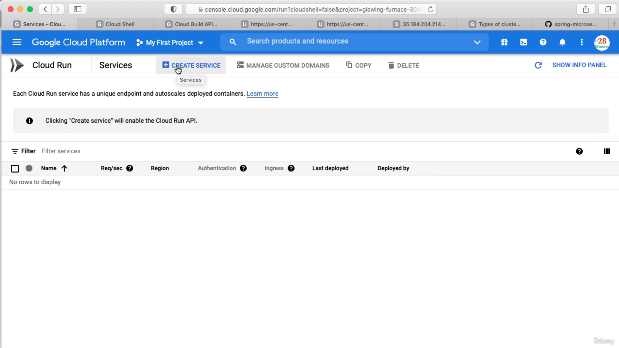

Click select to Container Image URL and use the default one provided by GC.

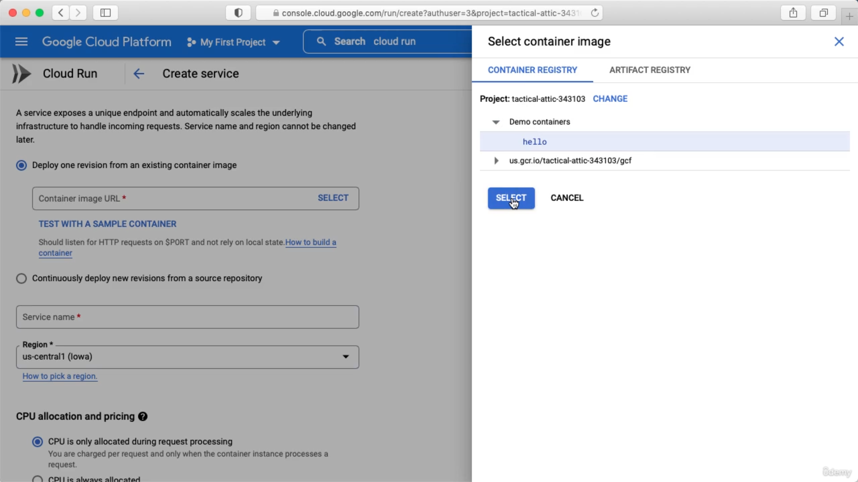

Once you created cloud run with a name and region you can not change the name and region.

We can edit the deployment and manage the traffic

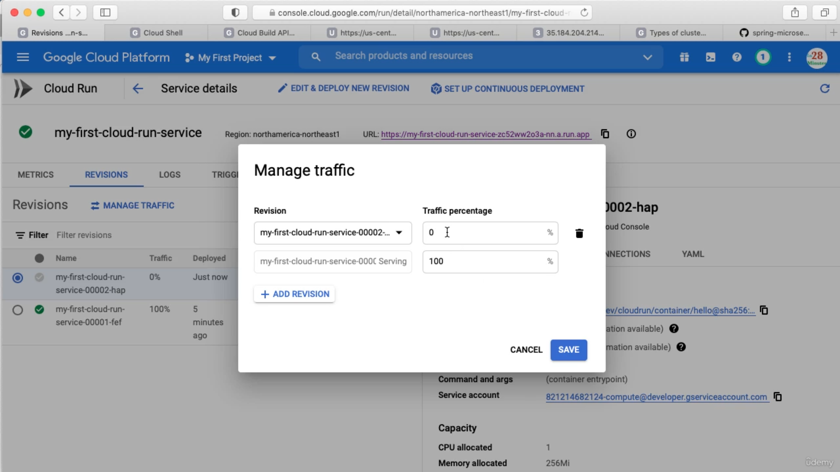

At the end click the service and delete the service

