Storage

Block Storage: kind of a hard disk attached to a VM’s. We can attach one Block Storage to ove VM only.

One file storage can be shared with multiple VM’s.

Type of Block Storage in GCP

Persistence Disks: These are network Block Storage and connected using host address of VM. There are three types of persistence disk Standard, Balanced and SSD.

Local SSD : present in the same host of your VM i.e. local to VM.

FileStorage is File Store in GCP

Demo

When we create a VM we can add a Block Storage to it

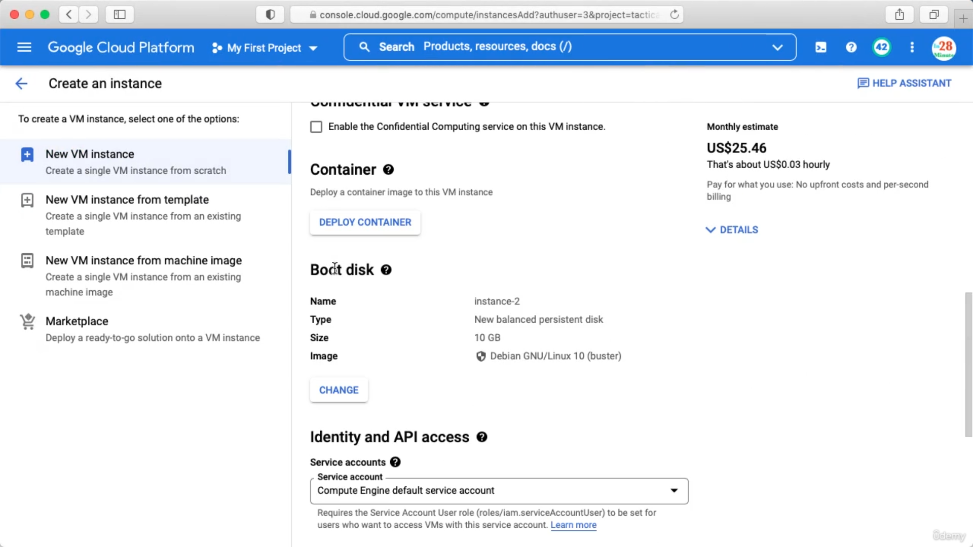

When we create a VM a Boot disk is automatically attached and by default it is a 10GB persistance disk.

If we want to expand this click below

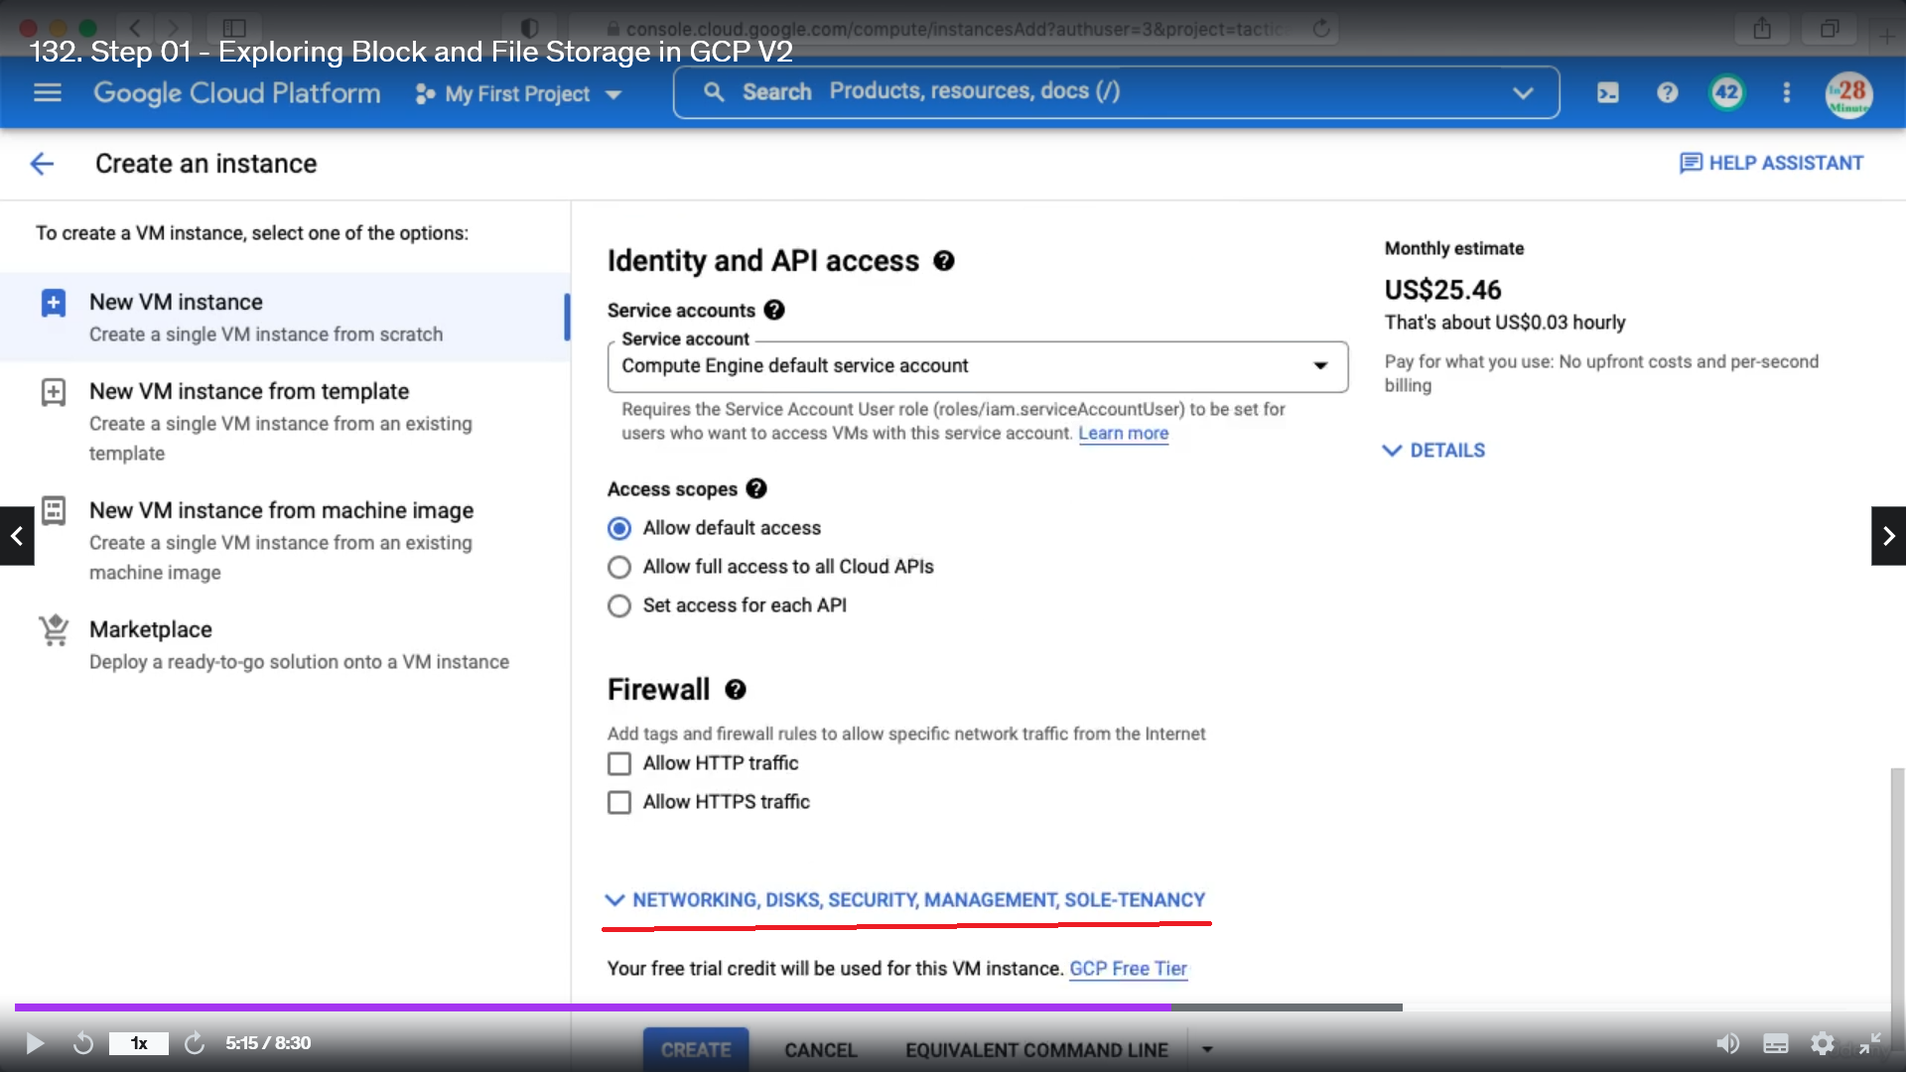

Click on disk

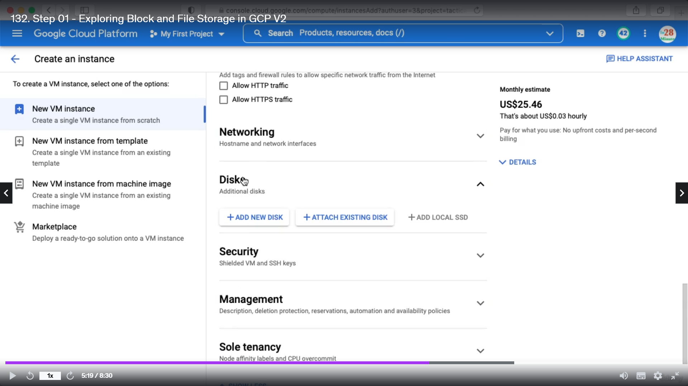

Click add new disk and you can configure there

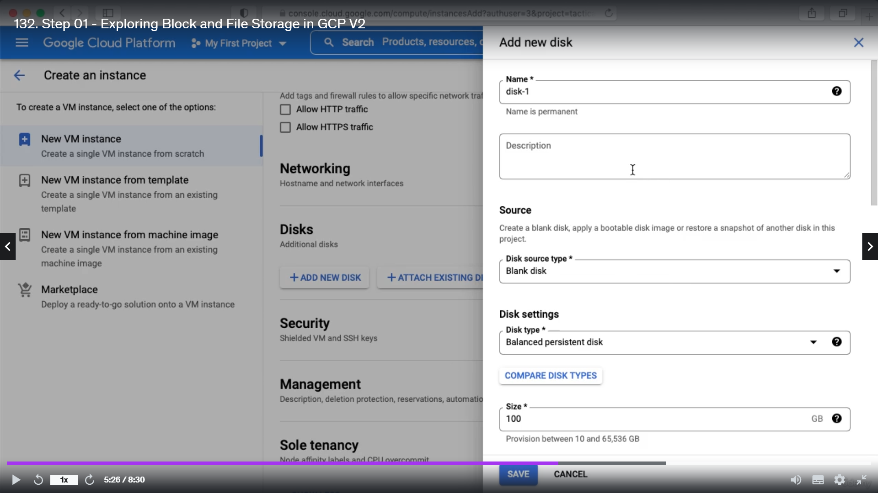

Local SSD is not available for all types of VM. For N2 type it is available.

You can create File Store by enabling below API.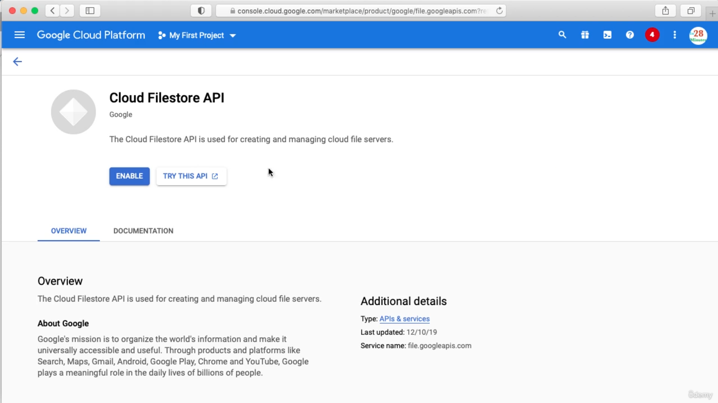

Once the API is enabled you can create a new instance of File storage

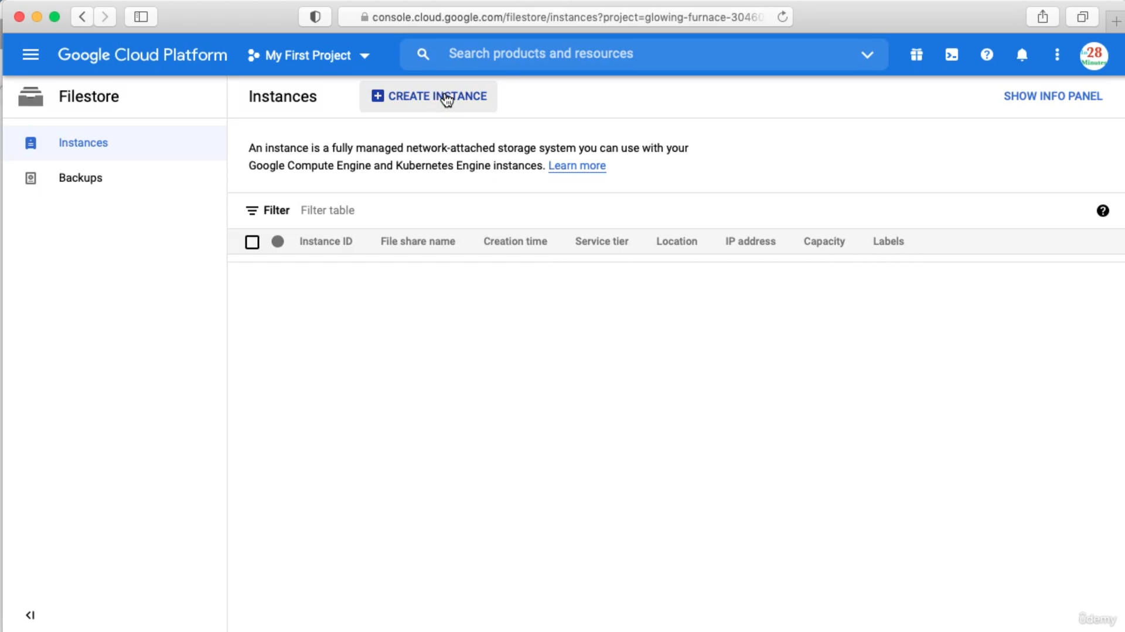

Once you create a File-Store you can SSH to VM and attach the File-Store.

If you want high performance use local SSD and if you want high durability use Persistent Storage. File storage is for storing files.

Chapter 2

When we click local SSD while creating new VM then we can choose the interface and the number of local SSD we want to connect. Google will automatically encrypt of whatever you store and you can not generate the key.

\*\*within a single host we can have multiple VM and multiple Block storage.

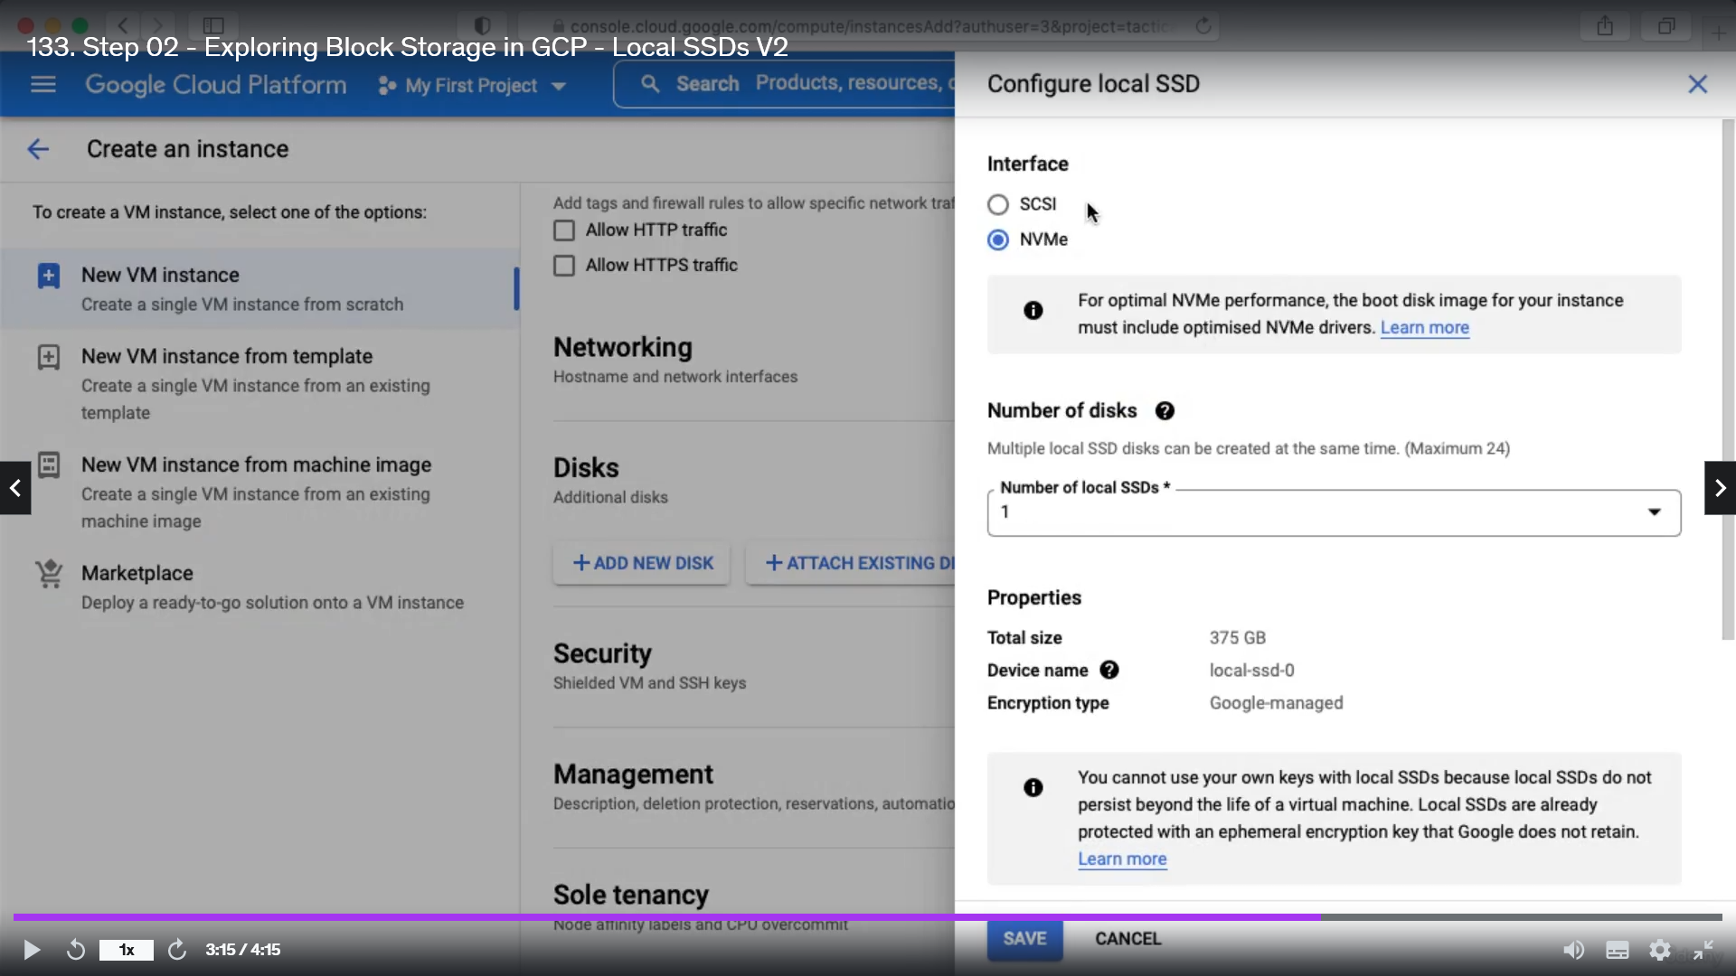

Chapter 3 and Chapter 4 and Chapter 5

PPT

Chapter 6

Persistence Disk Snapshots are time to time storage of your data.

Snapshots are incremental : The first snapshot have all the information of the PD and the second snapshot has the information which is not there in the first.