Cloud Data Store and Fire Store

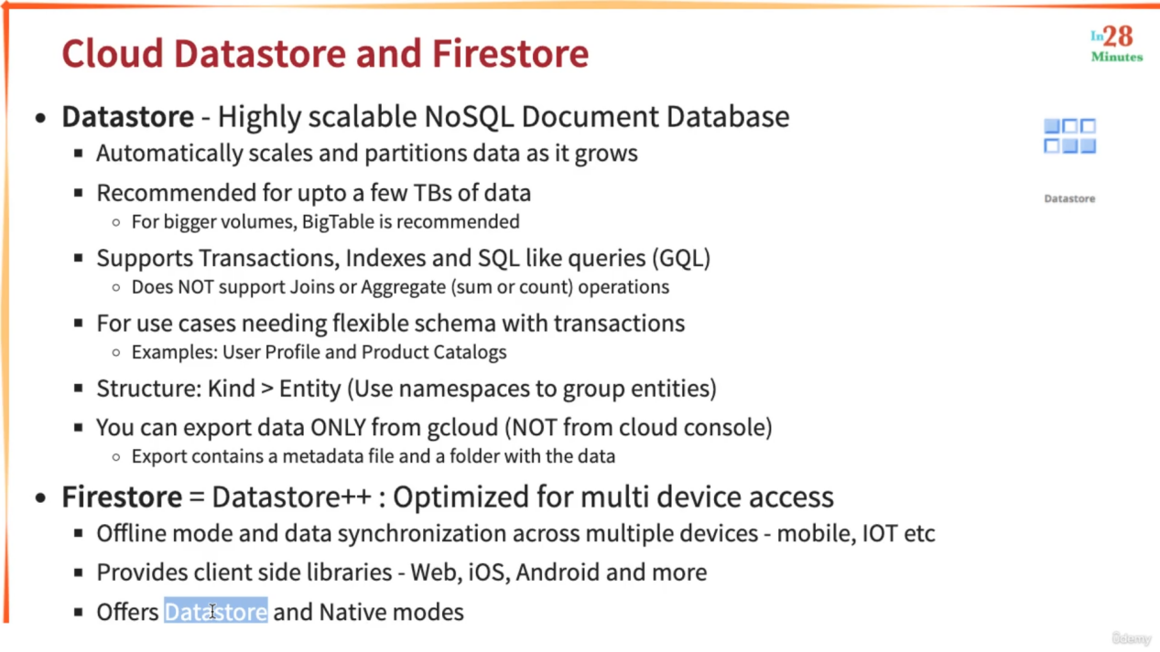

Demo

Search for Firestore

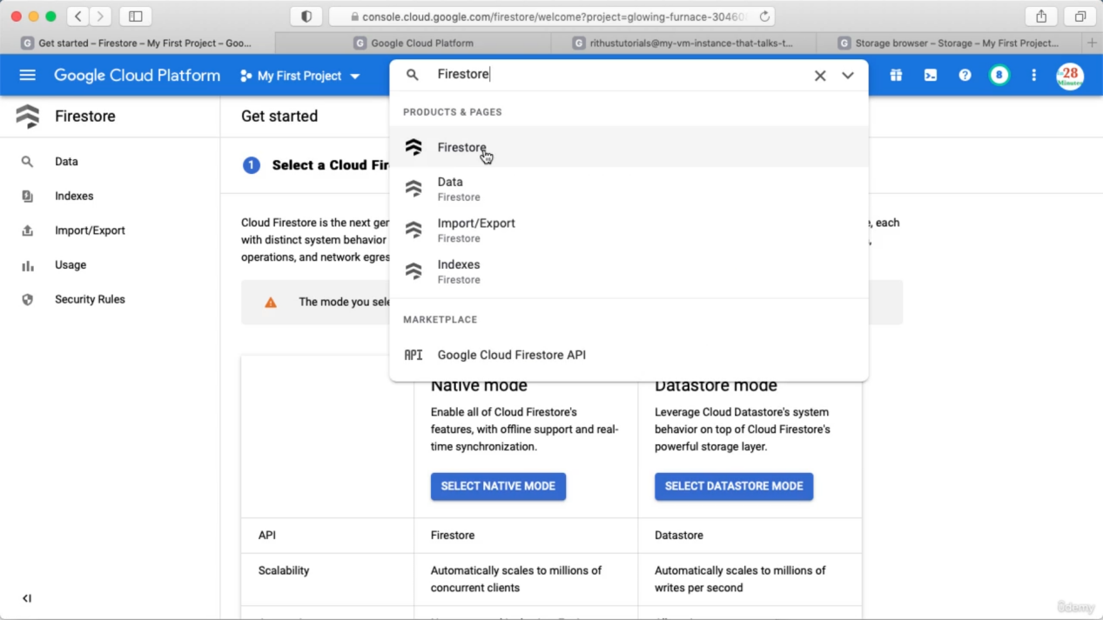

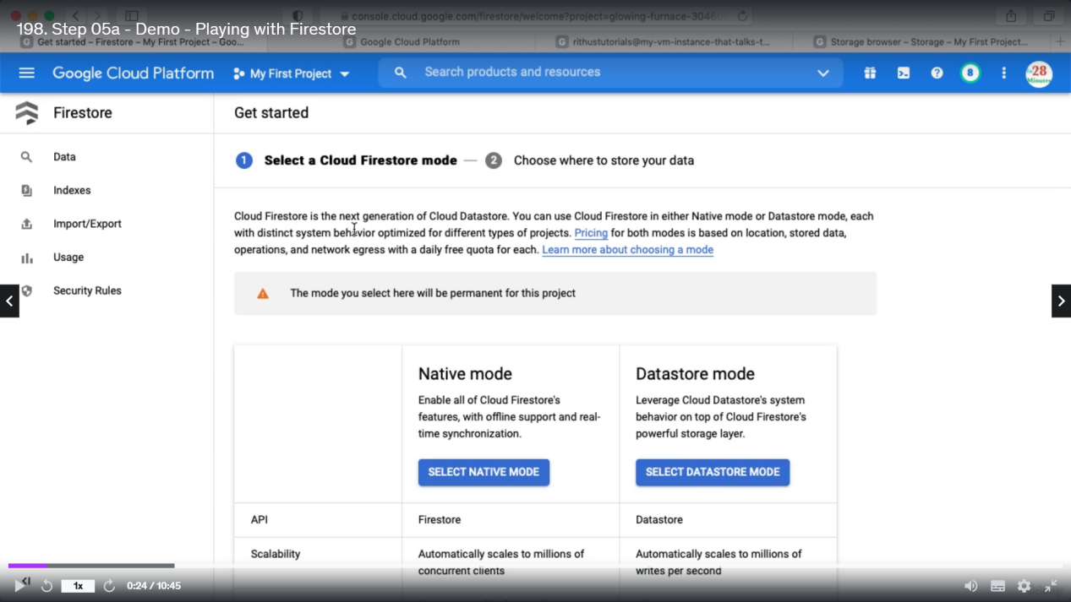

If you have old data store that you want to move to Firestore, then choose Datastore mode. If you are creating new projects then use Native mode.

Selected mode is permanent for a specific project.

Select Native Mode and choose location

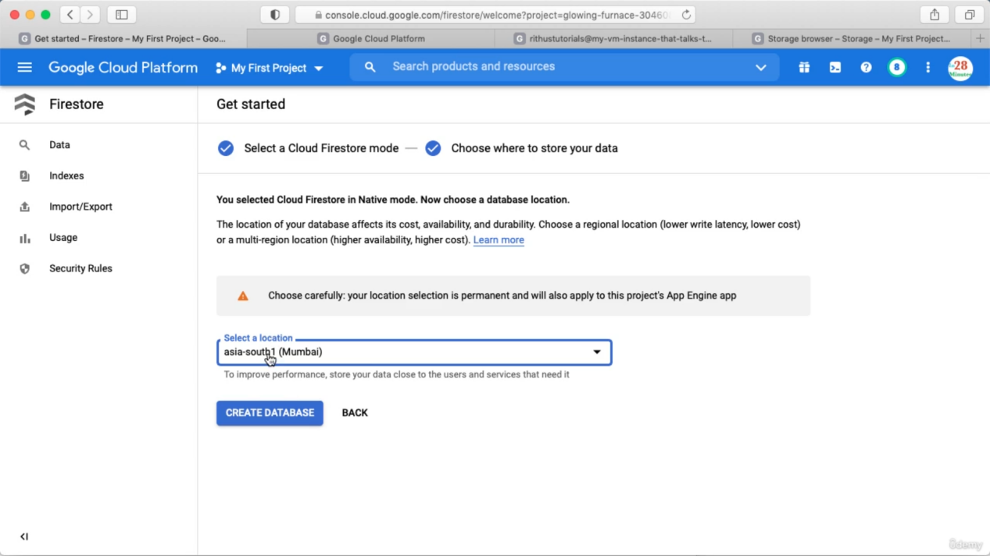

Click create database.

After creating database the screen will look like below

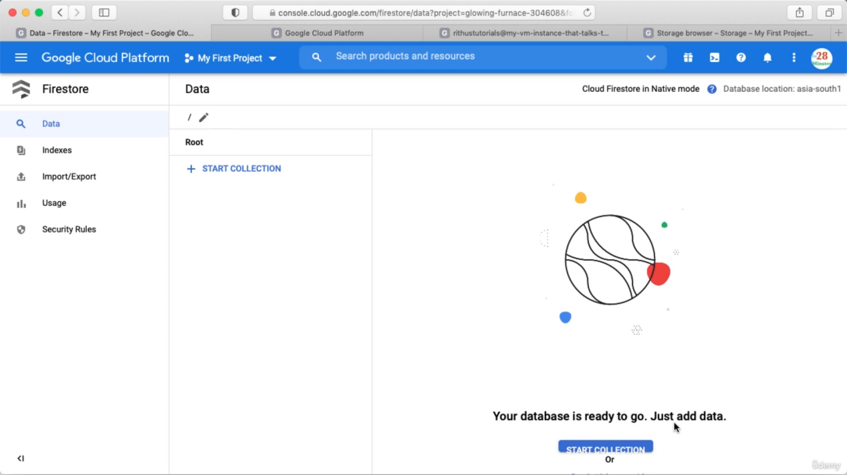

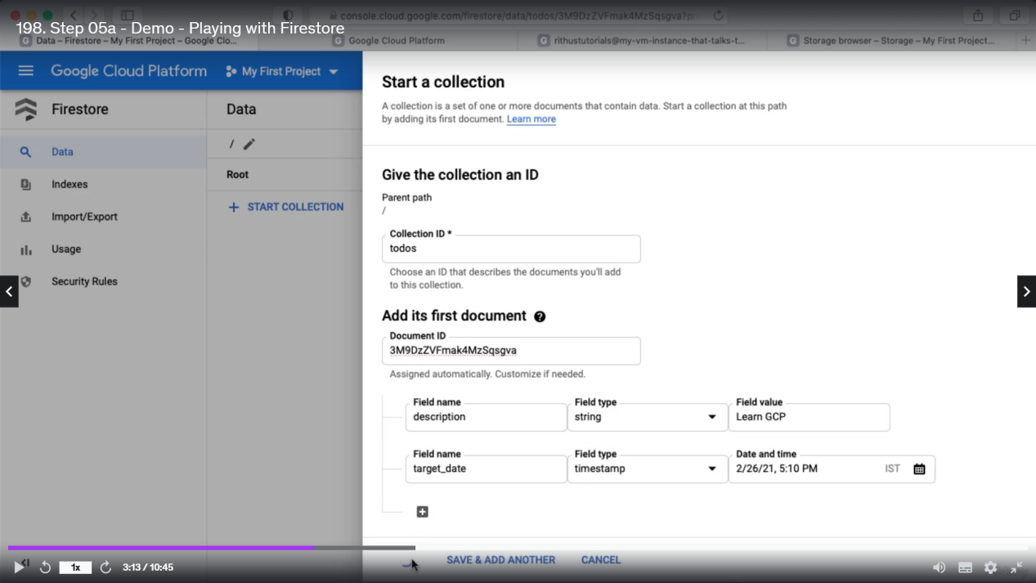

Start a collection and you can store data into it.

So, inside a collection we added a document and we can add more documents

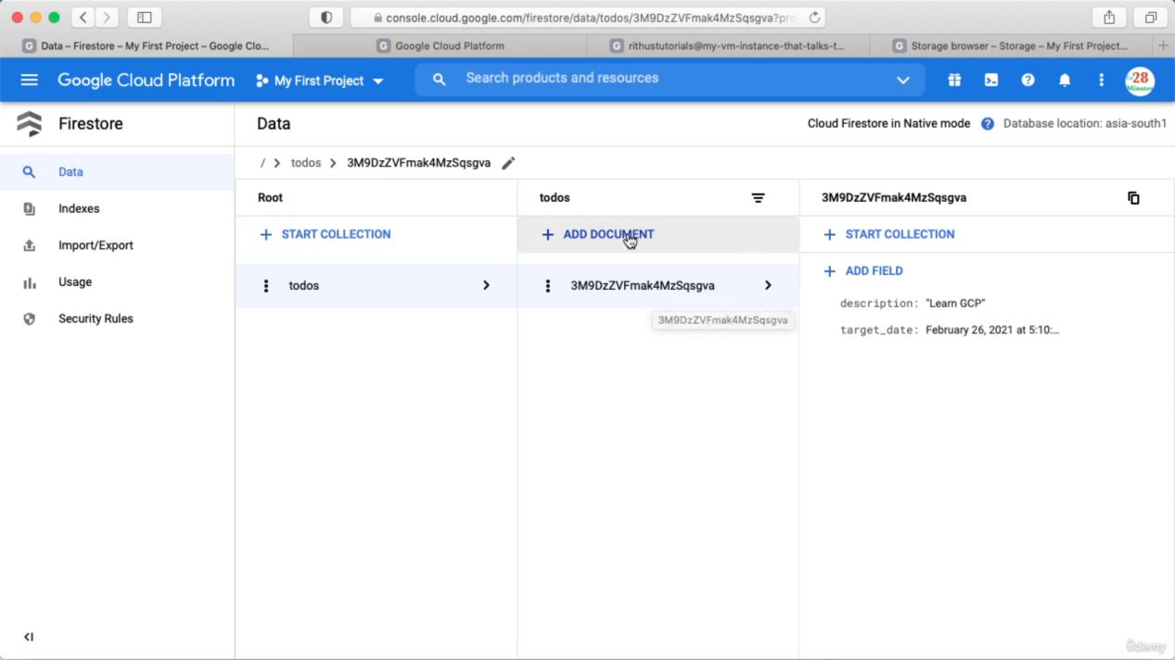

This is hierarchical : inside a document we can create a Collection also.

Go to index and create a new index

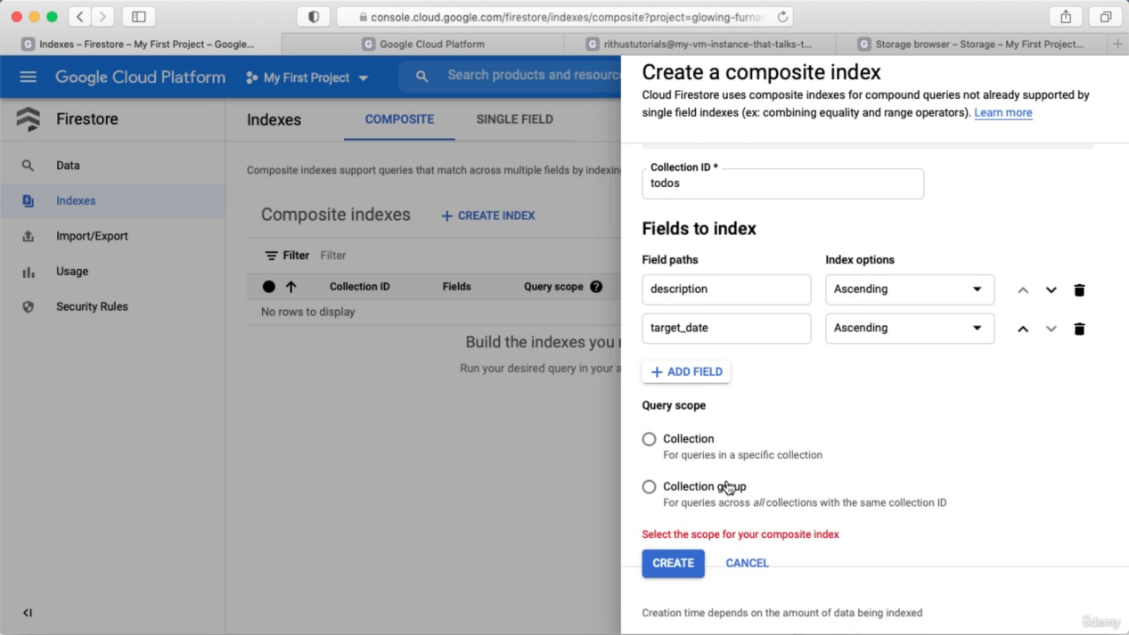

Go to data and you have option to filter data

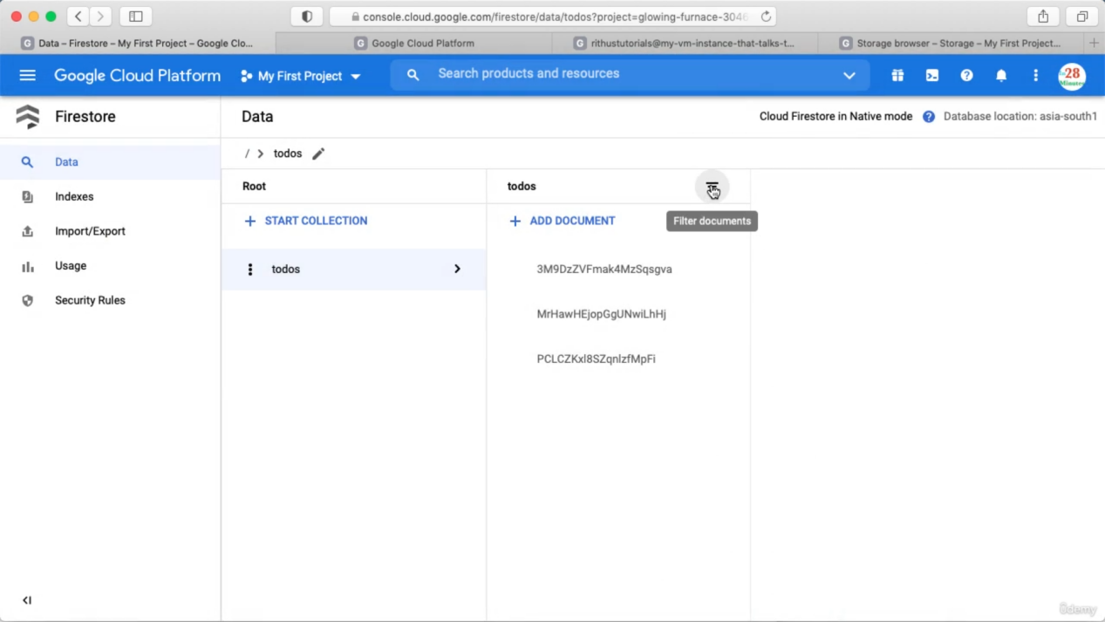

Import and Export

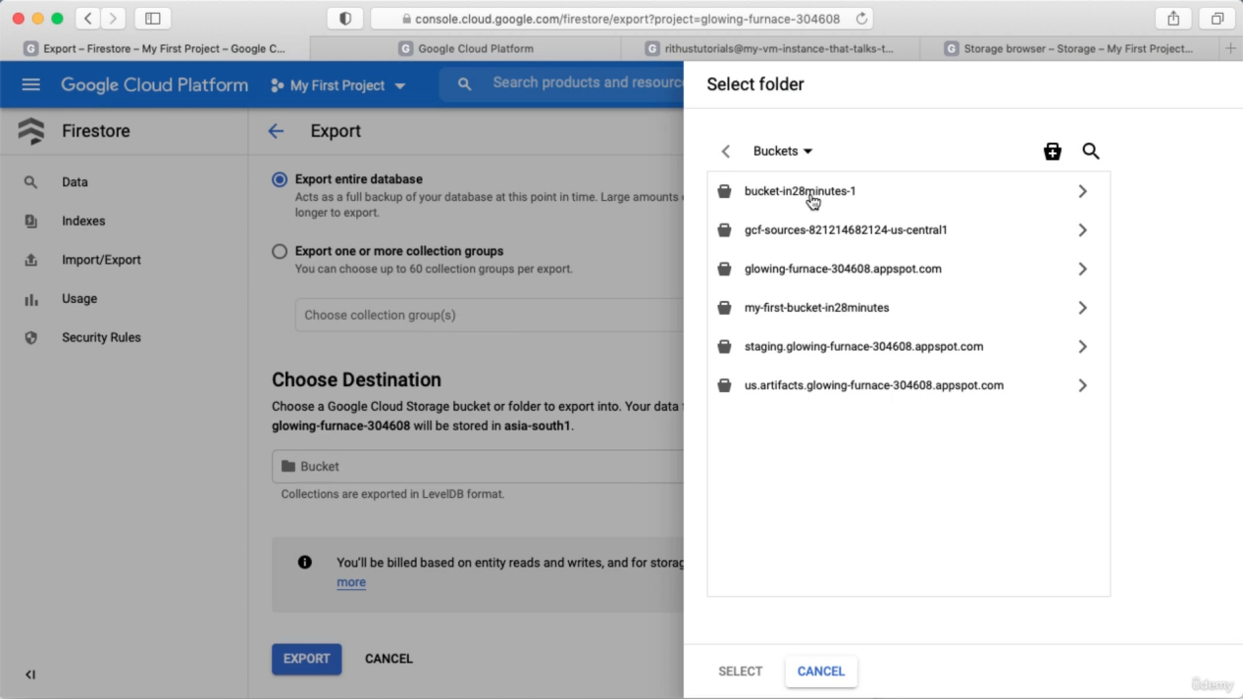

Cloud Big Table

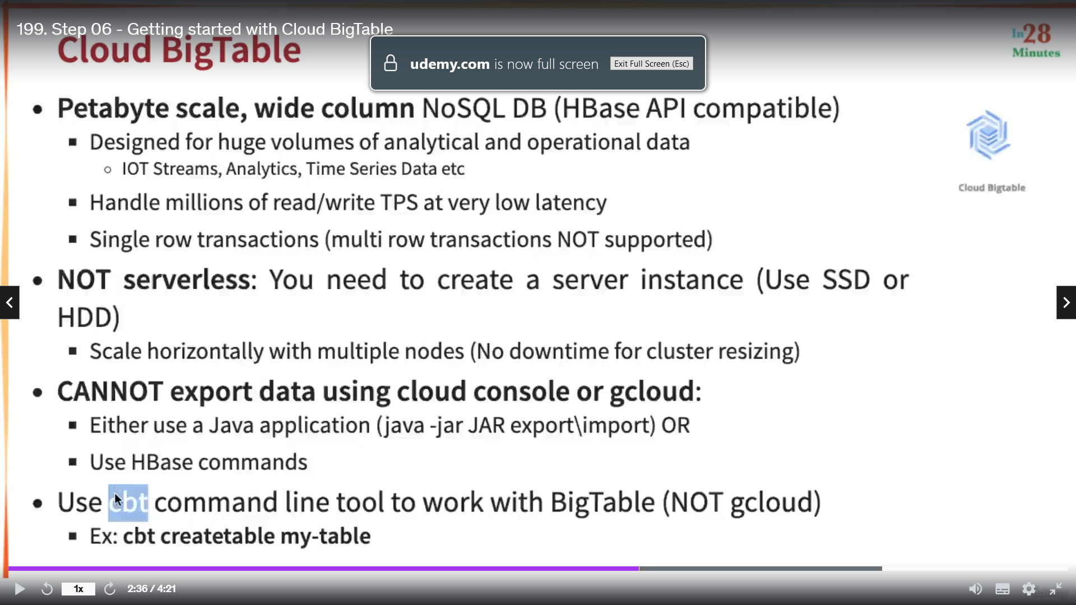

Cloud Big Table is Hbase DB compatible. We can export Cloud Big Table data to local Hbase DB or we can import local Hbase DB data to Cloud Big Table.

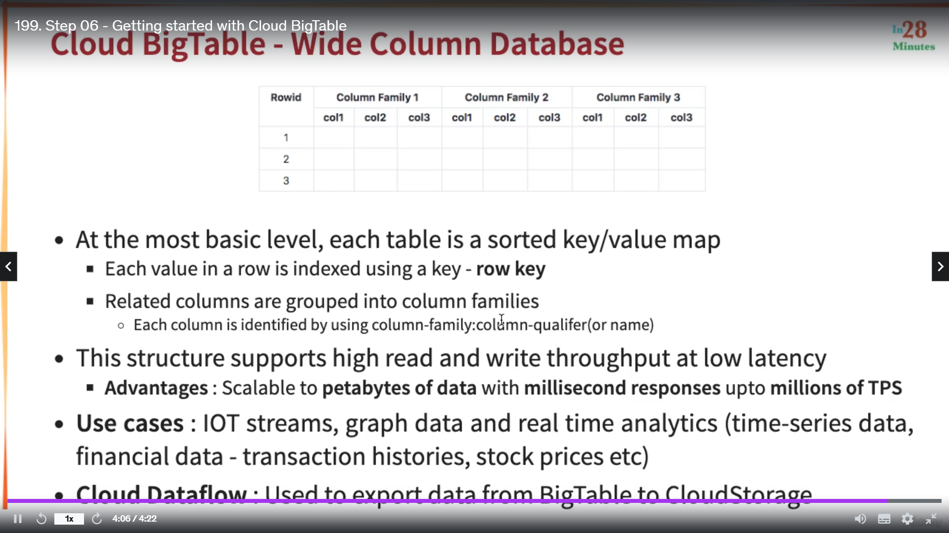

Memory Store DB