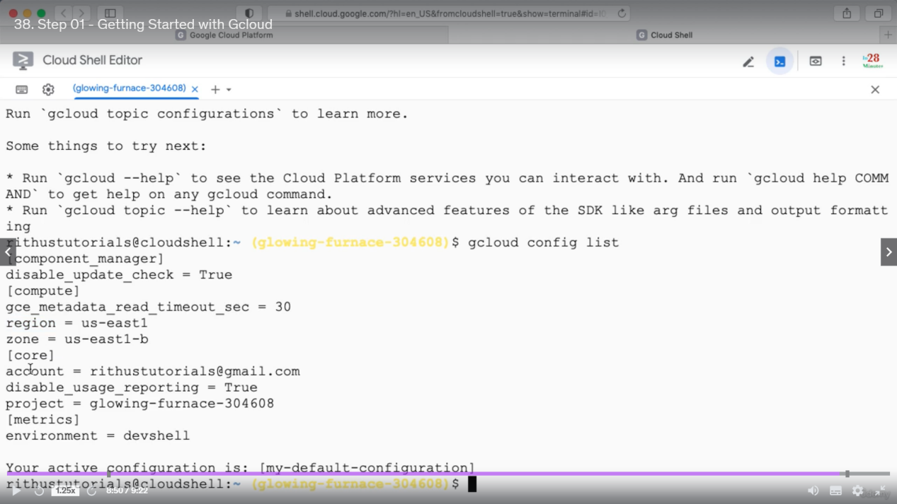

Important for exam: compute.region, compute.zone core.account, core.project

Important commands

1. gcloud config list project
2. gcloud config configurations list
3. gcloud config configurations activate my-default-configuration
4. gcloud config list => (list the entire configuration)
5. gcloud config list account => (list the accounts (as core is the default section we do not need to specify core/account))
6. gcloud config list compute/region => (as region is under compute so we need to specify compute/region (as per above image))
7. gcloud config configurations describe my-second-configuration
8. gcloud compute instances list
9. gcloud compute instances create
10. gcloud compute instances create my-first-instance-from-gcloud
11. gcloud compute instances describe my-first-instance-from-gcloud
12. gcloud compute instances delete my-first-instance-from-gcloud
13. gcloud compute zones list
14. gcloud compute regions list
15. gcloud compute machine-types list
17. gcloud compute machine-types list --filter zone:asia-southeast2-b
18. gcloud compute machine-types list --filter "zone:(asia-southeast2-b asia-southeast2-c)"
19. gcloud compute zones list --filter=region:us-west2
20. gcloud compute zones list --sort-by=region
21. gcloud compute zones list --sort-by=~region
22. gcloud compute zones list --uri
23. gcloud compute regions describe us-west4
25. gcloud compute instance-templates list
26. gcloud compute instance-templates create instance-template-from-command-line
27. gcloud compute instance-templates delete instance-template-from-command-line
28. gcloud compute instance-templates describe my-instance-template-with-custom-image

Exam: What will be the command for a particular scenario.

For Specific section help write help command as below

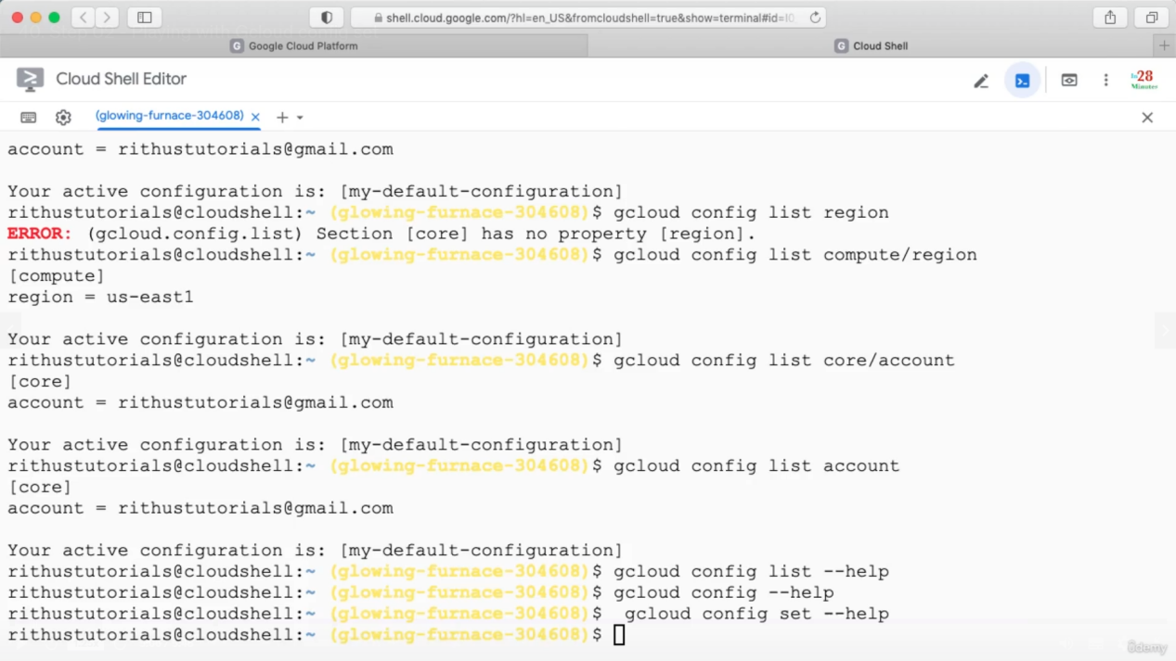

Configuration

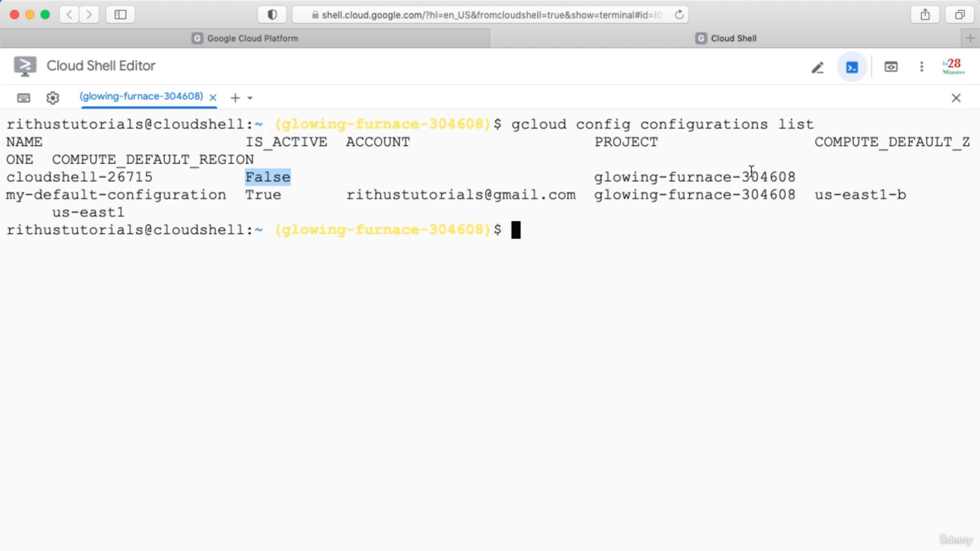

Create a configuration

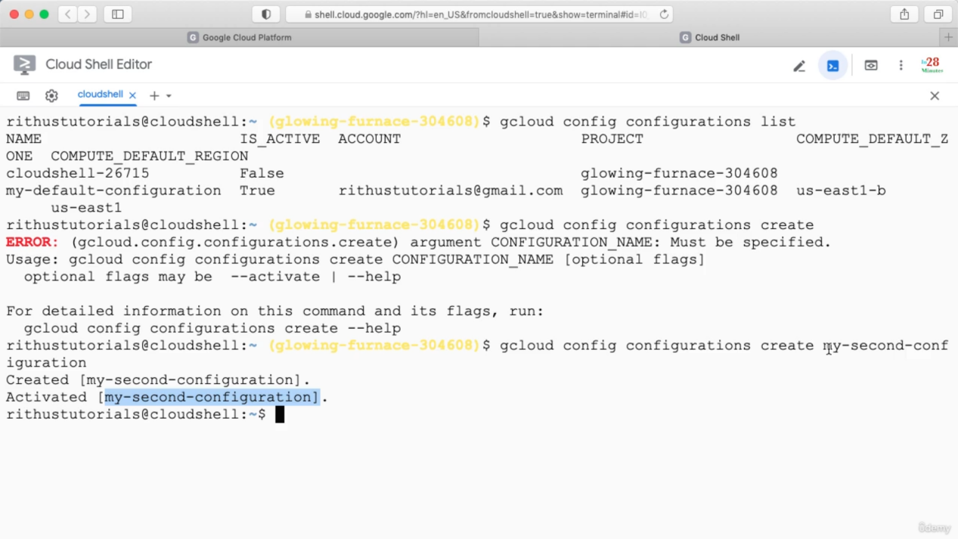

Set project in the configuration

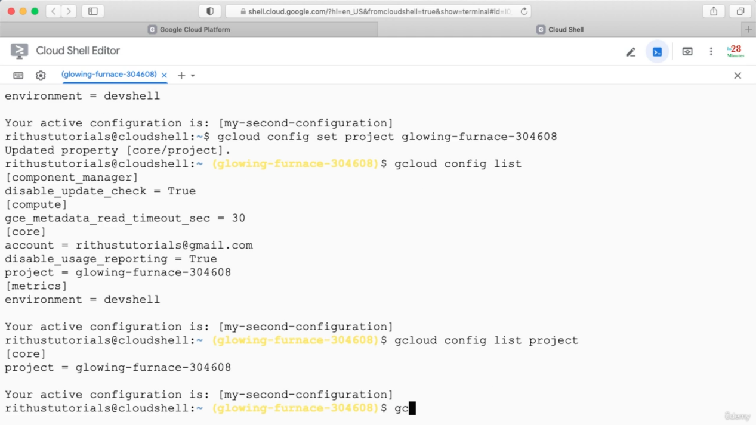

Activating another configuration

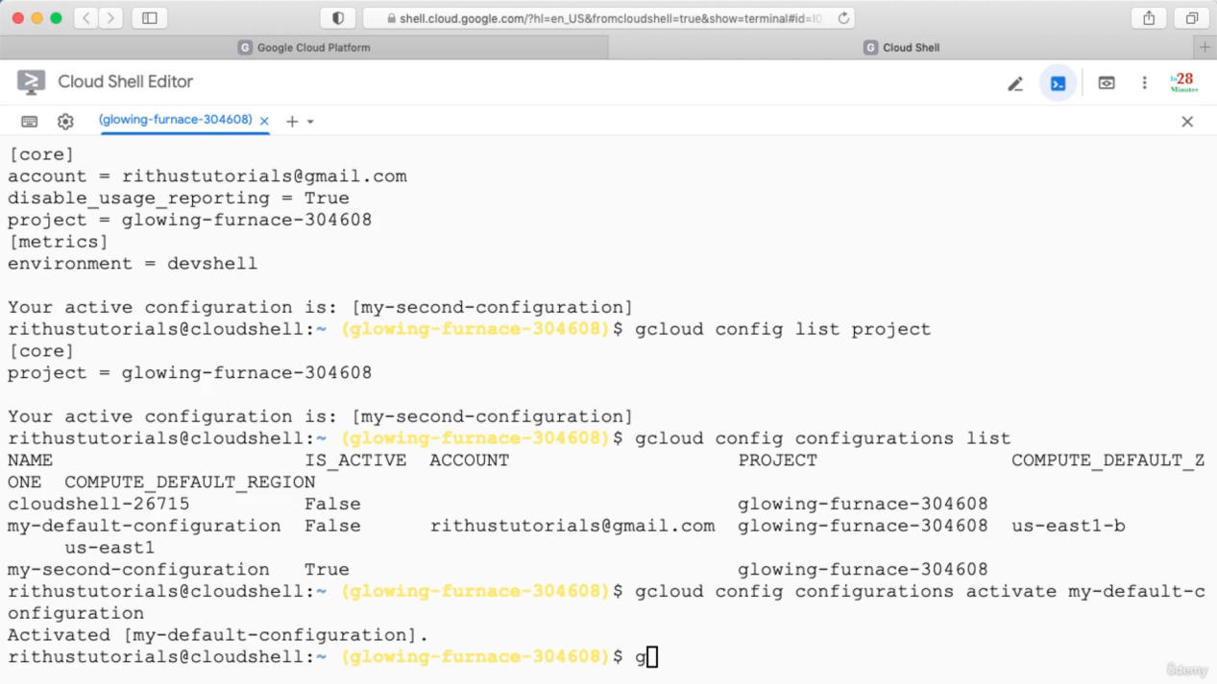

Describe (will show the property of a configuration)

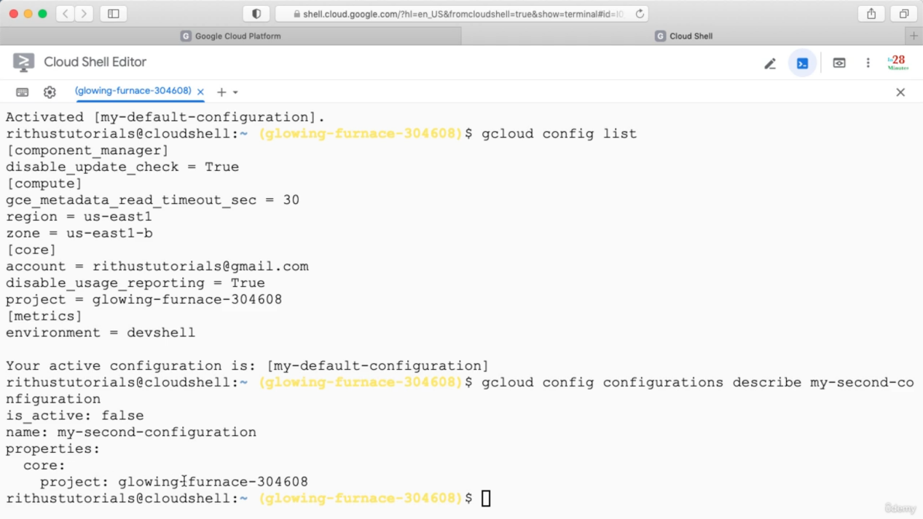

Gcloud command structure when we are playing with services

Gcloud configurations list => will list all the configurations.

Creating a new configuration

Gcloud config configurations create my-configuration

This will create a new configuration and activate it.

List all configurations

Gcloud config configurations list.

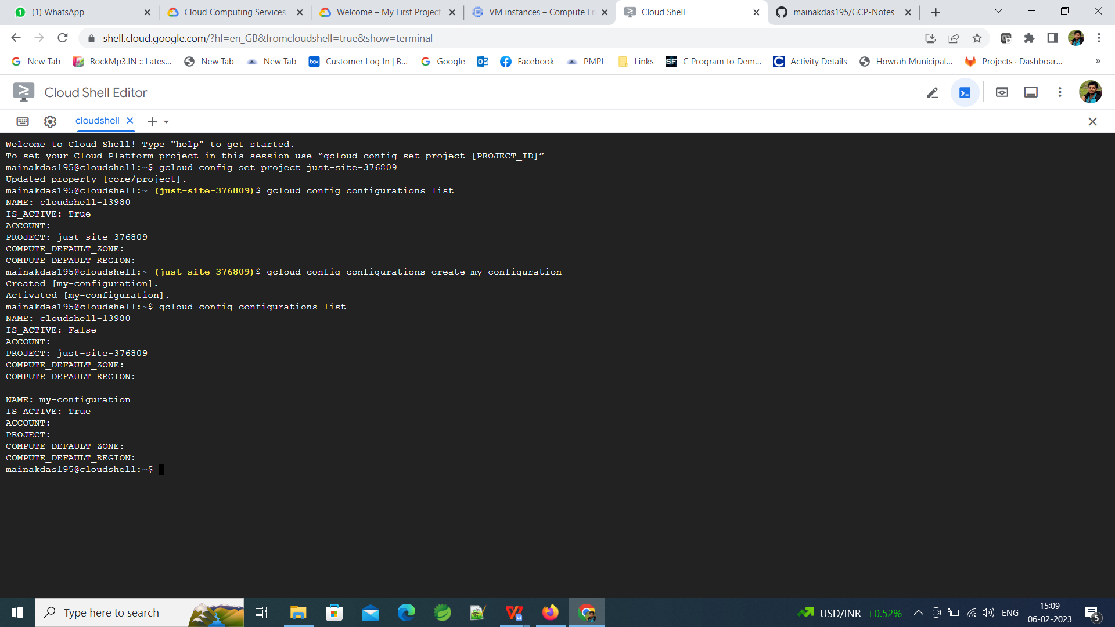

Add region and zone to the activated configuration

For this a project must be set otherwise we will get below error

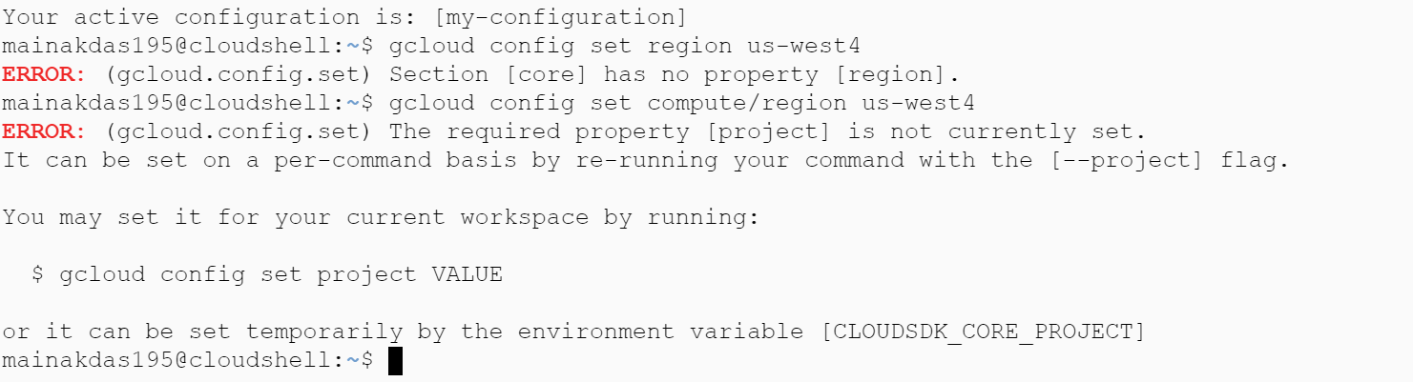

After we set the project this will work fine

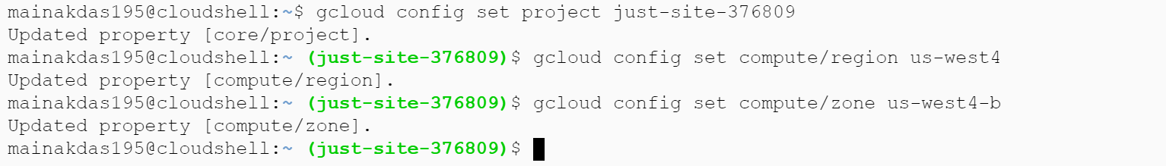

Now we can see the region and zone values are set: gcloud config list will list only the active configuration.

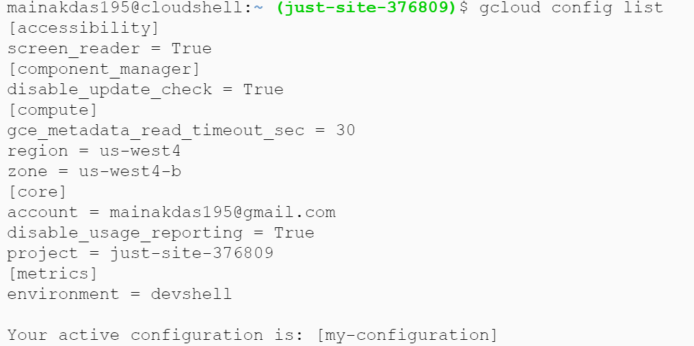

How to create a vm from gcloud: use compute

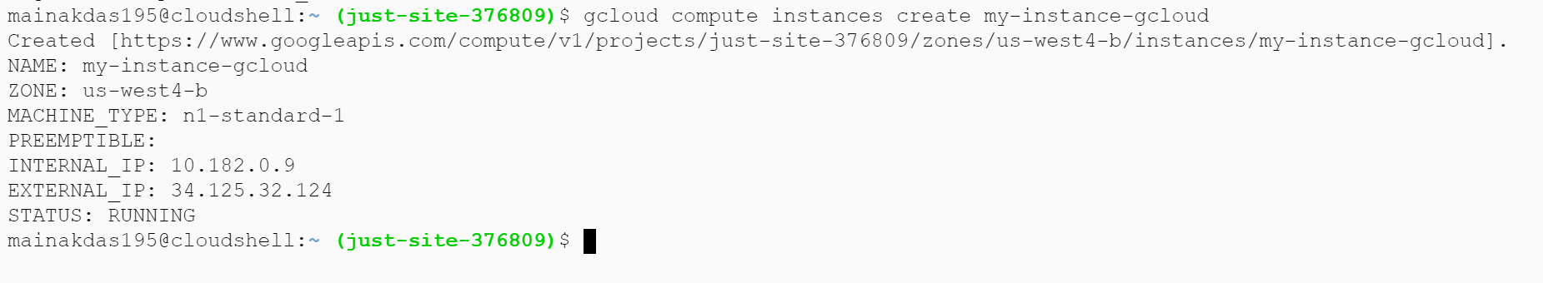

This new vm will take the region and zone from the current active configuration and other values are default values.

List all the vm instances whether they are running or not

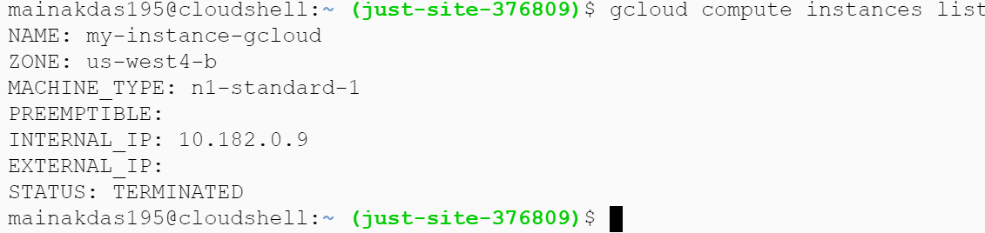

List all regions and zones

Gcloud compute regions list

Gcloud compute zones list

Set default region and zone for a project:

From console we can do it as below. Go to VM instance -> Settings -> Settings

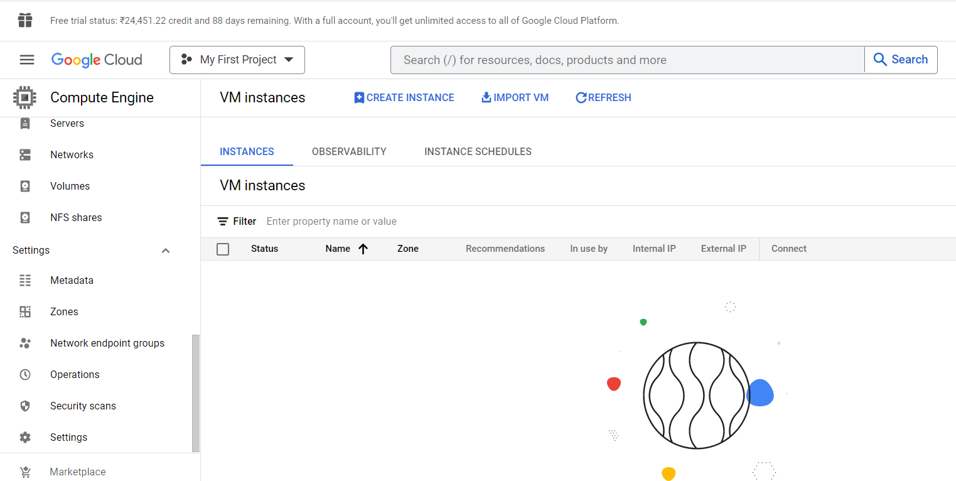

Inside setting we can set default region and zone.

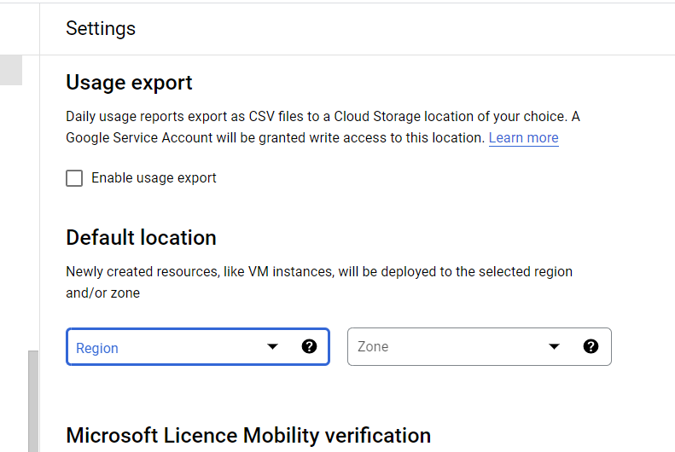

Using command

gcloud compute project-info add-metadata --metadata=google-compute-default-region=us-west4