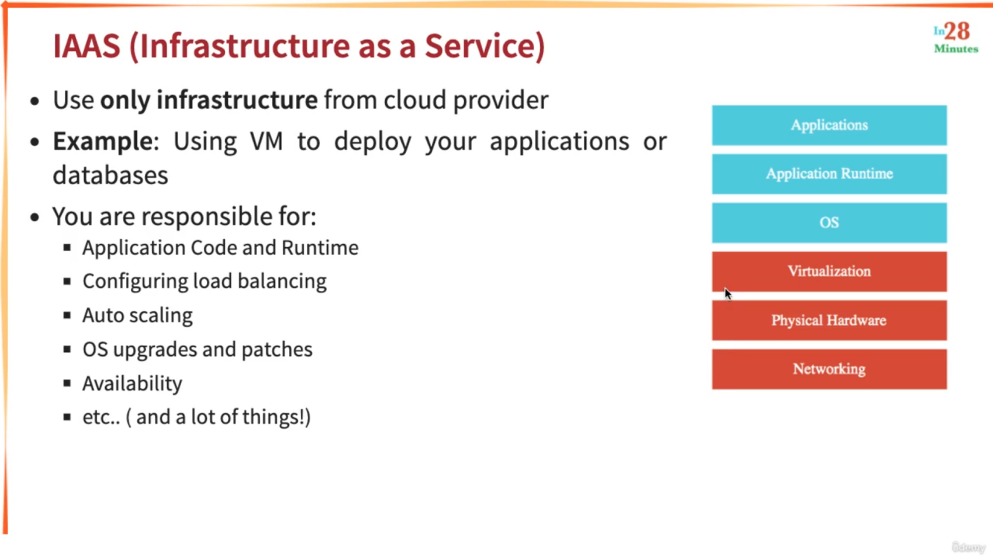

For IAAS, System will only provide the VM and we are responsible for installing the OS and Installing the Application Runtime (JDK or Python) and the application.

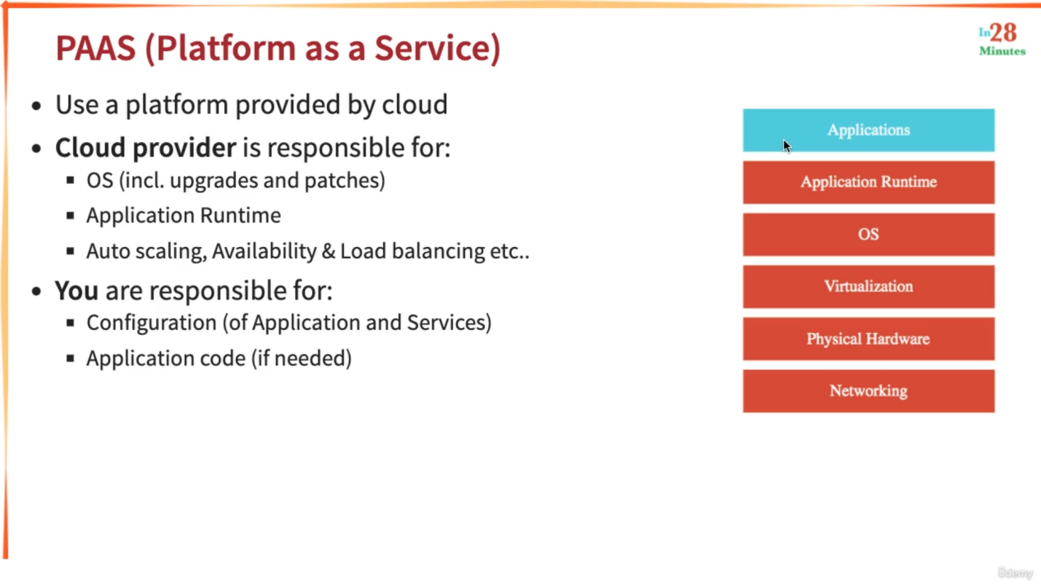

Example of PAAS : Google App Engine

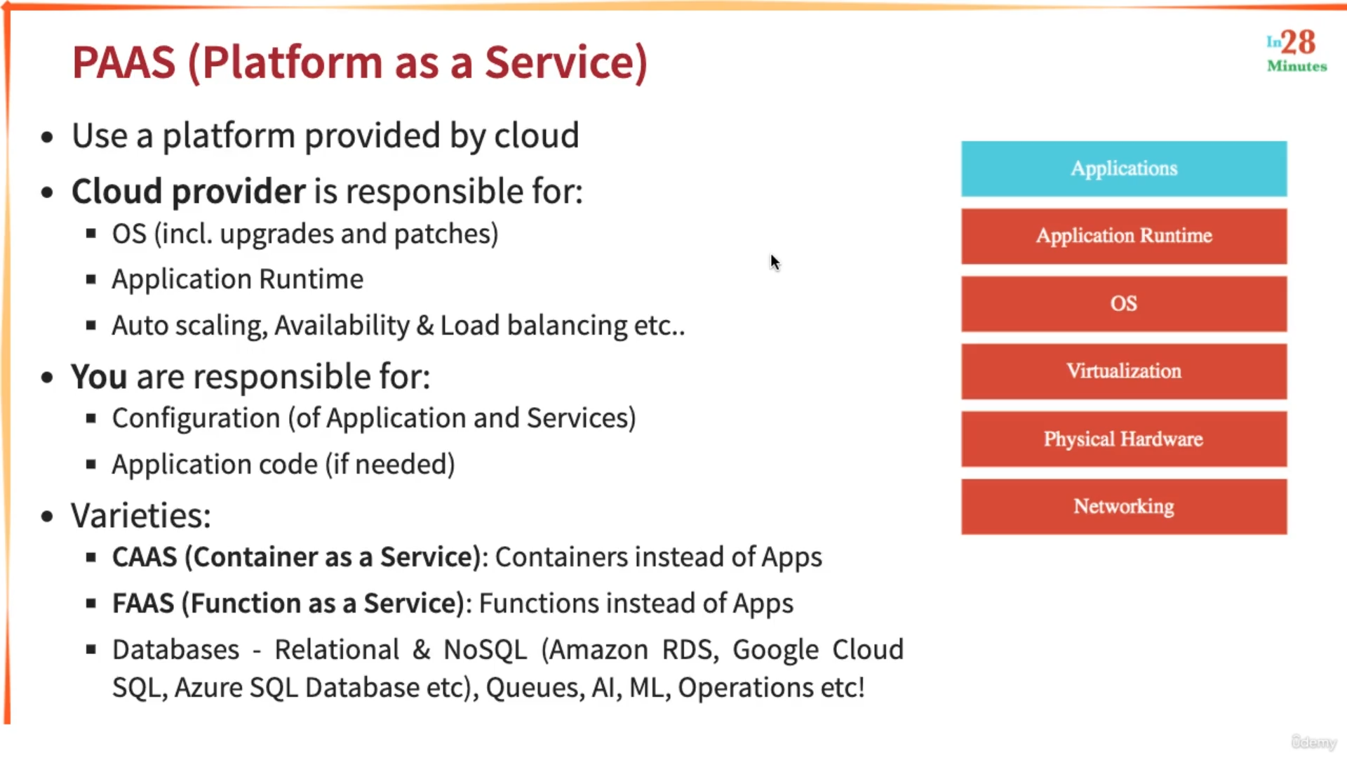

Variations of PAAS : CAAS : instead of Application container is running on top of Application Runtime.

Features of CAAS

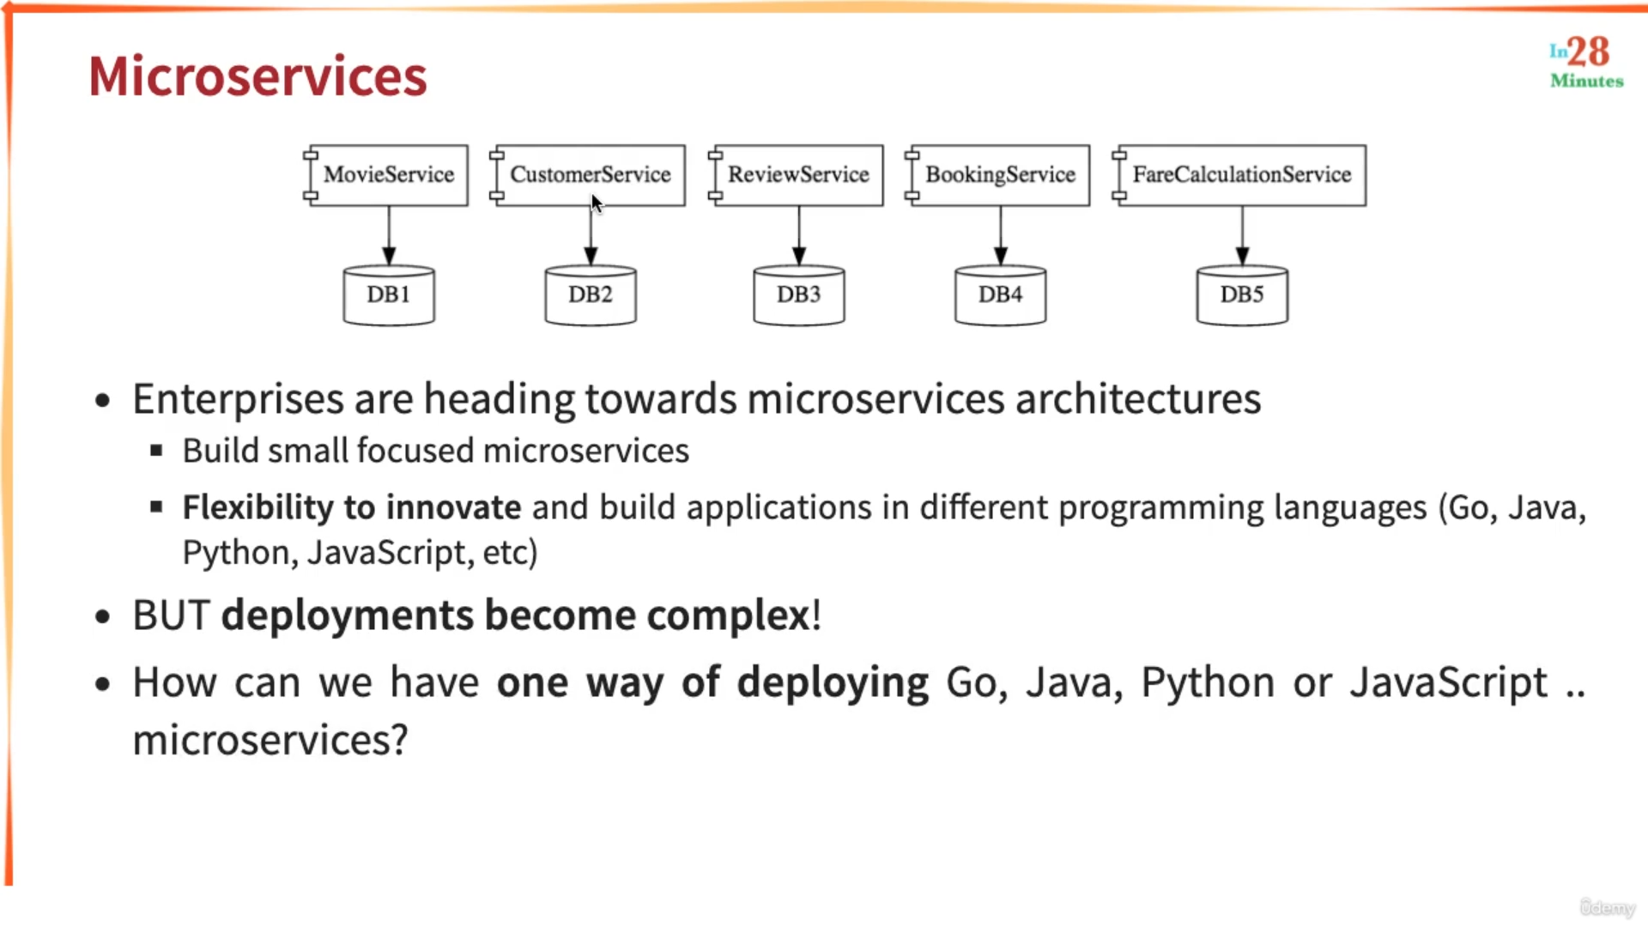

If different MS’s are developed in different languages then it becomes very difficult to deploy them in similar way. Containers help in these situations.

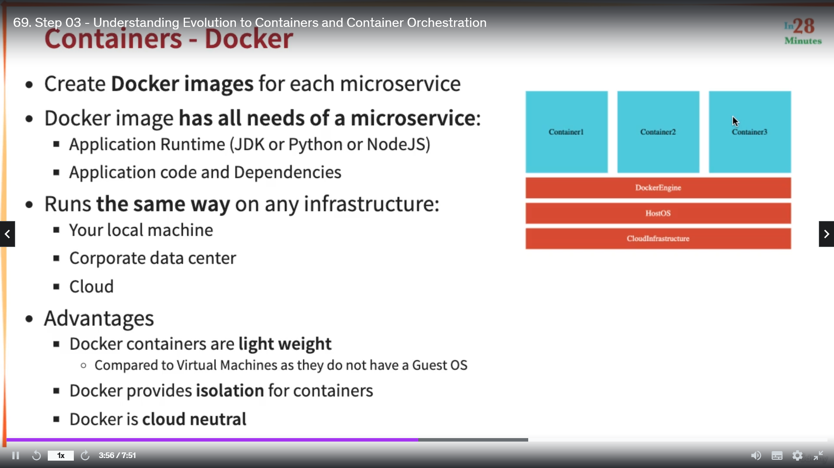

Along with Host OS Virtual Machines has Guest OS also but for Docker containers Guest OS is not required. Docker is cloud neutral means we can run it into any cloud provider AWS, GCP etc.

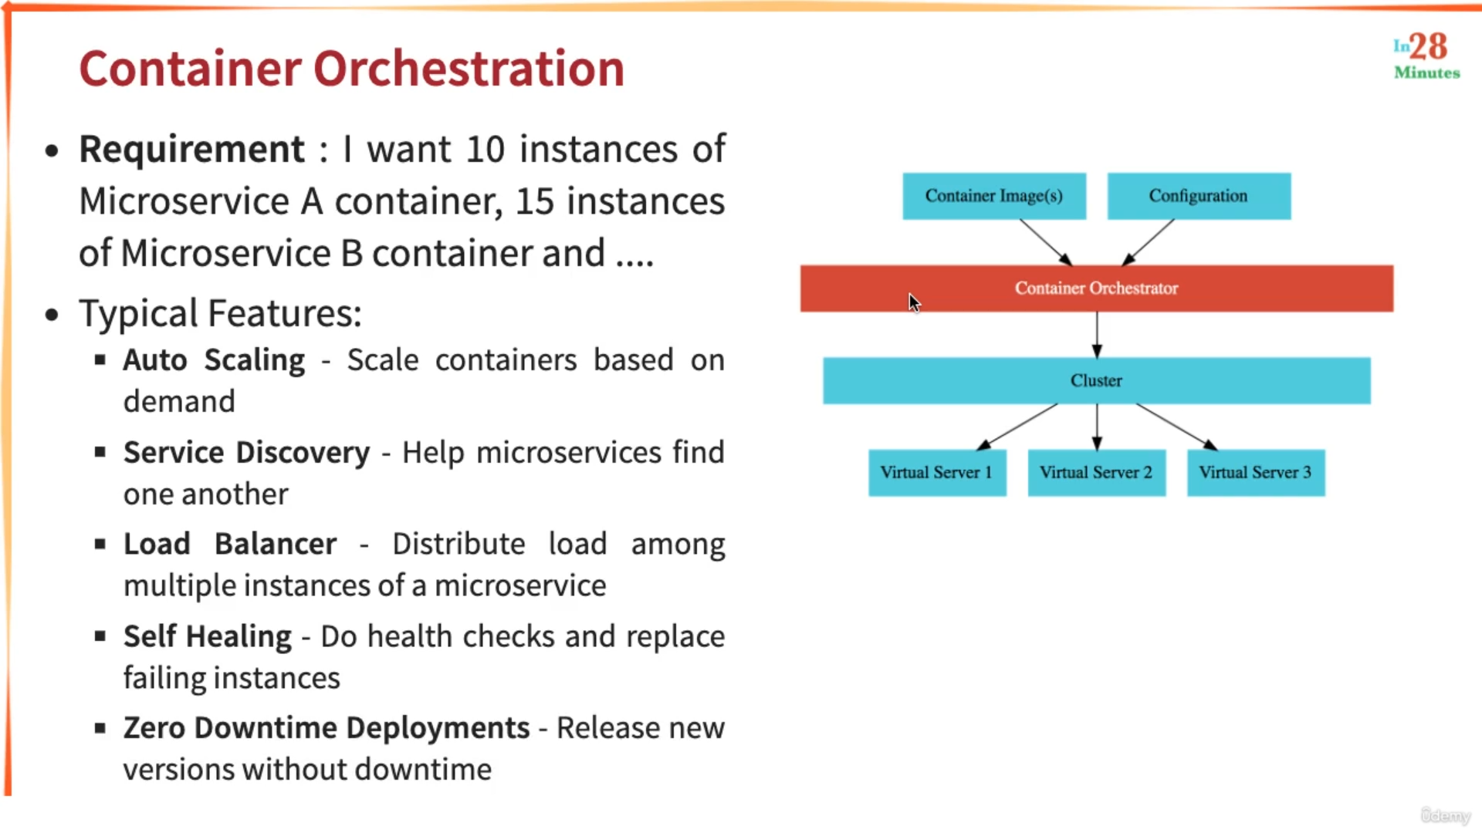

Containers are managed by container orchestrator and the different functionalities performed by Container orchestrator are mentioned above. For GCP, GKE is an example.

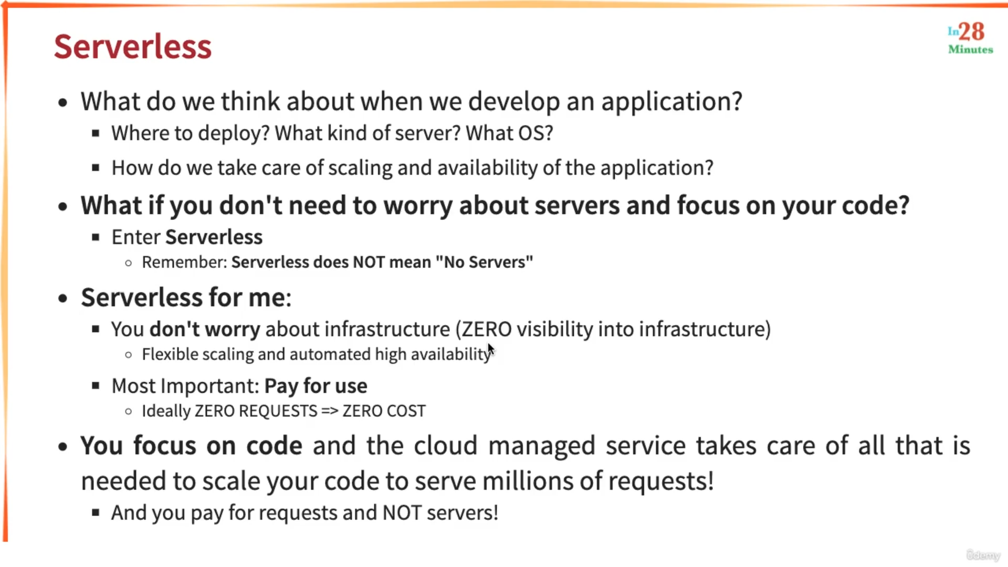

Google cloud functions are example of serverless.

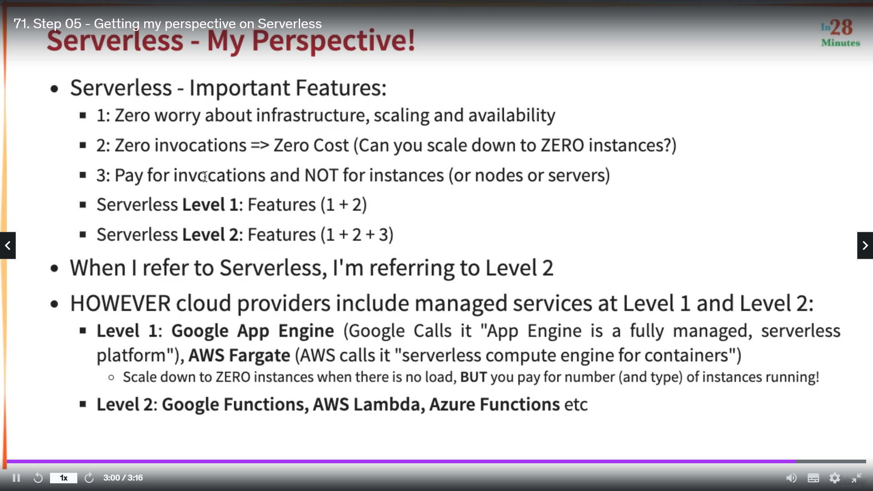

Point 2 : cost is for infrastructure like number of instances incresed cost will also high.

Piont 3 : pay for your function calls.

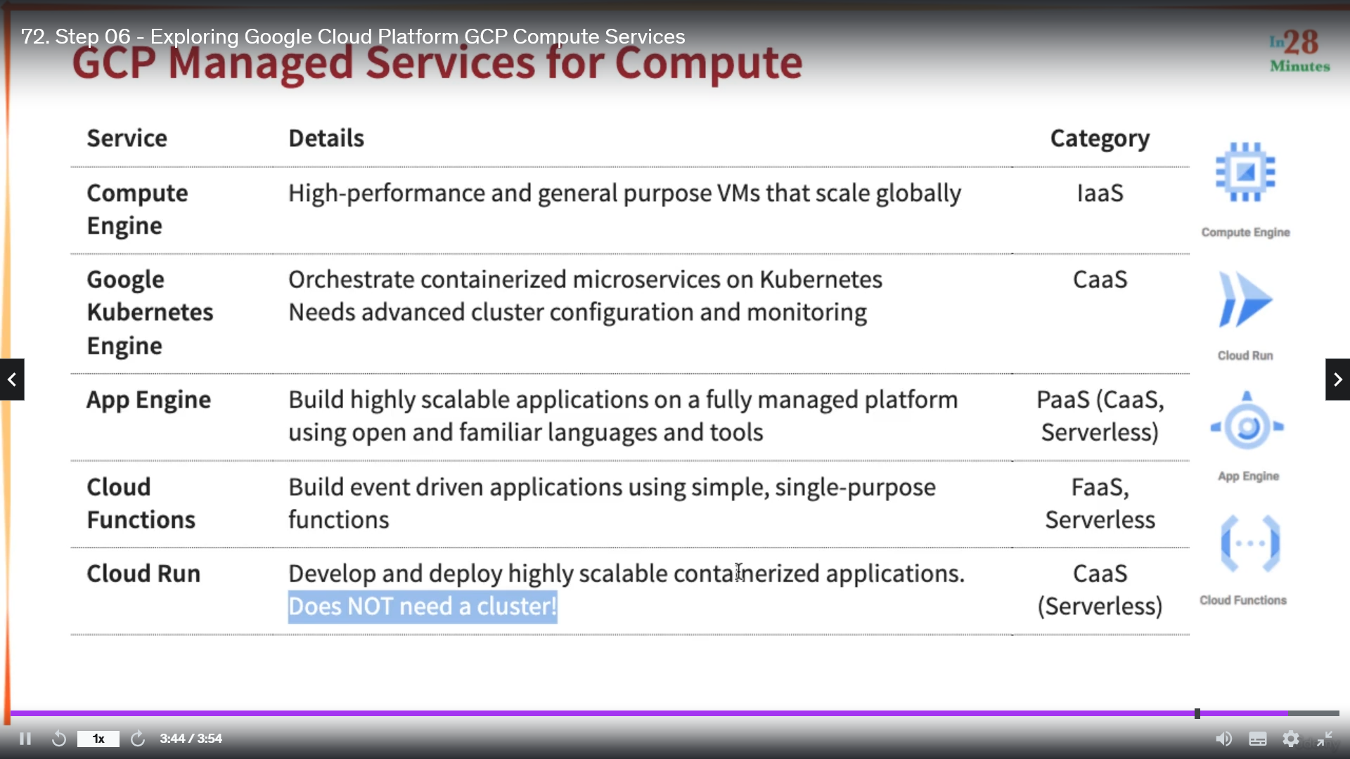

App Engine is helpful for simple container deployments, it does not provide variety of features for container deployment like GKE. So, it is CAAS. Also, App Engine can reduce to zero instance when there is no load. So, it is server less.

Cloud Run is new and the difference with GKE is highlighted in PPT.