Create image for your spring-boot application

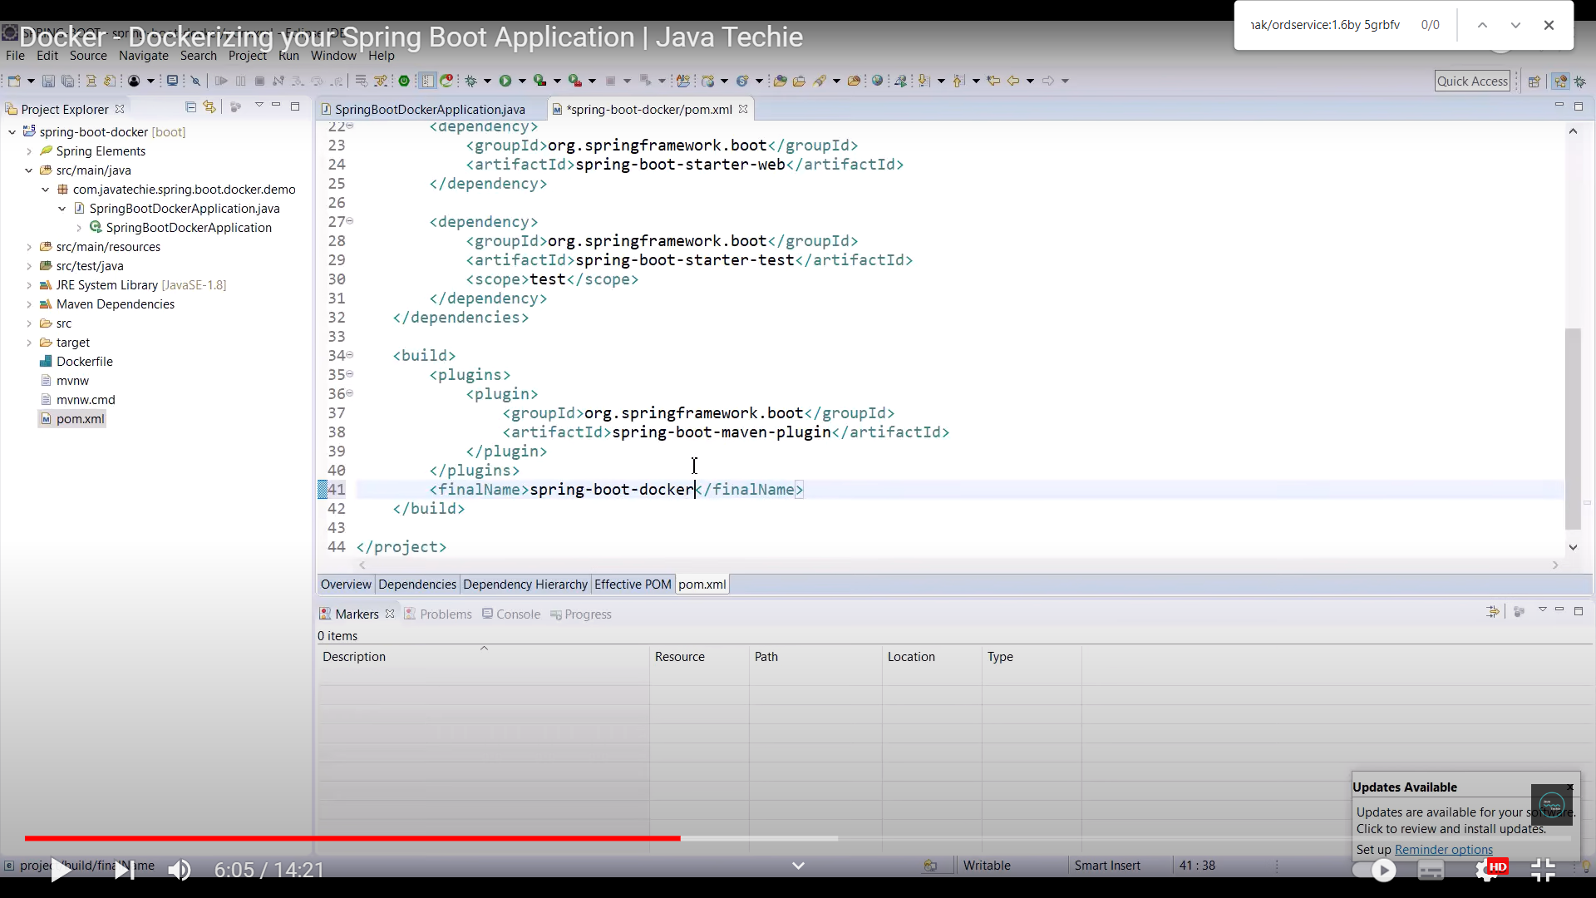

<finalName> will be the jar name of your application.

Create a Dockerfile and add the content as below

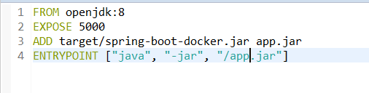

FROM openjdk:8 (base image on top of which our application image will be built)

ADD target/(give the jar name) (rename the jar)

ENTRYPOINT (command that docker should use while executing our project).

Creating a Repository in Docker hub

Go to your docker hub. Create a repository

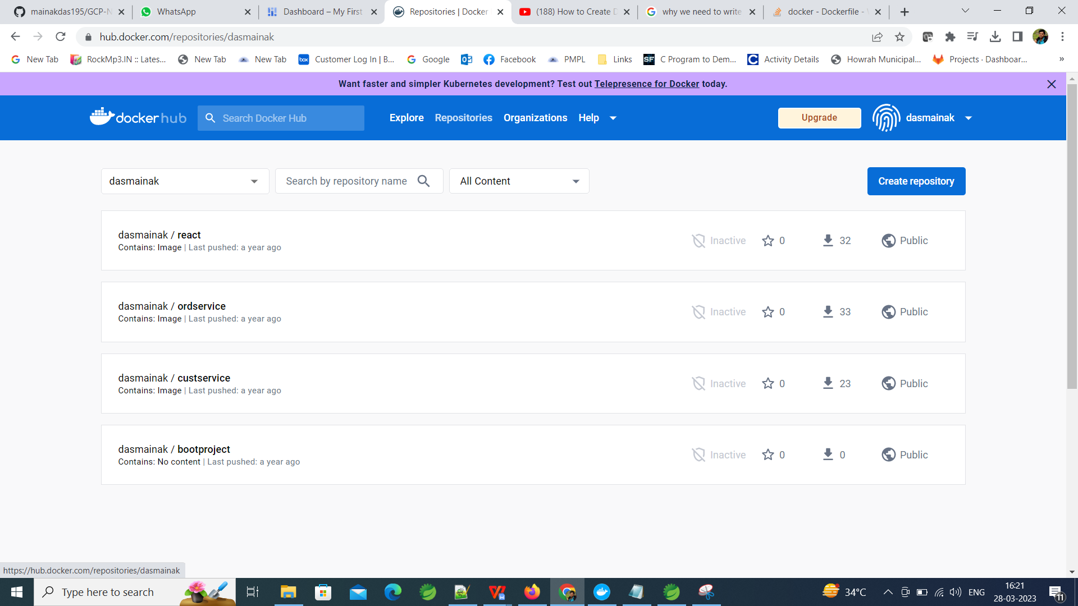

While creating repository, repository name can not contain any small letter.

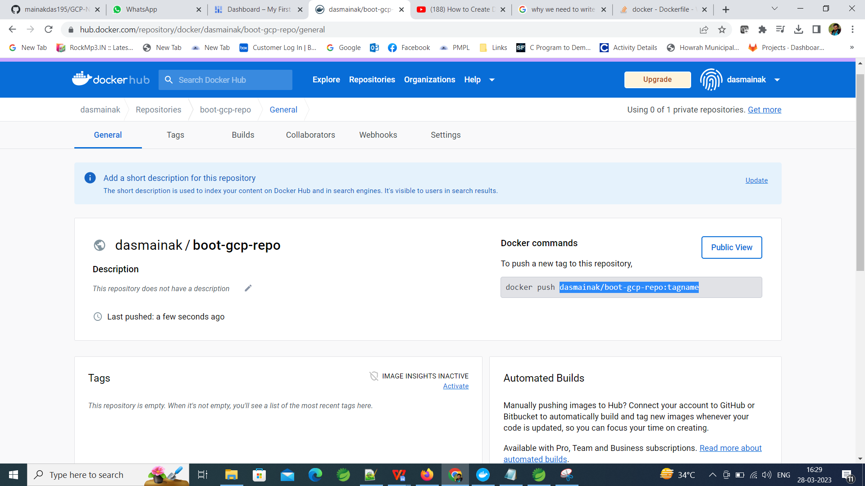

Here, the highlighted dasmainak/boot-gcp-repo is the Repository and tagname is the version.

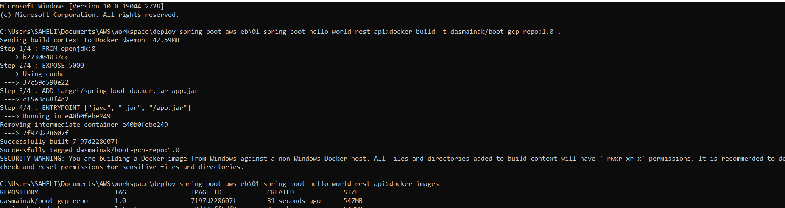

Docker build -t (**is the tag**) dasmainak/boot-gcp-repo:1.0 (**this is the repository and the tag**) . (dot is the Dockerfile to be considered inside the directory)

docker rmi 37ec19a15835 (This will delete a docker image)