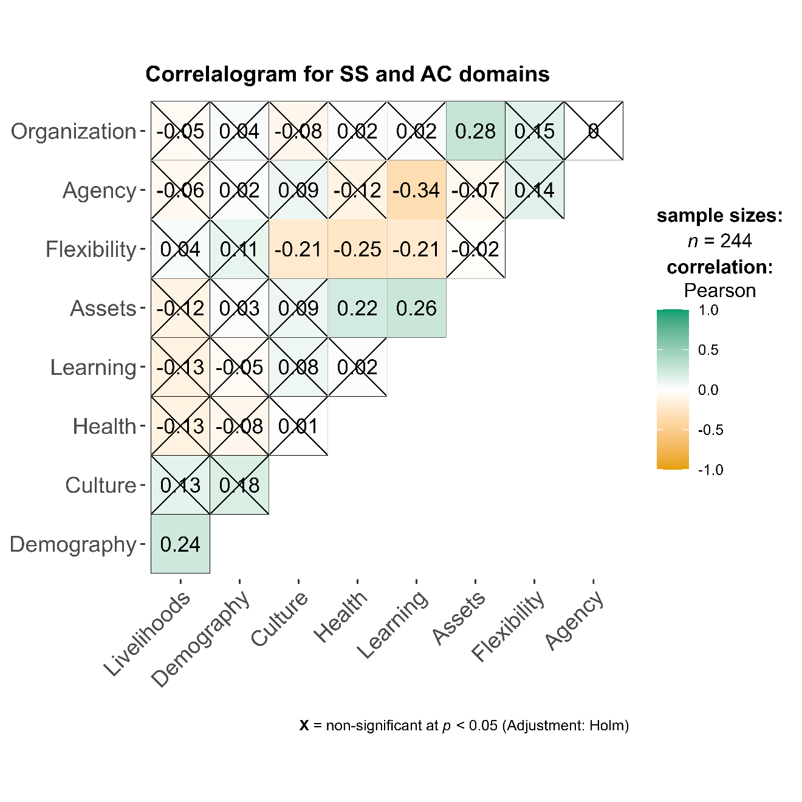Figure X1: This figure shows that to a larger extent the domains and independent noncorrelated measures, with weak correlations found between 5 pairs of domains. This means that domains measure different parameters and there is little or no ‘double counting’, and justifies the use of the selected domains as measures of sensitivity and adaptive capacity.

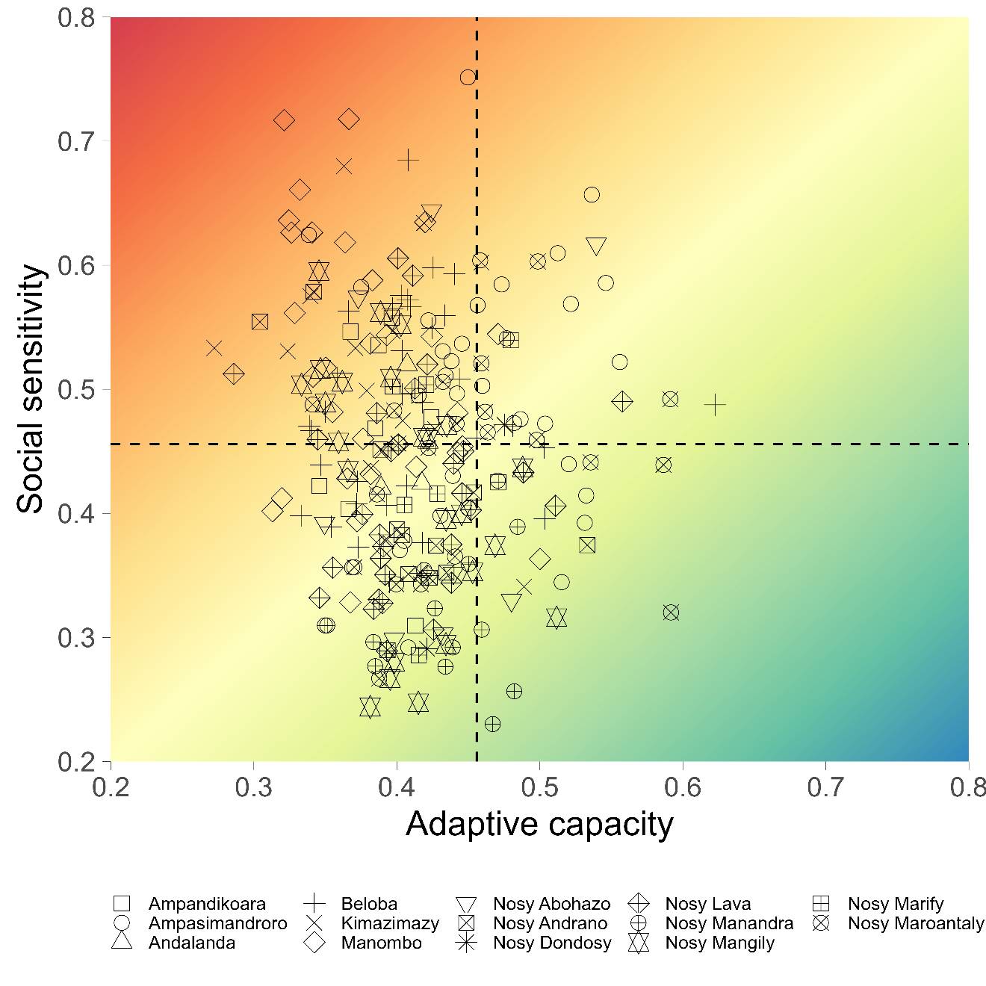

Figure X2: This figure shows the distribution of households across the social vulnerability space. Top lest is moderate to high sensitivity and low to moderate adaptive capacity. Bottom right quadrant is where most house should be, but according to the data, majority of the HH are in the low -moderate adaptive capacity region, while a significant proportion is on the low adaptive capacity-high sensitivity region. Some outlier households can also be found in each pf the quadrants.

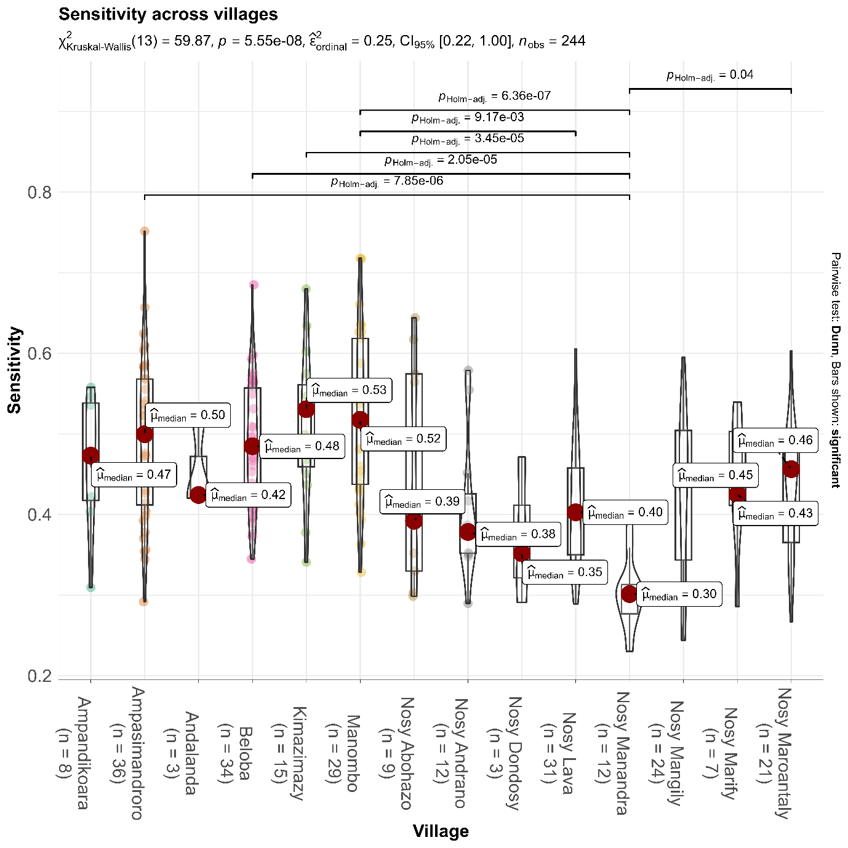

Figure X3: Here, nonparametric statistics (Kruskal-Wallis test) is applied to test the hypothesis that villages differ in their sensitivity. The statistic is significant (p<0.01). A Dunn pairwise test is then applied to compare among villages to determine which ones are significantly differ. The lines above the figure shows villages that are significantly different and the associated p value. For example, Nosy Maroantaly and Nosy Manandra are significantly different (i.e. they are connected by a line)

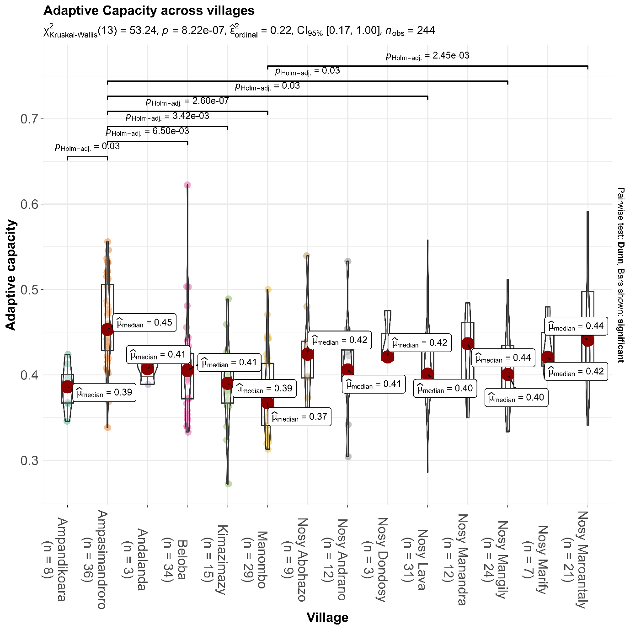

X4: Similar to X3 above, statistics are applied to test differences between villages for the adaptive capacity. It appears Ampasimandoro is significantly different (i.e. higher AC) from 5 other villages (Ampandikiara,Beloba,Kimazymazy,Manombo,Nosy Lava, and Nosy Mangily. Nosy Maroantaly and Manombo are also different