100299 – Muriuki Lewis Maina – ICS A

**Lab 1 link:** https://github.com/mainamuriuki274/100299_CCProjects

**LAB 2:**

Lexical Analyzer or scanner is the first phase when compiler scans the source code. This process can be left to right, character by character, and group these characters into tokens.

Below are the tokens I defined for my lexical analyzer:

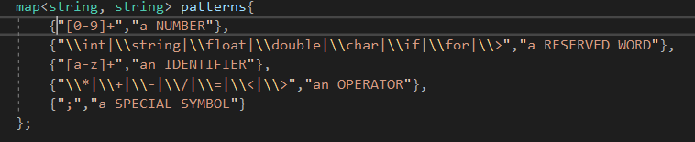

It will then use this code to map the strings to the different tokens:

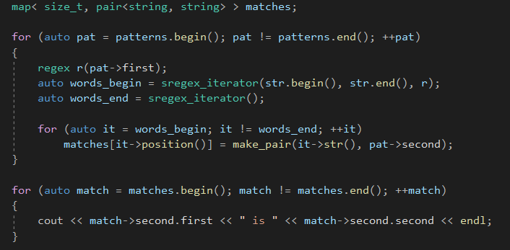

Therefore,

int a; a = a + 2;(*PS: The spaces are causing it to reloop)

will return:

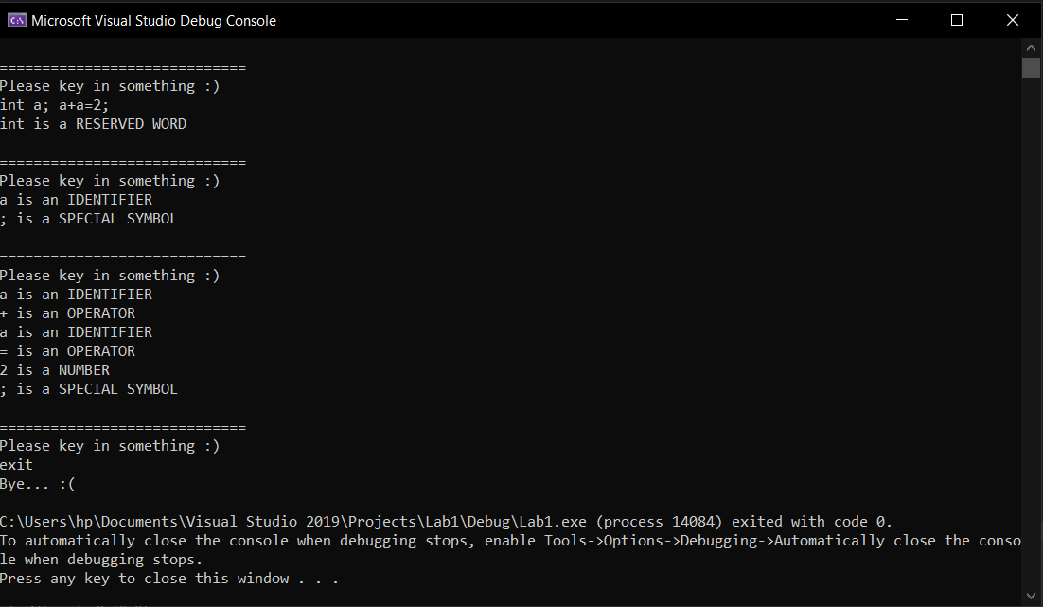

As we can see the string” int a; a+a=2;” has been tokenized e.g a as IDENTIFIER.