BioNTech GBS – Python Development Guide

The GBS macro/tool team develops code that is developed, maintained, and used by multiple users. Therefore, we place higher demands on code quality that go beyond validation and testing to allow continuous development, deployment and maintenance.

1. Python Project Template
Use the provided python development template for new projects. Currently there is only a “simple” template available. The simple template using conda as package manager. In future there will be a more sophisticated “advanced” template using poetry as package manage.
The templates provide the following benefits:
- Following appropriate folder structure
- Dependency management (requirement.txt/environment.yml | pyproject.toml)
- Pre-configured: Unit-test (pytest, pyproject.toml)
- Pre-configured: linter (pylint, .pylintrc)
- Pre-configured: formatter (ruff, pyproject.toml)
- Pre-configured: .gitignore
- Pre-configured: compiler spec file (pyinstaller: onefile, ondir, handling of external resources by compilation (e.g. images, config files))
- Pre-configured: GitHub action pipeline (environment generation, unit testing, linter, artifact creation)
- Basic tk-inter template
- Logging template
- Unit-Test template

Simple template currently does not contain: Shall I add?
- multi-threading for concurrent execution of GUI elements
- template for using config files
- template for using a icon via icon file

Usage:
Clone from: biontech-qm/gbs-pytemp-simple
- Create a new remote repository:
see therefore python_access_guide.docx
- Clone template (simple/advanced):
git clone https://github.com/biontech-qm/gbs-pytemp-simple.git
- Remove git history from local repo:
cd gbs-pytemp-simple
rm -rf .git
- Rename local folder with template to project name
- Initialize new local repo and push to origin:
git init
git add .
git commit -m "Initial commit"
git branch -M main
git remote add origin <link to new remote project repo>
git push -u origin main

2. GitHub - Version control:
Version control must be managed using the BioNTech GitHub server. No code must be maintained local.
- Each project requires its own project
- Use code from template repositories (advanced/simple projects)

GitHub Information:
- Organization: biontech-qm
- Team: GBS

- GitAction must run Linter and Formatter to ensure basic code quality
- GitAction must build final delivery. In the artefact registry of main branch, we have all developed versions available

3. Project Structure
Each project must contain the following elements. See therefore template repo biontech-qm/gbs-pytemp-simple

- readme.md
Contains basic information about the project, developers and usage
- .gitignore
Based on template, exclude:
- Build, dist
- pycatch *.pyc
- .venv
- *.log
- .github\workflows\base-pipe.yml
Based on template, run pylint, pytest, formatter (ruff)
- .pylintc (pylinter configuration file)
- ruff.toml (ruff configuration file, not required if a project.toml is used)
- src/ #for code
- tests/ #for unit tests
- Optional:
  - Scrips: /<my_notebook>.ipynb

Advanced project
- VENV: Poetry
- pyproject.toml
- poetry.toml (inc. [virtualenvs] in-project = true)

Simple project
- VENV: Conda
- pyproject.toml
- enviroment.yml+ requirement.txt
(We use enviroment.yml for creating productive conda environments, for the GitHub runner we currently need an pip environment. (see also Section 9)

- VS Code / IDE
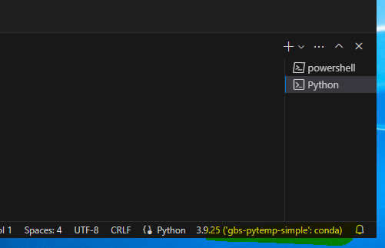
We currently use VS Code as IDE
  - Install Plug-Ins via VS Code Extension Tab
    - Python (by Microsoft)
    - Python debugger (by Microsoft)
    - Pylance (by Microsoft)
    - Optional: Jupyter (by Microsoft)
  - Ensure usage of the correct venv
    - Open options: Ctrl + Shift + P
    - Type: Python: Select Interpreter
    - Check current interpreter in the right bottom bar of vs code

- Conda – Virtual environment management
- Create new virtual environment from environment.yml
conda env create -f environment.yml -n <myenv>
- Activate environment:
conda activate <myenv>
- Create requirement.txt / environment.yml
python .\export_requirements.py --env_name <myenv>

Currently there is no BioNTech GitHub Conda Action available: therefore, the pipeline requires also a pip compatible requirement.txt. The provided script creates both. Also, possible (pure conda): conda env export --no-builds > environment.yml
- Add package
Conda install <package>

- Formatter/Linter
Basic formatter and linter must be used. The pipeline enforces formatted code.
We will use ruff as formatter (can also be used as linter and allows for auto-fixing). We will enforce a pylint score of >0.9 and no critical issues

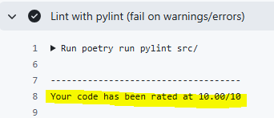
- Using linter pylint
  - pylint <myfile|module>
  - configuration file: .pylintrc
  - required score >9.0

- using formatter ruff
  - ruff format <myfile|module>
  - line-length = 100
  - configuration file: ruff.toml / or project.toml
- Optional (check with ruff)
  - ruff check <myfile|module>
  - (with auto fix (unsafe): ruff --fix <myfile|module>)

- Basic code quality agreements
  - Typing must be used! Type of arguments and return values
  - Docstring documentation of all important functions and classes
  - Separate logic & GUI & IO
  - Avoid usage of global variables, no plain text variable declaration
  - Avoid side effects
    - Functional style with return values
  - Always start in main.py with in if __name__ == "__main__": block
  - All imports at the start of the file

- Branch usage:
  - main: always functional, latest release
  - dev: current development efforts (workplace if only one active developer)
  - feature/<my-feature>:

9. Commit style:
Use specific tag
  - “feat: <message>”
  - “fix: <message>”
  - “refactor: <message>”
  - “release: <message>”

- Compilation (pyinstaller)
1. Onefile compilation.
- Advantage: all binaries and resources are packed into a zip file.
- Disadvantage: longer start time, as the file is first unpacked into a temporary folder. This requires all local resources to be searched for in the temporary folder. See therefore template resource_path function
pyinstaller main_onefile.spec
2. Onedir compilation
- Advantage: Application starts faster
- Disadvantage: Application is a folder. Best practice to create a shortcut for end users in a safe environment
pyinstaller main_standard.spec

11. Pull Requests
To merge from dev into the main branch, a pull request (PR) is required. It is best to first merge main back into dev to resolve any potential merge conflicts on the main server directly locally. Therefore do:
- Switch to dev branch:
git checkout dev
- Update from remove:
git fetch origin
- Merge main into dev:
git merge origin/main
(or if local main already updated git merge main)
- Solve all merge conflicts (if required), by using VS Code tab
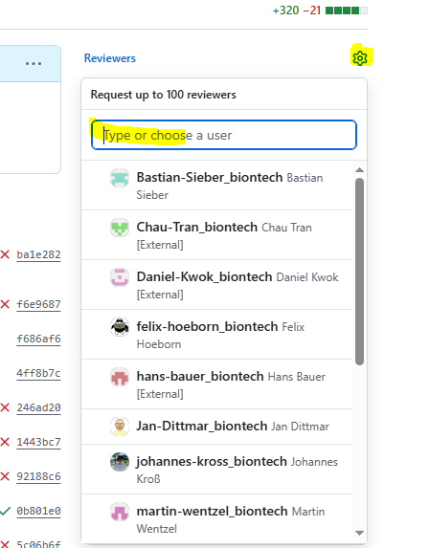
- Push dev to dev:
git add .
git commit -m “feat: add new feature”
git push
- Create PR using GitHub GUI.
    - Add another user as reviewer.
    - Contact reviewer and wait for approval
    - Complete merge.

