EDITPAGE and SDSFPAGE
User Reference Guide

Revised September 16, 2002

Version 1.26

Lionel B. Dyck
Kaiser Permanente Information Technology
25 N. Via Monte Ave
Walnut Creek, California 94598
E-Mail: Lionel.B.Dyck@kp.org

Table of Contents
Table of Contents 2
Introduction 3
EDITPAGE 3
SDSFPAGE 4
SDSFPAGE Example 4
Print to Sysout 6
Copy to Data Set 7
E-Mail Data Set 8
Transfer to Your PC 9
EDITPAGE Example 10
Print to Sysout 12
Copy to Data Set 12
E-Mail Data Set 13
Transfer to Your PC 14

Introduction
EDITPAGE and SDSFPAGE are ISPF Edit Macros that are intended to simplify the extraction of page-oriented data from a data set.

EDITPAGE is a front-end to SDSFPAGE and is designed for use under normal ISPF Edit while SDSFPAGE is intended for use under SDSF using SDSF Edit.

When either of these commands is used the data currently being edited will be copied into a new data set, which can then be:

- Browsed
- Printed
- Copied to another data set
- Mail using XMITIP
- Edited
- Transferred to a PC

Pages are determined by scanning the data for page eject carriage control values. Both Machine carriage control as well as ASA carriage control is supported. If a data set has no carriage control then the entire data set will be selected.

An option is provided to ‘count’ the pages and to insert a temporary record into the data indicating the location of each relative page. This option can be used if the page numbers in the report are not usable for selection.

Note that the only difference on the ISPF Panels is the title. EDITPAGE use will have a title of EDIT PAGE and SDSFPAGE use will have a title of SDSF PAGE.

EDITPAGE
EDITPAGE is a front-end to SDSFPAGE. The only processing that EDITPAGE does is to invoke SDSFPAGE, passing any provided parameters, and adding a special keyword of /EDIT which is then used to change the titles of the various panels to indicate that EDITPAGE is being used instead of SDSFPAGE.

The syntax of EDITPAGE is:

EDITPAGE | No parameters brings up the prompting panel
EDITPAGE ? | Displays the command syntax
EDITPAGE page | Selects a single page and bypasses the prompt panel
EDITPAGE from-page to-page | Selects the specified range of pages. If the to-page is larger than the number of pages in the data set there is no error message and all pages from the from-page to the end are selected.
EDITPAGE C | Counts the number of pages and inserts a temporary record in the data set indicating the relative page number. Once the relative page numbers are known the EDITPAGE command can be executed again with the correct page or page range.

The advantage to using EDITPAGE is that you can edit a data set, use EDITPAGE to make a temporary copy and then edit that copy for printing, copying, or mailing, all without affecting the original data. For example, using the CSVEDIT ISPF Edit command will change the data and you may want to do that on a copy of the data rather than the original data.

SDSFPAGE
SDSFPAGE is the application that is executed for both EDITPAGE and SDSFPAGE. The allowed syntax is:

SDSFPAGE | No parameters brings up the prompting panel
SDSFPAGE ? | Displays the command syntax
SDSFPAGE page | Selects a single page and bypasses the prompt panel
SDSFPAGE from-page to-page | Selects the specified range of pages. If the to-page is larger than the number of pages in the data set there is no error message and all pages from the from-page to the end are selected.
SDSFPAGE C | Counts the number of pages and inserts a temporary record in the data set indicating the relative page number. Once the relative page numbers are known the SDSFPAGE command can be executed again with the correct page or page range.

SDSFPAGE Example
SDSFPAGE is used under SDSF. To use it:

- Logon to TSO
- Get into ISPF
- Start SDSF
- Open the SDSF Status menu (SDSF command ST)
- Select the job that contains the report you are interested in using the? selection command. This opens the SDSF Job Data Set Display.
- Select the DDname, which contain the report you are interested in using the SDSF Edit (SE) selection command.

At this point you are in ISPF Edit under SDSF. You can delete any records that you want at this point (the records are NOT deleted on the report in the JES2 SPOOL – only in this copy of the data).

After making any changes to the data use the SDSFPAGE command to select all, one, or a range of pages from the data set.

- To select all pages enter SDSFPAGE 1 99999.

- To select a single page enter SDSFPAGE 5 (to select only page 5).

- To select a range of pages enter SDSFPAGE 3 10 (to select only pages 3 thru 10).

- If you enter SDSFPAGE with no parameters you will be prompted with this panel:

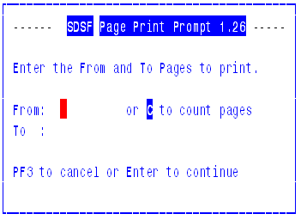

You can then enter the from page and to page numbers or enter a C in the from page field to count the pages.

You will then see the following ISPF panel:

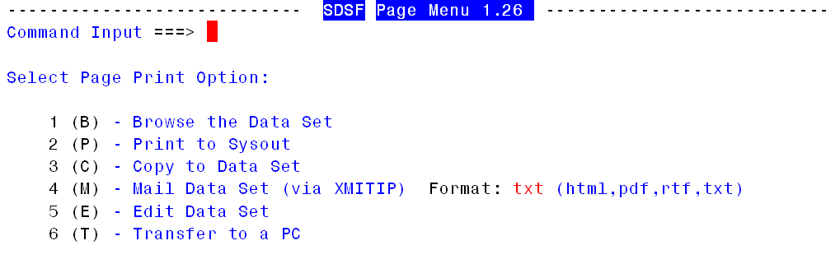

The six options available here are:

- Browse the selected page or pages. This allows you to verify that you have, in fact, selected the pages that you really wanted.
- Print to Sysout allows you to print the selected page or pages to a printer. See below for more information on this option.
- Copy to Data Set allows you to actually copy the selected page or pages to a data set. If the target data set does not exist you will be allowed to create it. See below for more information on this option.
- E-Mail Data Set invokes the XMITIP application, which allows you to send the selected page or pages to any Intranet or Internet e-mail address as a file attachment. The format of the file attachment can also be specified here. See below for more information on this option.
- Edit Data Set allows you to edit the selected page or pages.
- Transfer the dataset to your PC.

PF3 or Cancel at this point will return you to back to SDSF Edit with the data as it was before invoking the SDSFPAGE command.

Note that after options 1 (Browse) and 5 (Edit) that you will be returned to this menu. The other options will return to the original Edit session.

Print to Sysout
When option 2 is selected the following ISPF panel is displayed:

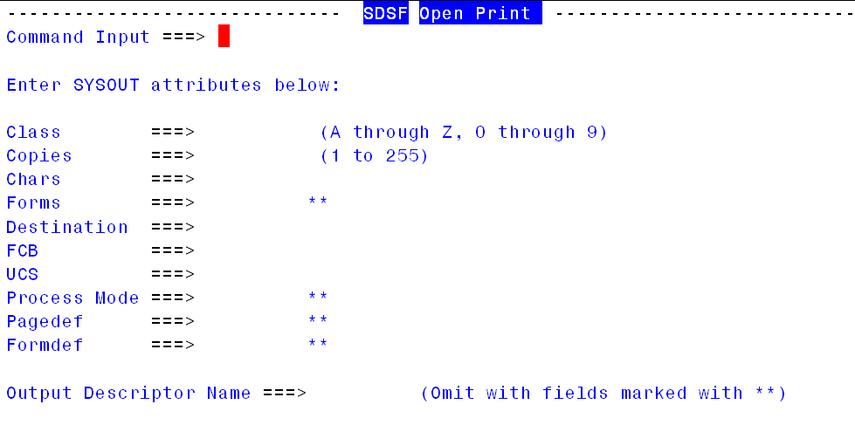

This panel is identical to the XS (extract to sysout) panel used by SDSF except that it is processed by the SDSFPAGE command.

Copy to Data Set
When option 3 is selected the following ISPF panel is displayed:

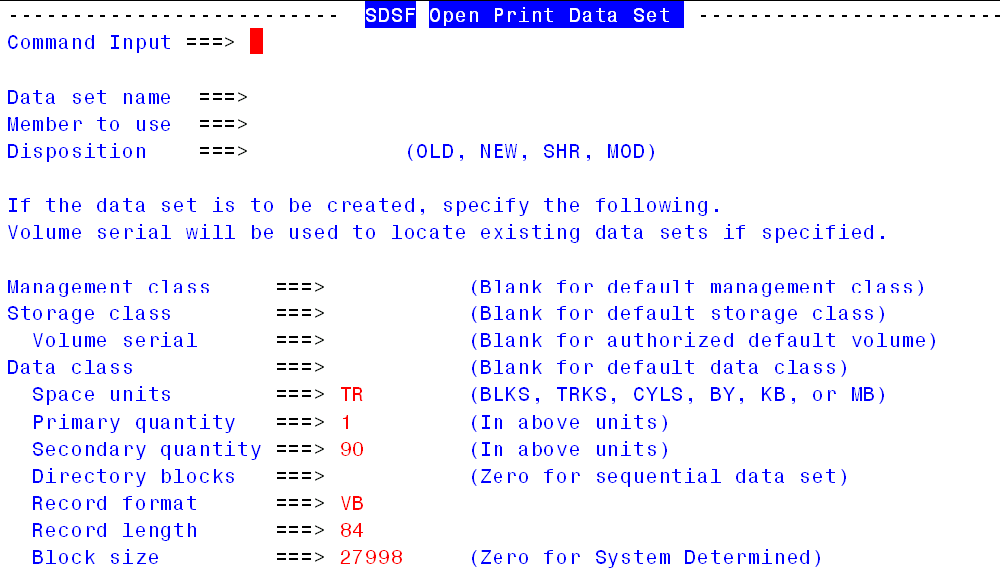

This panel is identical to the XD (extract to data set) panel used by SDSF except that it is processed by the SDSFPAGE command. The other difference is that the space allocation information is pre-filled in based upon the allocation information for the temporary dataset SDSFPAGE is working with.

E-Mail Data Set
This option will invoke the XMITIP application:

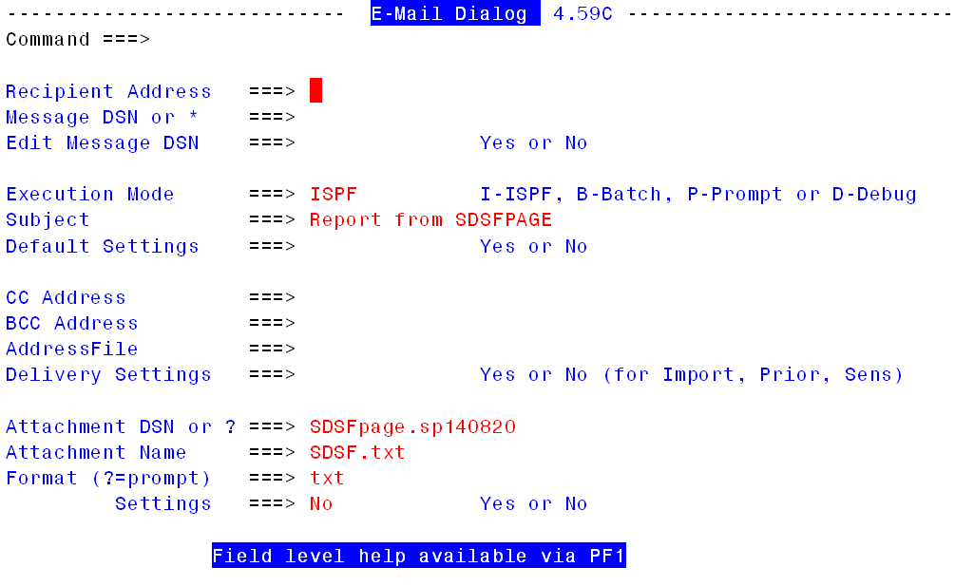

This panel has many fields that should be filled in by the user, among them are:

Recipient Address This must be the internet electronic mail address of the person you intend to send the data set to.

Subject This is preset by SDSFPAGE but you can change this to something more meaningful.

The other fields are optional at this point. To learn more use the field level help, which is accessed by, moving the cursor to a specific field and pressing PF1. You can also review the XMITIP Users Guide.

Transfer to Your PC
When you select the option to transfer the report to your PC you will see this panel:

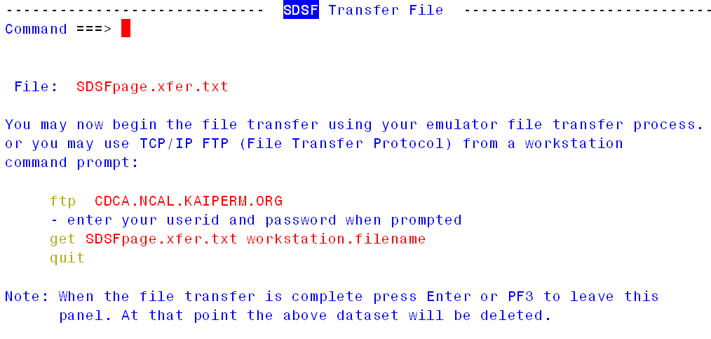

The file name specified is a temporary dataset that is created by this application. It is the host dataset name that you will download.

You can use the File Transfer option of your 3270 Emulator or you can use the TCP/IP FTP service on your PC. The sample FTP command is configured with the host name of the TSO system you are connected to.

EDITPAGE Example
EDITPAGE is used under SDSF. To use it:

- Logon to TSO
- Get into ISPF
- Start ISPF Edit
- Open a data set in Edit.

At this point you are in ISPF Edit on your data set.

After making any changes to the data use the EDITPAGE command to select all, one, or a range of pages from the data set.

- To select all pages enter EDITPAGE 1 99999.

- To select a single page enter EDITPAGE 5 (to select only page 5).

- To select a range of pages enter EDITPAGE 3 10 (to select only pages 3 thru 10).

- If you enter EDITPAGE with no parameters you will be prompted with this panel:

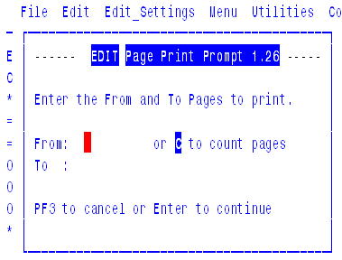

You can then enter the from page and to page numbers or enter a C in the from page field to count the pages.

You will then see the following ISPF panel:

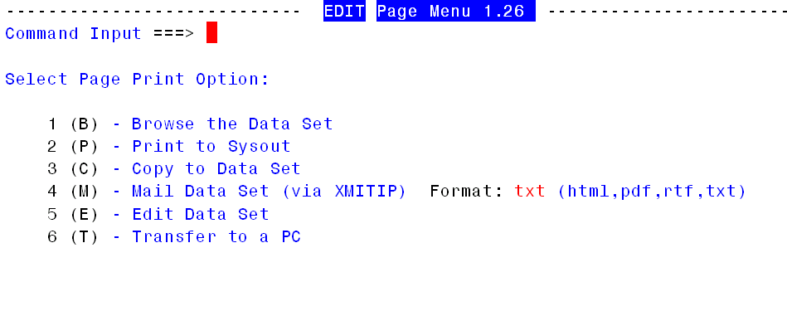

The six options available here are:

- Browse the selected page or pages. This allows you to verify that you have, in fact, selected the pages that you really wanted.
- Print to Sysout allows you to print the selected page or pages to a printer. See below for more information on this option.
- Copy to Data Set allows you to actually copy the selected page or pages to a data set. If the target data set does not exist you will be allowed to create it. See below for more information on this option.
- E-Mail Data Set invokes the XMITIP application, which allows you to send the selected page or pages to any Intranet or Internet e-mail address as a file attachment. The format of the file attachment can also be specified here. See below for more information on this option.
- Edit Data Set allows you to edit the selected page or pages.
- Transfer the dataset to your PC.

PF3 or Cancel at this point will return you to back to ISPF Edit with the data as it was before invoking the EDITPAGE command.

Note that after options 1 (Browse) and 5 (Edit) that you will be returned to this menu. The other options will return to the original Edit session.

Print to Sysout
When option 2 is selected the following ISPF panel is displayed:

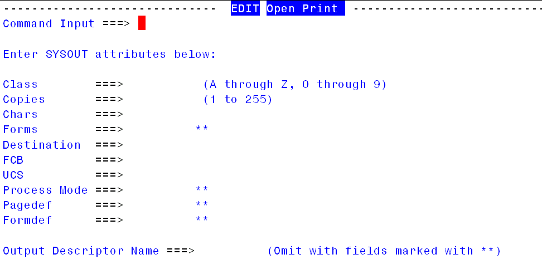

This panel is identical to the XS (extract to sysout) panel used by SDSF except that it is processed by the EDITPAGE command.

Copy to Data Set
When option 3 is selected the following ISPF panel is displayed:

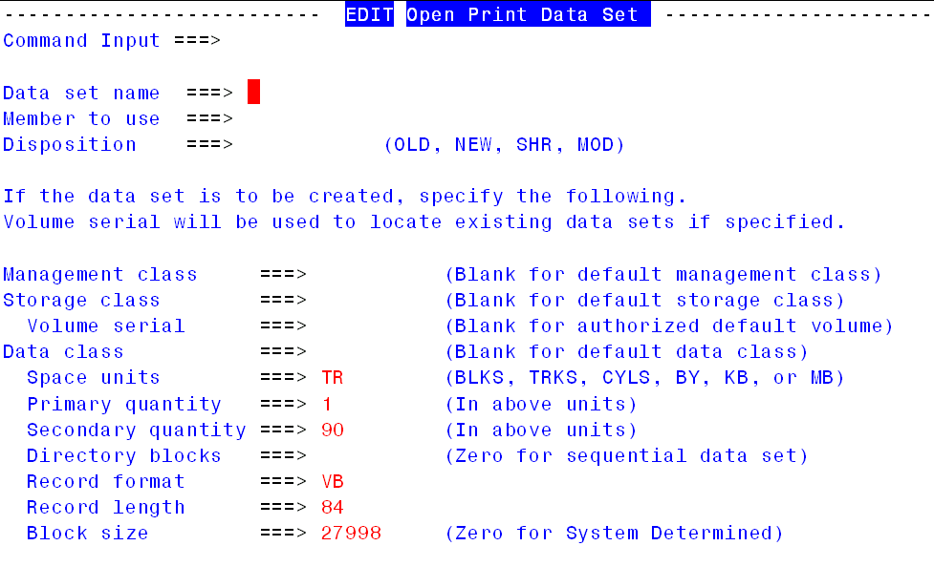

This panel is identical to the XD (extract to data set) panel used by SDSF except that it is processed by the EDITPAGE command. The other difference is that the space allocation information is pre-filled in based upon the allocation information for the temporary dataset EDITPAGE is working with.

E-Mail Data Set
This option will invoke the XMITIP application:

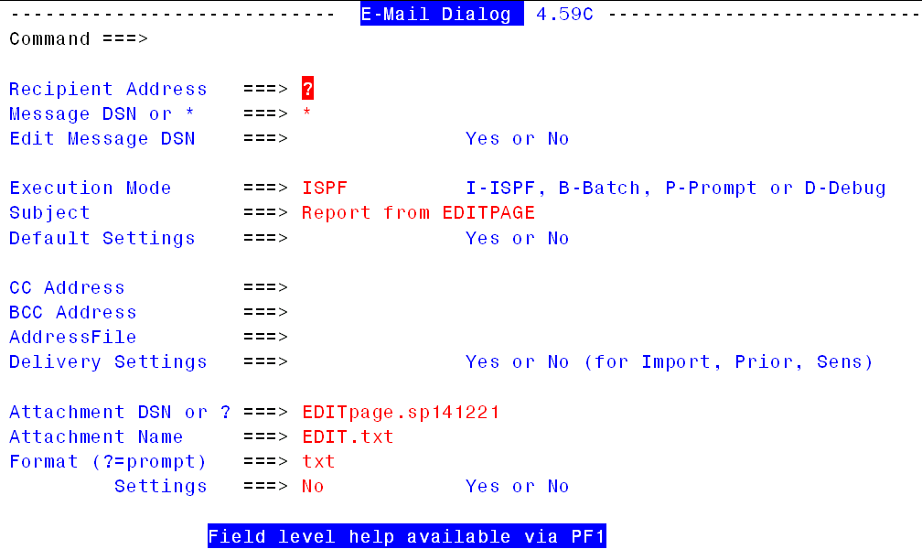

This panel has many fields that should be filled in by the user, among them are:

Recipient Address This must be the internet electronic mail address of the person you intend to send the data set to.

Subject This is preset by EDITPAGE but you can change this to something more meaningful.

From Address This should always be your internet electronic mail address.

The other fields are optional at this point. To learn more use the field level help, which is accessed by, moving the cursor to a specific field and pressing PF1. You can also review the XMITIP Users Guide.

Transfer to Your PC
When you select the option to transfer the report to your PC you will see this panel:

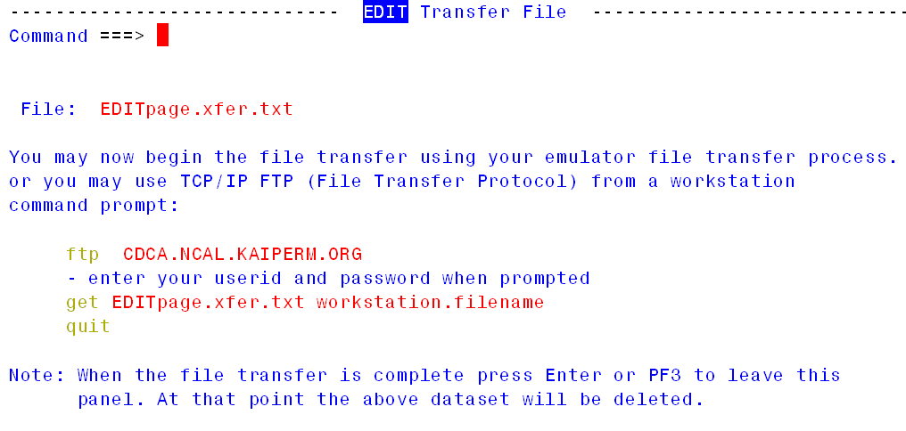

The file name specified is a temporary dataset that is created by this application. It is the host dataset name that you will download.

You can use the File Transfer option of your 3270 Emulator or you can use the TCP/IP FTP service on your PC. The sample FTP command is configured with the host name of the TSO system you are connected to.

