PDSMAN

&

EZYEDIT

(September 3, 2002)
Table of Contents

History ……………………………………………………………………………………. 3

Introduction ………………………………………………………………………………. 4

Started Task ………………………………………..……………………………………… 5

MVS Commands …………………………….……………………………………………. 6

Ezyedit ……………………………………….……………………………………….…… 7

Invoke Facility……………….…………………………………………………….. 8

Selection Panel ………………..…………………………………………………… 9

Options Menu …………………………………………………………………….. 12

Dataset List Display ………………………………………………………………. 17

Dataset Display Tailoring …………………………………………………………. 20

Member List Display ……………………………………………………………… 21

Member Display Tailoring ……………………………………………………….. 24
Command Shell …………………………………………………………………… 26

Title Maintenance …………………………………………………………………. 29

User Command or CLIST Shared Variable Pool …………………………………. 31

FASTCOPY ……………………………………………………………………….……… 33

Library Space Reuse Facility………………………………………………………………. 34

LLA Extensions …………………………………………………………………………… 36

JCL Example ……………………………………………………………………… 37

Batch Jobs …………………………………………………………………………………. 38

History

- 1979 - Created by Ian Cairns working for Software Design Associates, Australia.

- Written in Assembler

- 1981 - Goal Systems bought the marketing rights.

- 1992 - Legent acquired Goal Systems.

- 1995 - Computer Associates purchased Legent.

- Computer Associates still owns the marketing rights, but Software Design Associates owns the software.

- Both Software Design Associates and Computer Associates develop and maintain PDSMAN.

Introduction

- EZYEDIT
  - Enhanced ISPF 3.4

- FASTCOPY
- High-speed replacement for IEBCOPY with a lot of enhancements

- Library Space Reuse
- Provides a way to avoid nearly all PDS out-of-space conditions by dynamically reusing the “dead” areas with in the library.

- LLA/Extensions and Performance Options
- Reduces DASD I/O and can improve overall system performance by eliminating many of the directory searches performed for PDS members. This is achieved either by assisting you in using the IBM LLA facility to its fullest benefit or by using the performance options included with PDSMAN

- Library Member Archiving
  - Free DASD resources by allowing you to identify, archive, and purge inactive library members, based upon the date on which they were last referenced.

- Library Member Recovery
  - Allows us to easily recover both the current and previous versions of your library members when such recovery is required.

- PDSMAN Auditing Facility
    - Allows us to better control and manage library resources. This saves you time when developing new applications, undergoing an audit, performing maintenance, or doing the day-to day management of your libraries and also improves both the security and integrity of your library data.

- PDSMAN Comparison
    - Allows us to better control changes in your library environment by providing utilities to easily identify libraries and members that have changed and what those changes are.

Started Task

- Started task

- PDSMAN

- LIB.SYS.STC.PROCLIB

- Init Deck

- PDSMINIT

- LIB.SYS.STC.PARMLIB

- Used to customize PDSMAN

- All PDSMANs in the SYSPLEX use the same parm deck.

- Communications File

- PDSMMCPU DD DISP=SHR,DSN=LIB.SPP.PDSMAN.MCPU<site>

Where <site> is CHL, JAX, URP, DEV, etc…

- Used to communicate LLA changes to other PDSMANs in the sysplex.

- This facility can be disabled by removing the DD card.

- Items of Interest

- If you have a STEPLIB in PDSMAN proc it will be in "TEST MODE". This means that anyone wanting to use it must also use a "STEPLIB".

MVS Commands

S PDSMAN Start PDSMAN
P PDSMAN Stop PDSMAN
F PDSMAN,STOP Stop PDSMAN (Pulls his hooks out and resets SVC table)

F PDSMAN,HELP Display all modify commands
F PDSMAN,STATUS Display status of PDSMAN

F PDSMAN,NEWRULE Dynamically update configuration parm deck
F PDSMAN,RELOAD

F PDSMAN,XSYSLIB List LLA libraries for which updates are communicated cross systems

F PDSMAN,MCPUNET Display the status of the cross-system communication
F PDSMAN,HANDSHAKE Verify cross-system communication
F PDSMAN,STARTMCPU Enable cross-system communication subtask
F PDSMAN,STOPMCPU Disable cross-system communication subtask
F PDSMAN,NEWMCPU Bounce the cross-system communication subtask

F PDSMAN,SUSPEND Lets SVC request go to IBM, not PDSMAN
F PDSMAN,RESUME Lets SVC request go back to PDSMAN

F PDSMAN,DYNOFF=dsname Suspend Dynamic BLDL processing
F PDSMAN,DYNON=dsname Resume Dynamic BLDL processing
F PDSMAN,DYNRESET Reset Dynamic BLDL processing
F PDSMAN,RESET

F LLA,QUERY Displays all information on LLA datasets.
F LLA,ADD=dsname Add a library to LLA management.
F LLA,REMOVE=dsname Remove a library from LLA management.
F LLA,FREEZE=dsname Change LLA management mode for a PDS.
F LLA,NOFREEZE=dsname Change LLA management mode for a PDS.
F LLA,UPDATE=dsname, Selectively refresh a member in a PDS
MEMBER=mbrname

Ezyedit

Reduces screen switching

- Maintains list of commonly used dataset names

- Powerful pattern matching and command stacking facilities

- More efficient use of TSO resources, better response time

- Simple routing of output

- Additional productivity tools

Invoke Facility

From ISPF you can execute the below commands to invoke Ezyedit/PDSMAN

→ =E

→ EZY

→ =S.PXP

→ PDSMAN

→ LISTA

Selection Panel

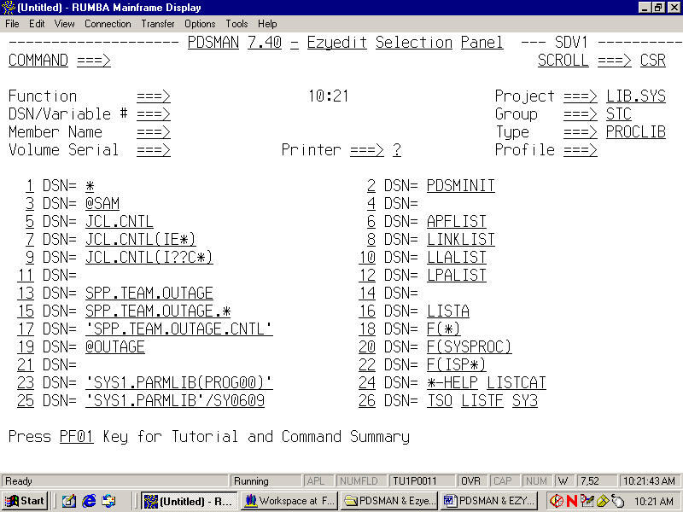

- Selection Panel – Function Field

(blank) …………………… Default is dataset or member list display

B …………………………… Browse
D…………………………… Delete
E …………………………… Edit
F …………………………… Find string
J ……………………………. Submit job
I ……………………………. Display VTOC info
L …………………………… Invoke member list
O ……………………………Ezyedit Option Panel
P …………………………… Print
R …………………………… Rename
S …………………………… Invoke member list
T …………………………… Issue TSO command
U …………………………… Update variable
V …………………………… View
Z …………………………… Compress PDS

ALTERDIR ……………….. Update Directory Blocks
CAT…………………………Catalog dataset
CREATE …………………... Allocate a new DSN model from existing DSN
DCF ……………………….. Invoke DCF/Script processing
DSCB ……………………… Display Dataset control block (DSCB1)
EMPTY ……………………. Empty PDS and release unused extents
EMPTYO ………………….. Empty PDS
ERASE …………………….. Delete DSN
EXEC ……………………… Execute CLIST/REXX
LISTA …………………….. Display TSO allocation

LOAD …………………..… Load dataset variables
PDSMAN …………………. Invoke PDSMAN
RECOVER ………………… Un-delete members
RELEASE ………………… Free un-used space
SAVE ……………………… Save dataset variables
SI ………………………….. Display system information
SPACE ……………………. Display available space on DASD volumes
UCAT ……………………… Uncatalog dataset
VALIDATE ……………….. Verify PDS

Note: If you place the cursor on the FUNCTION Field and press PF1 (HELP), a panel will appear displaying all the “Function Commands”. From there, detailed help can be obtained on any of the commands by placing the cursor in front of the command and pressing PF1 (HELP).

Selection Panel - DSN/Variable # Field

JCL.CNTL ……………………………………..… Personal DSN

‘SYS1.PARMLIB’ ……………………………..… Fully qualified DSN

‘SYS1.PARMLIB(PROG00)’…………………….. PDS(mbr)

‘SYS1.PARMLIB’/SY0001 ………………………. Fully qual. DSN with Volser

‘SYS1.PARMLIB(I??F*) …………………………. Member pattern

* ………………………………………………….. All datasets are to be displayed

LINKLIST, LPALIST, APFLIST, LLALIST ……. Keywords

PDSMINIT ………………………………… …….. Edit PDSMAN parm deck

F(SYSPROC) or F(ISP*) ……………………….… DDname or pattern

LISTC or TSO LISTC ……………………………. TSO Command

@OUTAGE ……………………………………….. Saved dataset or member list
Options Menu

From the Ezyedit Selection Panel type in “O” in the Function Field. Also, you can type in “O” on the Command line of the Dataset or Member list screen.

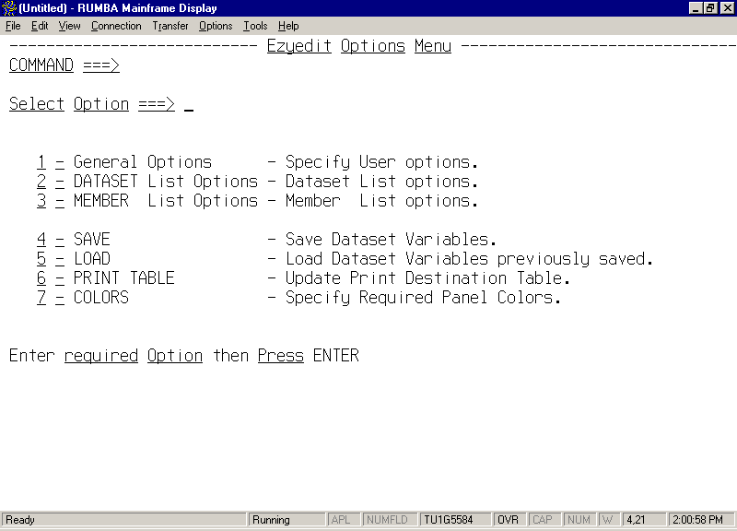
OPTIONS – General

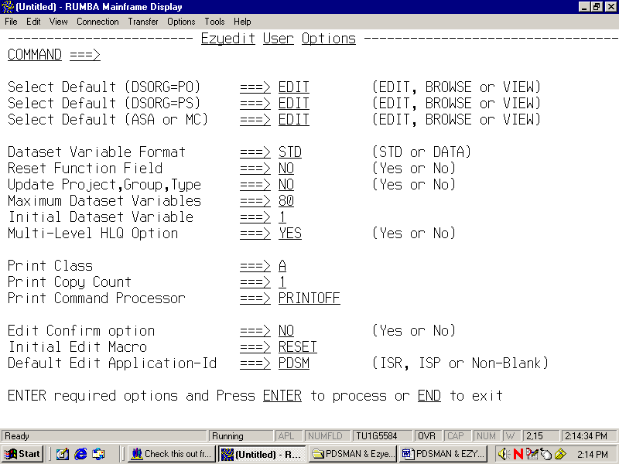
OPTIONS – Dataset List

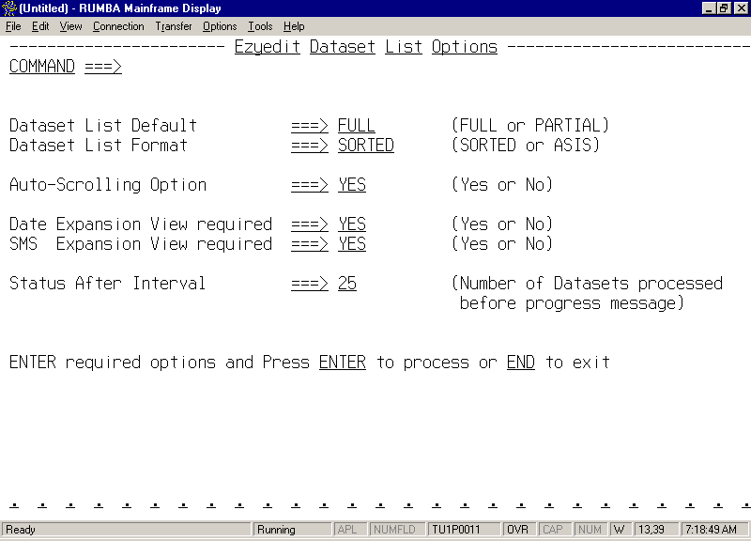
OPTIONS – Member List

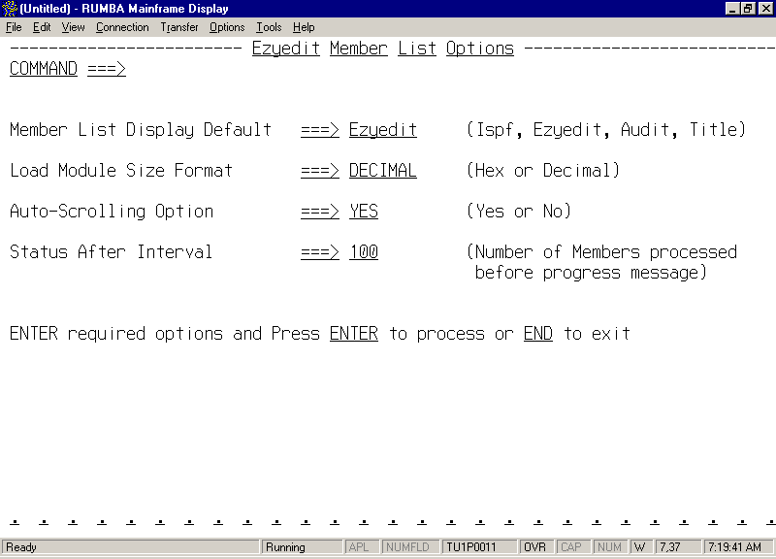
OPTIONS – Print Table

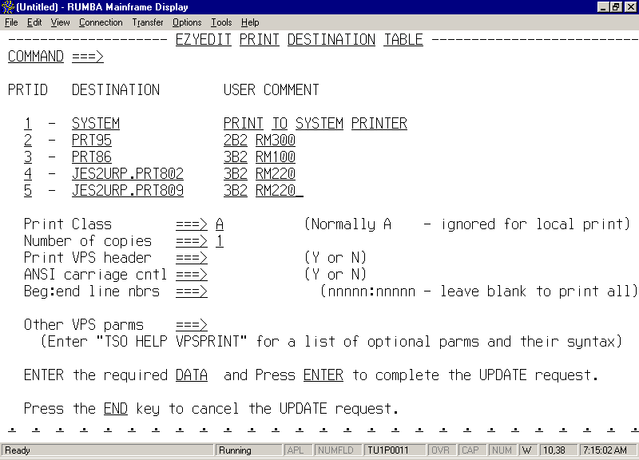

After inserting all printers, you’ll need to place a question mark (?) in the PRINTER field of the “Ezyedit Selection Panel”. This screen will then appear every time you request to print something. Allowing you to select a different printer.
Dataset List Display

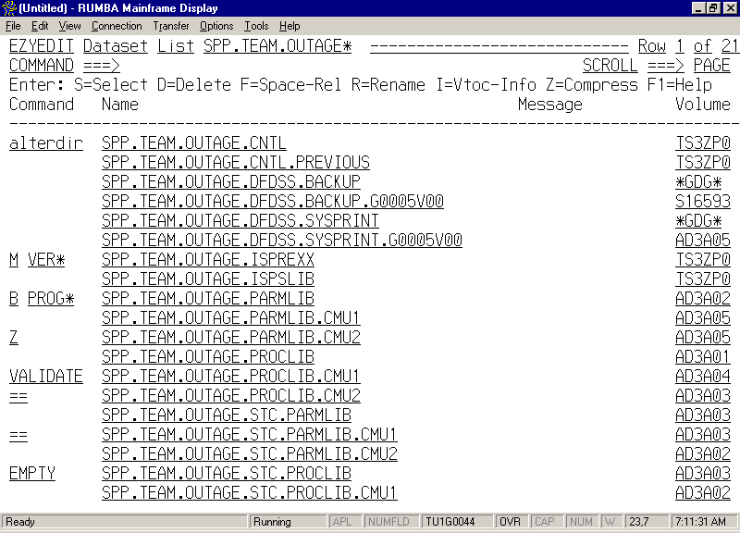

Dataset List - Primary Commands

CATCHECK ……………… Validate Catalog entries
CONFIRM ………………… Confirmation Panel
CONFIRMP ……………….. Print Confirmation Panel
DIRUSAGE ……………….. Summarize directory usage by PDS
FIND …………………….… Find a dataset name or string
FINDMEM ………………… Find a member in the datasets listed
(Example: FMEM <member> ALL)
HARDCOPY ……………… Print current display
IF …………………….…….. Conditional dataset filter
INCLUDE …………………. Include additional datasets
LLASTATS…………………Display LLA usage statistics
LLATRACE …………….… Display LLA Trace table info
LOCATE ……………….…. Locate the specified dataset/mbr
NOVERIFY ……………….. Disable display of confirmation panel
O ……………………..…….. Esyedit Option Menu panel
REFRESH …………….…… Rebuild dataset/mbr list
REPLACE ……………….… Perform string scan/replace
RESET ………………….…. Reset display and all options
SAVE ……………………… Save current dataset list as a PDS member
SCAN ……………………… Perform string scan
SORT ……………………… Sort the dataset/mbr list
USAGE ……………………. Summarize track usage
VERIFY…………..………. Enable confirmation panel
X …………………………… Exclude dataset/mbrs

Note: If you place the cursor on the COMMAND Line and press PF1 (HELP), a panel will appear displaying all the “Primary Commands”. From there, detailed help can be obtained on any of the commands by placing the cursor in front of the command and pressing PF1 (HELP).

- Dataset List - Line Commands

(blank) ……………………. Select dataset or member

B ………………………….. Browse
D…………………………… Delete
E …………………………… Edit

F …………………………… Find string
I ……………………………. Display VTOC info
M ………………………….. Member list
P …………………………… Print
R …………………………… Rename
S …………………………… Select
U …………………………… Update variable
V ……………………………View
Z …………………………… Compress PDS
/ ……………………………. Position display to this dsn
= …………………………… Repeat previous line

ALTERDIR ……………….. Update Directory Blocks
CAT…………………………Catalog dataset

CREATE …………………... Allocate a new DSN model from existing DSN
DCF ……………………….. Invoke DCF/Script processing
DSCB ……………………… Display Dataset control block (DSCB1)
EMPTY ……………………. Empty PDS and release unused extents
EMPTYO ………………….. Empty PDS
ERASE …………………….. Delete DSN
LLAADD………………….. Add dsn to LLA Management
LLAREM …………………. Remove dsn to LLA Management
LLAFREZ ………………… Chg LLA management to FREEZE mode
LLANOFR ………………... Chg LLA management to NOFREEZE mode
LLAREF ………………..… Refresh LLA entries
LLACHECK …………….… Verify LLA is synced with PDS directory
PDSMAN …………………. Invoke PDSMAN
PM ………………………… Print Member List
RECOVER ………………… Un-delete members
UCAT ……………………… Uncatalog dataset
VALIDATE ……………….. Verify PDS

Note: If you place the cursor in the area where you would type the line command and press PF1 (HELP), a panel will appear displaying all the “Line Commands”. From there, detailed help can be obtained on any of the commands by placing the cursor in front of the command and pressing PF1 (HELP).
Dataset Display Tailoring

IF <fieldname> operator <value>
  - The IF command filters the display based on the contents of any field name or column header.
  - Operators are EQ, NE, LT, GT, LE, GE. If an operator is omitted, then EQ is assumed.
  - The value can contain an asterisk “*”, for wildcard.
  - Example: IF DSORG EQ PO

- INCLUDE <dataset name, keyword or pattern> [volume]
  - Used to include additional datasets.
  - The dataset can contain the wildcard character, “*”.
  - Un-cataloged datasets can be included in the display by including a volume.
  - Examples: INCLUDE SYS1.*
INCLUDE LINKLIST
INCLUDE SYS1.* SYSRS1

- X <dataset or pattern | ABOVE | BELOW>
  - Allows for easy removal of entries.
  - X ABOVE excludes all datasets above the dataset currently being displayed.
  - X BELOW excludes all datasets below the dataset currently being displayed.
  - Example: X SYS1.*

- SORT [field] [sequence]
  - Allow you to re-order the dataset list by field name or column header.
  - Sort sequence can be specified as A – Ascending or D – Descending
  - Example: SORT VOL D

- REFRESH [dataset , keyword, or pattern]
  - Rebuilds the dataset list without having to exit to the Selection Panel
  - Example: REF SYS1.*

- SAVE [member name]
  - Saves the contents of the current dataset list as a library member.
  - The output dataset must be a PDS and have LRECL=80.
  - A panel will appear displaying the member name, description, and dataset on were to save the dataset list.
  - Dataset lists can be reloaded by specifying the member name prefixed by an @ sign in the DSN/variable # field on the Selection Panel or as an object on the REFRESH or INCLUDE dataset list primary command.

Member List Display

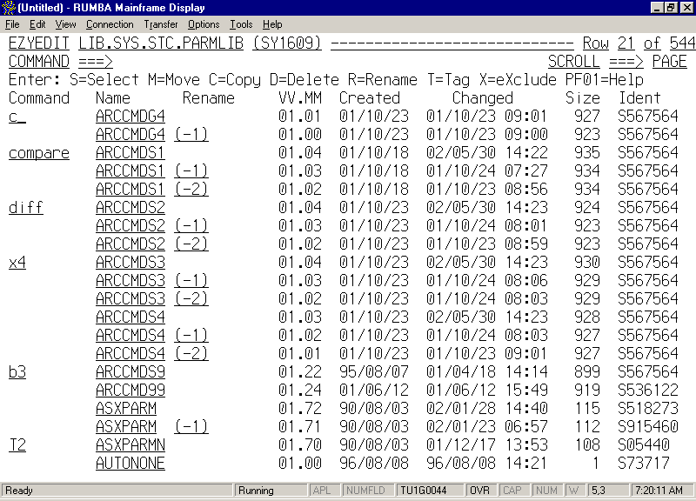

Member List - Primary Commands

CONFIRM ………… Confirmation Panel
CONFIRMP ………. Print Confirmation Panel
FIND ……………… Find a dataset name or string
FOLD ……………… Cause lower case letters to be translated on printing
HARDCOPY ……… Print current display
IF ………………….. Conditional dataset filter
INCLUDE …………. Include additional datasets
LOCATE …………. Locate the specified dataset/mbr
NOFOLD …………. Reset the FOLD option
NOVERIFY ………. Disable display of confirmation panel
O ………………….. Esyedit Option Menu panel
OUTPUT …..……… Save current member list as a PDS member
PACKINFO……….. Identify member that are ISPF PACKED format
REFRESH …………. Rebuild member list
REPLACE ………… Perform string scan/replace
RESET ……………. Reset display and all options
SCAN ……………… Perform string scan
SORT ……………… Sort the dataset/mbr list
TAG ………………. Process logical groups of members
USAGE ……………. Display dataset space utilization
VERIFY……………. Enable confirmation panel
X …………………… Exclude dataset/mbrs

Note: If you place the cursor on the COMMAND Line and press PF1 (HELP), a panel will appear displaying all the “Primary Commands”. From there, detailed help can be obtained on any of the commands by placing the cursor in front of the command and pressing PF1 (HELP).

- Member List - Line Commands

(blank) ……………………. Select dataset or member

B ………………………….. Browse
C …………………………… Copy
D…………………………… Delete
E …………………………… Edit
J ……………………………. Job Submit

M ………………………….. Member list
P …………………………… Print
R …………………………… Rename
S …………………………… Select
T …………………………… Tag or Untag
U …………………………… Undelete a non-load module member
X …………………………… Exclude
V …………………………… View
/ ……………………………. Position display to this dsn
= …………………………… Repeat previous line

COMPARE ……………….. Perform compare function

DCF ……………………….. Invoke DCF/Script processing
DIFF ……………………….. Perform difference function
DIR ………………………… Display formatted directory entry
EXEC ……………………… Execute a user CLIST/REXX
IDR …………………………List load module IDR data
LLAREF ………………..… Refresh LLA entries
MAP ……………………… Map a load module
PACK …………………….. PACK a member
PDSMAN …………………. Invoke PDSMAN
SUM …………………..…… List load module summary data
TITLE ……………………. Display/update Title information
UNPACK …………………. UNPACK a member

Note: If you place the cursor in the area where you would type the line command and press PF1 (HELP), a panel will appear displaying all the “Line Commands”. From there, detailed help can be obtained on any of the commands by placing the cursor in front of the command and pressing PF1 (HELP).

Member Display Tailoring

IF <fieldname> operator <value>
  - The IF command filters the display based on the contents of any field name or column header.
  - Operators are EQ, NE, LT, GT, LE, GE. If an operator is omitted, then EQ is assumed.
  - The value can contain an asterisk “*”, for wildcard.
  - Following keywords can be specified for the IF command:
AUTH Display authorized load library members (AC=1)
ALIAS Display alias members
TODAY Display members that have been updated in the last 24 hours
WEEK Display members that have been updated in the last 7 days
MONTH Display members that have been updated in the last 30 days
YEAR Display members that have been updated in the last year
MINUS Display previous member versions (for example MBR (-1))
  - Examples: IF IDENT EQ S915460
IF TODAY

- INCLUDE <member name or pattern>
- Used to include additional members.
  - The member name can contain the wildcard character.
  - Examples: INCLUDE $CHK1
INCLUDE $VER*

- X <member name or pattern | ABOVE | BELOW>
  - Allows for easy removal of entries.
  - X ABOVE excludes all members above the dataset currently be displayed.
  - X BELOW excludes all members below the dataset currently be displayed.
  - Example: X IEB*

- SORT [field] [sequence]
  - Allow you to re-order the member list by field name or column header.
  - Sort sequence can be specified as A – Ascending or D – Descending
  - Example: SORT CHANGED D

- REFRESH [member or pattern]
  - Rebuilds the member list without having to exit the member list panel.
  - Example: REF ABC*

- RESET
  - Re-displays all members in the PDS.
  - The command re-reads the directory for the latest members and statistics

- SAVE [member name]
  - Saves the contents of the current member list as a library member.
  - The output dataset must be a PDS and have LRECL=80.
  - A panel will appear displaying the member name, description, and dataset on were to save the member list.
  - Member lists can be reloaded by specifying the member name prefixed by an @ sign in the DSN/variable # field on the Selection Panel or as an object on the REFRESH or INCLUDE member list primary command.

- TAG <command>
- Allow unrelated members to be processed as a logical group.
- The following are valid TAG select commands
ALL Tag all members in the current member list.
RES Reset (untag) all currently tagged members.
ONLY Exclude all members that are not tagged from the member list
MINUS Tag all previous member versions. For example MBR(-1) TOTAL Display the total records or kilobytes, depending on the
DSORG of all currently tagged members.
- TAG processing can also be performed conditionally, where members are tagged based on the contents of another field. Format for conditional tag processing is
TAG <fieldname> <operator> <value>
- Examples:
Tag all members beginning with ABC*
TAG ABC*
Tag all members and copy them to another dataset
TAG ALL; TAG C

Tag all members starting with the character A, delete the members and do not display the delete confirmation panel.
TAG A*; TAG D NOVERIFY
Tag all members that have been updated in the past 24 hours and copy them to another dataset.

TAG TODAY; TAG C
Tag all members that have been updated by userid S915460 and then delete them.
TAG ID EQ S915460; TAG D
Tag all members that have not been modified since 91/01/01 and copy them to another dataset
TAG CHANGED LT 91/01/01; TAG C
EZYEDIT Command Shell

Alternative to ISPF command shell (ISPF 6) to invoke TSO commands, CLISTS, REXXs and ISPEXEC functions. To invoke the Ezyedit Command Shell type in TSO ? on the ISPF primary command line, you do not have to be in Ezyedit or PDSMAN to use this feature.

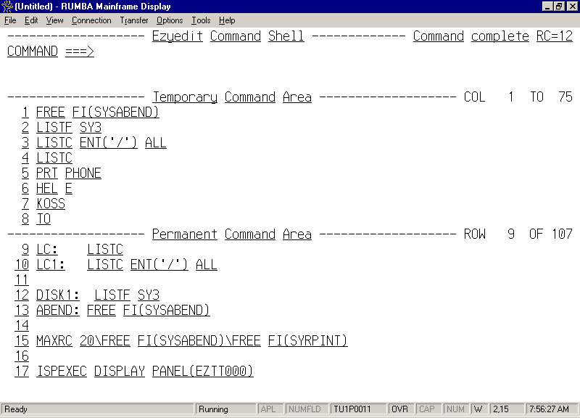

The Ezyedit Command Shell Display is a powerful, easy-to-use platform for executing TSO commands, CLISTs, or REXX execs. The display remembers the most recent commands you have executed and allows you to define and save your own commands. You can enter commands to be executed directly on the display. You can also, execute any of the saved commands by entry number, label, or by simply positioning the cursor over the desired entry.

- Primary Command Area

  - Extends for three lines to allow for long commands or multiple commands separated by the command delimiter character.

- Temporary Command Area

- Ezyedit Command Shell saves the eight most recently executed unique commands in a push-down list called the Temporary Command area.
- As new commands are executed, they are added to the top of the list and the oldest entry is dropped.

- Permanent Command Area

- Provides an area where you can save your own commands, including those you execute frequently or commands with long or complex syntax.
- Can assign your own command labels to the entries to make it easier to remember. Labels can be up to 16 characters in length and must begin with an alphabetic character. They must start in column 1 and should be immediately followed by the label delimiter character, a colon “:”. You should not choose names that are actual ISPF Primary Commands.

- Other Items of Interest

- When multiple commands are present, they are executed in order from left to right
- Maximum length of saved command is 252 characters
- Saved commands are automatically converted to upper case

- Special Characters

? <label | nn> Change a command before executing
&<label | nn> Repeat command. Execute command and retain in on
primary command line.
*-< label | nn > Trap and browse the output from TSO commands

: Label character
\ Command delimiter character
/ Cursor data character

- SET Statement

SET PERMCOUNT nnnn Increase no of Permanent slots. Cannot reduce slots.
SET CMDLBL x Change label character, default is “:”
SET RECALL x Change recall character, default is ?
SET REPEAT x Change repeat character, default is &
SET CMDDEL x Change command delimiter character, default is \
SET CMDDEL ISPF Set command delimiter equal to that used by ISPF
SET CMDTRAP x Change trap and browse character, default is –
SET CSRDATA x Change cursor data character, default is /
QUERY CHARACTERS Display current settings

SET TRAPDD ddname Trap into a permanent file
SET TRAP ON | OFF Trap command output and place in permanent file
SET TRAP Determine status of output trapping and ddname used
QUERY TRAPPDD Determine status of output trapping and ddname used
TITLE Maintenance

- Invoke PDSMAN
- Select option 11 - Member Title Maintenance
- Input the PDS name and select option “1” to Allocate the title member.

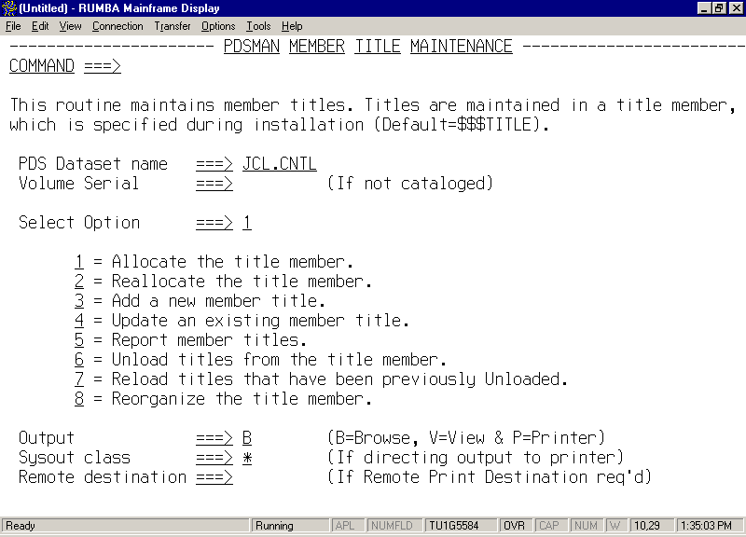

Specify the number of title descriptions to contain in the $$$TITLE member

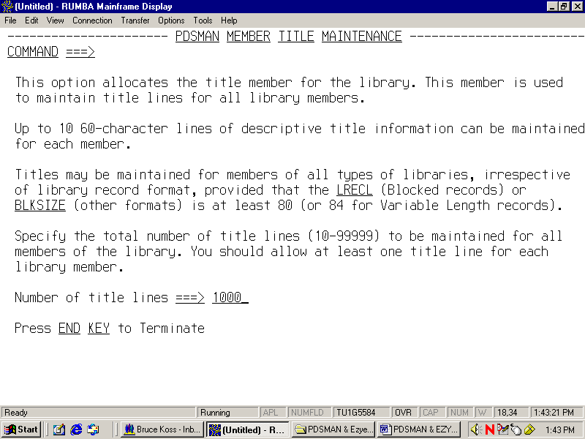

After creating the $$$TITLE member you may want to set your member list default panel to TITLE. You can accomplish this by going to the Options Menu and selecting “Member List Options”. Then change the DEFAULT DISPLAY to TITLE.
User Command or
CLIST Shared Variable Pool

- Shared Variable Pool - Output

DSN Dataset name specified on the Selection Panel (44)
VOL Volume serial specified on the Selection Panel (6)
DSN2 Fully qualified dataset name, quotes removed and TSO
User prefix inserted if required (44)
VOL2 Volume serial on which dataset resides (6)
DEVICE Device type (7)
DSORG Dataset organization (4)
LIBTYPE Library type – LIBRARY if PDSE, or PDS (7)
RECFM Dataset record format (6)
LRECL Dataset logical record length (5)
BLKSZ Dataset blocksize (5)
SPCTYPE Space allocation type (5)
(CYLINDER, TRACK, BLOCK, MEGABYTE, KILOBYTE, or BYTES)
SPCPRIM Primary space allocation (5)
SPCSEC Secondary space allocation (5)
SPCALOC Space allocated (in allocation units) (5)
SPCUSED Space used (in allocation units) (5)
SPCPCNT Space percentage utilized (5)
SPCBTRK Number of blocks per track (5)
TRKALOC Space allocated in tracks (5)
TRKUSED Spaces used in tracks (5)
EXTALOC Extents allocated (5)
EXT USED Extents used (5)
DIRALOC Directory blocks allocated, for DSORG=PO (5)
DIRUSED Directory blocks used, for DSORG=PO (5)
DIRMEM Number of members, for DSORG=PO (5)
CDATE Creation date (10)
EDATE Expiration date (10)
RDATE Date last referenced (10)
CONFIRM Display confirmation panel – Y/N (1)

- Shared Variable Pool – Output (cont.)

CATFLAG Catalog status (1)
0 – dataset is cataloged on a volume other than VOL2
2 – dataset is cataloged on a volume other than VOL2
6 – dataset is not cataloged
8 – dataset is not available on volume VOL2
dataset is either a) deleted b) migrated c) non-dasd dataset
EZYPUPD Update Project-Group-Type option - Y/N or blank if option has not been specified (1)
PRJ1 Project field (8)
LIB1 Group field (8)
TYPE1 Type field (8)

- Member List – Shared Variable Pool - Output

The following additional variables are available in the SHARED variable pool, if the user command has been invoked from Member List processing.

MEMBER Current member name (8)
TAG Tag flag either “T” or blank (1)
VMSG Contents of the Rename field

- Shared Variable Pool - Update

A user command or CLIST can set the following SHARED pool variables in order to communicate with Dataset List processing:

NEWDSN Update dataset name to appear in list (44)
MSG Status message to appear in list (16)
REFRESH Refresh dataset information – Y/N (1)

FASTCOPY

DDNAMES
//FCOPYOFF DD DUMMY……….Disable Fastcopy.
//FCOPYON DD DUMMY………. Enable Fastcopy (default).

- SYSIN Cards

COPY OUTDD=,INDD=,LIST=[YES|NO],RESET,COPYALIAS
MOVE OUTDD=,OUTDD=,LIST=[YES|NO],RESET,COPYALIAS
RESET
Will empty PDS, release secondary extents, and clone DCB info
COPYALIAS
Copy/move all alias

COPYMOD OUTDD=,INDD=,MAXBLK=,MINBLK=,COPYALIAS,LIST= MAXBLK
Block size with which records are written out.
Specify a multiple of 1024K. Default value is the output BLKSIZE.
If MAXBLK exceeds the output BLKSIZE, the output BLKSIZE is
increased.

MINBLK
Specify a multiple of 1024K.
Minimum BLKSIZE with which records are written out.

COMPRESS OUTDD=
VALIDATE OUTDD=
ALTERDIR OUTDD=,BLOCKS=[+|-]nnnn

EMPTY OUTDD=

Will delete all members and release secondary extents
EMPTYO OUTDD=
Delete all member and does NOT release secondary space.
RELEASE OUTDD=
Will free any unused secondary extents.

EDITDIR OUTDD=
DELETE MEMBER=
RETAIN MEMBER=

RENAME MEMBER=

RECOVER OUTDD=
Undelete members in a PDS. Member names will be ZZZ0001, etc…
Library Space Reuse Facility

  - Assists in preventing X-37 abends. Prevents frequent compressing of PDS datasets

  - A space map member, $$$SPACE, is created by PDSMAN after a library has been compressed by IEBCOPY or if IEBCOPY is used to copy members into an empty library for which Library Space Reuse has been specified.

  - The creation of the space map member, $$$SPACE, requires that there be 2 free tracks available.

  - By design, the space map member appears to be an empty member and is invalidated if it is moved, such as occurs when it is copied to another library or when the library is migrated by HSM. PDSMAN recognizes this situation the next time the library is updated and dynamically re-creates the space map in these circumstances. This process, which should be regarded as normal, is accompanied by messages PDSM021-11 and PDSM021-12 indicating the attempted and successful space map recreation

  - If the size of the member is not altered when the member is updated, Library Space Reuse normally replaces the member in its original location. If the member is altered, the space vacated by the replaced member is recorded but is useable only if no members follow in the same track (otherwise they would be erased by the formatting write operation).

  - Each time the library is compressed, the space map member is deleted by PDSMAN before the library is (re) created after the compression.

  - When IEBCOPY is used to copy a group of members into an non-empty library for which space reuse is effective, space reuse is performed after all members have been processed, not after each individual member is copied.

  - Some systems such as IMS, CICS, and LLA may maintain BLDL entries in storage for extended periods of time. In these situations, space belonging to a replaced member should not be reused while there is any possibility that the old version of the replaced member may still be accessed, either on the system performing the update or on a system with the library is shared.

  - In libraries for which space reuse is effective, all alias names must be deleted from the library or replaced when the owning member is deleted or replaced. Failure to do so results in the alias entry pointing to a free space area that may be reused by a different member at a later time.

  - When PDSMAN is not active on all systems in a multiple system environment, Library Space Reuse is effective only for updates performed by the system(s) on which PDSMAN is active. Members updated by the system(s) without PDSMAN are processed normally, with the areas vacated by replaced or deleted members marked as UNRECORDED. These unrecorded areas are not available for space reuse. The net effect is that Library Space Reuse, while still operational, is somewhat less effective. Compressing the library removes the unrecorded areas.

LLA Extensions

LLA Auto Update

- Eliminates the need for manual LLA intervention and the problem of accessing out-of- date members by updating LLA at the time the members update takes place

- Extended LLA Commands

- Libraries can be added or removed from LLA, updated, or have their management mode changed directly from the console using new LLA commands such as F LLA,ADD DSN=<dsn>.
- No longer a need to edit parmlib members or learn LLA control statement syntax.
- These commands are available online and batch interfaces.

- LLA Monitoring

- Continually examines the status of LLA, detecting and tracking all ADDs, REMOVEs, UPDATEs, and management mode changes that take place.
- This facility also provides positive acknowledgement that auto-updates or ELOCs have completed successfully.
- Optional messages provide an audit trail or when LLA modifications occurred.

- Cross-System Notification

- All changes or updates to LLA managed libraries are reflected to all lpars in the sysplex.
- You no longer need to remember to refresh or update LLA on every system when a member is updated or LLA is modified.

- LLA Reporting
- The LLACHECK report allows you to quickly diagnose situations where LLA returns an incorrect version of a module.
- The LLATRACE report provides a convenient method for reporting the contents of another useful diagnostic tool, the LLA Trace Table.
- Internal LLA statistics, including an indication of modules that have been staged to the Virtual Look-Aside Facility (VLF), are reported by LLASTATS.
JCL Example

//@LNKCPY JOB SDBIL,'COPY',CLASS=T,MSGCLASS=X,NOTIFY=&SYSUID
//*--------------------------------------------------------*
//* PURPOSE: HOW TO COPYING MEMBERS TO A LINK LIST DSN
//*--------------------------------------------------------*
//LLAREM EXEC PGM=COMMAND
//IEFRDER DD *
F LLA,REMOVE=LNK.SPP.TEST.LINKLIB,XSYS
//WAIT30 EXEC PGM=COMMAND,PARM='DELAY=30'
//IEBCOPY EXEC PGM=IEBCOPY
//SYSPRINT DD SYSOUT=*
//SYSUT1 DD DISP=SHR,DSN=SPP.TEST.LINKLIB.NEW
//SYSUT2 DD DISP=SHR,DSN=LNK.SPP.TEST.LINKLIB
//SYSIN DD *
COPY INDD=((SYSUT1,R)),OUTDD=SYSUT2,COPYALIAS
//WAIT31 EXEC PGM=COMMAND,PARM='DELAY=31'
//LLAADD EXEC PGM=COMMAND
//IEFRDER DD *
F LLA,ADD=LNK.SPP.TEST.LINKLIB,XSYS

PDSMELOC-03 LLA REMOVE Detected for LinkList Library

LNK.SPP.TEST.LINKLIB
PDSMLMON-04 PDSMAN has detected that LLA LookAside is
Not active for all LinkList libraries

PDSMELOC-03 LLA ADD Detected for LinkList Library
LNK.SPP.TEST.LINKLIB
PDSMLMON-02 LLA Update Issued for LinkList(Normal)library
LNK.SPP.TEST.LINKLIB

PDSMLLA -01 LLA Update Issued for LinkList (Normal)
library LNK.SPP.TEST.LINKLIB
PDSMLLA -DX Diagnostic End: -End of PDSMLLA Diagnostics -
PDSMLMON-02 LLA UPDATE Detected for LinkList Library
LNK.SPP.TEST.LINKLIB
Batch Jobs

PDSM10 – Empty and space release

//PDSM13 EXEC PGM=PDSM13,PARM='RELEASE | EMPTY | EMPTYO’
//PDSMPDS DD DISP=SHR,DSN=*****.*****.******

PDSM13 – Map and Analysis

//PDSM13 EXEC PGM=PDSM13,PARM='STATS | SPACE | SMAP | VALIDATE |
MAP | LMAP'
//PDSMRPT DD SYSOUT=*
//PDSMPDS DD DISP=SHR,DSN=*****.*****.******

PDSM18 - Scan/Replace

//PDSM18 EXEC PGM=PDSM18,PARM='+++CKUP*'
//PDSMRPT DD SYSOUT=*
//PDSMPDS DD DISP=SHR,DSN=******.********.*****
//SYSIN DD *
OPTION TRANSLATE=Y MISSMSG=N LISTMEM=N
SCAN TARGET='text string’,SCOL=##,ECOL=##
…. or ….
REPLACE TARGET='old text',NEW='new text',SCOL=##,ECOL=##

- PDSM23 - Create $$$TITLE member

//PDSM25 EXEC PGM=PDSM23,PARM=’ALLOC=nnn | REALLOC=nnnn | REORG |
REPORT ’
//PDSMPDS DD DISP=SHR,DSN=***.****.*****
//PDSMRPT DD SYSOUT=*

- PDSM25 – Display member sizes

//PDSM25 EXEC PGM=PDSM25
//PDSMPDS DD DISP=SHR,DSN=***.****.*****
//PDSMRPT DD SYSOUT=*
//PDSMSEL DD *
+BC*

- PDSM27 – Report duplicate members

//PDSM25 EXEC PGM=PDSM25
//PDSMPDS DD DISP=SHR,DSN=***.****.*****
//LPALIST DD DUMMY
//LINKLIST DD DUMMY
//PDSMRPT DD SYSOUT=*
//PDSMSEL DD *
+BC*/SCAN

- PDSM32 – Delete member and generations

//PDSM32 EXEC PGM=PDSM32
//PDSMPDS DD DISP=SHR,DSN=LIB.SYS.STC.PROCLIB
//PDSMRPT DD SYSOUT=*
//SYSIN DD *
DELETE KOSS PURGE DELETE ABC AND ALL ITS VERSIONS
DEL ABC PURGE
DEL IEFAPF00 PREVONLY ONLY DELETE MEMBER IEFAPF00'S VERSIONS
DEL IEFBR14 ONLY DELETE MEMBER IEFBR14 ITSELF
DEL DEF PURGE CLEANUP DELETE MEMBER DEF AND ALL POSSIBLE
PREVIOUS VERSIONS

- PDSM33 – Compare datasets

//PDSM33 EXEC PGM=PDSM33,PARM='COMPARE'
//PDSMOLD DD DISP=SHR,DSN=**.********.*******
//PDSMNEW DD DISP=SHR,DSN=**.********.*******
//PDSMRPT DD SYSOUT=*
//PDSMSUPDT DD DISP=SHR,DSN=******.*****.**** /* GENERATE Only */

PARM=
COMPARE COMPARE OLD AND NEW MODULES, REPORTING
DIFFERENCES AND ALSO UNMODIFIED LINES
DIFF COMPARE OLD AND NEW MODULES, REPORT
ONLY DIFFERENCES
GENERATE COMPARE OLD AND NEW MODULES AND GENERATE
A CHANGE FILE CONTAINING THE DIFFERENCES
APPLY APPLY ONE OR MORE CHANGE FILES TO DATASET
TO GENERATE A NEW COMPOSITE MODULE
SUMMARY APPLY ONE OR MORE CHANGE FILES TO DATASET
AND REPORT THE COMPOSITE MODULE, HIGHLIGHT-
ING ALL INSERTED AND REPLACED LINES.

