JumpList User Guide

Introduction

JumpList allows the organization of data set groups by profile names. A profile name could relate to the latest ongoing project or could relate to a set of JCL utilities or compile and link JCL. JumpList allows you to Edit, View, or Browse PDS, Sequential data sets, and Generational data sets. It also supports File Tailoring through its Initial Script function. This provides one way to compile programs or provide other advanced functionality. Delete, copy, and rename functions are left to the DSLIST function of Edit. DSLIST is equivalent to option 3.4 of ISPF and provides the means to perform data set maintenance. This function is invoked by using the ESCR, for Edit Screen, command in CMD for a partitioned data set.

JumpList is also a task manager. It allows you organize jobs, TSO commands, and Rexx commands and utilities by a profile name. Part of the task manager routine allows you to create your own JumpList commands. This feature allows JumpList to be customized to your specifications. You can add the features that I relegated to DSLIST, add change control processes, compile processes, or even invoke external utilities or rexx procedures.

Use this guide instead of referring to the JumpList article published in Technical Support magazine.

Creating a new profile

To create a new JumpList profile, enter TSO JUMPLIST profname, where profname is the profile name to use. An example is TSO JUMPLIST NEWPROF where NEWPROF is a profile that I used for a CICS project. A new JumpList screen appears with 10 blank lines.

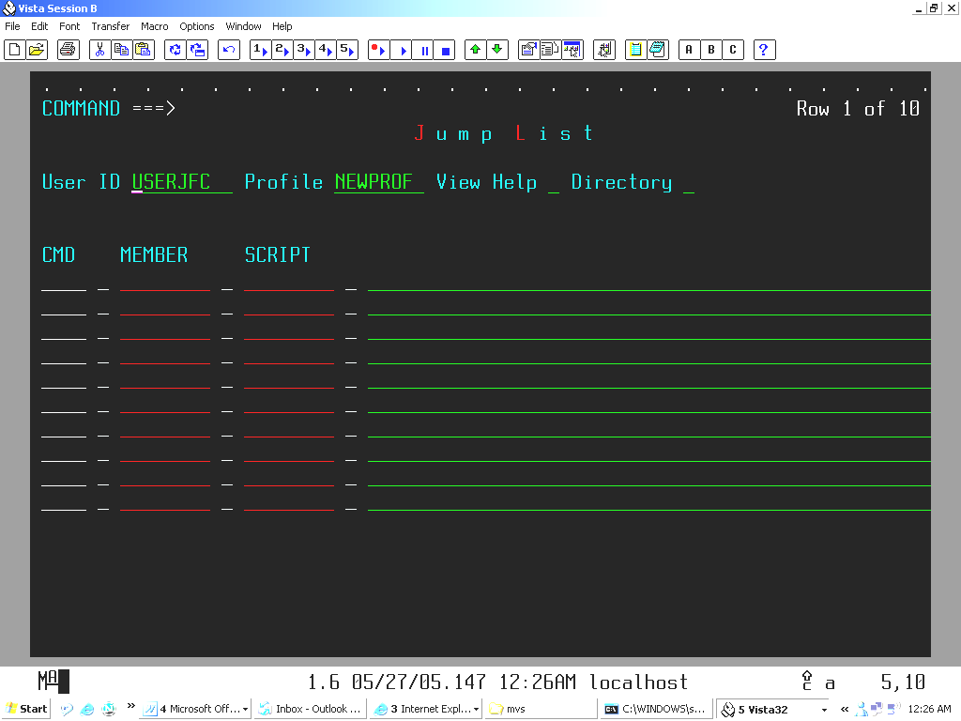

You can add or delete lines using the /I and /D commands. See the command summary section for more details. You then add the data set names and members of the programs.

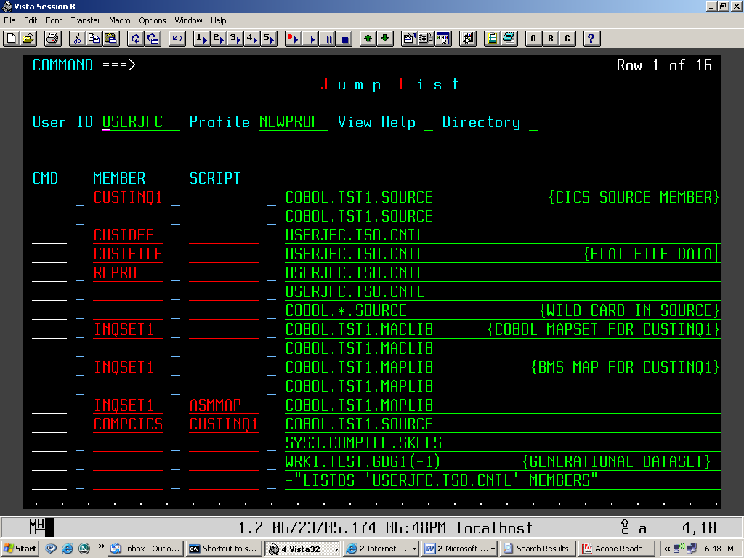

The screen is now associated with the profile name which I use to gain access during a later session. I can edit, view, or browse the members or data sets listed on the screen. If I wish, I can add new data sets or delete or overwrite existing entries. Since the entries are persistent, they will be available the next time that I use JumpList.

Using Initial Scripts

Refer to the screen shot on the previous page. An Initial Script is entered under SCRIPT. It can operate as a standalone Rexx script by using the XS for Execute Script command or it can operate in conjunction with the File tailoring services with the FE, for File tailor Edit, command or with the FJ, for File tailor Submit, command. With the File tailoring commands, the script is executed then the file tailoring process is performed. This enables the initialization of symbolic variables used by file tailoring. An example FT file is compile JCL. The script will execute and initialize the variables needed to resolve a compile. Refer to the compile method that utilizes this service in the appendix for a more detailed look at how the service operates. This service differs from the Immediate Script and User Command services in that it only processes Rexx and TSO commands. This relaxes the requirement that all commands be preceded by a dash character since the service already knows the command type. When used with the file tailoring service, a script name must be defined even if it is empty. The name of the script becomes associated with the service name FTJCL. This name will refer to the file tailoring JCL name in the file tailoring library referred to by the ISPSLIB libdef. In other words, the script name is the JCL name. This can be overridden in the script by specifying FTJCL = ‘some other jcl name’.

The advantage of the Initial Script is its support for File Tailoring services which you can invoke without special knowledge of how it operates.

Executing Immediate Scripts

JumpList can also process Rexx and TSO commands with immediate scripts. It is not always convenient to remember ISPF commands such as ISRDDN, which provides allocation information. I preceded the command with a dash to tell JumpList to process to start the command processor. The XI command executes the script.

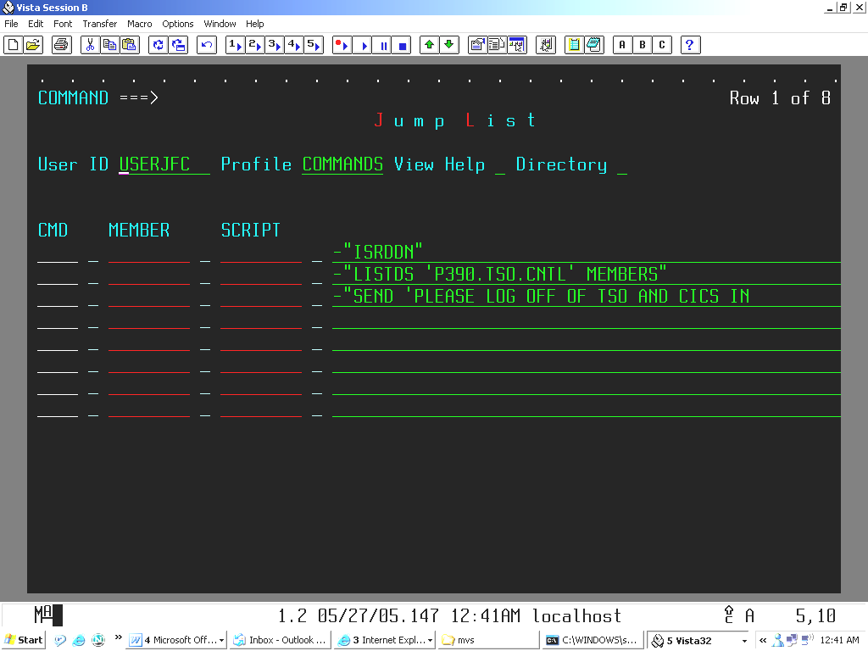

Since the data line field is only 49 characters long, space can be a problem on the screen for commands that demand it. The entry field can be expanded with the /XPND command. This allows the entry of 2025 characters of information. As you can imagine, this feature can allow you to automate rather complicated procedures that would normally have to be performed through keying. One of the uses of the utility is to create an operator profile where the operator can send broadcast messages to announce IPL times. Also, console commands can be executed, providing the ability to execute systems level commands such as starting and stopping various subsystems or executing start up or shut down commands for the system IPL. This topic is beyond the scope of this article but in general, any command that can be executed through rexx and an associated address space can be utilized in JumpList.

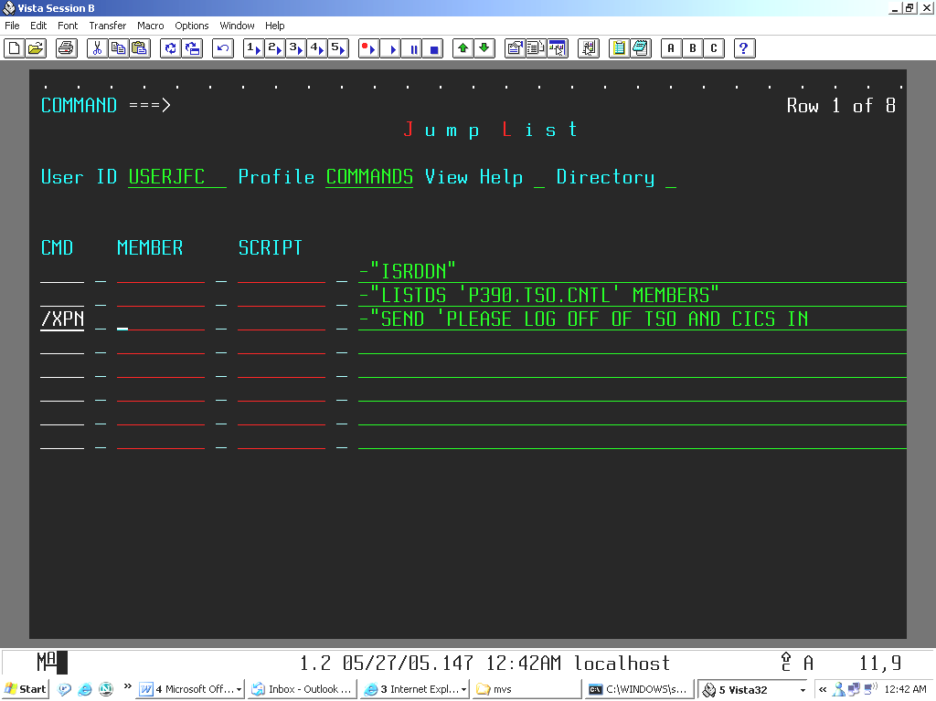

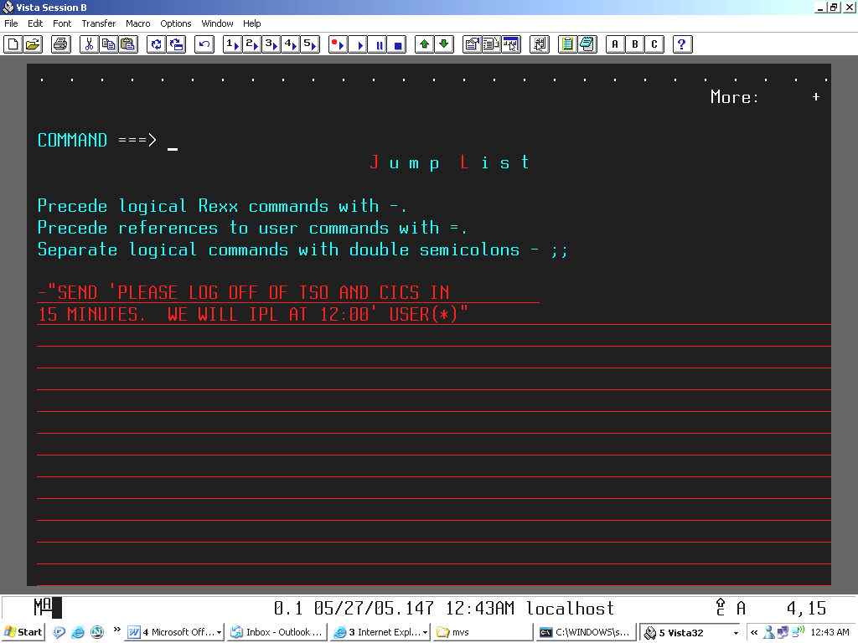

Utilizing User Commands

An extension of the immediate script capability is the ability to create user commands. Up to 1000 commands can be utilized and this limit can be extended with a coding change to JumpList. Two types of user commands are available. They are local commands and supervisor commands. The first consists of local commands that are available only to the user who created them. For instance, if USERJFC created a series of commands, these commands will only be available to that user. The second type of user command is Supervisor. Supervisor commands are global commands that are owned by the supervisor and are available to all JumpList users. This approach allows the control and implementation of mission critical commands. Between the two types of commands, 1000 commands are available to both types. You can even reference commands that were previously entered by appending them with an equal ‘=’ sign.

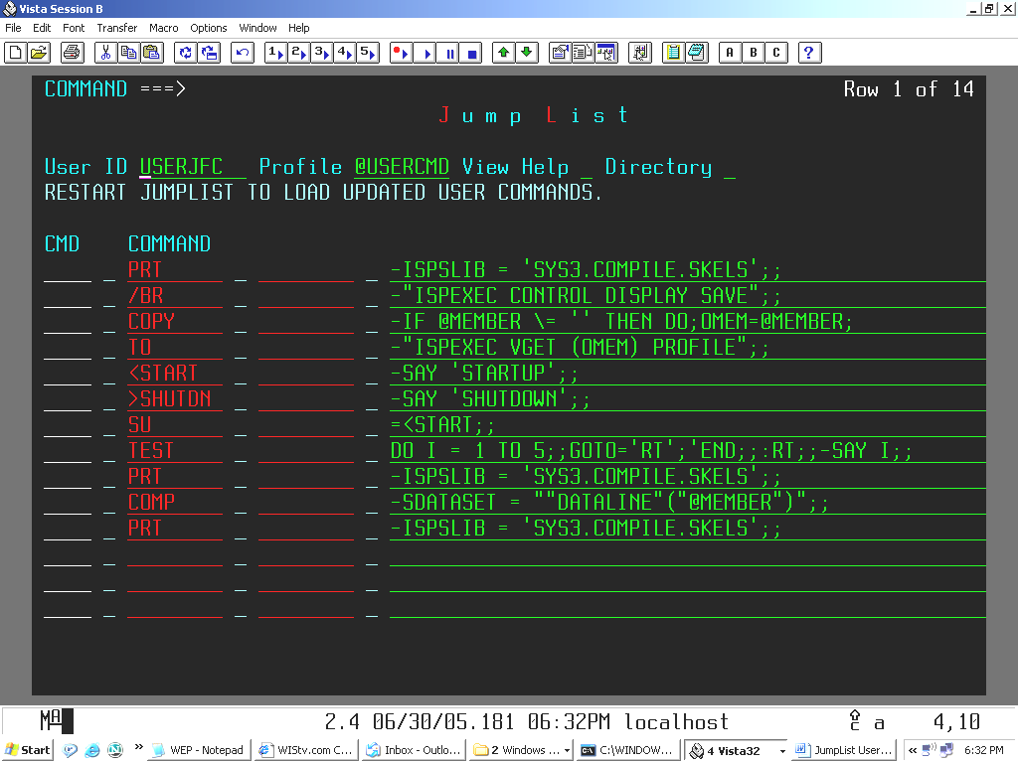

To create user commands, you must first enter @USERCMD in the profile field. This simply creates a new user profile, but with a twist. This profile name is recognized by JumpList as the user command table and builds an associative table of commands every time JumpList is restarted. The new command names will be entered under COMMAND. Note that the size of the new command name can only be up to 4 characters in length if they are to be invoked as browser commands. As start up and shut down commands, they can be up to 8 characters in length. As with the immediate script entries, a combination of Rexx and TSO commands can be entered to comprise the new command. Also, previously defined user or supervisor commands can be included in the new command. These commands could also have other commands imbedded within them. User and Supervisor commands can also become start up and shut down commands. If a command is preceded with the < character, then it becomes a start up command that is executed when JumpList is started. If a command is preceded with the > character, then it becomes a shut down command that is executed when JumpList terminates. This provides the ability to connect and logoff to the Ispf Workstation or to the DB2 or IMS subsystems. Multiple start up and shut downs commands can be initiated at one time. As with Immediate scripts, the size of the data line field can be expanded using the /XPN command.

When JumpList sees an imbedded user or supervisor command, it performs a recursive call on the user command stack to process that statement. This means that the variables that you may have coded for that call are visible only within its execution and will be destroyed when control returns to the calling statement. This is normally not a problem. If you would like to transport call information from one level to another, the CALLPARM. structure is available. This is a Rexx associative variable which allows you to pass information back and forth between calls. To help in debugging commands the TRACE = 1 command is available. It will show execution of a user command and show the return code of its operation. Add this command to the user command script. After the problem is resolved it can either be removed or turned off by TRACE = 0.

Within an Immediate Script or User Command script, execution of the script can be altered using the GOTO=label conscript. There may be situations where a previously defined command needs to be executed conditionally. This is not possible using a logical Rexx statement such as -DO II = 1 TO 100;=CMD1;END;; where =CMD1 is a previously defined command. The intent here is to execute the command 100 times. The GOTO=label command provides the capability needed, as shown here.

-X=1;;:label;;X=X+1;=CMD1;;-IF X < 100 THEN GOTO='label';;

:label is a user defined label name. The colon tells the processor that the following name is a label. This allows for previously defined user commands to be conditionally executed in a script.

Using Foreign Profiles

You can also use the profiles that were created by another user. Simply change the User ID to the one desired. If the profile is in use by the owner then a temporary profile will be created. You cannot modify the temporary profile. If the requested profile is new then that profile will be created under the foreign login ID.

Profile Directory Listing

JumpList allow you to view a directory listing of the profiles and scripts that have been allocated for a particular user id. From the main menu, select Directory with an S. A listing of all available profiles and scripts will appear on the panel. You can select an available profile with the S command. This is useful when you do not know the name of a particular profile. You can also delete a profile or script with the D command. These commands are entered in the CMD field next to the entry to be processed. If you need to perform more advanced editing functions, such as moving or renaming profiles or scripts, they are stored in “userid”.JUMPLIST for profiles and “userid”.JUMPLIST.SCRIPTS for scripts where userid is the TSO login account id. You can also build user commands to provide these functions.

Installing as a Site Command

JumpList can be utilized as a site command with the appropriate entry in the site commands table. This allows for the utility to be utilized without have to key TSO before every invocation of it. It can also be installed with an alias which will allow for it to be called with an alias name, such as JLIST.

Using Comments

Comments are entered by enclosing them with ellipses, such as {THIS IS A COMMENT}. Comments can trail the command entry or can precede it. If the command precedes the command then the comment must start in column 1. The comment has to be closed out with the } character.

Naming Convention

Please note that the profile name is actually a member entry in the table library, so it must conform to member naming conventions. This means that its length cannot exceed 8 characters and it must conform to the naming conventions used by TSO and ISPF.

Installation Guide

To install JumpList, first download file 717 from the CBT tape. The URL is http://cbttape.org/updates.htm. Click on file 717 to download. Once the zip file is downloaded, unzip it to a known PC directory. To upload the XMI file to the mainframe, first use =6 on the TSO command line to go to the TSO Command Shell screen. Each emulator varies in the method used to upload a file to the host. In my case, I use the Transfer option of the emulator and select Send to Host. The XMI file is selected using the Browse function. The target destination must be a sequential file of fixed length and 80 characters in length. You may need to create such a file using the 3.4 option. I called mine TEMP.UPLOAD. Be sure that the transfer option is set to Binary. After the file is uploaded to the destination, I use the RECEIVE command to receive the file. Use RECEIVE INDS(‘TEMP.UPLOAD’). The received file creates TSO data sets that usually begins with CBT, such as CBT.CBT466.FILE717.PDS. In some cases, it may begin with SBGOLOB.
It is a good idea to screen print the unload screen that appears when the receive command is processed to note the actual data set names that are created. If the files cannot be created then check for RACF authorization to allow for files beginning with CBT or SBGOLOB to be allocated. Within the received PDS, edit the INSTALL file. Each component of JumpList is contained in this file and it is necessary to modify the JCL to allow the unloaded components to go to their required PDS’. In the case of the main JumpList program, modify the SYSUT2 DD name to point to the PDS used for your shop’s rexx execs. In the case of the four JumpList panels, modify the SYSUT2 DD name to point to the PDS used for your shop’s ISPF panels. For the panels, only one SYSUT2 DD name will be shown since it loads the three panels. Once the utility is properly installed, the owner of the utility will need to edit the Rexx program and make the noted parameter changes to it. They are explained in detail at the top of the program. The changes will be necessary if the owner decides to make global commands available to the user group, such as the Print command that I described earlier in this article.

JumpList Command Summary

/I – Inserts a blank line into the display table
/Ixx – Inserts xx number of lines into the display table. xx is a numeric value which represents the number of lines to insert..
/D – Deletes a single line from the display table.
/Dxx – Deletes xx number of lines from the display table. xx is a numeric value which represents the number of lines to delete.
/R – Replicates a single line in the display table.
/Rxx – Replicates xx number of lines in the display table. xx is a numeric value which represents the number of replicated lines.
/XPN – Expands the entry line for data sets or scripts up to 2045 characters.
E – Edits a member or data set.
ESCR – Forces the SCR edit function of option 3.4. This option allows copy, delete, move, and other maintenance functions of data sets and their members/
V – Views a member or dataset. The View function has the same rules as Edit.
B – Browses a member or a data set. The Browse function uses the same rules as Edit but with a few exceptions. VSAM files can be browsed. Also, if only DATASET is specified then the PDS or sequential file is browsed.
Z – Compresses a PDS.
J – Submit JCL.. Submits the JCL that is specified in MEMBER.
ES – Edit Script function. Edits the script in INITIAL.
ESCR – Edit data set using DSLIST. Equivalent to editing with option 3.4.
XI – Execute Immediate Script function. Executes the TSO and Rexx commands on a entry line.
XS – Execute Script function. Executes the Rexx commandst specified in SCRIPT.
FE – File tailor Edit. Edits the results of the file tailoring request.
FJ – File tailor submit. Submits the results of the file tailoring request.
/RESET – Resets the @USER and JUMPPROF names in the variable pool in the case that they prevent the utility from starting.
/CLOSE – A command line function that forces the release of the table data sets in the event some event prevents them from closing properly. This is unlikely to occur.

@USERCMD invokes the user command interface. Enter it as the profile name.

Additional Command Examples

The base JumpList utility lacks commands to perform data set operations such as PRINT, COPY, MOVE, RENAME, DELETE and so on. But the User Command capability allows us to build these commands into the system. In fact, practically any command imaginable can be built using this facility. I will show the code for the above commands and how to integrate them into the utility.

Print Command Example

The Print command was not included in the basic utility because of varying JCL requirements. See the previous screenshot and look at the PRT command. /XPN expands the data entry lines.

-ISPSLIB = 'SYS3.COMPILE.SKELS';;
-"ISPEXEC LIBDEF ISPSLIB DATASET ID('"ISPSLIB"') STACK";;
-"ISPEXEC VGET ZTEMPF";;
-"ISPEXEC FTOPEN TEMP";;
-"ISPEXEC FTINCL PRINT";;
-"ISPEXEC FTCLOSE";;
-"ISPEXEC CONTROL DISPLAY SAVE";;
-"ISPEXEC VGET ZTEMPN SHARED";;
-"ISPEXEC LMINIT DATAID(ZTEMPDD) DDNAME("ZTEMPN")";;
-"SUBMIT '"ZTEMPF"'";;
-"ISPEXEC CONTROL DISPLAY RESTORE";;
-"ISPEXEC LMFREE DATAID("ZTEMPDD")";;
-"ISPEXEC LIBDEF ISPSLIB";;

Print Code
The LIBDEF for ISPSLIB can be omitted if it is provided during the login proc. If provided as shown in this example, the ISPSLIB data set must be a previously allocated pds. Using this method provides flexibility in the event that the libdef that is allocated in the login proc is racf protected. Key in the example as shown and press enter to commit the changes. The prior screen will be shown. To refresh the command processor, PF3 back to ISPF and then reenter JumpList with TSO JUMPLIST. The PRT command is now available for to print a pds member. Before doing so, the PRINT JCL must be loaded in the ISPSLIB libdef data set.

//&USER.A JOB ACCT#,
// &USER, **JOB STATEMENT GENERATED BY SUBMIT**
// NOTIFY=&USER,
// MSGLEVEL=(1,1)
// EXEC PGM=IDCAMS
//SYSPRINT DD SYSOUT=*
//SYSIN DD *
REPRO INDATASET(&DATALINE(&@MEMBER)) -
OUTFILE(SYSPRINT)
/*
Print JCL

Copy and Move Commands

The COPY command uses the COPY TO format to enable a member name to be copied from one pds to another. COPY will be entered in the command field of the object member. TO will be entered in the command field of the object data set. Two commands will be created, COPY and TO. COPY simply queries the existence of the member name and pds that it belongs to and verifies that they actually exist. The names are stored in the variable pool to be retrieved by the TO command. The TO command reads the profile variables and then performs LMF operations to copy the member to the new data set. The MOVE command works like the COPY command.

-IF SYSDSN("'"ODIR"("OMEM")'") \= 'OK' THEN DO
ZEDLMSG = 'INVALID DATA SET OR MEMBER NAME';RETURN;END
ELSE DO;
INFO1 = 'USE THE ''TO'' COMMAND TO COPY THE MEMBER TO THE DESIRED DATA SET';
END
-IF @MEMBER \= '' THEN DO;
OMEM=@MEMBER;
"ISPEXEC VPUT (OMEM) PROFILE";
ODIR=DATALINE;
"ISPEXEC VPUT (ODIR) PROFILE";
OCMD = 'COPY'
"ISPEXEC VPUT (OCMD) PROFILE";
END;;
COPY Code

-IF @MEMBER \= '' THEN DO;
OMEM=@MEMBER;
"ISPEXEC VPUT (OMEM) PROFILE";
ODIR=DATALINE;
"ISPEXEC VPUT (ODIR) PROFILE";
OCMD = 'MOVE';
"ISPEXEC VPUT (OCMD) PROFILE";
END;;
-IF SYSDSN("'"ODIR"("OMEM")'") \= 'OK' THEN DO;
ZEDLMSG = 'INVALID DATA SET OR MEMBER NAME'
RETURN;
END;
ELSE;
INFO1 = 'USE THE ''TO'' COMMAND TO MOVE THE MEMBER TO THE DESIRED DATA SET'

MOVE Code

-"ISPEXEC VGET (OMEM) PROFILE";;
-"ISPEXEC VGET (ODIR) PROFILE";;
-"ISPEXEC VGET (OCMD) PROFILE";;
-IF SYSDSN("'"DATALINE"'") = 'OK' THEN TDIR = DATALINE;ELSE RETURN;;
-"ISPEXEC CONTROL ERRORS RETURN";;
-"ISPEXEC LMINIT DATAID("ZTEMPDA") DATASET('"ODIR"')";;
-"ISPEXEC LMINIT DATAID("ZTEMPDB") DATASET('"TDIR"')";;
-IF OCMD = 'COPY' THEN
"ISPEXEC LMCOPY FROMID("ZTEMPDA") FROMMEM("OMEM")
TODATAID("ZTEMPDB") TOMEM("OMEM") REPLACE";;
-IF OCMD = 'MOVE' THEN
"ISPEXEC LMMOVE FROMID("ZTEMPDA") FROMMEM("OMEM")
TODATAID("ZTEMPDB") TOMEM("OMEM") REPLACE";;
-"ISPEXEC LMFREE DATAID("ZTEMPDA")";;
-"ISPEXEC LMFREE DATAID("ZTEMPDB")"

TO Code

DELete Command

This command will enable you to delete a member from a pds or even the contents of the pds. Since we do not want to accidentally delete a needed member or data set, we need to add verification code to prevent mass deletes.

-IF @MEMBER = '' THEN DO;
ZEDLMSG = 'A MEMBER NAME OR MEMBER PATTERN MUST BE SPECIFIED';RETURN;END;;
-IF DATALINE = '' THEN DO;
ZEDLMSG = 'A DATA SET MUST BE SPECIFIED';RETURN;END;;-TRACE = 1;;
-IF @MEMBER = '*' THEN;
"ISPEXEC LMINIT DATAID("ZTEMPDA") DATASET('"DATALINE"') ENQ(EXCLU)";
ELSE;
"ISPEXEC LMINIT DATAID("ZTEMPDA") DATASET('"DATALINE"') ENQ(SHRW)";;
-"ISPEXEC LMOPEN DATAID("ZTEMPDA") OPTION(OUTPUT)";;
-IF @MEMBER ='*' THEN DO;SAY 'ALL MEMBERS WILL BE DELETED! REPLY WITH Y TO
CONTINUE';PARSE UPPER PULL RESPONSE;END;;
-IF RESPONSE = 'Y' THEN ZEDLMSG = 'ALL MEMBERS DELETED';;
-"ISPEXEC LMMDEL DATAID("ZTEMPDA") MEMBER("@MEMBER")";;
-"ISPEXEC LMCLOSE DATAID("ZTEMPDA")";;
-"ISPEXEC LMFREE DATAID("ZTEMPDA")";;

DELete Code

COMPile Command

The compile JCL resides in the ISPSLIB library. In my example, the LIBDEF is defined as SYS3.COMPILE.SKELS. I included the capability to resolve 3 types of compiles, that include Cobol, BMS Maps, and Command level Cobol. Since space is a consideration on the entry page, an external call can be made to a Rexx module that contains information about LANGUAGE and COMPILER type. The variable pool will be utilized to pass the information to and from the external call. Or, you can define the LANGUAGE and COMPILER type in a separate user command and use the CALLPARMS. associative variable to pass information back and forth.

The command opens the source program and read the top three lines for compile information. The information will include the type of program to compile, such as BMS map, Cobol2, Cobol for MVS, Assembler, and so on. I also included the ability to detect the LNKPARM information. You can include any additional information needed to resolve your compile. Since space is an issue on the extended lines, the logic could have incorporated into a separate Rexx module and called from the script. Information concerning the compile process would have to be passed back and forth using the variable pool. Using this process can greatly expand on the depth of the compile procedure and can could allow for Ispf tables to be utilized to store program information. Using the top 3 lines of a program is an acceptable way of storing compile information, as is shown in this example. Be aware that if table libdefs are utilized they must be invoked with the STACK command to avoid corrupting JumpList’s use of these libdefs.

-SDATASET = ""DATALINE"("@MEMBER")";;
-"ALLOCATE DD(COMPDD) DSN('"SDATASET"') SHR REUSE";;
-"EXECIO 1 DISKR "COMPDD" (FINIS";;-"FREE DD(COMPDD)";;-PARSE PULL PLINE;;
-PLINE = SUBSTR(PLINE,8,66);;-PLINE=TRANSLATE(PLINE,' ','/-,*');;
-IF POS('ASMMAPS',PLINE) > 0 THEN LANGUAGE = 'MAPS';
ELSE IF POS('CICS COB',PLINE) > 0 THEN LANGUAGE = 'CICS';
ELSE IF POS('COBOL2',PLINE) > 0 THEN LANGUAGE = 'COBOL';;
-IF LANGUAGE = 'MAPS' THEN COMPILER = 'ASMMAP';
ELSE IF LANGUAGE = 'CICS' THEN COMPILER = 'COMPCICS';
ELSE IF LANGUAGE = 'COBOL' THEN COMPILER = 'COMPILE';;
IF POS('NCAL',PLINE) > 0 THEN LNKPARM = 'NCAL';
ELSE IF POS('CALL',PLINE) > 0 THEN LNKPARM = 'CALL';ELSE LNKPARM = 'LET';;
-ISPSLIB = 'SYS3.COMPILE.SKELS';;
-"ISPEXEC LIBDEF ISPSLIB DATASET ID('"ISPSLIB"') STACK";;
-"ISPEXEC VGET ZTEMPF";;
-"ISPEXEC FTOPEN TEMP";;
-"ISPEXEC FTINCL "COMPILER"";;
-"ISPEXEC FTCLOSE";;
-"ISPEXEC CONTROL DISPLAY SAVE";;
-"ISPEXEC VGET ZTEMPN SHARED";;
-"ISPEXEC LMINIT DATAID(ZTEMPDD) DDNAME("ZTEMPN")";;
-"ISPEXEC EDIT DATAID("ZTEMPDD")";;
-"ISPEXEC CONTROL DISPLAY RESTORE";;

Compile Code

//&USER.A JOB ACCT#,
// &USER, **JOB STATEMENT GENERATED BY SUBMIT**
// NOTIFY=&USER,
// MSGLEVEL=(1,1)
//LIBS JCLLIB ORDER=(USER.PROCLIB)
//ASM EXEC DFHMAPS,MAPNAME=&@MEMBER
//SYSUT1 DD DSN=&DATALINE(&@MEMBER),DISP=SHR
//

BMS Map Assembler JCL

Alternate Compile Methods

Method 1
The first, and easiest, method is to simply reference a data set and compile member. I need to edit the JCL and make the required changes for the program that I need to compile, such as MORCAL1. I can submit the compile from the edit by keying SUBMIT or by using the J command in CMD.
.

Method 2
This method involves File Tailoring and creating a user script for the compile. The compile JCL will reside in the library pointed to by the ISPSLIB LIBDEF. This library is defined by the systems group and is where commonly used skeletal procedures are stored. You must know the name of this data set to use this service.

In this example, ASMMAP and COMPCICS are the skeletal JCL names that I have defined in SYS3.COMPILE.SKELS. This data set is referred to by the ISPSLIB libdef and will be different in your system. For the ASMMAP example, I have a script defined for ASMMAP. The program to compile is INQSET1 and it resides in COBOL.TST1.MAPLIB. To access the script, I enter the ES command in CMD and press enter.

ES_ _ INQSET1 _ ASMMAP _ COBOL.TST1.MAPLIB
___ _ COMPCICS _ CUSTINQ1 _ COBOL.TST1.SOURCE

In the Script Editor, I enter the parameters needed to resolve the compile. In this example, no additional parameters need to be resolved, so I press enter to commit a blank script. If parameters need to be resolved, enter them as they appear in the JCL. In JCL, you may have a &LNKPARM=’NCAL’ parameter. In the script, you can override the parameter by using LNKPARM = NCAL or whatever it needs to be to resolve the compile.

I press enter to commit the script and PF3 to return to the prior panel.
To compile the program, I use the FJ command in CMD next to the script name and press enter. I can also use FE if I want to preview the JCL before compiling it.

