Interactive Short DisAssembler (ISDA)
User’s Guide [Version 2.0]
- Introduction
ISDA is a small tool for supporting diagnosis in a z/OS environment under ISPF and IPCS. There exist various disassemblers which deal mainly with load modules. The IPCS list subcommand can do disassembling as well based on dump contents.
Due to some discomfort with this tool there arose the idea to combine the technique shown by Doug Nadel in his vcursor utility with some rexx code to implement the relations between symbolic and machine instructions. The result was a cursor sensitive disassembler that starts its work at a position defined by the user and shows the symbolic instructions in a pop up window under ISPF or in a list screen under IPCS.
Positioning:
ISDA is not intended to work as a reengineering tool, but to show the data and control flow inside a relatively short sequence of instructions.
ISDA works on any type of screen content under ISPF or IPCS containing machine code instructions (e.g. SVCDUMPs, CEEDUMPs, SYSUDUMPs, and the like).
- Changes related to Version 2
Besides some bug fixes the new instructions of the z9 and z10 machines are now supported. An additional interface for reading instructions from a file was added.

New instructions related to z9 and z10 machines
The old version of ISDA supported instructions up to the instruction set of the z990 machine. ISDA 2.0 is capable of disassembling instructions of the z9 and the z10 machine as well. The nearly 300 new instructions deal mainly with decimal floating point arithmetic (DFP) and long immediate formats.
Examples of these new instruction codes are: MVHHI, CU14, MY. See the POPs for reference.

New interface for reading machine instructions from files
Mainly for test purposes it is now additionally possible to disassemble instructions by reading them from a file. ISDA assumes that this file is allocated to DDName(FINISDA). A new parameter controls the way of reading from a file.
This test driver shows how to call ISDA in filemode:
/* rexx Test ISDA with filemode */
address tso

/* alloc file containing machine codes (i.e. HLASM Listing) */
"alloc da(TOTALOPC.LIST) fi(finisda) shr reuse"

tcstco = 0 /* meaningless in filemode */
tcnmrows = 0 /* meaningless in filemode */
sdadbg = 'P' /* write output to DDNAME(SDADBG) */
insrc = 'F.9.14' /* start in col 09 and read 14 chars in each line */

call isda tcstco tcnmrows sdadbg insrc

exit
In this case the PS Dataset TOTALOPC.LIST contains a HLASM Listing that is to be disassembled in order to verify the correctness of the result of ISDA. The insrc parameter begins with the letter f and contains the start column and length of each line to be read.
- Architecture and Installation
ISDA is capable of dealing with arbitrary screen sizes and does not need any configuration input besides that described below under “Invocation”.
The utility is completely written in rexx. The whole stuff is embedded in a single source file. It runs under ISPF as well as under IPCS whilst it detects the appropriate runtime environment by itself.
ISDA operates on information provided by the ISPF variable ZSCREENI which contains the pure Image of an ISPF screen. It grabs the data and reformats them into lines in order to associate coordinates and cursor positions (the latter provided by ISPF variable ZSCREENC).
Under IPCS ISDA accesses dump data by invoking the evaluate subcommand.
There exist several panels that are part of the rexx source. They are built dynamically during runtime (as in vcursor).
To install ISDA it should be put into a library which is part of a SYSPROC or SYSEXEC concatenation.
For operation under ISPF a PF-key should be assigned to the Command
TSO %ISDA.
For operation under IPCS a PF-key should be assigned to the Command
IPCS %ISDA
- Invocation and Output
Invocation and output differ depending on the environment. Under IPCS the rules follow the principles of rexx scripts for IPCS, under ISPF (further named as ‘non-IPCS’) there have to be made some additional definitions for screen coordinates and output.

Invocation of ISDA in a non-IPCS Environment
In this environment the invocation of ISDA is a 2-step process, since ISDA needs to know where the left margin of the dump begins. Despite it starts disassembling at the cursor position, subsequent lines of the dump are captured from this defined left margin up to the rightmost character which is obviously a pair of hex chars.

1st Step: set left margin and number of rows
To set the left margin and the row amount, simply call ISDA as a TSO command without parameters:
TSO %ISDA
As a result you get the following panel (this is from an EJES display showing a SYSUDUMP List):

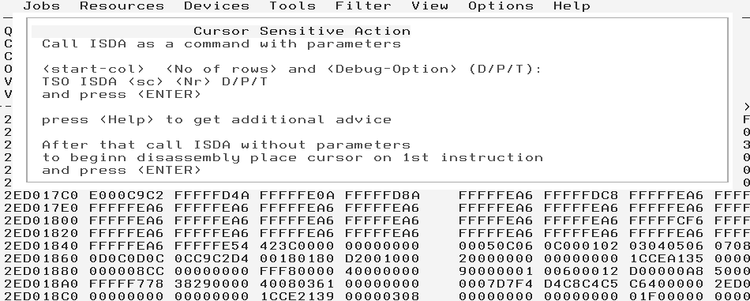

In a SYSUDUMP instructions normally begin at screen column 11. Therefore you enter:
TSO %ISDA 11 5
for getting up to 5 rows of instructions, beginning at column 11.
ISDA quits this command:

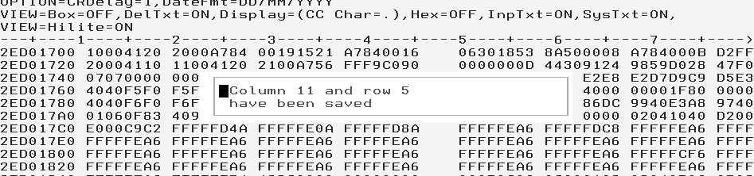

Now ISDA is ready for disassembling.

2nd Step: doing Disassembly
In order to get the symbolic instructions, just assign the Command
TSO %ISDA
to a PF-Key, e.g. PF20.
Then place the cursor at the beginning of the code sequence and hit <PF20>.

Disassembling Portions of a SYSUDUMP
Referring to the example above, the cursor is placed as follows:
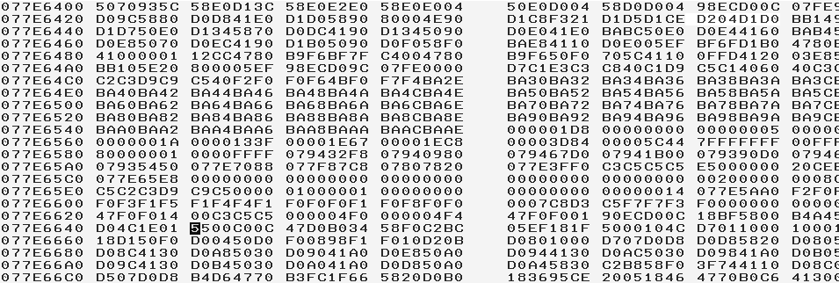
After hitting <PF20> you see the symbolic instructions:
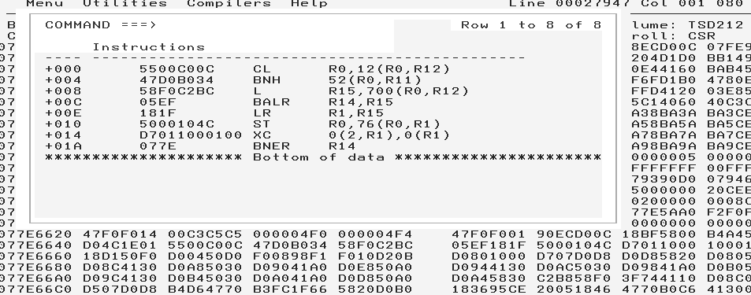

Disassembling the neighbourhood of a PSW-Address in a LE Dump
Since LE dumps contain only a small amount of instructions related to an error, ISDA is suitable for displaying these instructions around a PSW-Address. You place the cursor at the beginning of the instruction sequence and hit <PF20>:
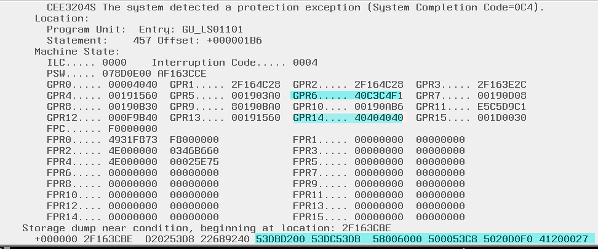

After hitting <PF20> you get:

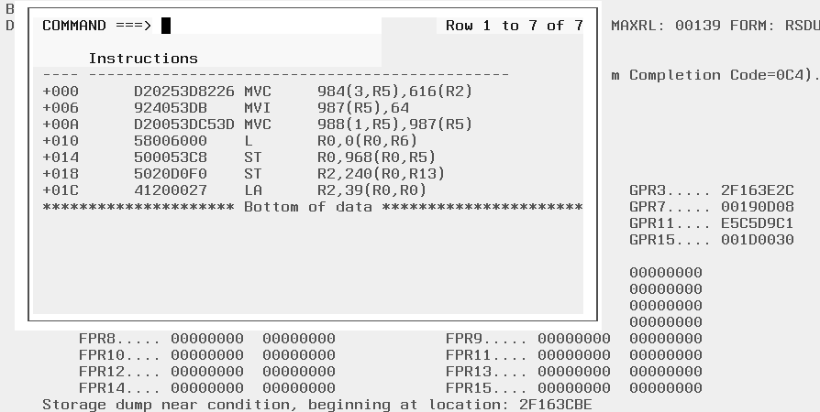

The symbolic instructions show a reference via R6 which has a value of x’40C3C4F1’, as shown above. This value causes the protection exception.

Additional Output from ISDA in a non-IPCS Environment
As far as the user does not enter additional parameters when invoking ISDA, output is presented in a pop up window.
However, there exists a possibility to get the symbolic instructions additionally in a temporary file that can be accessed by the editor. To accomplish this, invoke ISDA with the P (protocol) option:
TSO %ISDA 11 5 P
In this example, ISDA starts at column 11, grabs 5 rows of dump and writes the symbolic instructions additionally to file SDADBG. This file can be accessed via DDLIST:

The content of SDADBG is:
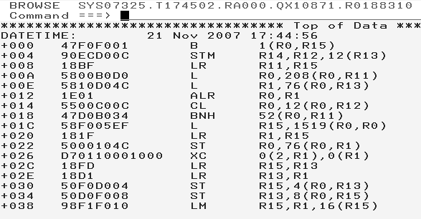
Via the clipboard of the editor this content can be brought everywhere in the system.

Invocation of ISDA in an IPCS Environment
Due to architectural differences between IPCS and ISPF, calling ISDA in an IPCS Environment differs slightly from that described above. Additionally, in IPCS output from ISDA is not brought into a popup-window, but displayed by using the note subcommand of IPCS.

1st Step: Set Number of Bytes and Debug-Level
Within IPCS, ISDA may be called as:
ipcs %isda <Number of Bytes>
As a line command under IPCS.
<Number of Bytes> can assume a value between 8 and 512.
For the sake of simplicity it is recommended, to assign a PF-Key (as in the former examples, it is again PF20) to the command:
IPCS %ISDA <Number of Bytes>
If the user wants to get additional output, e.g. for debugging purposes, the command has to be assigned in that way:
IPCS %ISDA <Number of Bytes> 0 D
This causes ISDA to provide additional output to control its internal behaviour.

Note: There exists another option:
IPCS %ISDA <Number of Bytes> 0 T
In this case the rexx trace is switched on. Be careful when using it, lots of rows in TSO line mode will be produced. Use it only in case of strange errors.

2nd Step: doing Disassembly
After having set the amount of data to be disassembled, just place the cursor at the beginning of the instruction sequence and hit PF8:
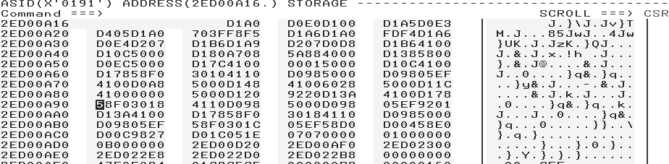

After hitting <ENTER> you get:
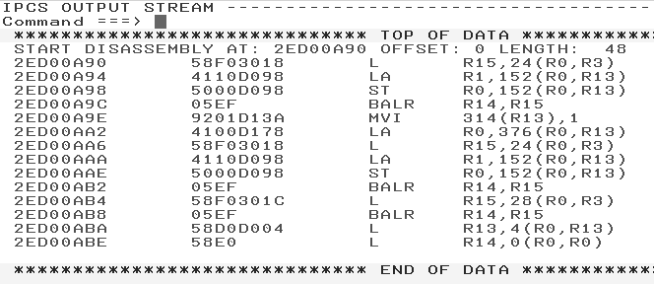
Note that, different from a non-IPCS display, the absolute starting address from the beginning of the instruction sequence is displayed on the left.
- About the Author
In the course of beginning with dump analysis I felt the need to have a handy utility to show me the symbolic Opcodes of machine instructions together with the addresses inside a dump – since I’m not able to remember all the about 1,400 variations that exist for a zSeries processor and I didn’t want to look at the reference summary every time I needed the information.

