Printing on LAN attached printers from Z/os

PRTLAN allows you to print the content of a file or a PDS member from z/OS directly to a Lan attached printer.

Prerequisites :

- The z/OS USS definitions for TCP/IP must be active
- The file to be printed must be catalogued
- The LAN printers to be used have been previously defined to PRTLAN

PRTLAN can work both on-line, from ISPF or TSO, and batch BATCH via standard JCL.

TSO execution…

TSO PRTLAN printer-name file-name

For example :

TSO PRTLAN VI11PR DB00988.V000.CNTL($DASDIO)

It is also possible to start a dialogue by simply entering the command :

TSO PRTLAN

Specify Printer-Name DataSet-Name or ?,Q to Quit
( Eg. vi11pr your.pdf.file(member) without quote )

In this case type “?“ to obtain a list of defined printers:

Printer Tcp/Ip Add. Description
------------------------------------------------------
VI06PR ! 172.24.7.155 ! PRINTER H/P OS/DBMS
VI11PR ! 172.24.7.160 ! PRINTER XEROX OS/SYSTEMS
VI15PR ! 172.24.7.164 ! PRINTER XEROX OS/COMSERV
VI22PR ! 172.24.7.171 ! PRINTER H/P OPR/ENGIN.

Specify Printer-Name DataSet-Name or ?,Q to Quit
( Eg. vi11pr your.pdf.file(member) without quote )

***
BATCH execution…

PRTLAN can also be called via JCL as follows :

//PCSGT988 JOB (PR00,PR0),'PRTLAN',CLASS=F,NOTIFY=&SYSUID
//* ------------------------------------------------------- *
//EXCTSO EXEC PGM=IKJEFT01,DYNAMNBR=30
//SYSEXEC DD DSN=your_exec_library,DISP=SHR
//SYSTCPD DD DISP=SHR,DSN= your_tcpip_parmlib(TCPDATA)
//SYSTSPRT DD SYSOUT=*
//SYSPRINT DD SYSOUT=*
//SYSTSIN DD *
PRTLAN VI01PR DB00988.V000.CNTL($DASDIO)
PRTLAN VI06PR DB00988.V000.CNTL(DASDIO)
PRTLAN VI06PR DB00988.V100.CNTL($DASDIO)
PRTLAN VI11PR DB00988.V000.CNTL($DASDIO)
/*

Each individual PRTLAN execution will produce its log in the job output :

SDSF OUTPUT DISPLAY PCSGT988 JOB05135 DSID 102 LINE 1
COMMAND INPUT ===>
1READY
PRTLAN VI01PR DB00988.V000.CNTL($DASDIO)
PRTLAN-09E The printer is not defined.
READY
PRTLAN VI06PR DB00988.V000.CNTL(DASDIO)
PRTLAN-01E No member (DASDIO) exists
READY
PRTLAN VI06PR DB00988.V100.CNTL($DASDIO)
PRTLAN-02E No dataset found DB00988.V100.CNTL($DASDIO)
READY
PRTLAN VI11PR DB00988.V000.CNTL($DASDIO)
PRTLAN-01I File DB00988.V000.CNTL($DASDIO) printed on VI11PR
READY
END
******************************** BOTTOM OF DATA *****************

It is possible to specify different print formats by adding one of the following parameters after the printer and file name as follows :

- / PORT portrait format, 60 x 80 and character 11 pt.
- / WIDE landscape format, 103 x 132 and character 06 pt.
- / LAND landscape format, 60 x 132 and character 09 pt.
- / 2UP landscape format, 80 x 66 and character 06 pt, with 2 , side to side, pages.

//SYSTSIN DD *
PRTLAN VI01PR DB00988.V000.CNTL($DASDIO) / PORT
PRTLAN VI06PR DB00988.V000.CNTL($DASDIO) / WIDE
PRTLAN VI06PR DB00988.V100.CNTL($DASDIO) / LAND
PRTLAN VI11PR DB00988.V000.CNTL($DASDIO) / 2UP
/*

The different formats are generated from a different Rexx program, “PYPRINT”, which appends the relative PostScript instructions at the beginning of the print file creating a temporary work file to be deleted once the file has been printed successfully.
Interaction execution…

In ISPF the program can be called in 3 different ways :

- From the “3.4” ISPF panel or a BROWSER/EDIT/VIEW member list by entering in one of the rows the command “PRTLAN” and then slectiong one of the printers available.

- By entering the command “TSO PRTLAN filename/library” selecting one of the printers listed.

- By calling it directly from an EDIT/VIEW session by entering “PRTLAN printer-name” on the command line or simply “PRTLAN” to select one of the printers displayed on the next panel.

From an ISPF “3.4” panel, simply enter PRTLAN next to the file to print :

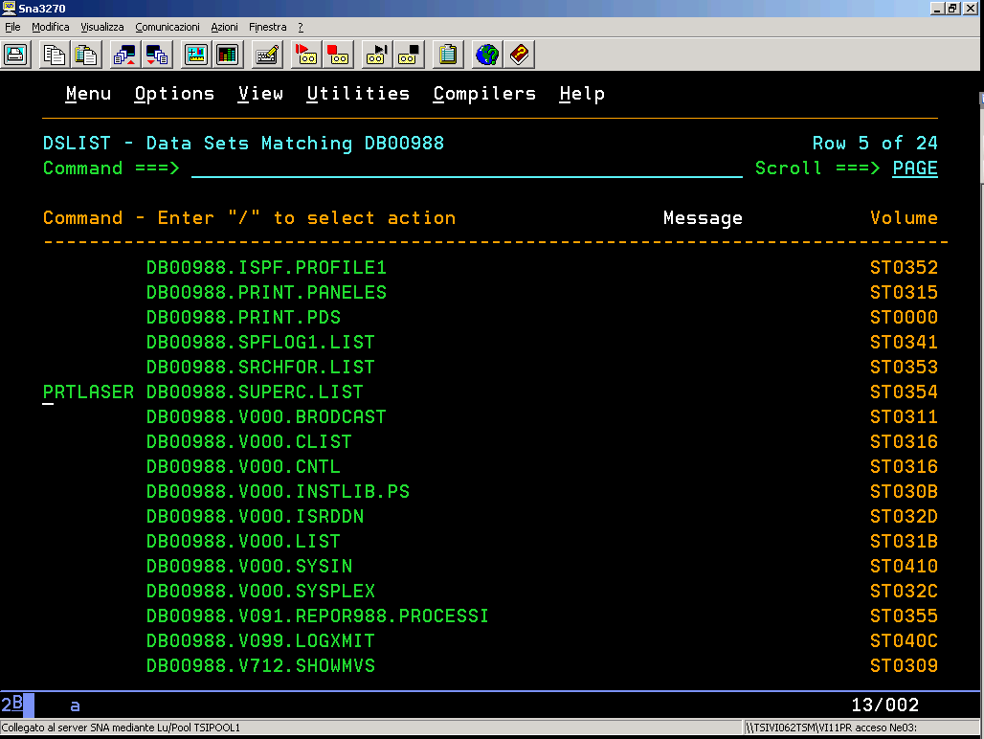

and select the desired printer with “S” from the list of printers that will be displayed.

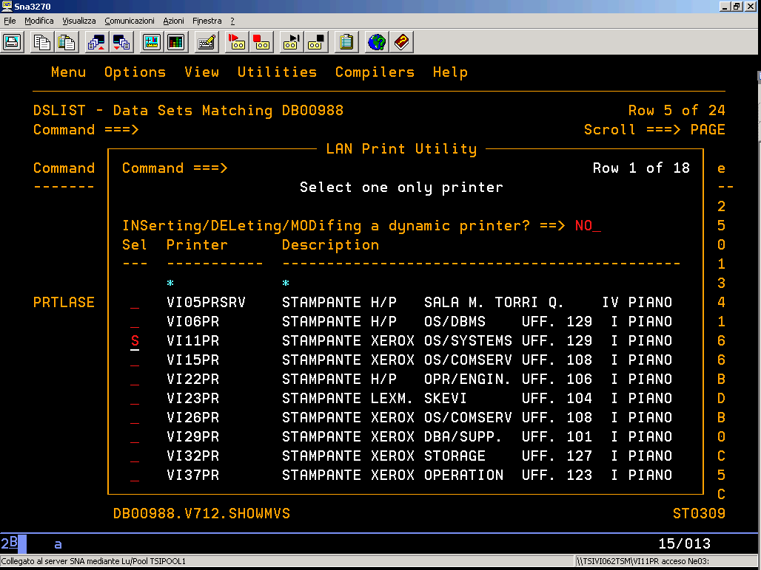

From any command line of an ISPF session by typing :

TSO PRTLAN file-name/library

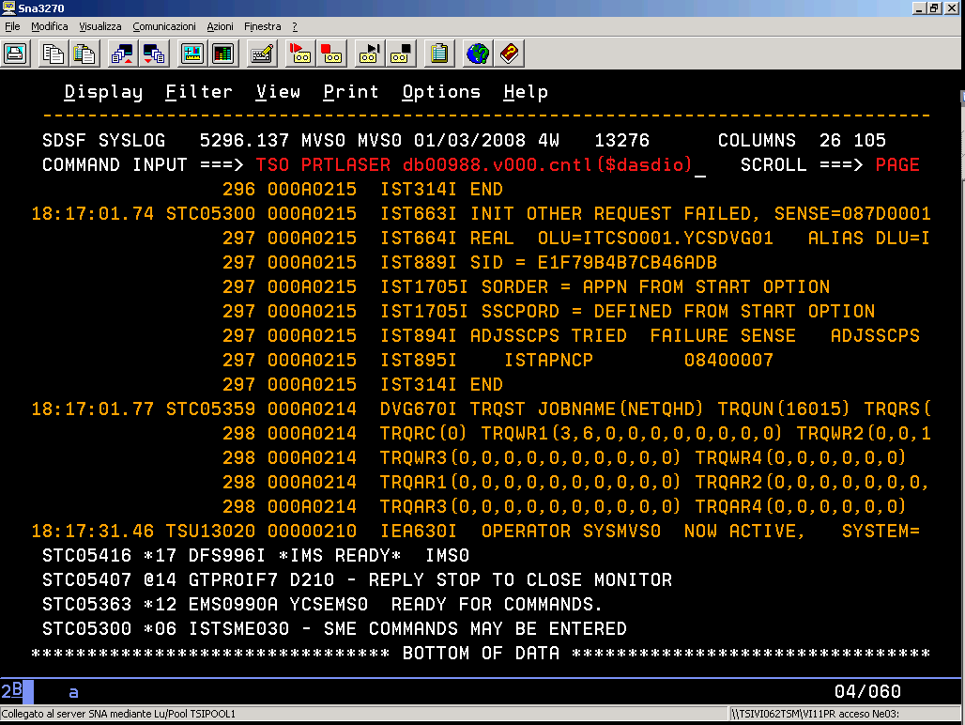

and select the desired printer with “S” from the list of printers that will be displayed.

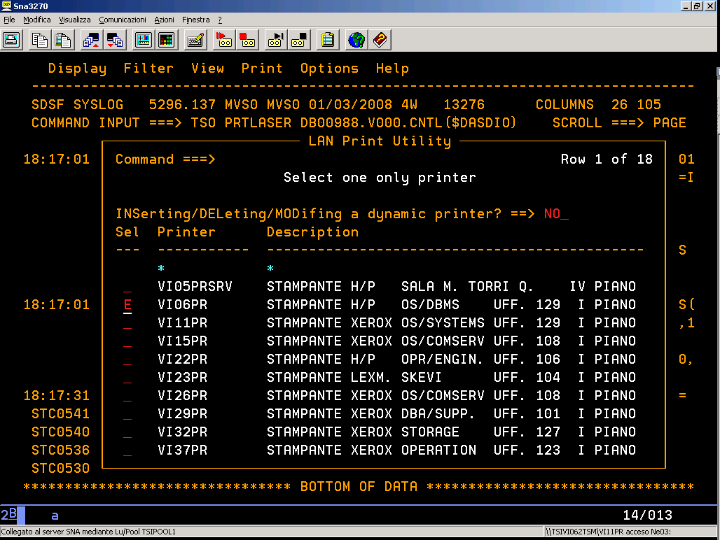

While EDITing or VIEWing a sequential file or PDS member, after having saved any changes, you can also print directly by entering :

PRTLAN printer-name

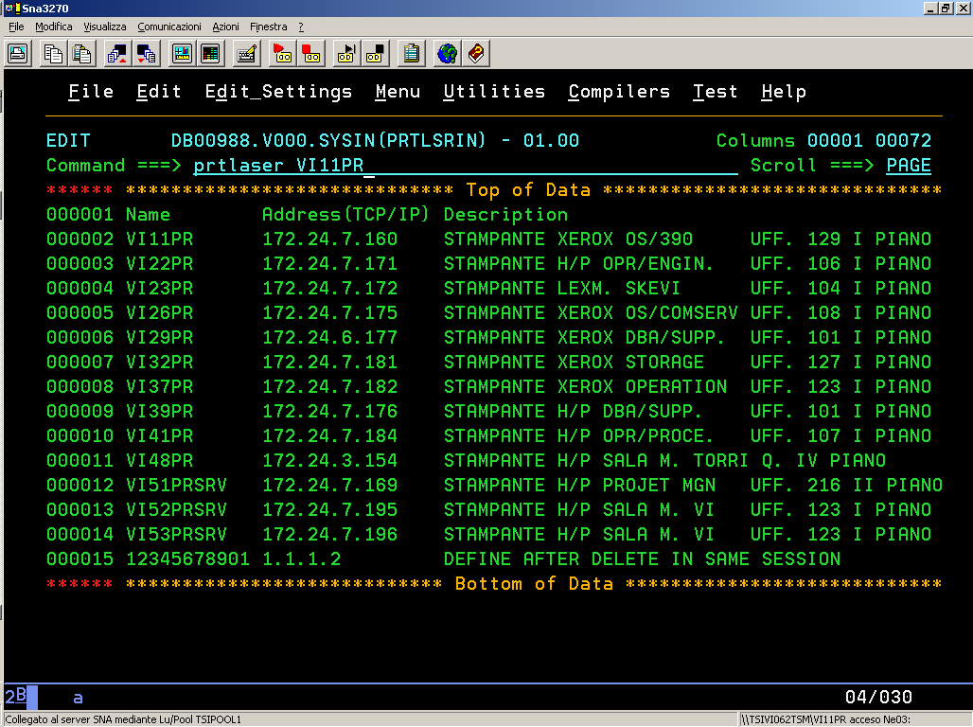

Alternatively, just enter PRTLAN and select the correct printer on the next panel.

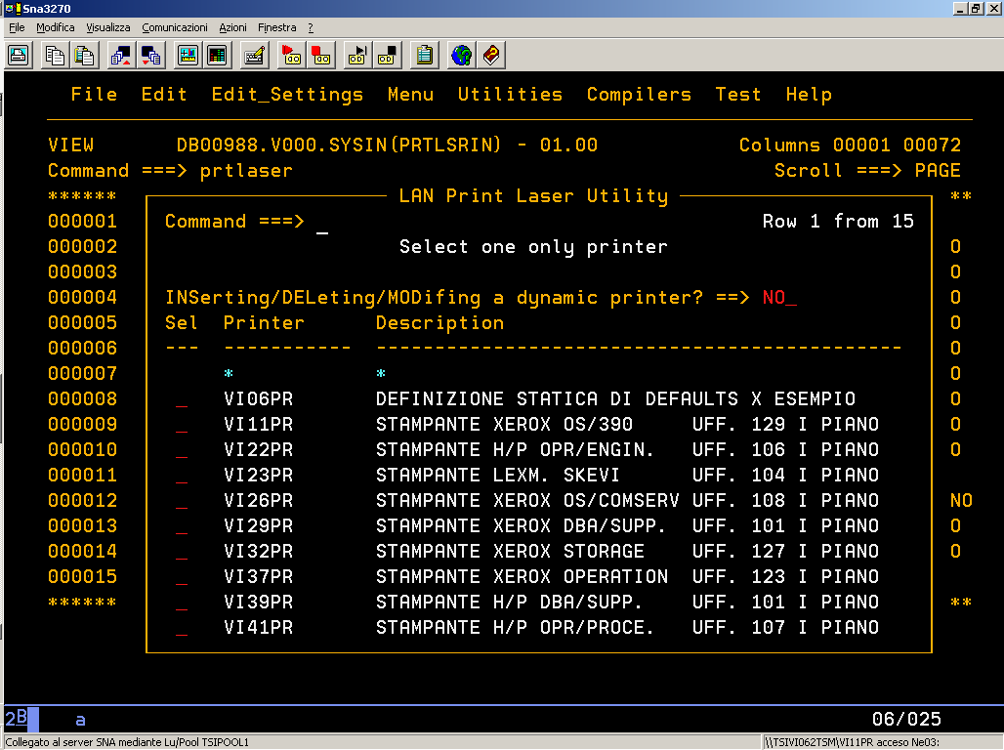

During the interactive session help is also available by pressing PF1 and pressing enter to scroll through all the panels.

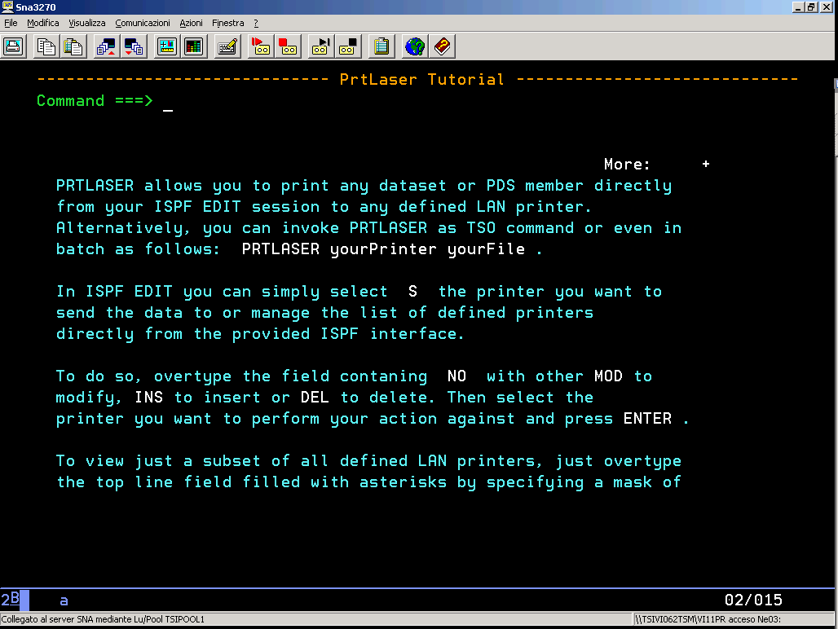

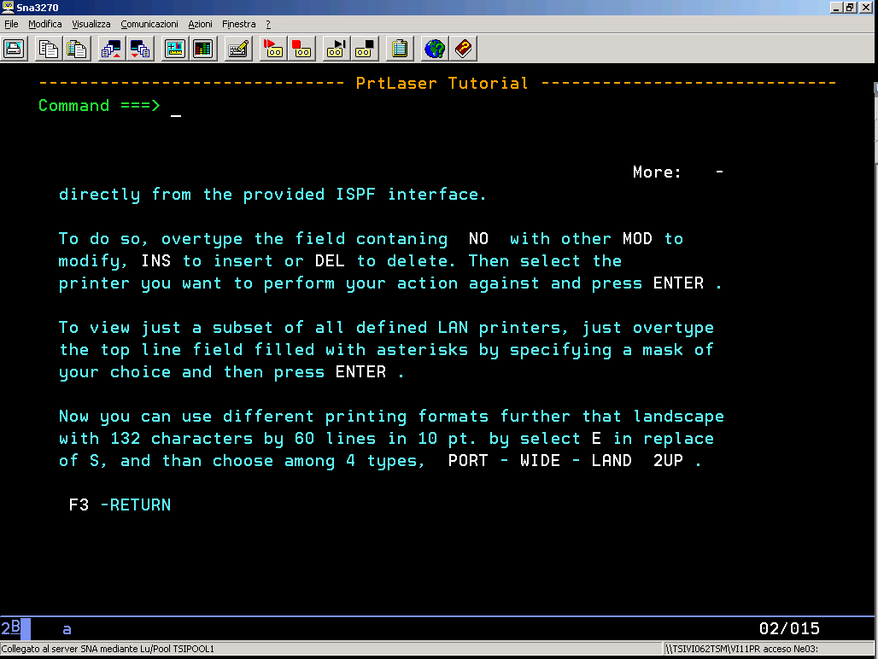

In order to achieve optimum print quality, it is possible to interactively specify the RECORD length and the number of LINES to print.

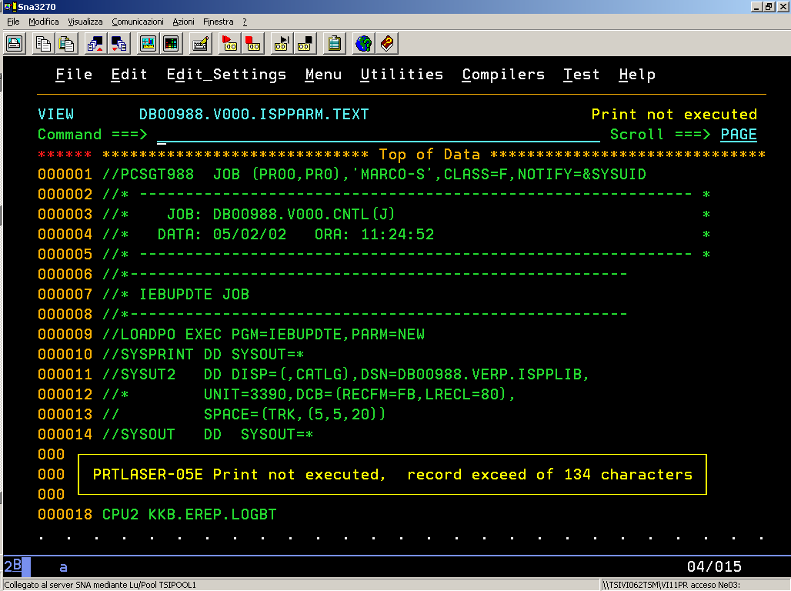

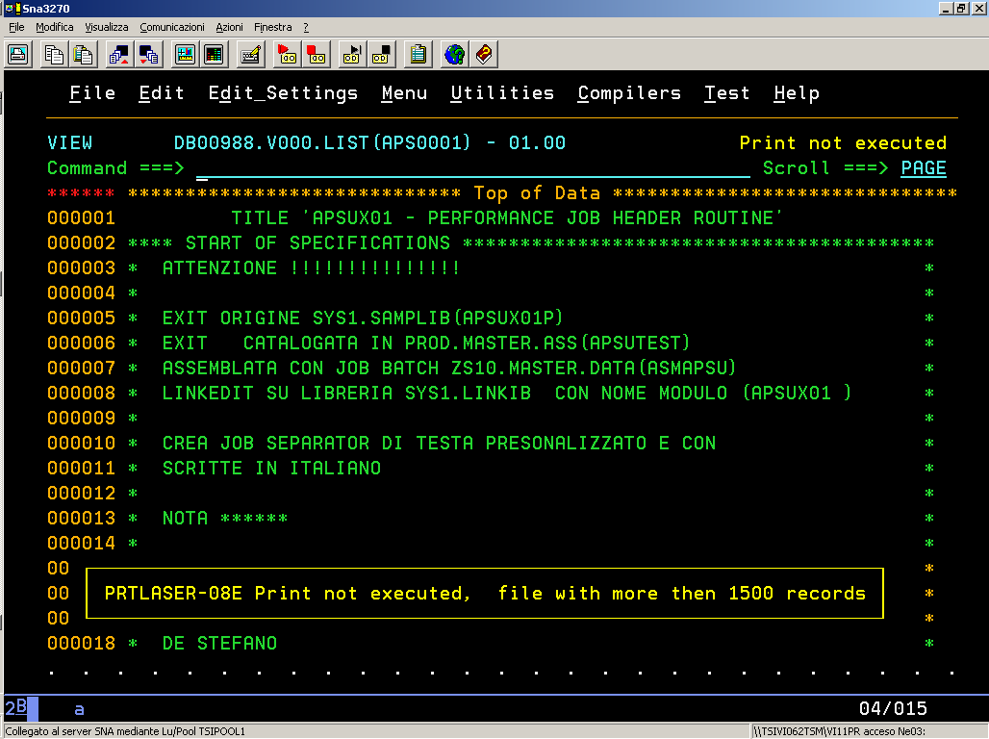

Warning messages are issued whenever a given restriction has been exceeded :

PRTLAN-05E Print not executed, record exceed of 134 characters
PRTLAN-08E Print not executed, file with more then 1500 records

The restriction reguarding the number of LINES does not apply in batch or TSO mode.

How to define printers ....

There 2 types of printer definitions:

- Static default definitions cannot be deleted or modified permanently and are available to all PRTLAN users.
- Personal dynamic definitions can be added, modified or removed manually from individual users interactively or by directly updating the member “user-id.V000.SYSIN(PRTLSRIN)” .

The 2 different options can coexist, in other words it is possible to use static definitions, dynamic definitions or both.

Dynamic definition of printers

Each user add, modify ordelete indipendently the available printer definitions.

These modifications are personal and will not be available to any other user.

Personal printer definitions can also be made either interactively or manually.
The interactive mode is available within PRTLAN , specifying “INS” in the printer panel at the line

INSerting/DELeting/MODifing a dynamic printer? ==> ___

INS

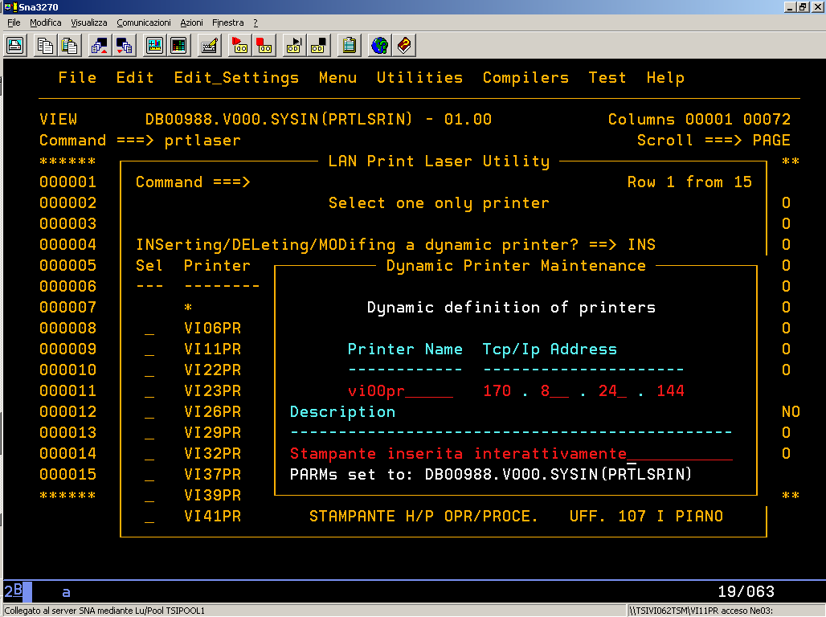

To add a new printer, enter its name and press ENTER :

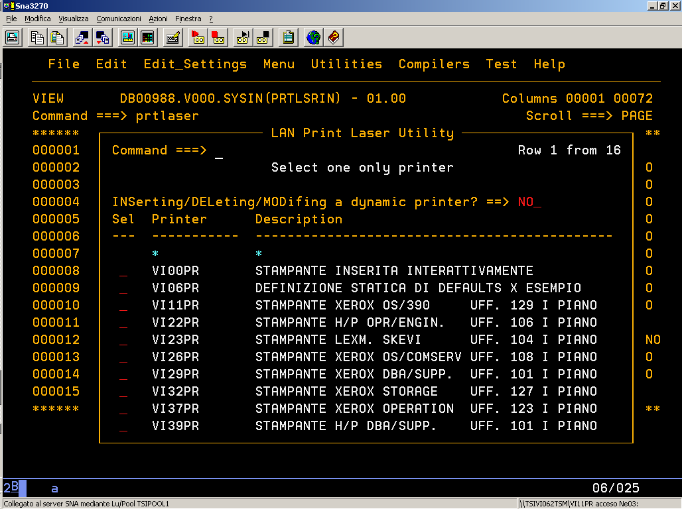

The same definitions can be modified by entering “MOD” in the same command line :

MOD

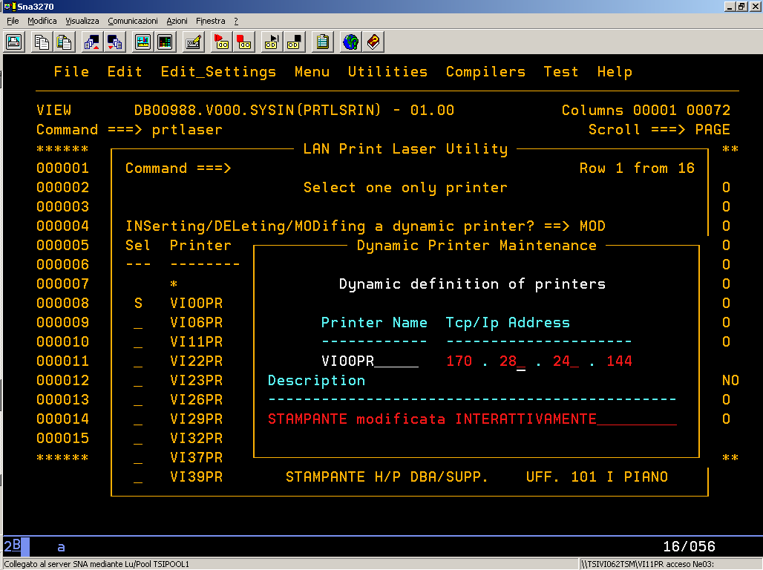

and confirming by pressing ENTER :

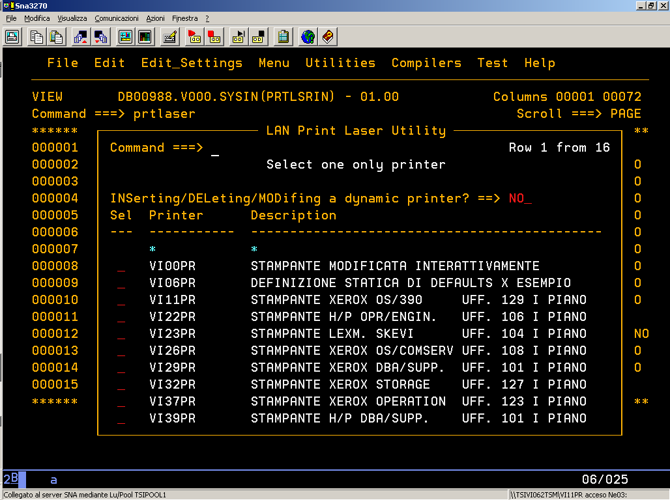

In the same way, an existing definition can be removed by entering “DEL” :

DEL

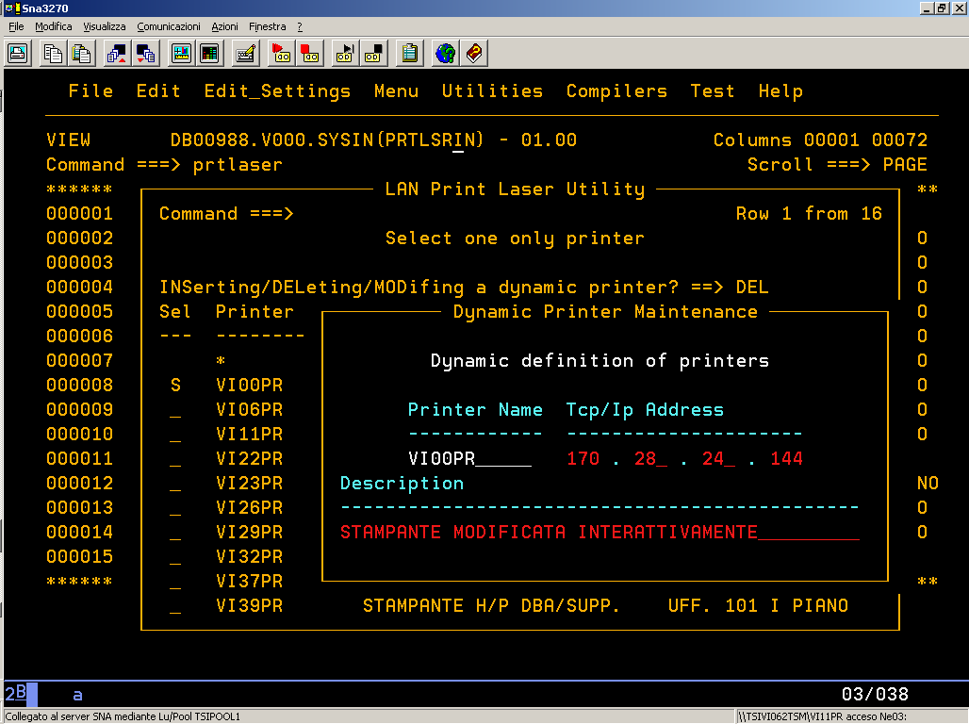

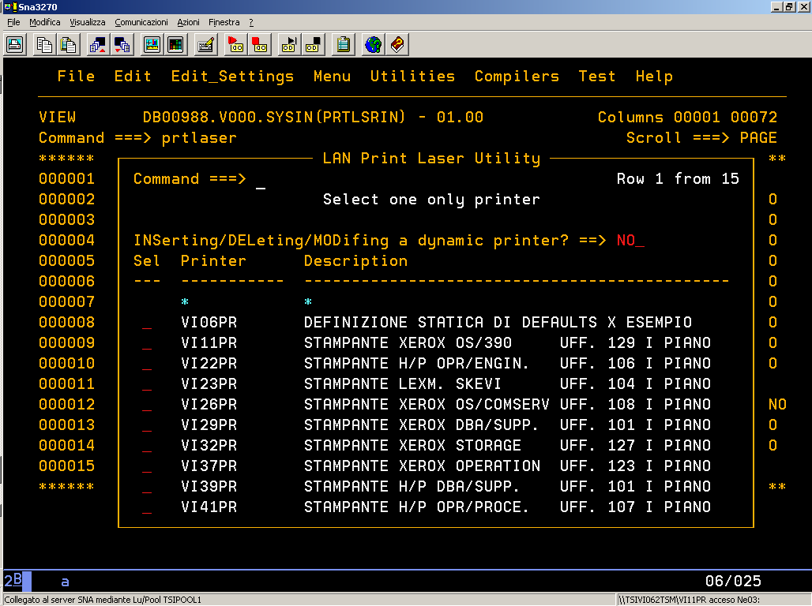

Each function is it breakable by PF03 key.

It is also possible to carry out any of the previous operations manually by simply editing member PRTLSRIN, automatically created by PRTLAN to record the dynamic definitions, bearing in mind that the library name is :

user-id.V000.SYSIN(PRTLSRIN)

It is also possible to define up front any of the parameters as in the example below :

________________________________________________________________________________
EDIT DB00988.V000.SYSIN(PRTLSRIN) - 01.00 Columns 00001 00072
Command ===> _______________________________________________ Scroll ===> PAGE
****** ***************************** Top of Data ******************************
=COLS> ----+----1----+----2----+----3----+----4----+----5----+----6----+----7--
000001 Name Address(TCP/IP) Description
000002 VI11PR 172.24.7.160 PRINTER XEROX OS/390 UFF. 129 I PIANO
000003 VI22PR 172.24.7.171 PRINTER H/P OPR/ENGIN. UFF. 106 I PIANO
000004 VI23PR 172.24.7.172 PRINTER LEXM. SKEVI UFF. 104 I PIANO
000005 VI26PR 172.24.7.175 PRINTER XEROX OS/COMSERV UFF. 108 I PIANO
000006 VI29PR 172.24.6.177 PRINTER XEROX DBA/SUPP. UFF. 101 I PIANO
000007 VI32PR 172.24.7.181 PRINTER XEROX STORAGE UFF. 127 I PIANO
000008 VI37PR 172.24.7.182 PRINTER XEROX OPERATION UFF. 123 I PIANO
000009 VI39PR 172.24.7.176 PRINTER H/P DBA/SUPP. UFF. 101 I PIANO
000010 VI41PR 172.24.7.184 PRINTER H/P OPR/PROCE. UFF. 107 I PIANO
000011 VI48PR 172.24.3.154 PRINTER H/P SALA M. TORRI Q. IV PIANO
000012 VI51PRSRV 172.24.7.169 PRINTER H/P PROJET MGN UFF. 216 II PIANO
000013 VI52PRSRV 172.24.7.195 PRINTER H/P SALA M. VI UFF. 123 I PIANO
000014 VI53PRSRV 172.24.7.196 PRINTER H/P SALA M. VI UFF. 123 I PIANO
000015 12345678901 1.1.1.2 DEFINE AFTER DELETE IN SAME SESSION
****** **************************** Bottom of Data ****************************

Should a particular printer already be defined statically, any other dynamic definition will be ignored.
Please note that PRTLAN automatically rejects any definition containing a TCP/IP address syntactically incorrect.

