TACKLE REQUIREMENTS:

* Minimum 4 separate pages → 5 branches on GitHub

1. Home

2. Meet the team

3. Landscapes

4. Game demo

5. Work with us

* Minimum 2 interactive elements

1. Drop-down navigation bars

2. Photographs gallery

COLOR PALETTE:

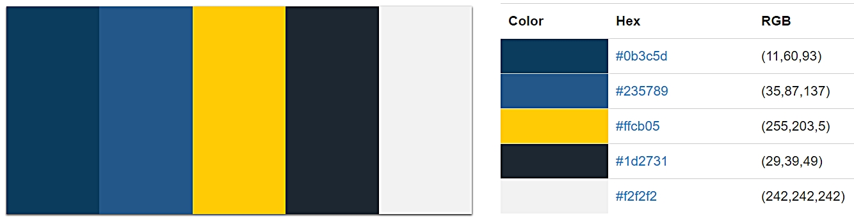

SKETCH:

1. Home

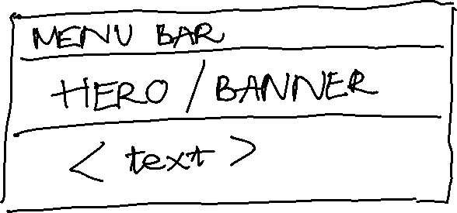

2. Meet the team

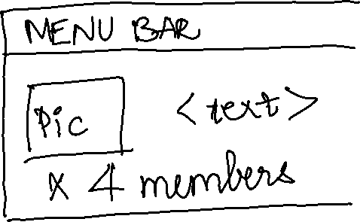

3. Landscapes

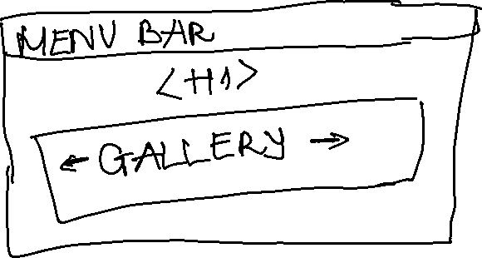

4. Game demo

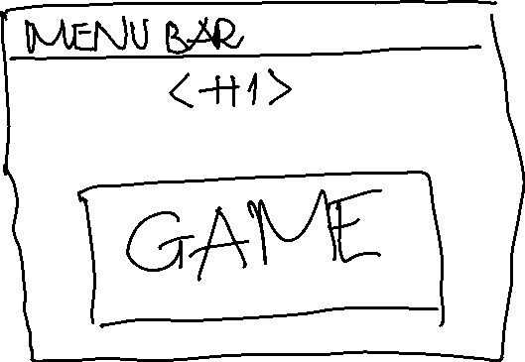

5. Work with us

