# Department of Computer Sc. & Engg, Govt. Engg. College – Thrissur PROJECT(P1) Interim Evaluation of project progress

**2022-2023 ODD**

1. **Program:** B.Tech. in Computer Sc. & Engineering **Batch:** 2019 Adm.
2. **Team Members:**

1. Devi Krishna M K Uni. Reg. No: TCR19CS026

2. Maria Viji George Uni. Reg. No: TCR19CS039

3. Navneeth Variar Uni. Reg. No: TCR19CS047

4. Niranjan Neelakantan (leader) Uni. Reg. No: TCR19CS049

1. **Team leader:** Niranjan Neelakantan Uni. Reg. No: TCR19CS049 **Group number:** 8
2. **Guided by:** Mrs. Princy Ann Thomas, Assistant Professor
3. **Broad area:** Artificial Intelligence
4. **Sub area:** Natural Language Processing and Optical Character Recognition
5. **Project Title:** Automated Hand-written Malayalam Descriptive Answer Script Evaluation System Using Machine Learning

# Objectives of project work:

**O1:** To alleviate the task of malayalam answer paper evaluators.

**O2:** To explore different techniques to improve the accuracy of Malayalam handwriting recognition algorithms.

**O3:** To tweak the existing automated evaluation systems and enhance the scope and usability of it.

**O4:** To increase the familiarity with the concepts of optical character recognition and machine learning techniques.

**O5:** To design and implement a prototype by efficiently utilising the diverse skills of the team, using concepts of project management and software development.

# Skill set matching:

Students have to identify the Skill set needed to complete the project work and match the skills of participating members to this set, to ensure that sufficient talent is available with team for the project completion

Items in angled brackets need to be filled by students as per their team and work

The number of skills used here are for example; actuals may be more or less. Adjust the table in such cases

Mark the matching in a 3 point scale 0-no talent, 1- Low talent, 2- Medium talent, 3-High talent. Aim of the project work is to ensure all members a medium talent in all skill set, at minimum at end of course

Remove this note in the final document

Identified Skill set for project

Python3: *<>*, SK2: *<* Description *>*, SK3: *<* Description *>*, SK4: *<* Description *>*, SK5: *<* Description *>*, SK6: *<* Description *>*



| **Skill needed in Project** | *Sk1* | *Sk2* | *Sk3* | *Sk4* | *Sk5* | *Sk6* |
| --- | --- | --- | --- | --- | --- | --- |
| *<* Name1 limitlength *>* | 00 | 01 | 02 | 03 | 00 | 01 |
| *<* Name2 limitlength *>* | 03 | 02 | 01 | 00 | 03 | 02 |
| *<* Name3 limitlength *>* | 02 | 03 | 00 | 01 | 02 | 03 |
| *<* Name4 limitlength *>* | 01 | 02 | 03 | 00 | 01 | 02 |

1. **Important information about project work** Score off the unwanted choices in each group OR fill in the information in blank portions

| **Classification:**  *{*Internal*}{*Internal with External Collaboration*}*  *{*External Internship*} {*Other: *<*fill here*>}* | *{*Industrial/Social*}{*Academic Research*}*  *{*new idea*} {*new variant of an idea*}*  *{*//e/x/i/s/t//in//g//w//o//r/k//*}*/ |
| --- | --- |
| **Source of Idea:** | *{*Student*} {*Guide*} {*BOTH*}* |



1. **Important information about project potential** Score off the unwanted choices in each group OR fill in the information in blank portions. Use this item if the work qualify as Industrial/social variant of a new idea as per Classification in point above

| **Product is *NEW Variant***  *{*System-both H/W, S/W*}{*Software*}*  *{*Has IPR content-/N//O//YES*}*  *{*IPR at Design /a/n//d//F//i/n/i/s/h//e/d///G//o//o/d//s level*}* | *{*Industrial/S//o/c//ia//l*}{*Finished Goods*} {*//S/e//r/v/i/c/e//*}*  *{*Can compete globally/l/o//c/a/l/l/y/*}*  *{*Global /C//o/n//t/i/n/e//n/t/ L//o//c/a/l//N//o//t Patentable *}*  *{*Business value Immediate /t/o//d//o//e//s/t/i/m//a/t//io//n/ *}* |
| --- | --- |
| *{*Variation by Parametric tuning*}*  *{* Alternate /d/e/s//ig//n/, implementation*}* | *{*Run faster, More work per /u//n/i/t//t/i/m//e/, dollar *}*  *{* Better acceptance by end users *}* |
| *{*Scalable*} {*Portable*} {*Ethical*} {*Safe*}* | *{*/O//l/d/ Current technology*} {*Future Technology*}* |
| *{*OSS License*} {*OSS/Proprietary mix*}* | *{*Proprietary*}* /*{*/C//o/l/l/a/b//o//r/a/t/o//r/*} {*Own Startup*}* |

# Related works:

(Name at least three core references inspired you to come up with this new work, put cross reference by the side )

(a) Subjective Answers Evaluation Using Machine Learning and Natural Language Processing - [1]:

The paper proposes a novel approach using different NLP techniques like Wordnet,Word2vec,cosine

similarity to evaluate subjective answers automatically.Solution statements and keyword matching are used to evaluate the answers.ML model is trained to predict the scores.

(b) Proposed method to Malayalam Handwritten Character Recognition using Residual Network enhanced by multi-scaled features - [2]: A novel hybrid approach for recognizing the characters of malayalam handwritten texts is proposed in the paper.By combining the statistical features and structural features of the characters,more accuracy is obtained in malayalam character recognition. The proposed system has claimed to have obtained around 97 percentage accuracy in malayalam character recognition.

(c) Towards Automated Evaluation of Handwritten Assessments - [3]: The paper introduces a framework that integrates ideas from information retrieval,NLP and feature based keyword spotting to automate the evaluation of short descriptive answers.Along with keywords from textual reference,semantically relevant keywords to that in textual reference is obtained using information retrieval and various Natural Language Processing Techniques.The added feature of spotting semantically relevant keywords has resulted in the increased accuracy of score prediction.

# Project synopsis:

(Answer to the questions below need to be in a para, clear and concise)

* 1. Problem diagnosis:



(describe the problem domain, concisely state what kind of issues exist in the current practice that you would like to address. Be as specific as you can)

* 1. Problem statement:

(A problem statement is a short, succinct explanation of a problem you are about to solve, knowing already its feasibility)

* 1. Methodology of solution:



(describe how you propose to address the diagnosed problems, Methodology of your solution)

* 1. Correctness and completion of work:



(What kind of metrics will you use to evaluate your success in solving the targeted problems)

* 1. Demonstration plan:



(How exactly will your customer know that you achieved what you promised? How does the evaluator know correctness and completion of your work)

* 1. Your technical development:



(What all skills/Knowledge will you develop by doing this work, in addition to what is specified in CO’s. How does it improve your employability, professional life?)

# Work plan:

Import the approved Action plan from Zeroth proforma form. Suggest your initial work plan in a table for this semester, by filling the blank dates(as your proposal). Note that a detailed workplan in a different form will be asked later. You can cutout the latex table portion from that file, include here and modify it

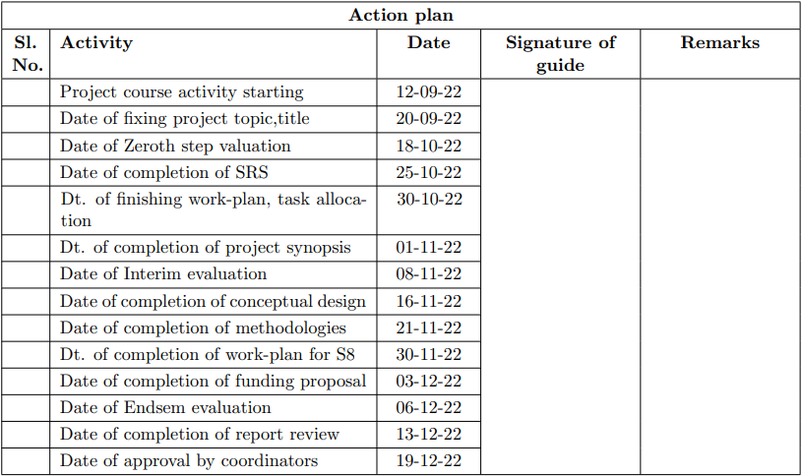

# Completion in one semester time:

Score off the unwanted choices in each group OR fill in the information in blank portions

| **Completion of work:***{*can n//o/t/ be completed*}* | *{*by Action plan time /e/a//r/li/e/r///t/h/a//n/ of item 12  *<*your suggestion*>}* |
| --- | --- |
| **Draft Report writing:** *{*can /n/o//t be completed*}* | *{*by Action plan time /e/a//r/li/e/r///t/h/a//n/ of item 14  *<*your suggestion*>}* |
| **Funding requirement:** *{*/N//I/L/ Needs funding*}*  through *{*Own resource*} {*Institutional*}* | arranged by *{*Student*} {*Guide*} {*BOTH*}*  *{*funding agency:*<*fill the details*> }* |
| *{*Approximate cost expected:*}<* fill the details *>* | |
| *{*Other:*}<* fill the details, any relevant info you want to provide to evaluators *>* | |

# Approximate Workload distribution:

Items shown in angled brackets need to be replaced based on your work. Figures shown are examples to help you. Do workout these figures with help of guide and fill them. Use short notations of sufficient length so that table alignment is not lost

Horizontal totaling Σ Mem i Vertical totalling Σ Work * Mem i

In the sample shown Mem3 has the most workload, almost even balance of workload

It need to be true statement, as of NOW; if found false at later evaluation, defaulter will face serious consequences To easily fill it, students should plan the stages and corresponding percentage workload of the total work load. After filling this column, as per the division of labor, percentage for each member can be found and entered. Please remove this instructions in the final document

Member1: *<* Name *>* Member2: *<* Name *>*

Member3: *<* Name *>* Member4: *<* Name *>*



|  | **% Work** | *Mem1%* | *Mem2%* | *Mem3%* | *Mem4%* | **TOTAL** |  |
| --- | --- | --- | --- | --- | --- | --- | --- |
| **Completed** | | | | | | |  |
| *<* Work1 limitlength *>* | 05 | 30 | 20 | 20 | 30 | 100 |  |
| *<* Work2 limitlength *>* | 10 | 40 | 00 | 20 | 40 | 100 |
| *<* Work3 limitlength *>* | 15 | 10 | 10 | 40 | 40 | 100 |
| **To be Completed** | | | | | | |  |
| *<* Work4 limitlength *>* | 20 | 40 | 40 | 10 | 10 | 100 |  |
| *<* Work5 limitlength *>* | 20 | 10 | 40 | 40 | 10 | 100 |
| *<* Work6 limitlength *>* | 15 | 10 | 10 | 40 | 40 | 100 |
| *<* Work7 limitlength *>* | 15 | 10 | 10 | 40 | 40 | 100 |
| **TOTAL** | 100 | 20 | 21.5 | 31 | 27.5 | 100 |  |

# Plan for self publication:

Write your suggestions here as a pointed list specifically on (1) Publishing yourselves as a professional and work you are doing on a web-page (2) about possibility of a paper, if so at what venue (3) exhibiting your product, competing with others on the same area, if so at what means, venues

# Facilities to be provided by department:

Write your suggestions here as a pointed list

* Uninterrupted high speed wi-fi connection.
* Lab space to work
* High end machine capable to train ML models with large datasets.

# References:

Provide all reference including any journal, conference, text portions, handbook portions, collections, previous

work-report, technical reports, web references, publications of your guide

[1] Abdul Rehman Javed Natalia Kryvinska Shahab S. Band Muhammad Farrukh Bashir, Hamza Arshad. Subjective answers evaluation using machine learning and natural language processing. IEEE Access, 9(25), November 2021.

[2] Chandran Saravanan Samatha P Salim, Ajay James. Proposed method to malayalam handwritten character recognition using residual network enhanced by multi-scaled features. 2019.

[3] Jawahar C.V Vijay Rowtula, Subba Reddy Oota. Towards automated evaluation of handwritten assessments, 2019.

# Approval note of Guide:

Remarks guide wants to mark specific to **this** seminar by **this** Student using **this** idea reservation request. If no comments, put NIL; do not leave as blank

# Date of approval:

**Signature of Student**

**email-id:** [niranjan2neelakantan@gmail.com](mailto:niranjan2neelakantan@gmail.com)

**Signature of Guide**

**email-id:** princyannthoma@gectcr.ac.in

Note:- Use these e-mail ids for communication. Communication send to any other address is invalid or is not part of seminar correspondence.