AI build log
Razorpay Trusted Collections Agent — how the build was done, what the AI did, and where I made the calls.
Ujjwal Goel · 55 commits, 5–13 October 2026 · ~5,000 lines of application code, 8,400 lines of rules and content, 37 tests
AI tools and models used
Tool or model | What it was used for | Build-time or runtime
Claude Code (Opus and Sonnet) | Wrote the application code, the tests, the sample book and the rule harness; ran the research sweeps | Build-time
Claude Sonnet, via API | Runs inside the product: drives each turn of the live call, then reviews the finished call and scores it against the rules (LLM_MODEL, LLM_REVIEW_MODEL) | Runtime
Sarvam AI | Hindi and Hinglish speech to text and text to speech on the live call | Runtime
Replit + GitHub | Hosting and deployment, with its agent working the same repository in parallel | Build-time
Wispr Flow | Transcribed and summarised the three lender interviews | Build-time
The distinction that matters: one set of tools built the product, and a different set runs inside it. The agent a borrower speaks to is a Claude model with Sarvam speech on either side; the thing that wrote it is Claude Code.
Key prompts, workflows and agent setup
The agent's behaviour does not live in code. It lives in content files that are read fresh on every call — agent.md for how Meera speaks, script.md and policy.json for what she may say, guardrails.json and review-checks.json for what counts as a breach, and decision-rules.json for the thresholds that route a borrower. Changing her tone, or the number of bounces that sends a case to a person, is a text edit.
Two prompts do the work, and both return JSON rather than prose. The turn prompt takes the call so far and returns what to say, what to speak aloud, which action to take (one payment link, raise a ticket, hand off) and whether to end the call. The review prompt takes the finished transcript and returns the outcome, the reason, the root cause, the promise, the borrower's cooperation and a verdict on every rule. Structured output is what lets the rest of the system be ordinary code.
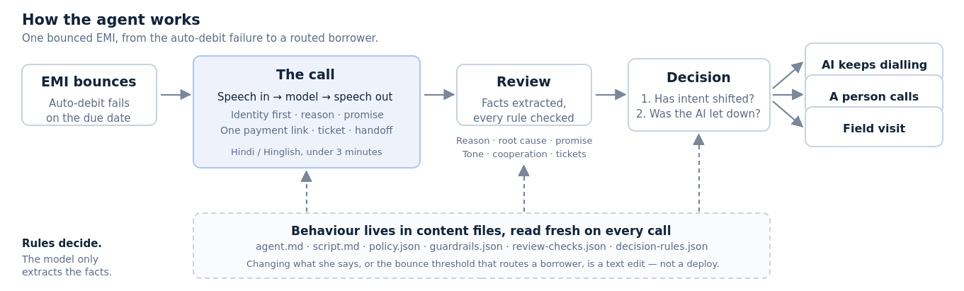
The agent: the call produces facts, the rules produce the route.
The build loop mattered as much as the prompts. Claude was connected to GitHub, and GitHub to Replit, so a change was live in minutes and I could watch it. More usefully, the call logs are pushed back to a branch in the same repository, so Claude could read what actually happened on a real call — what the borrower said, which rule tripped, where the agent stalled — and I could act on it immediately instead of listening to recordings and writing notes by hand.
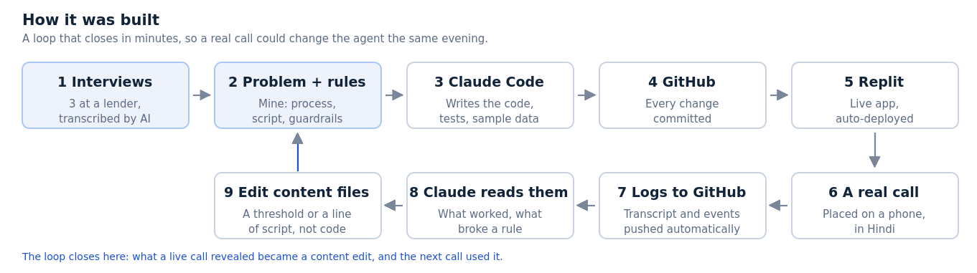
The build loop: a live call could change the agent the same evening.
Every change ran the same gate before it was committed: typecheck, build, 37 tests, then a screenshot of the actual screen that the AI had to look at before claiming it worked. The decision engine deliberately has no runtime imports so its tests run standalone.
One AI output I rejected, corrected or significantly improved
[ To be completed ]
Candidates under consideration: the demo mode built on a separate interface, rejected because a demo on different screens proves nothing about the product; the fabricated statistic caught during review; the six-persona signal model cut down to one borrower with real history.
What the AI did versus what I decided
What I decided and defined | What the AI did
Chose the problem: brainstormed broadly, then set my own selection criteria and stress-tested each candidate against them before committing to post-bounce collections. | Scored the candidates against my criteria, argued the weak ones down, and researched the market size, the bounce data and the RBI recovery directions.
Defined the collections process itself — buckets, the post-bounce workflow, what a good agent does — from my own years in the domain, then corrected it against three lender interviews I ran. | Turned that process into a working call flow, state machine and data model, and transcribed and summarised the interviews.
Wrote the inputs that govern behaviour: the guardrails, the rule checks that count as a breach, the tonality and the call script. | Implemented each rule twice — as exact code and as an AI reviewer — so a flag from either counts, and built the harness that scores every call.
Set the decision design: rules decide the route, the model only extracts facts. One persona with real history rather than six shallow ones. | Built the decision engine, the confidence walk behind it, and 12 tests that pin the thresholds.
Specified the dashboard: which tabs exist, what each one answers, and which metrics matter enough to be shown large. | Built the screens, computed the metrics across a 100-call sample book, and rebuilt them when I changed the structure.
Judged every output: what shipped, what was cut, and what was wrong. | Produced far more than shipped, which is what made cutting cheap.
The honest summary: the AI was a computational assistant. It did the heavy lifting — code, computation, research, sample data — and it sharpened what I already knew by arguing with it. It did not choose the problem, define the collections process, write the guardrails or decide what the dashboard should answer. Those came from my own time in this domain and from the three interviews.
Known limitations, risks and verification steps
- The numbers are synthetic. Every metric on the performance screens comes from a 100-call sample book, not from live borrowers. They show the measurement works, not that the agent works.
- The weights are uncalibrated. Nothing yet records whether a promise was kept, so the confidence walk behind the decision has never been checked against a real outcome. Until it is, the thresholds are reasoned, not proven.
- The AI reviewer is untuned. The 29.7% hard-rule breach rate on sample calls is partly the reviewer being strict and partly the agent being wrong, and I cannot yet separate the two.
- How it was verified. Rules are checked twice, by exact code and by the model, and a flag from either counts. 37 automated tests pin the decision thresholds and the metric arithmetic. Screens were checked by screenshot, not by assertion. Every figure in the product note carries a source and a confidence level, and the figures I calculated myself are labelled as mine.
- Where I had to verify the AI directly. It produced a statistic that was not in the data. It is the reason every number in these documents was traced back to either a source or a computation before it shipped.

