Contents

Introduction: 2

Task -7 2

Things I have learnt: 2

Task – 1 2

Task – 2 4

Task -3 12

Task – 4 14

Task – 5 14

Way it can be improved: 15

Most Difficult Development Parts: 15

Introduction: I was requested to develop a website for Lucy’s Pet Service. They gave some requirement criterion. I have tried to complete those. Here is the documentation describing how to use this application.

# Task -7

## Things I have learnt:

Learning is a continuous process. It can’t be finished in one or 2 tasks. But every single task can help us with a lot of experiences. Here I am going to demonstrate the things I have experienced through all over this assignment. The learnings are demonstrated as different task basis.

### Task – 1

Setup Page: Following image shows the folder structure of my file list. The setup page is named as setup.php in the config folder.

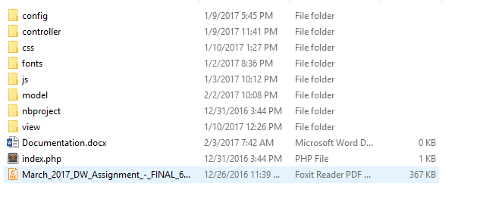

Running the setup file will prepare the database for use.

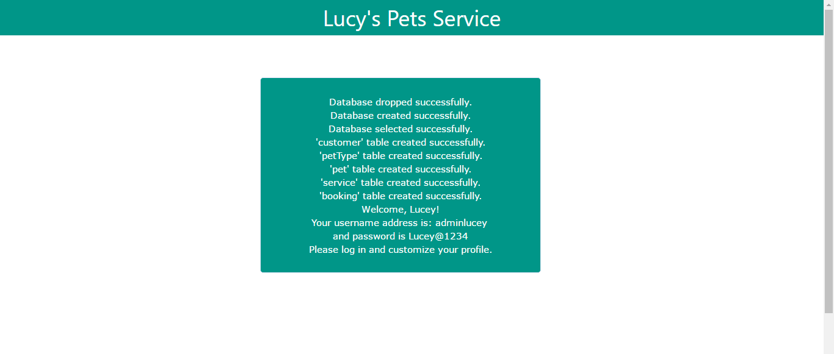  
After setting up the database, the following window appeared along with showing the username and password for admin registration.

### Task – 2

Running the index.php in the root directory will take the user in login window. The login window is shown below:



All user can log in from here.

I was told to make the page as secured as I can. The following diagram shows the code for login.php file.

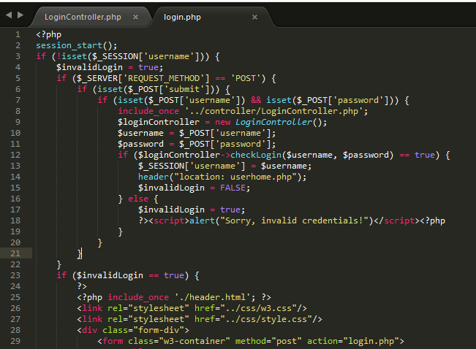

The following diagram shows the code for LoginController.php file codes.

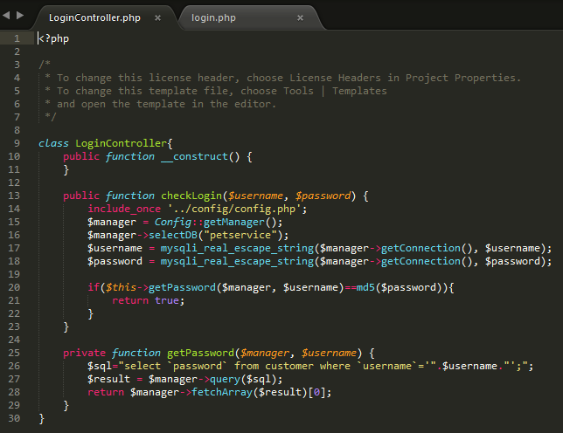

If a user is not logged in, he/she can go for the registration by clicking “register” link. The registration page is shown below:

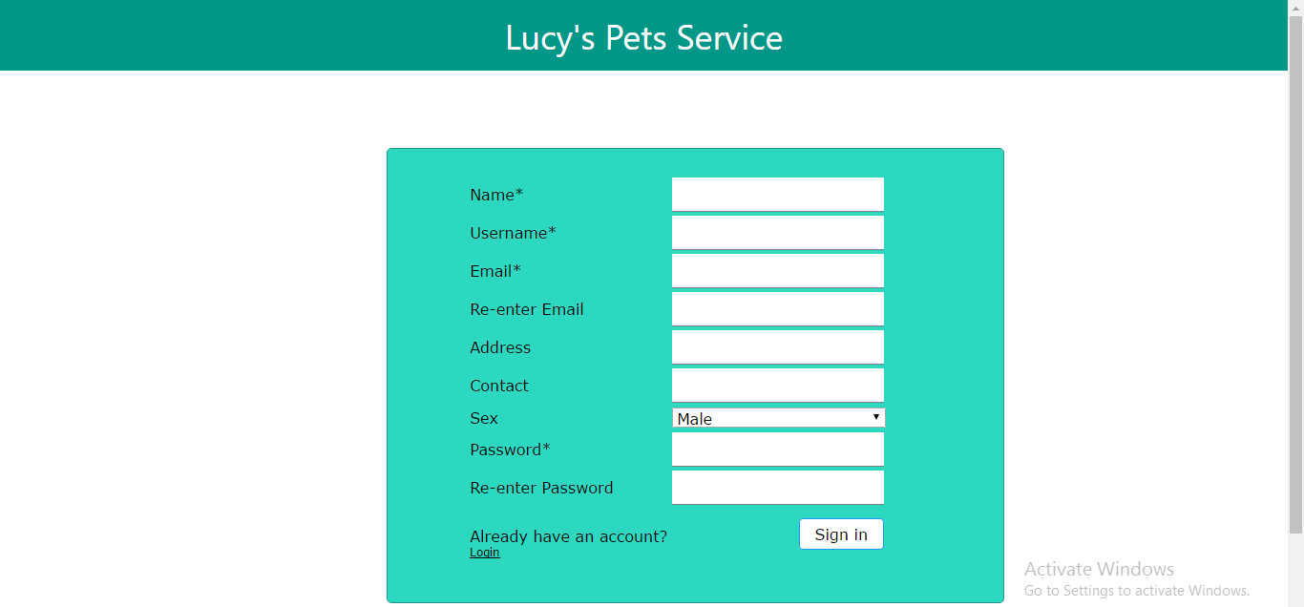

The registration page has also been made much secured by validating all data required to sign up. The checking are show in below diagrams.

1. Submitting empty form:

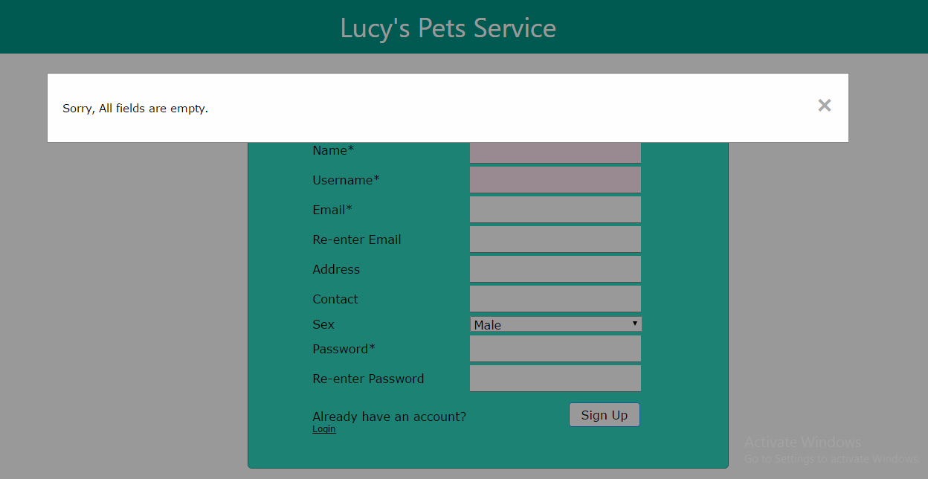

1. Submitting without the name:

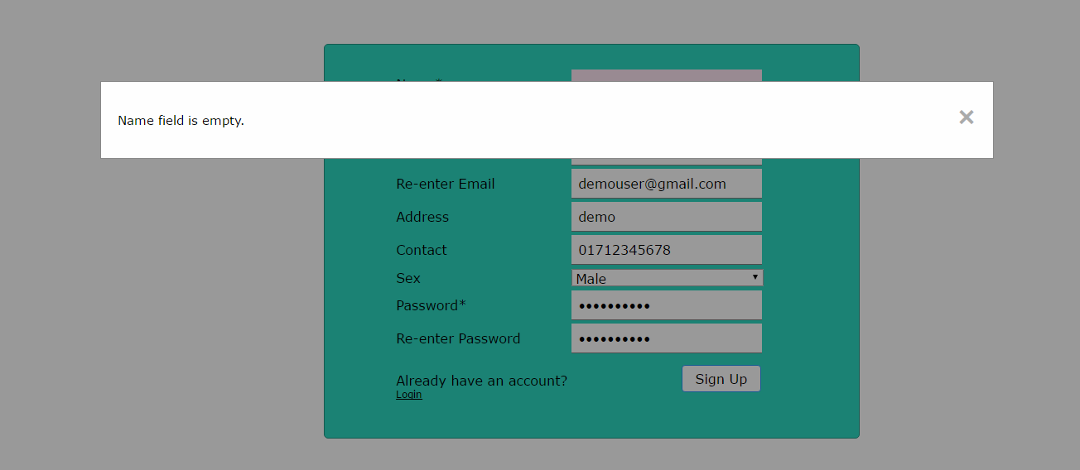

1. Without username:

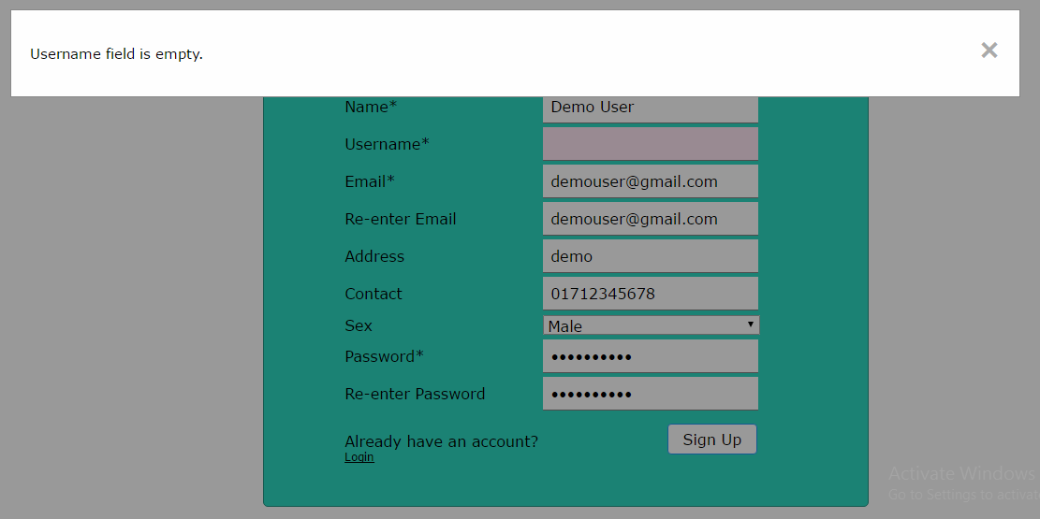

1. Empty email field:

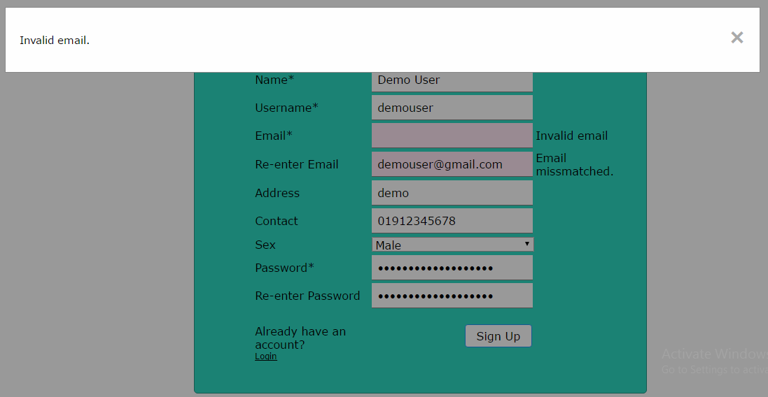

1. Password check:

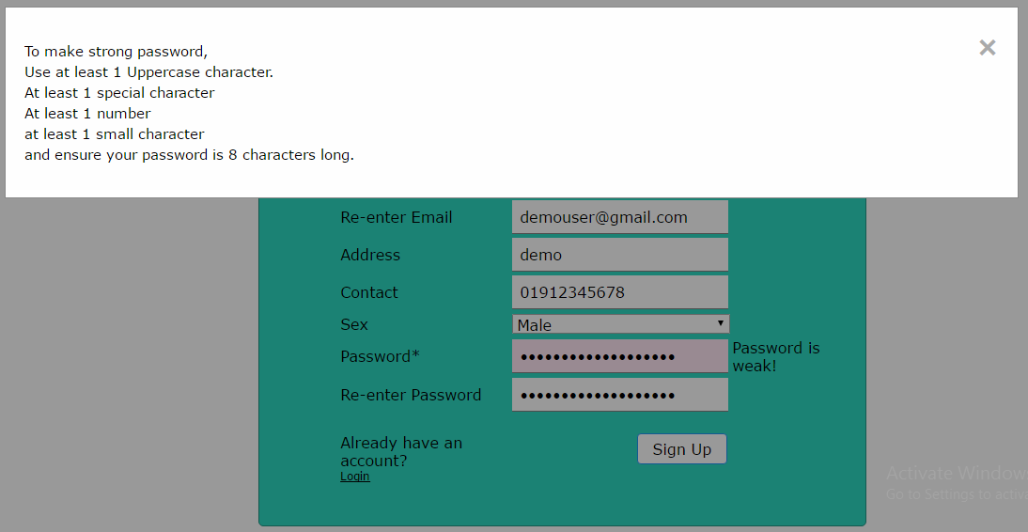

The code for registration.php page is shown below:

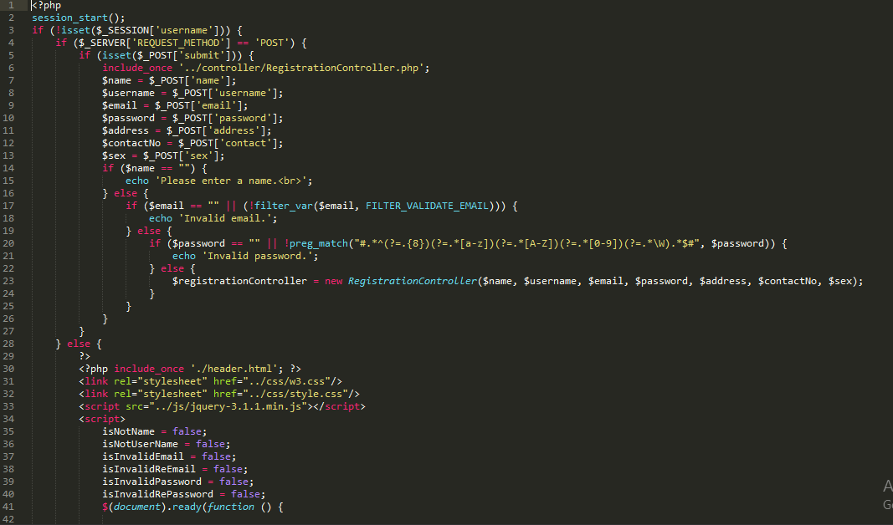

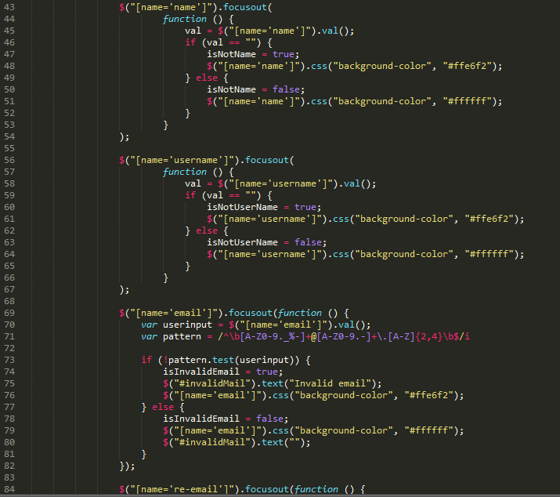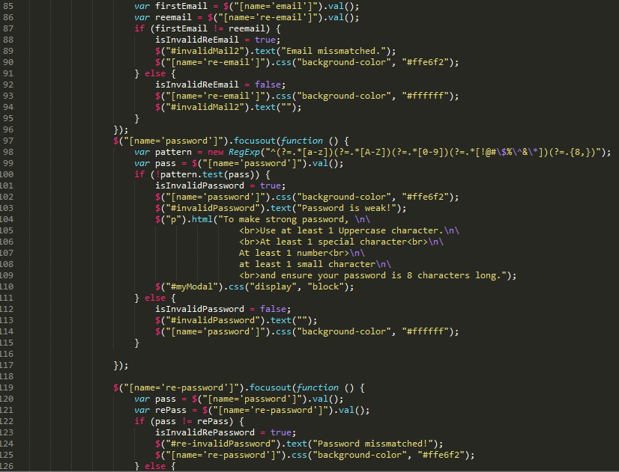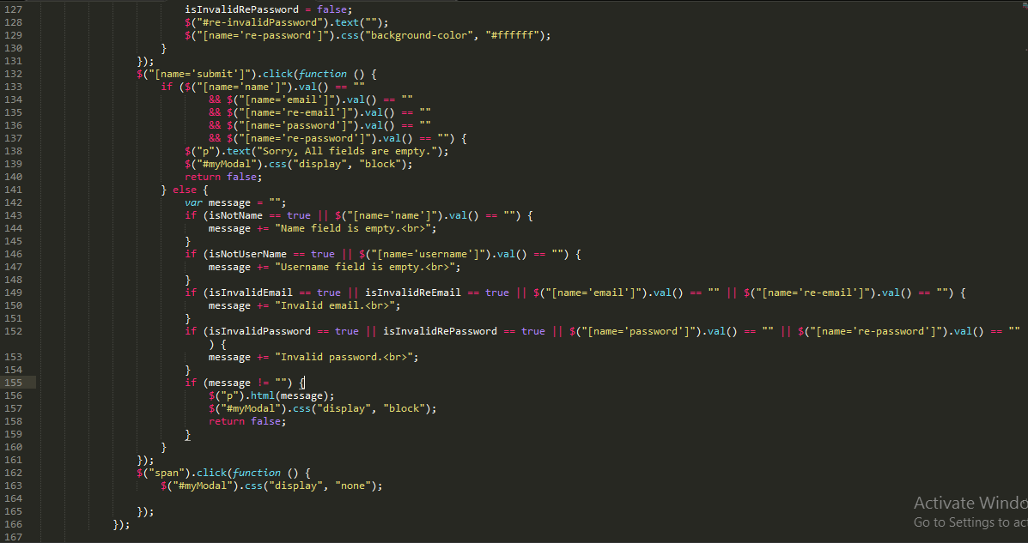

### Task -3

After logging into the user account, user can perform all his tasks as required.

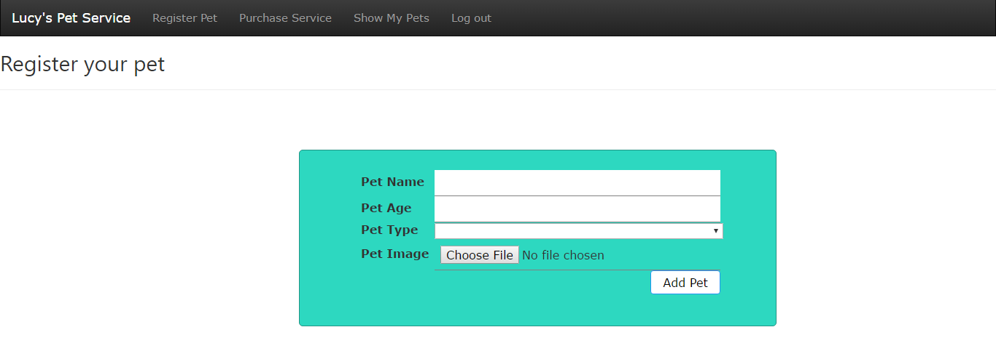 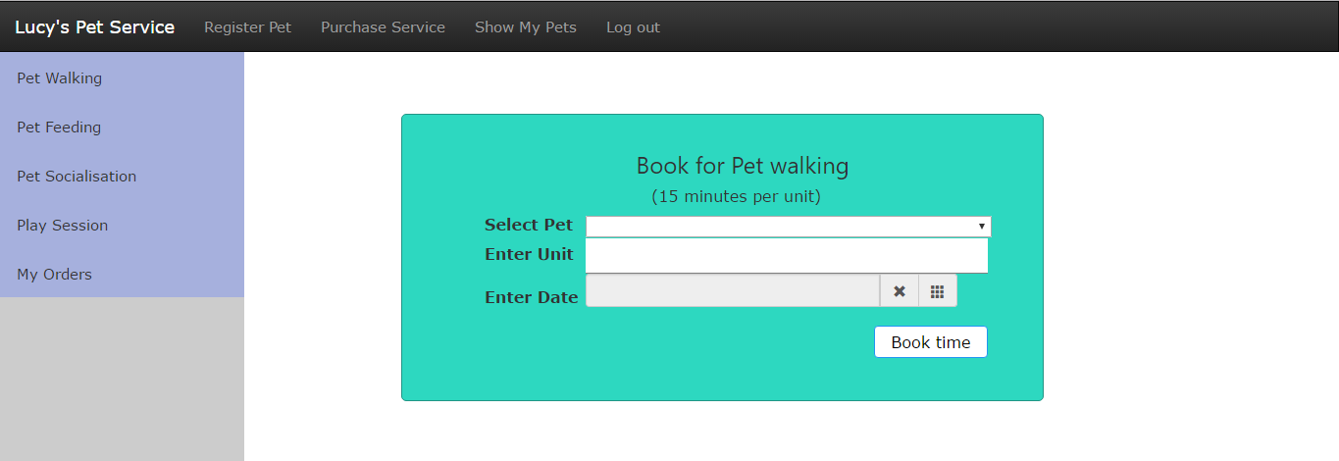 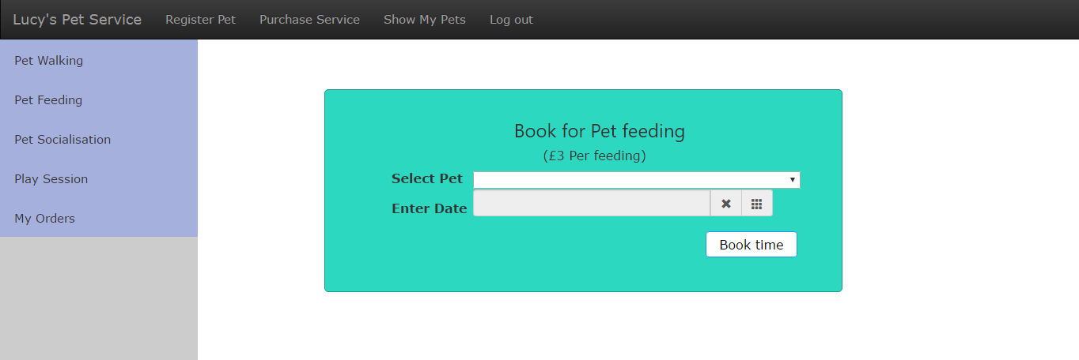 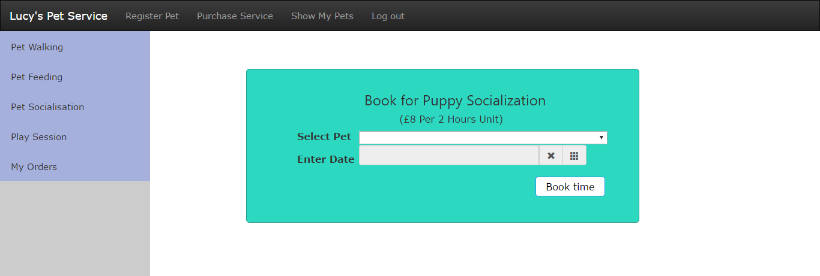 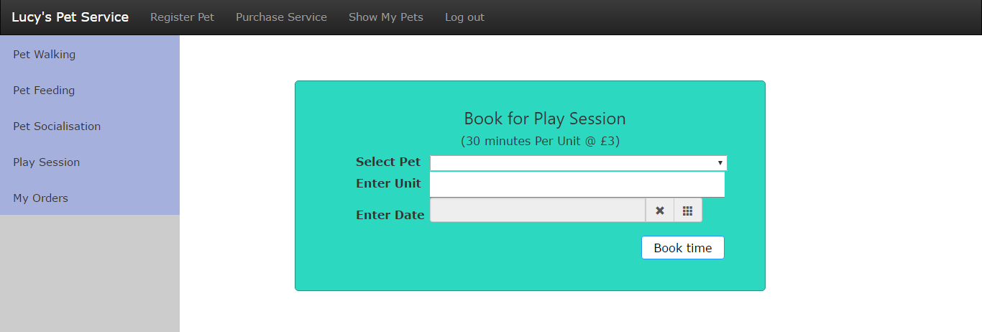

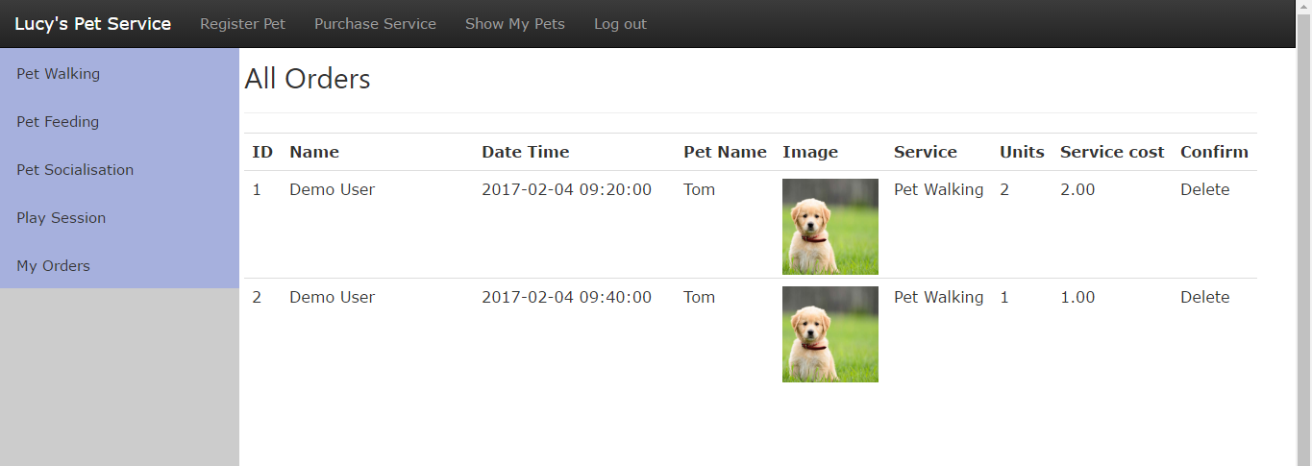

### Task – 4

I have added the calendar to show dates in calendar form.

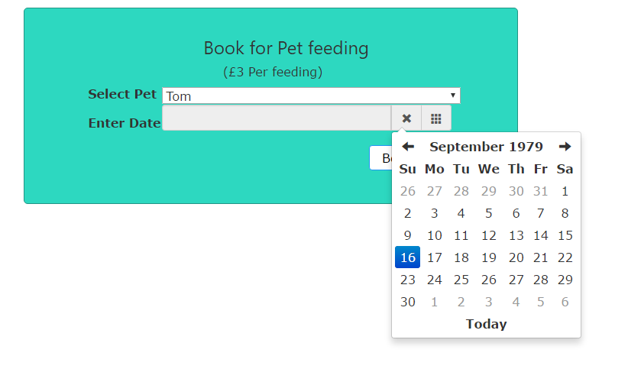

### Task – 5

The cost has been calculated.

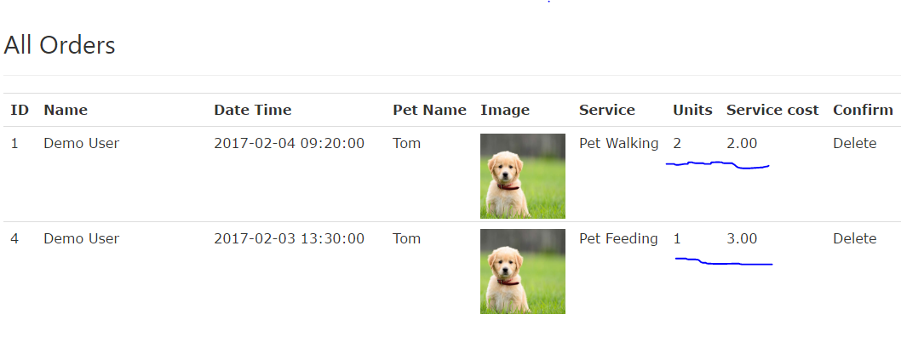

Through this task I have learnt a lot of things. I have learnt the way server handles different user requests, how the layers work together in application stack, different security issues at the application stack, how to handle user sessions, orders etc. I have also learnt to upload images and other files in the server, difference between server request methods etc.

## Way it can be improved:

A lot of improvement can be put here. The design is not enough gorgeous. It could be made more gorgeous, attractive and also interactive. The usability is not good enough in this site. It needs a lot of work to do for usability. Though I have tried to test both the admin and user panel as much as I could, but only after deploying in the real working environment, it would help to figure out if there is any more testing needed. A very important thing to take care of for any real world application is User Experience. As this task has been completed for academic purpose, I haven’t taken the user experience in my consideration. But if it is going to be deployed as a system for real business, assessing the user experience is mandatory.

## Most Difficult Development Parts:

There were no parts I found that difficult.